
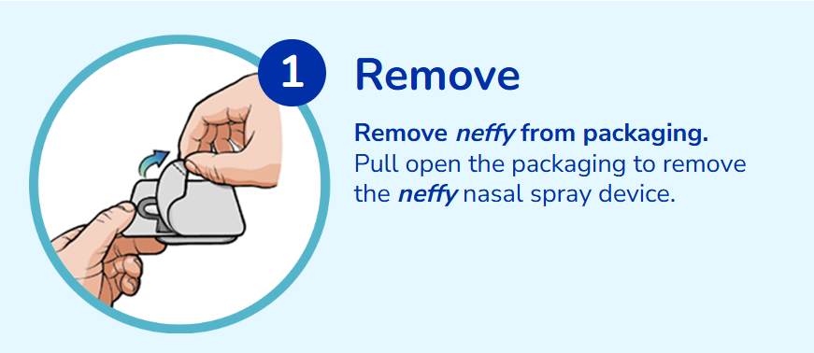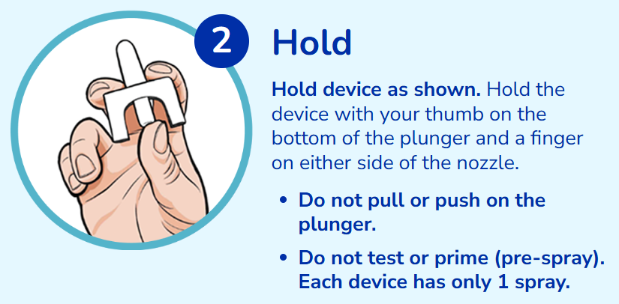

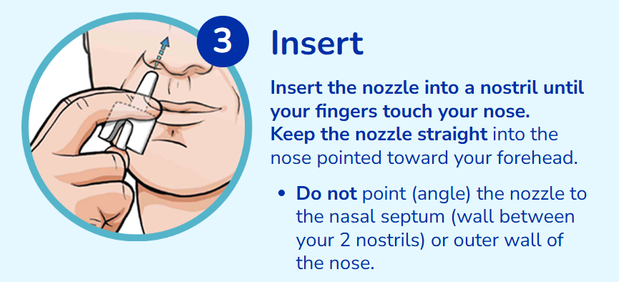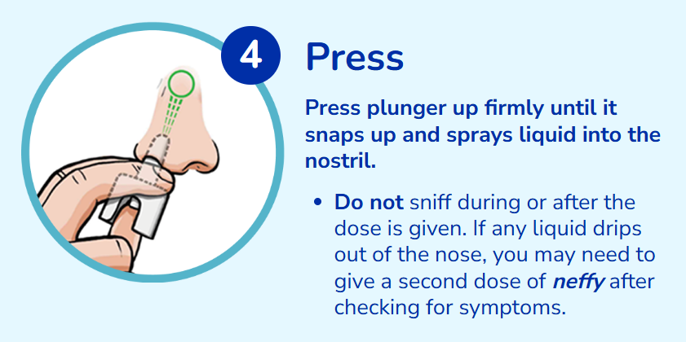
Check for symptoms after the first dose of neffy. If symptoms get worse or come back, give second dose of neffy in the same nostril starting 5 minutes after the first dose
Get emergency medical help – call 9-1-1 – for further treatment of the allergic emergency (anaphylaxis) after using neffy. Tell EMS personnel that neffy nasal spray has been used and the time it was administered. Give EMS personnel the used neffy device.

