Late Work
Elizondo ES accepts student late work. All late work is submitted within quarterly timeframes.
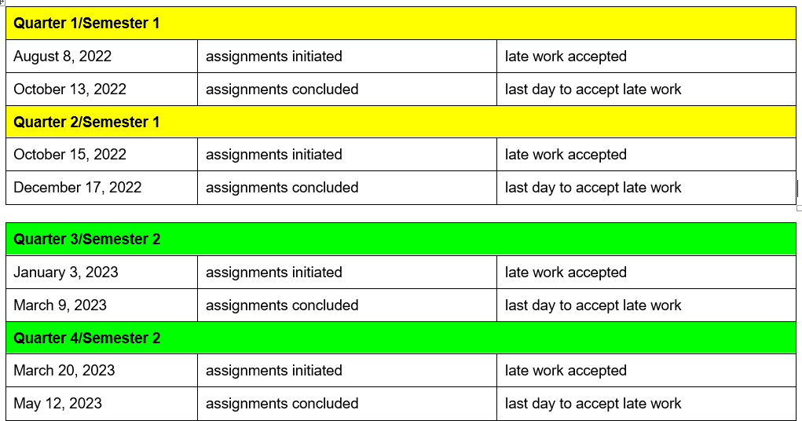

Late or Missing Work
Assignments, tests, and/or projects recorded in the Grade Book can be submitted within the quarterly timeframes.

Recording in the Grade Book
- The mark “M” is 50% in the Grade Book indicates the assessment is missing.

Parent Communication
Teachers will notify students/families of late or missing work via an email, face-to-face conference, or phone conversation within 3 days of the missed assignment.

- All parent communication is recorded in the Teacher Contact Log in Infinite Campus.
- Teachers must clearly communicate the deadline for the acceptance of late work.
- Teachers must communicate the quarter deadlines (see above) at the beginning of the school year and during the school year to all parents. (Provide information during Open House)
- Teachers must keep copies of all assignments, tests, Project-based rubrics for quick reference in the event a parent has questions and/or concerns.

Late or Flagged Assignment Reports

Teachers will run a Late or Flagged Assignments report within Infinite Campus to identify students with excessive late work. Teachers run this report weekly on Thursday. All students with missing/late/flagged work, the teacher will notify the parent via a parent phone conference or a face- to-face conference. Teachers record of these conversations in the Teacher Contact Log located in Infinite Campus.

Progress Reporting Schedule 2022-2023

Semester | 1
Semester 1 Begins | August 8, 2022
Progress Reporting via IC | September 2, 2022
Progress Reporting via IC | September 23, 2022
Unsatisfactory Progress Reporting to Parent/Guardians via IC | October 14, 2022
Progress Reporting via IC | November 4, 2022
Progress Reporting via IC | December 2, 2022
End of Semester 1 | December 18, 2022
Semester | 2
Semester 2 Begins | January 3, 2023
Progresss Reporting via IC | January 27, 2023
Progress Reporting via IC | February 17, 2023
Unsatisfactory Progress Reporting to Parent/Guardians via IC | March 10, 2023
Progress Reporting via IC | April 7, 2023
Progress Reporting via IC | April 28, 2023
Progress Reporting via IC/Grade Book Finalized | May 12, 2023
Last Day for Semester 2 | May 22, 2023

See Grade Book Expectations section of handbook for more information.

