Elementary
Books can be found on www.getepic.com

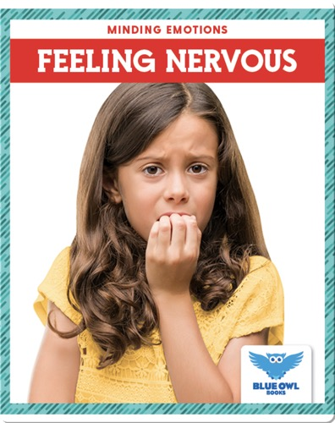 Written by Amber Bullis, MLIS
Feeling Nervous
Discover how to recognize nervousness in yourself and others, how to best respond to it, and how to communicate about those feelings.

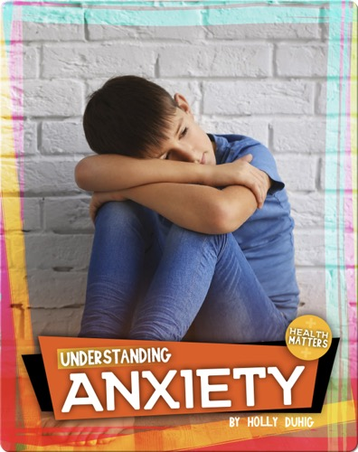 Written by Holly Duhig
Understanding Anxiety
Anxiety is a very common problem that can affect our daily lives and well-being. The good news is that anxiety is highly treatable.

Video clip found on www.getepic.com


These DIY stress Balls are fun and easy to do! You just need a few ingredients and then it’s time to squish these squishy stress balls away.

Middle School

Books can Be Found on Epic.

https://www.getepic.com/

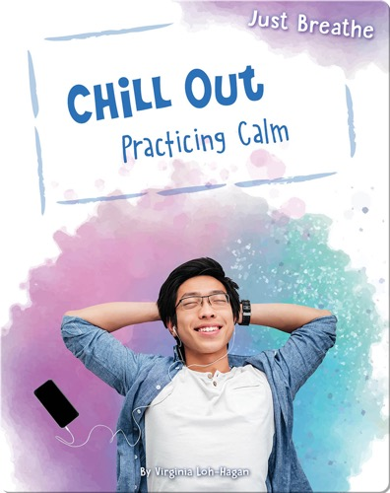 by Virginia Loh - Hagen
Chill Out
Description: Discover how to practice mindfulness.
Throughout your day by slowing down.and responding
thoughtfully to everyday situations.

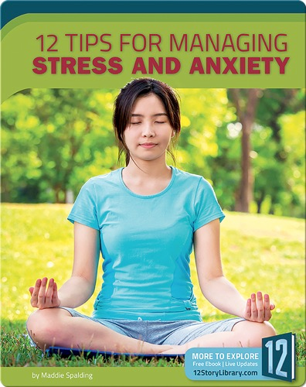 by Maddle Spalding
12 tips For Managing Stress and Anxiety.
Description: Offers readers 12 tips for managing stress and anxiety,
Including practicing time management ,staying active, and keeping a journal.

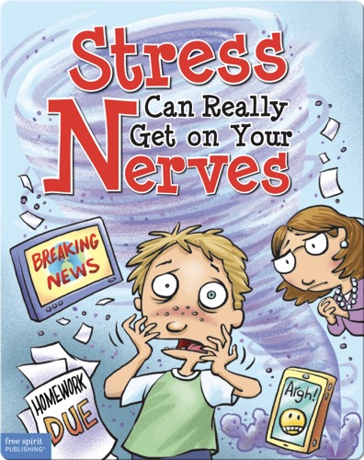 by Steve Mark
Stress can Really Get To Your Nerves
Description: Revised classic provides a humorous take on a nerve
Wracking topic-stress- includes modern stressors such as terminology and social media.

Video Clip found in Epic.

Video: Stress and Anxiety

How to Deal with Exam Stress and Anxiety :
Description: In today’s science of study I look at some tips as proven by science to help you deal with exam stress and anxiety.

High School

Mackin Via Books

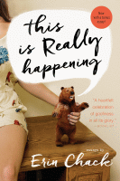

This is really happening

Erin Chack
Description:
A collection of essays by Erin Chack about the millennial experience, ranging from her first kiss, to her first chemotherapy session at age 19, to struggles with anxiety.

