
Kindergarten Math
Unit 7: Using Numbers and Data to Make Sense of My World
Dear Families,

We want to make sure that you understand the mathematics your child will be learning this year. Below you will find the standards we will be learning in Unit 7.

Each standard is in bold print, and below each one is an explanation with examples. Please let your teacher know if you have any questions. We appreciate your partnership and support.

K.NR.3.1: Describe numbers from 11 to 19 by composing (putting together) and decomposing (breaking apart) the numbers into ten ones and some more ones.
Students should be able to…

- put together (compose) and break apart (decompose) numbers into a group of ten ones and some further ones to understand that these numbers are composed of ten ones and one, two, three, four, five, six, seven, eight, or nine ones.
- use strategic thinking in order to communicate quantities for authentic purposes.

Example:

In what ways can you decompose the number 15?

Answer:
I decomposed 15 in my head into one full ten frame and five more on another ten frame.
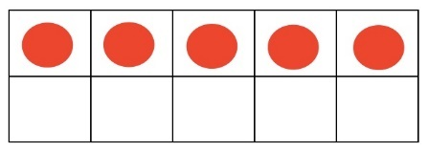
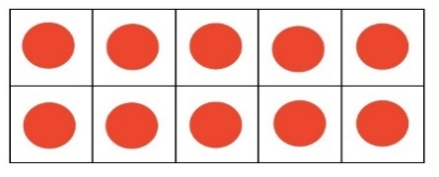

K.NR.5.1: Compose (put together) and decompose (break apart) numbers up to 10 using objects and drawings.
Students should be able to…

- Compose (put together) and decompose (break apart) numbers up to 10 using objects and drawings.

Example:
Ms. Smith needs to water 10 plants in her classroom. She already watered 4 plants. How many more plants does she need to water?
Answer:
The answer is 6. Students can use a ten frame to answer this question.
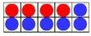
The student puts 4 red counters on the ten frame. They can count the empty spaces or fill them with counters to see that they need 6 to fill the rest of the ten frame.

K.NR.5.2: Represent addition and subtraction within 10 from a given context using a variety of representations and strategies.
Students should be able to…

- solve authentic, mathematical problems involving the addition and subtraction of single-digit whole numbers.
- use a variety of strategies such as: counting on, counting backward, and making a ten.

Examples:
- 3 birds were sitting in a tree, and 2 more birds flew onto the tree. How many birds were in the tree then?
- Toni had 8 guppies. She gave 3 guppies to Roger. How many guppies does Toni have now?
- 6 girls and 4 boys were playing soccer. How many children were playing soccer?

  - Answers:
- 5 birds
- 5 guppies
- 10 children

K.NR.5.3: Use a variety of strategies to solve addition and subtraction problems within 10.
Students should be able to…

- Solve addition and subtraction within 10 using a variety of strategies.
Examples:
- The teacher says, “Show me how to solve 8 take away 5.”
- There are 3 black ducks and 2 brown ducks. How many ducks are there in all?
Answers:
- The student can use objects, fingers, mental images, drawings, sounds (like claps), verbal explanations, or equations to answer this problem. 8 – 5 = 3.
- The student holds up 5 fingers to represent 5 total ducks.

K.NR.5.4: Fluently add and subtract within 5 using a variety of strategies to solve practical, mathematical problems.
Students should be able to:
- practice these skills by acting out the stories (problems) using a variety of manipulatives to represent the people, animals, or objects.
- use manipulatives, fingers, drawings, mental math, etc. to solve problems.

Examples:
- Molly saw 3 red cars driving by. Then she saw 4 yellow cars drive by. How many cars did Molly see?
- There are 6 markers in the bag. 2 of the markers are blue and the rest are orange. How many are orange?
- Ben found 5 eggs and put them in his basket. He gave 2 eggs to his sister. How many eggs are left in the basket?
Answers:
- 7 cars
- 4 orange markers
- 3 eggs

K.PAR.6.1: Create, extend, and describe repeating patterns with numbers and shapes, and explain the rationale for the patterns.
Students should be able to…
- understand patterns that include spatial, color, location, shape, and symbols (letter/ number).
Example:
Extend the pattern:
K.PAR.6.2: Describe patterns involving the passage of time using words and phrases related to actual events.

Students should be able to…

- use terms such as now, earlier, later, before, after, yesterday, today, tomorrow, morning, afternoon, evening, day of the week, week, month, year.

Example:

The teacher will say, “Today is Wednesday. Layla brought her new water bottle to school. She got the water bottle yesterday. What day did she get her new water bottle?”

Answer:

Tuesday

K.MDR.7.3: Ask questions and answer them based on gathered information, observations, and appropriate graphical displays to solve problems relevant to everyday life.
Students should be able to...
- ask questions and answer them based on gathered information, observations, and appropriate graphical displays.
Example:
A student is shown a picture of a school bus with kids. The teacher will ask, “What mathematical question do you have?”
Possible Answer:
How many windows does the school bus have?

