
Kindergarten Math
Unit 6: Geometric & Spatial Reasoning: 3-D Shapes in my World
Dear Families,

We want to make sure that you understand the mathematics your child will be learning this year. Below you will find the standards we will be learning in Unit 6.

Each standard is in bold print, and below each one is an explanation with examples. Please let your teacher know if you have any questions. We appreciate your partnership and support.

K.GSR.8.1: Identify, sort, classify, analyze, and compare two-dimensional shape and three-dimensional figures, in different sizes and orientations, using informal language to describe their similarities differences, number of sides and vertices, and other attributes.
Students should be able to…

- understand how three-dimensional figures are composed of two-dimensional shapes.
- identify real life examples of cubes, cones, cylinders, and spheres.

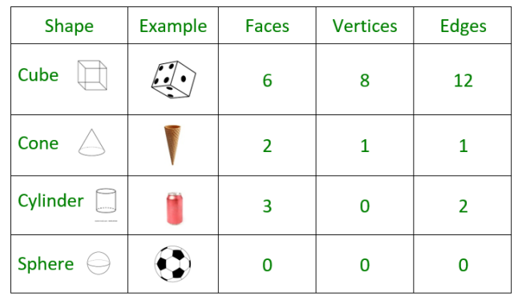

Example:

The teacher shows a picture of a soccer ball. The teacher will ask, “What shape is this? How many faces does it have? How many vertices does it have?”

Answer:
The soccer ball is a sphere. It has zero faces and zero vertices.

K.GSR.8.2: Describe the relative location of an object using positional words.

Students should be able to…
- explain the location of an object in relation to another object using positional language, such as “above,” “below,” “beside,” “in front of,” “behind,” or “next to.”
Examples:
- Describe the position of the pencil to the cup.
- Describe the position of the boy in line.

Answers:
- The cup is beside the pencil.
- The boy is behind the girl in line.

K.GSR.8.3: Use basic shapes to represent specific shapes found in the environment by creating models and drawings.
Students should be able to…
- create models with items like Play-Doh, toothpicks with marshmallows, popsicle sticks, technology, etc.
Example:
Create a triangle using toothpicks and marshmallows.
Answer:

K.GSR.8.4: Use two or more basic shapes to form larger shapes.
Students should be able to…

- form (compose) larger shapes by putting together smaller shapes through exploration and play.

Example:
Use the 7 tangram pieces to make a fox.
Answer:

K.MDR.7.1: Directly compare, describe, and order common objects, using measurable attributes (length, height, width, or weight) and describe the difference.
Students should be able to…

- use language such as heavier, lighter, longer, taller, shorter, wider, larger, smaller.
- use a variety of techniques and tools to compare, describe, and order objects.
- use a reference object being compared as a tool to describe the other object(s).

Examples:
- The teacher shows the student a shoe worn by adults (red shoe) and a shoe worn by a child (blue shoe). The teacher will ask, “How are the shoes different?”
- The teacher shows the child a can of beans and a smaller can of tuna. The teacher will ask, “How are these shapes alike? How are these shapes different?”

Possible Answers:
- The red shoe is heavier than the blue shoe. The red shoe is also longer!
- Both shapes are cylinders with 3 faces. The can of beans is taller than the can of tuna.

K.MDR.7.2: Classify and sort up to ten objects into categories by an attribute; count the number of objects in each category and sort the categories by count.

Students should be able to…
- sort objects by characteristics such as color, heavier, lighter, longer, and shorter.

Example:
The teacher gives the student a collection of buttons and asks the student to sort them by color and how many they count.
Answer:
The student separates the buttons into different piles based on color. Then, the student counts the number of buttons in each pile. Finally, the student organizes the groups by the quantity in each group: orange buttons (3), green buttons next (4), purple buttons with the green buttons because purple also has 5.
K.MDR.7.3: Ask questions and answer them based on gathered information, observations, and appropriate graphical displays to solve problems relevant to everyday life.
Students should be able to...
- ask questions and answer them based on gathered information, observations, and appropriate graphical displays.
Example:
Student is shown a picture of a playground. The teacher will ask, “What mathematical question do you have?”
Possible Answer:
How many slides are there?

K.PAR.6.2: Describe patterns involving the passage of time using words and phrases related to actual events.

Students should be able to…

- use terms such as now, earlier, later, before, after, yesterday, today, tomorrow, morning, afternoon, evening, day of the week, week, month, year.

Example:

The teacher will say, “Today is Wednesday. Layla brought her new water bottle to school. She got the water bottle yesterday. What day did she get her new water bottle?”

Answer:

Tuesday

