
Kindergarten Math
Unit 4: Numerical Reasoning: Using Numbers Within 20
Dear Families,

We want to make sure that you understand the mathematics your child will be learning this year. Below you will find the standards we will be learning in Unit 4.

Each standard is in bold print, and below each one is an explanation with examples. Please let your teacher know if you have any questions. We appreciate your partnership and support.

K.NR.1.1: Count up to 20 objects in a variety of structured arrangements and up to 10 objects in a scattered arrangement.
Students should be able to…

- count to answer “how many?” questions with up to 20 objects arranged in a variety of ways (a line, a rectangular array, or a circle), or up to 10 objects arranged in a scattered configuration.

Example:
There are 16 stuffed animals in a circle. How many do you have?
Answer:
The student will count and say 16.

K.NR.1.2: When counting objects, explain that the last number counted represents the total quantity in a set (cardinality), regardless of the arrangement and order.
Students should be able to…

- instantly see how many objects are in a group without counting (subitizing).
- understand that the last number counted represents the total quantity in a set (cardinality), when counting objects regardless of the arrangement and order.
- understand that even if the objects are moved around, there are still the same number.

Example:
The teacher sets up cubes in rows and columns for the student to count. The student counts 12 cubes. The teacher rearranges them into a circle. How many cubes are there now?
Answer:
The student should recognize that there are still 12 cubes in the set without needing to recount them.

K.NR.2.1: Count forward to 100 by tens and ones and backward from 20 by ones.
Students should be able to...
- count forward to 100 by tens and ones.
- count backward from 20 by ones.
Example:
Count to 100 by tens.
Answer:
10, 20, 30, 40, 50, 60, 70, 80, 90, 100

K.NR.2.2: Count forward beginning from any number within 100 and count backward from any number within 20.

Students should be able to…

- count forward and backward from any given number using the known number sequence.
Note: This is a verbal expectation. They do not have to identify numbers as they count.

Examples:

- Count forward starting at the number 53.
- Count back starting at the number 16.

Answers:

- The student should show that he/she can count forward by ten more numbers. The student starts at 53 and is able to count to 63.

- The student should show that he/she can count backward to a number ten less. The student starts at 16 and is able to count backward to 6.

K.NR.3.1 Describe numbers from 11 to 19 by composing (putting together) and decomposing (break apart) the numbers into ten ones and some more ones.

Students should be able to…

- use ten frames, drawings, objects, and/or an equation to help them.

Examples:

- I have ten ones and 3 more ones. How much do I have?
- Here is the number 16. How can you decompose 16 into ten ones and some additional ones?

Answers:

- 13 is represented using ten frames, unifix cubes, and an equation:

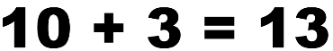
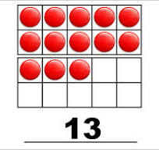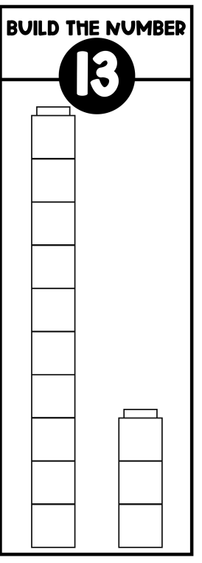

2. 16 is decomposed using number bonds, a picture, and ten frames.

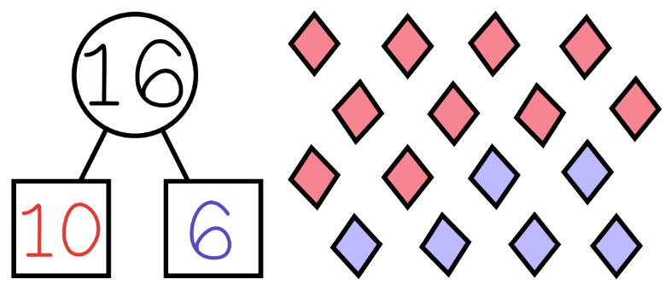
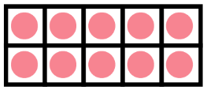
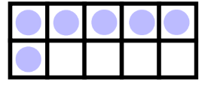

K.NR.4.1: Identify written numerals 0-20 and represent a number of objects with a written numeral 0-20 (with 0 representing a count of no objects).
Examples:
- What numbers do you see? 15 13 17 12
- Write the number of objects you see on the paper.



Answers:
- The student verbally responds with the answers 15, 13, 17, 12
- 14

