1st Grade Social Studies
Year at-a-Glance
2025-2026

Quarter 1 | Quarter 2 | Quarter 3 | Quarter 4
August 4-October 3 | October 6-December 19 | January 6-March 13 | March 23-May 21
Content Strands  Government/Civics  Culture  Geography History | Content Strands  Economics  History  Culture | Content Strands  History  Government/Civics  Economics | Content Strands  Government/Civics  Culture  Economics  History
Standards  1.17  1.1  1.2  1.3  1.10  1.11  1.12  1.13  1.26  Note: Please use this suggested pacing as a guide. It is understood that teachers may be up to 1 week ahead or 1 week behind depending on the needs of their students.  . | Standards  1.4  1.5  1.6  1.26  1.8  1.9  1.1  1.2  1.3 | Standards  1.03  1.26  1.17  1.18  1.19  1.15  1.20  1.26  1.14  1.16  1.21 | Standards  1.22  1.23  1.24  1.25  1.03  1.07  1.26  1.03

Note: Please use this suggested pacing as a guide. It is understood that teachers may be up to 1 week ahead or 1 week behind depending on the needs of their students.

First Grade-Tennessee’s Place in the United States: Quarter 2 Curriculum Map Scope and Sequence

Topic | Week and  Weekly Text Title | Weekly Focus | Standards
Economics | Week 1:  Oct. 6-10  Studies Weekly-Week 26 | Students will learn what products are and understand examples of goods that people use and buy. | 1.04
Economics | Week 2:  Oct. 20-24  Studies Weekly-Week 27 | Students examine services and understand examples of services people provide. | 1.05
Economics | Week 3:  Oct. 27-31  Studies Weekly-Week 28 | Students distinguish how people can be both consumers and producers of both goods and services. | 1.06
History/Culture | Week 4:  Nov. 3-7  Studies Weekly-Week 15 | This week students learn about Veterans Day. Why do we celebrate Veterans Day and Memorial Day? We learn about how Veterans Day used to be called Armistice Day, why we celebrate veterans on that day and what “armistice” means. | 1.26
History | Week 5:  Nov. 12-14  Studies Weekly-Week 16 | Revere the Rat’s singing “Over the River and Through the Wood” as he is packing to visit his grandma for Thanksgiving. He shares some of his favorite family traditions and talks about why we celebrate Thanksgiving. Rev also shares some fun facts about Thanksgiving. | 1.26
Economics | Week 6:  Nov. 17-21  Studies Weekly-Week 31 | Students will identify, compare and contrast needs and wants. | 1.08
Economics | Week 7:  Dec. 1-5  Studies Weekly-Week 32 | Students will learn about saving or spending money. What do you save your money for? | 1.09
Culture | Weeks 8-9:  Dec.8-19  Winter Celebrations and Traditions | Students will describe the cultural aspects of a place, including a student’s community and state and define multiculturalism as many different cultures living within a community and state. Students will also compare and contrast family traditions and customs among different cultures within a student’s community and state. | 1.01, 1.02, 1.03

First Grade-Tennessee’s Place in the United States: Quarter 1 Curriculum Map Introduction

What Will First Grade Students Learn This Year?
First grade students will continue their study of social studies by learning about Tennessee’s place in the United States through culture, economics, geography, government and civics, and history.

Emphasis on African American History and Local History
The Tennessee Social Studies Standards highlight specific African Americans and eras throughout history of which African Americans have significantly made contributions. The MSCS Social Studies team has worked to include and expose students to additional African Americans and local history in quarterly curriculum maps. This was done to offer students the opportunity to understand the connections of their communities to the world as a whole, and to understand how things have changed over time. All suggested additions are standards aligned and support current curriculum and resources provided.

Planning with the Curriculum Map
The purpose of curriculum maps is to help teachers pace the year to ensure all the standards within a course will be addressed and taught. Curriculum maps offer a sequence for delivering content and provide a clear scope for what must be taught to all students based on the Tennessee Social Studies Standards. Please keep in mind that the curriculum map is meant to be a component of effective planning and instruction; it is not meant to replace teacher planning or instructional practice.

Weekly Guidance for Studies Weekly
The K-5 Social Studies curriculum maps provide weekly guidance to support teachers in their teaching. In an effort to support teachers, curriculum maps highlight the Studies Weekly anchor text, supplemental texts, primary and secondary sources, suggested instructional strategies and tasks, and suggested assessments. Although the curriculum maps allow flexibility and encourage teachers to make thoughtful adjustments, there is an expectation that all children have access to rigorous content and effective teaching practices. It is recommended that K-2 students receive 30 minutes of instruction every other day of the week (60-90 minutes per week). It is recommended that 3-5 students receive 30 minutes per day of social studies instruction (150 minutes per week).

Orientation to Studies Weekly: Video Training
Teachers who are unfamiliar with Studies Weekly may learn how to use and implement these resources by clicking HERE and reviewing desired training videos.

Online Access to Studies Weekly
Teachers may access Studies Weekly online using the credentials below:
- Click HERE and login with username: shelby_county@scsk12.org and password: County1

Once there, teachers may navigate to their respective grade level text:

First Grade | Tennessee Studies Weekly First Grade
Social Studies Practices
The social studies practices are skills students are expected to apply to create and address questions that will guide inquiry and critical thinking. These practices should be regularly applied throughout the year. Students will progress through the inquiry cycle (SSP.01-SSP.04) by analyzing primary and secondary sources to construct and communicate their conceptual understanding of the content standards and to develop historical and geographic awareness.
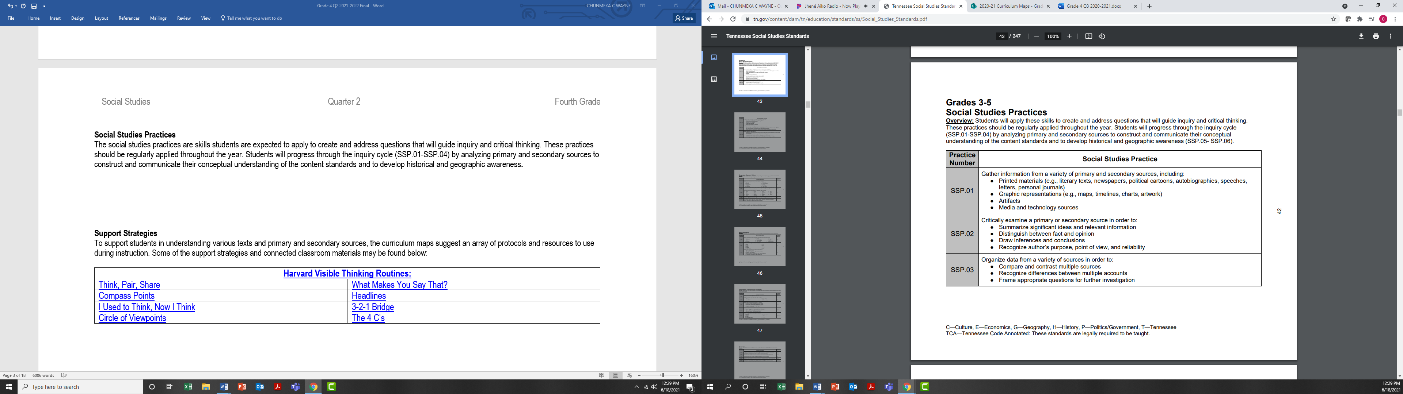
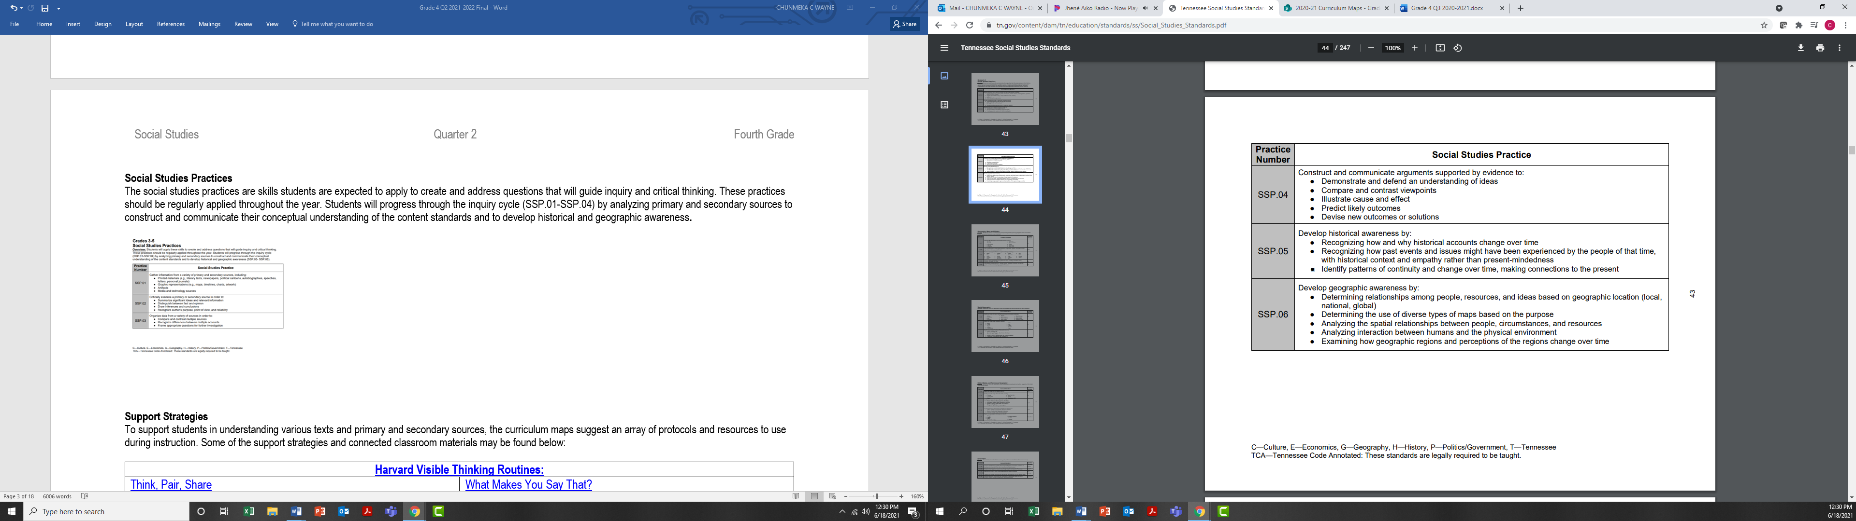

Support Strategies
To support students in understanding various texts and primary and secondary sources, the curriculum maps suggest an array of protocols and resources to use during instruction. Some of the support strategies and connected classroom materials may be found below:

Studies Weekly Resources (Found Under the General Resources Tab) | Harvard Visible Thinking Routines:
Most Important Book | Think, Pair, Share
Display Tray | Compass Points
Penny for Your Thoughts Debate Carousel | I Used to Think, Now I Think
Cornell Note-Taking Method | What Makes You Say That?
Flip Book for Taking Notes | Chalk Talk
KWL Chart | 3-2-1 Bridge
Primary Source Analysis | The 4 C’s

Week 1- Setting Up Shop (Studies Weekly-Week 26)
Essential Question(s) | What are products?
Standards | 1.04 Give examples of products (goods) that people buy and use.
Objective | SWBAT summarize and list key details form sources IOT give examples of products (goods) that people buy and use.
Texts | Tennessee First Grade: Our Place in the United States Click HERE and login with username: shelby_county@scsk12.org and password: County1
Vocabulary | Products, consume, dry goods, retail, sell, buy, store, money, hardware
Teacher Guided Text Specific & Text Dependent Questions | Setting Up Shop  - Why do people sell things?  - What sort of things do people want?  - What experiences do you have with trading to get what you want? | What Will Rev Sell?  - Why would people need to buy clothes?  - What sort of products get used up?  - What makes a good product?  Types of Products  - Where can you buy these products?  - Why might people buy the products listed?
Suggested Protocols and Resources | Back to Back, Fact to Face | Think, Pair, Share
Extension Activities | Students will complete the Products in my Community activity sheet.  Students will complete the Types of Products activity sheet.
Additional Topic Specific Resources | Goods and Services: Video
Assessment | Studies Weekly Assessment: Week 26

Week 2- At Your Service (Studies Weekly-Week 27)
Essential Question(s) | What are goods and services, and how do people use them to make money?
Standards | 1.05 Give examples of services (producers) that people provide.
Objective | SWBAT summarize and list key details form sources IOT give examples of services (producers) that people provide.
Texts | Tennessee First Grade: Our Place in the United States Click HERE and login with username: shelby_county@scsk12.org and password: County1
Vocabulary | Good, service, shop, buy, sell
Teacher Guided Text Specific & Text Dependent Questions | At Your Service  - What are goods?  - What are some examples of goods?  - What is a service? | What is a Service? and Types of Service  - How do people choose what service they would like to offer?  - What are some examples of people who do services for others?  - What type of people would want to buy a service? | Can You Perform a Service? and Revere, At Your Service!  - Why might people choose a certain good/service over another?  - How could you make more people want to buy your good or service?
Suggested Protocols and Resources | Back to Back, Fact to Face | Think, Pair, Share | Back to Back, Fact to Face
Extension Activities | Students will complete the More Goods and Services activity sheet.  Students will complete the Writing Sentences activity sheet.
Additional Topic Specific Resources | Goods and Services Activity Sheet
Assessment | Students Weekly Assessment: Week 27

Week 3- Producers Seeking Consumers (Studies Weekly-Week 28)
Essential Question(s) | What are producers and consumers, and why are they important to our economy?
Standards | 1.06 Distinguish how people are consumers and producers of goods and services.
Objective | SWBAT summarize texts and list key details IOT distinguish how people are consumers and producers of goods and services.
Texts | Tennessee First Grade: Our Place in the United States Click HERE and login with username: shelby_county@scsk12.org and password: County1
Vocabulary | Goods, services, consumer. Producer, economy
Teacher Guided Text Specific & Text Dependent Questions | Producers Seeking Consumers  - What is a producer?  - What is a consumer?  - Why does an economy need producers and consumers? | What are Goods and Services? and Are You a Producer or a Consumer?  - What are goods?  - What are services?  - Why do we need producers and consumers in a healthy economy? | Producers Can Be Consumers, Too!  - What are producers?  - What could a producer do to be more competitive with other producers?  - What happens when there is more demand for a product than products that are available?
Suggested Protocols and Resources | Back to Back, Fact to Face | Think, Pair, Share | Back to Back, Fact to Face
Extension Activities | Students will complete the Consumer or Producer activity sheet.  Students will complete the Producer, Consumer, Good, and Service activity sheet.
Additional Topic Specific Resources | Producers and Consumers for Kids: Video
Assessment | Students Weekly Assessment Week: 28

Week 4- Veterans Day-Thanking Soldiers (Studies Weekly-Week 15)
Essential Question(s) | What is Veterans Day, and why do people celebrate it?
Standards | 1.26 Identify and describe the events or people celebrated during the following national holidays, and examine why we celebrate them: Veterans’ Day
Objective | SWBAT summarize texts IOT identify and describe the events or people celebrated during Veterans Day.
Texts | Tennessee First Grade: Our Place in the United States Click HERE and login with username: shelby_county@scsk12.org and password: County1
Vocabulary | Veteran, soldier, protect, war, honor, patriot, armed forces
Teacher Guided Text Specific & Text Dependent Questions | Veterans Day  - What is a veteran?  - What is the difference between a veteran and a soldier? | Armed Forces and The Armed Forces Help Us  - Why are veterans considered important members of our community?  - What can we do to say thank you to veterans for all of their hard work? | Veterans Day and Celebrating Veterans Day  - Why do we have parades on Veterans Day?  - Why is it important to celebrate Veterans Day?  - What are a few different types of military members or veterans?
Suggested Protocols and Resources | Back to Back, Fact to Face | Think, Pair, Share | Back to Back, Fact to Face
Extension Activities | Students will complete the What’s the Idea activity sheet.  Students will complete the Veterans Day Thank You Card activity sheet.
Additional Topic Specific Resources | Veterans Day Facts for Kids
Assessment | Students Weekly Assessment: Week 15

Week 5- Thanksgiving (Studies Weekly-Week 16)
Essential Question(s) | Why do people celebrate Thanksgiving?
Standards | 1.26 Identify and describe the events or people celebrated during the following national holidays, and examine why we celebrate them: Thanksgiving Day
Objective | SWBAT summarize texts IOT identify and describe the events or people celebrated during Thanksgiving.
Texts | Tennessee First Grade: Our Place in the United States Click HERE and login with username: shelby_county@scsk12.org and password: County1
Vocabulary | Thanksgiving, celebrate, feast, worship, harvest, community
Teacher Guided Text Specific & Text Dependent Questions | Thanksgiving Day  - What is Thanksgiving?  - Why do people celebrate Thanksgiving?  - Compare Thanksgiving to Christmas. How are they the same?  - How are they different? | The Pilgrims and Building a Community  - Who were the Pilgrims?  - Who helped the Pilgrims?  - How did the American Indians help the Pilgrims? | The First Thanksgiving and Thanksgiving Day  - Who made Thanksgiving a holiday?  - Who was at the first Thanksgiving feast?
Suggested Protocols and Resources | Back to Back, Fact to Face | Think, Pair, Share | Back to Back, Fact to Face
Extension Activities | Students will complete the Thanksgiving Timeline activity sheet.  Students will complete the Historical Event activity sheet.
Additional Topic Specific Resources | Thanksgiving Story for Kids: Video
Assessment | Students Weekly Assessment Week: 16

Week 6- Searching for Needs, Looking for Wants (Studies Weekly-Week 31)
Essential Question(s) | What is the difference between something you need and something you want?
Standards | 1.08 Determine the difference between basic wants and needs, and provide examples of each.
Objective | SWBAT summarize texts and list key details IOT determine the difference between basic wants and needs and provide examples of each.
Texts | Tennessee First Grade: Our Place in the United States Click HERE and login with username: shelby_county@scsk12.org and password: County1
Vocabulary | Need, want, important, must
Teacher Guided Text Specific & Text Dependent Questions | Searching for Needs, Looking for Wants  - What is a need?  - What is a want?  - Can you tell me which is more important, a need or a want? | Do You Really Need It?  - Have you ever thought you needed something, only to find out you didn’t need it?  - Can you give me some examples of things you thought you needed but didn’t really need?  - Have you ever not been able to get something you really needed? | Things You Need and Things You Want  - What is the worst thing that will happen if you do not get what you want?  - What is the worst thing that will happen if you do not get something that you need?
Suggested Protocols and Resources | Back to Back, Fact to Face | Think, Pair, Share | Back to Back, Fact to Face
Extension Activities | - Students will complete the Is It a Need or Want activity sheet.  - Students will complete the Needs and Wants activity sheet.
Additional Topic Specific Resources | Needs and Wants Songs/Video  Needs and Wants Read Aloud: Video
Assessment | Students Weekly Assessment: Week 31

Week 7- Pennies, Dimes, and Dollars (Studies Weekly-Week 32)
Essential Question(s) | How do people decide what to buy?
Standards | 1.09 Assess factors that could influence a person to use or save money.
Objective | SWBAT compare and contrast the acts of spending and saving money IOT assess factors that could influence a person to use or save money.
Texts | Tennessee First Grade: Our Place in the United States Click HERE and login with username: shelby_county@scsk12.org and password: County1
Vocabulary | Save, bought, money, want, need, enough
Teacher Guided Text Specific & Text Dependent Questions | Pennies, Dimes, and Dollars  - What sort of things would you save your money for?  - How might you save your money for what you want? | What Makes People Save?  - What defines something you want?  - What defines something that you need?  - What are some times that you have to save for something you want? | Why Save?  - Which of the reasons that students have given seems most important?  - Is it important to save? Why?
Suggested Protocols and Resources | Back to Back, Fact to Face | Think, Pair, Share | Back to Back, Fact to Face
Extension Activities | - Students will complete the Save or Buy activity sheet.  - Students will complete the Making Choices About Money activity sheet.  - Students will listen to and view The Berenstain Bears -Trouble with Money and answer the following questions: What did Brother and Sister want to purchase? How did their parents feel about what they wanted to purchase? What plan did Brother and Sister come up with to make the purchase? What jobs did Brother and Sister do to make money?
Additional Topic Specific Resources | Saving for Freckles Text and TDQs
Assessment | Students Weekly Assessment: Week 32

Weeks 8-9- Winter Celebrations and Traditions
Essential Question(s) | What are some traditions people practice in the winter?
Standards | 1.01 Describe the cultural aspects of a place, including a student’s community and state.  1.02 Define multiculturalism as many different cultures living within a community and state.  1.03 Compare and contrast family traditions and customs among different cultures within a student’s community and state.
Objective | SWBAT read various texts and list key ideas IOT compare and contrast family traditions and customs among different cultures within a student’s community and state.  SWBAT read various texts winter traditions IOT share the main ideas and details about different winter traditions.
Texts | Tennessee First Grade: Our Place in the United States Click HERE and login with username: shelby_county@scsk12.org and password: County1
Vocabulary | Tradition, holiday, family, celebrate
Teacher Guided Text Specific & Text Dependent Questions | Kwanzaa  - What is Kwanzaa?  - How do families to Celebrate Kwanzaa?  Chinese New Year  - What is Chinese New Year?  - When is Chinese New Year celebrated?  - What do people do during Chinese New Year? | Christmas  - What is Christmas?  - When is Christmas celebrated?  - What do people do to celebrate Christmas?  Hanukkah  - What is Hanukkah?  - When is Hanukkah celebrated?  - What do people do to celebrate Hanukkah?
Suggested Protocols and Resources | Back to Back, Fact to Face | Think, Pair, Share
Extension Activities | Students will complete the My Family activity sheet to describe traditions practiced in their family.
Additional Topic Specific Resources | Winter Traditions Around the World
Assessment | Students will draw and label a winter celebration or tradition they practice with their family or friends.

