Cleaning Services for Oldham County Schools:
Central Office, Administrative Annex, and Transportation Buildings FY 26

Bid Date: December 1st, 2025

Time of Opening: 2:00 P.M.

Location: Oldham County Schools
Administrative Annex
1900 Button Lane
LaGrange, KY 40031
Phone: (502) 222-3777 ext. 104
Fax: (502) 222-0955

OLDHAM COUNTY BOARD OF EDUCATION
6165 W. Highway 146
Crestwood, KY 40014

December 2025

INDEX TO SPECIFICATIONS

Cleaning Services for Oldham County Schools:
Central Office, Admin Annex, & Transportation Buildings - FY 26

Pages

Invitation to Bid 1-3
Prohibition Against Conflicts of Interest, Gratuities, and Kickbacks 1-1
Form of Proposal 1-2
Central Office, Admin Annex, & Transportation Cleaning Specifications 1-4
Drawings Indicating Areas To Be Cleaned (Not To Scale) 1-4

1 of 3

INVITATION TO BID

BOARD OF EDUCATION OF OLDHAM COUNTY, KENTUCKY
EQUAL OPORTUNITY/AFFIRMATIVE ACTION EMPLOYER
6165 W. Highway 146
CRESTWOOD, KENTUCKY 40014

Cleaning Services for Oldham County Schools: Central Office, Administrative Annex, and Transportation Buildings – FY 26
`

The Oldham County Board of Education will receive sealed bids for the furnishing of Cleaning Services for Oldham County Schools: Central Office, Administrative Annex, and Transportation Buildings – FY 26.

You are invited to submit a sealed bid, subject to the terms and conditions of this invitation to bid. Please read the instructions and specifications carefully. Failure to comply with these instructions may disqualify your bid.

Sealed bids will be received until 2:00 P.M., December 1st, 2025 at Oldham County Schools, Administrative Annex, 1900 Button Lane, LaGrange, KY 40031 Attention: Stu Martin, Plant and Operations Manager, and then publicly opened and read aloud. NO BIDS RECEIVED AFTER THIS TIME WILL BE CONSIDERED. The Board of Education cannot assume the responsibility for any delay as a result of failure of the U.S. Postal Service or other delivery services to deliver bids on time.

A copy of the bid documents may be obtained by vendors planning on submitting a proposal at the Maintenance Department, Oldham County Schools, 1900 Button Lane, LaGrange, KY 40031 between the hours of 8:00 AM and 4:00 PM, Monday through Friday. Any questions regarding this bid shall be directed to Stu Martin at (502) 222-3777 ext. 104.

Bids may not be withdrawn for a period of 45 days after the designated time for receipt of bids.

Envelopes containing bids must be clearly marked on the outside of the envelope that a bid is enclosed and title of the bid. Bids mailed or delivered by courier shall be inserted into two envelopes, with the inner envelope containing the bid.

The Owner reserves the right to accept any bid, to reject any or all bids, to waive any informalities in bids received where such acceptance, rejection or waiver is considered to be in the best interest of the Owner, and to reject any bid where evidence or information submitted by the bidder does not satisfy the Owner that the bidder is qualified to carry out the details of the contract documents.

Contract Period - The Oldham County School District is seeking a 1­ year contract with an option for 4 additional years. Ninety days before the end of the 1­ year contract, the Facilities Department will review the performance of the vendor to determine the viability of executing the two one-year renewal options. Vendor will be notified of this decision before the end of the 1 ­year contract term. The Oldham County Schools also reserves the right to cancel the contract at any time, with or without reason, with a 60­ day written notice.

2 of 3
INSURANCE REQUIREMENTS

The Bidder shall at all times during the contract maintain in full force and effect, Employers Liability, Workers Compensation, Public Liability and Property Damage Insurance, including contractual liability coverage. All insurance shall be provided by insurers and policy limits acceptable to the Oldham County Schools and before commencement of service hereunder, the Contractor agrees to furnish Oldham County Schools with certificates of insurance or other evidence satisfactory to the Oldham County Board of Education to the effect that such insurance has been procured and is in force. Such insurance shall be no less than the following amounts:

Coverage Limits of Liability
Public Liability $200,000.00 one person/maximum each person
$500,000.00 one accident/maximum each person
Property Damage $200,000.00 one accident/maximum
$500,000.00 aggregate”
Worker’s Compensation:
a. State Statutory
b. Applicable Federal Statutory
c. Employer’s Liability $100,000.00

Comprehensive or Commercial General Liability (including Premises-Operations; Independent Contractor’s Protection; Product Liability and Completed Operations; Broad Form Property Damage):
a. General Aggregate $1,000,000.00
b. Products-Completed Operation Aggregate $1,000,000.00
c. Personal/Advertising Injury (per person) $1,000,000.00
d. Each Occurrence (Bodily Injury & Property $1,000,000.00
Damage.
e. Limit per Person Medical Expense $ 5,000.00

Contractual Liability:
a. General Aggregate $1,000,000.00
b. Each Occurrence (Bodily Injury & Property $1,000,000.00
Damage).

Automobile Liability:
a. Bodily Injury $500,000.00 Each Person
$1,000,000.00 Each Accident
b. Property Damage $500,000.00 Each Accident, or a combined single
limit of $1,000,000.00.

Excess Liability Umbrella Form:
a. General Aggregate $1,000,000.00
b. Each Occurrence $1,000,000.00

Current proof of compliance must be kept on file with the Oldham County Schools during the life of the contract. The Oldham County Schools shall be made aware of any policy changes sixty (60) days in advance of the changes.

3 of 3
REGULATIONS

This Invitation to Bid is issued in accordance with the provisions of the Kentucky Model Procurement Code (KRS 45A) as adopted by the Oldham County Board of Education. All vendors are advised that procurement will be conducted under these statutes and regulations, which govern competitive sealed bidding, evaluation, award, and contract administration. The Board reserves the right to reject any and all bids and to waive any informalities or technicalities in accordance with KRS 45A.365.

CHALLENGE OF A BID AWARD

A challenge to an award of a bid should be made in writing within 48 hours of the bid opening. Rejection of a bidder or offerer is a drastic action which must be based upon adequate evidence rather than mere accusation. In assessing adequate evidence, consideration shall be given to how much credible information is available, its reasonableness in view of surrounding circumstances, corroboration or lack thereof as to important allegations and inferences which may be drawn from the existence or absence of affirmative facts. The person or persons making the challenge must provide information and specifics, in writing, that will allow the District to properly assess the challenge.

Challenges should be mailed or delivered to:

Stu Martin
Oldham County Board of Education
Administrative Annex
Director of Maintenance
1900 Button Lane
LaGrange, KY 40031

1 of 1

PROHIBITION AGAINST CONFLICTS OF INTEREST, GRATUITIES, AND KICKBACKS”

NO EMPLOYEE OR OFFICIAL OF THE BOARD OF EDUCATION OF OLDHAM COUNTY, KENTUCKY, ELECTIVE OR APPOINTIVE, SHALL TAKE, RECEIVE, OR OFFER TO TAKE OR RECEIVE, EITHER DIRECTLY OR INDIRECTLY, ANY REBATE, PERCENTAGE OF CONTRACT, MONEY, OR OTHER THINGS OF VALUE, AS AN INDUCEMENT OR INTENDED INDUCEMENT, IN THE PROCUREMENT OF BUSINESS OR THE GIVING OF BUSINESS, FOR OR TO, OR FROM, ANY PERSON, PARTNERSHIP, FIRM, OR CORPORATION, OFFERING, BIDDING FOR, OR IN OPEN MARKET SEEKING TO MAKE SALES TO THE BOARD OF EDUCATION OF OLDHAM COUNTY, KENTUCKY.

NO PERSON, FIRM, OR CORPORATION SHALL OFFER TO MAKE, PAY, OR GIVE, ANY REBATE, PERCENTAGE OF CONTRACT, MONEY OR ANY OTHER THING OF VALUE, AS AN INDUCEMENT OR INTENDED INDUCEMENT, IN THE PROCUREMENT OF BUSINESS OR THE GIVING OF BUSINESS, TO ANY EMPLOYEE OR TO ANY OFFICIAL OF THE BOARD OF EDUCATION OF OLDHAM COUNTY, KENTUCKY, ELECTIVE OR APPOINTIVE, IN HIS/HER EFFORTS TO BID FOR, OR OFFER FOR SALE, OR TO SEEK IN THE OPEN MARKET.

1 of 2

OLDHAM COUNTY BOARD OF EDUCATION FORM OF PROPOSAL
MAINTENANCE DEPARTMENT

Date: December 1st, 2025 To: (Owner) OLDHAM COUNTY BOARD OF EDUCATION

Project Title: Cleaning Services for Oldham County Schools: Central Office, Admin Annex, & Transportation Buildings

City, County: Crestwood/LaGrange, Oldham

Name of Contractor: ___________________________________________________________________________

Mailing Address: _____________________________________________________________________________________

Business Address: __________________________________________________Telephone:________________________

FAX: ____________________________

Having carefully examined the Conditions and Specifications, the undersigned bidder proposes to furnish the specified equipment in accordance with the contract documents and any addenda listed below for the price stated herein.

Addendum _________________ (Insert the addendum numbers received or the word "none" if no addendum received.)

BASE BID:

For the furnishing the required inspections, in accordance with the contract documents, I/We submit the following lump sum price of:
_____________________________________
Use Figures

____________________________________________________ Dollars & _________________________________Cents
Use Words Use Words

Base Bid Breakdown (Accounting Purposes Only):

- Central Office Building ………………………………………………………………………… $
- Administrative Annex Building…………………………………………………………………. $_______________
- Transportation Building…………………………………………………………………………. $_______________

TOTAL (Must Equal Base Bid) $_______________

2 of 2

OLDHAM COUNTY BOARD OF EDUCATION FORM OF PROPOSAL
MAINTENANCE DEPARTMENT

TIME LIMIT FOR EXECUTION OF CONTRACT DOCUMENTS

In the event that a bidder's proposal is accepted by the Owner and such bidder should fail to execute the contract within ten (10) consecutive days from the date of notification of the awarding of the contract, the Owner, at his option, may determine that the awardee has abandoned the contract. The bidder hereby agrees that failure to submit herein above all required information and/or prices can cause disqualification of this proposal.

Submitted by:

NAME OF CONTRACTOR: ____________________________________________________________________________

AUTHORIZED REPRESENTATIVE: _____________________________________________________________________
Signature

NAME (typed): ______________________________________________________________________________________

TITLE: _____________________________________________________________________________________________

This form shall not be modified. Attach supplemental form of proposal information pages for project specific requirements as needed.

Attach the following to the bid:

- List of equipment to be used in execution of the contract owned by the bidder.

- List of equipment to be used in execution of the contract to be rented/leased by the bidder.

- Number of employees to utilized for the cleaning services (breakdown per building).

- Number of anticipated man-hours to clean each facility (nightly tasks and weekly tasks)

- List of chemicals proposed for use.

1 of 4

Specifications
Cleaning Services for Oldham County Schools Central Office, Administrative Annex, and Transportation Buildings – FY 26

GENERAL REQUIREMENTS

LOCATIONS: Central Office Administrative Annex Transportation Building
6165 W. Highway 146 1900 Button Lane 1800 Button Lane
Crestwood, KY 40014 LaGrange, KY 40031 LaGrange, KY 40031

LABOR
Contractor shall furnish an adequate number of properly trained cleaning personnel together with sufficient and competent supervision in order to provide satisfactory nightly cleaning services. Cleaning services shall be performed Monday through Friday, excluding weekends and holidays when the District’s offices are normally closed. All employees of the contractor assigned to the OC Schools Central Office and Administrative Annex buildings shall be thoroughly investigated and have completed a criminal background check, if applicable, before being permitted to work.

SUPPLIES
Contractor shall furnish, at Contractor’s expense, all cleaning supplies and chemicals. Oldham County Schools requires that “green” chemicals be used. An up to date binder of SDS (formerly MSDS) sheets for all chemicals used by the Contractor must be kept in the first floor custodial area of each building. This list of supplies must be approved, in writing, by Oldham County Schools. The following supplies will be provided by Oldham County Schools: trash can liners, toilet tissue, paper towels, air fresheners, and liquid hand soap. Contractor shall fill toilet room dispensers daily with adequate supplies to last throughout the next day.

OLDHAM COUNTY SCHOOLS SMOKING POLICY
SMOKING IS PROHIBITED IN ALL OLDHAM COUNTY SCHOOL’S BUILDINGS.

LIGHTS (CONSERVATION OF ENERGY)
Only those lights necessary for cleaning in the immediate area in which employees are working should be lighted. All lights shall be turned off upon leaving offices that have been cleaned.

SECURITY
Contractor shall be responsible for all keys and access devices issued to its employees. Keys shall not be left in doors, and employees are not to admit anyone, under any circumstances, into the offices they are working in. Exterior doors are not to be propped open at any time. All doors shall be closed, and checked upon leaving offices that have been cleaned. Contractor shall be responsible for setting all intrusion alarms and shall be responsible for any call-backs for not setting alarms properly. Employees of Contractor shall not disturb papers on desks, open drawers or cabinets, use telephones or computers, or tamper with personal property. Employees of Contractor shall report to Oldham County Facilities Management Personnel anything out of the ordinary, such as doors unlocked, clogged toilets or drains, broken fixtures, and lights out of order, etc.

CONTRACTOR PROVIDED EQUIPMENT
1. Contractor shall provide, at their expense, all hand or power tools, machines, and equipment necessary to perform the cleaning
and/or work as specified. Only commercial type equipment is to be used.
2. Contractor shall furnish with their bid a list of equipment to be used. All hand or power tools, machines, and equipment necessary
to perform the specified work are to be approved by the Facilities Management Department.
3. All equipment shall be maintained in first-class working condition satisfactory to the Facilities Management Department.
Acceptable spare equipment must be available for replacement of broken items within twenty-four (24) hours.
4. Upon notification by the Facilities Management Department that any of the Contractor’s equipment is unacceptable, the Contractor
shall have seven (7) days to replace said unacceptable equipment. If the Contractor fails to replace unacceptable equipment
within the seven (7) day period, Oldham County Schools reserves the right to withhold $50.00 per day, up to a maximum of
$1000.00 per month, from the Contractor’s contract amount until said unacceptable equipment is replaced.

2 of 4

Specifications
Cleaning Services for Oldham County Schools Central Office and Administrative Annex, and Transportation Buildings – FY 26

CARPET CLEANING REQUIREMENTS
In order to maintain the appearance and quality of the carpet throughout the OC Schools Office and Annex buildings, daily spot cleaning shall be required. Complete and thorough carpet cleaning shall be completed one time per calendar year by the Contractor.
Spot Cleaning
Spot cleaning of carpets shall be performed nightly using an approved method by properly trained personnel. If it is determined by the Facilities Management Department that spot cleaning is not being consistently and adequately performed by the contractor, Oldham County Schools reserves the right to hire its own source for nightly spot cleaning services with the cost being deducted from the Contractor’s contract amount. Base shall be kept clean at all times.

CLEANING REQUIREMENTS
It is the purpose of these specifications to insure that all services and materials necessary, to clean and keep clean all portions of the buildings, are provided. It is understood that the highest possible standards of cleanliness are to be maintained. The following sets forth the tasks and frequencies with which said tasks are to be performed, and shall in no way be construed as an exhaustive or absolute listing of responsibilities.

Lobby Areas
Nightly
1. Clean interior and exterior glass on entry doors.
2. Dust and damp mop floors, including elevator floor, as applicable.
3. Spot clean finger marks, smudges, etc. from walls and partitions.
4. Vacuum carpets, floor mats, and runners thoroughly, including corners and under tables and mats. Spot clean as necessary.
5. Damp wipe/clean table tops and counter tops.
6. Empty waste containers. Replace liners and damp wipe as necessary.
Weekly
1. Dust furniture, window blinds, ledges, and sills.
Quarterly
1. Clean tables and chairs, including table bases and chair legs (must be done at least quarterly, but may be required more frequently).
2. Vacuum upholstered panels.
Semi-Annually
1. Wall coverings should be cleaned with an approved cleaning agent.
2. Clean metal and plastic modular panels.
3. Painted walls should be wiped down to eliminate cob webs and dust accumulation.

Private Offices
Nightly
1. Empty waste containers. Replace liners and damp wipe as necessary.
2. Spot clean finger marks, smudges, etc. from walls and partitions.
3. Vacuum carpets, floor mats, and runners thoroughly, including corners and under tables and mats. Spot clean as necessary.
Weekly
1. Dust furniture, equipment, file cabinets, window sills, blinds, and ledges in accordance with schedule to be provided by Contractor.
Only those surfaces cleared of papers and personal items are required to be dusted.
2. Clean chairs, desks, and counter surfaces in accordance with schedule to be provided by Contractor. Only those surfaces cleared of
papers and personal items are required to be dusted.
Quarterly
1. Vacuum upholstered chairs.
Semi-Annually
1. Vacuum fabric panels.
2. Clean steel panels and files.
3. Clean metal and plastic modular panels.
4. Painted walls should be wiped down to eliminate cob webs and dust accumulation.

3 of 4

Specifications
Cleaning Services for Oldham County Schools Central Office, Administrative Annex, and Transportation Buildings – FY 26

Stairways
Nightly
1. Dust sweep all treads.
2. Vacuum stairway carpet.
3. Dust risers, handrails, etc.
4. Spot or damp mop to remove spillage.
Semi-Annually
1. Clean wall surfaces.

Restrooms
Nightly
1. Clean and disinfect all fixtures and surfaces.
2. Mop Floors
3. Re-stock paper products, soap, and air fresheners, as needed

Training / Meeting Rooms
Nightly
1. Empty waste containers. Replace liners and damp wipe as necessary.
2. Spot clean finger marks, smudges, etc. from walls and partitions.
3. Vacuum carpets, floor mats, and runners thoroughly, including corners and under tables and mats. Spot clean as necessary.
Weekly
1. Dust furniture, equipment, file cabinets, window sills, blinds, and ledges in accordance with schedule to be provided by Contractor.
Only those surfaces cleared of papers and personal items are required to be dusted.
2. Clean chairs, desks, and counter surfaces in accordance with schedule to be provided by Contractor. Only those surfaces cleared of
papers and personal items are required to be dusted.
Quarterly
1. Vacuum upholstered chairs.
Semi-Annually
1. Vacuum fabric panels.
2. Clean steel panels and files.
3. Clean metal and plastic modular panels.
4. Painted walls should be wiped down to eliminate cob webs and dust accumulation.

Vinyl Composition Tile Flooring
Nightly / Regular Maintenance
1. Sweep, dust mop, or vacuum nightly to remove dirt, grit, and soil.
2. Damp mopping of the floor should be performed on a regular basis using a properly diluted neutral detergent solution.
Periodic Maintenance
1. As needed, scrub the floor with a properly diluted neutral detergent solution using a single disc (30 rpm or less) or automatic floor
machine and the appropriate scrubbing pad, (red for light scrub, blue/green for deep scrub).
2. If using a single disc floor machine, remove dirty cleaning solution with a wet vacuum or mop.
3. Thoroughly rinse the entire floor with fresh, clean water, and allow it to dry completely.
4. If there is sufficient (3-5 coats) of finish remaining on the floor, buff, spray buff, or burnish to restore gloss- weekly.
5. If needed, additional coats of floor finish (Johnson Complete ONLY) may be applied and finished at this time.
Annually (Administrative Annex Only)
1. Strip old wax down to tile surface and wax tile with six (6) coats of Johnson Complete Wax. Buff as recommended by wax
manufacturer to a high gloss finish.

4 of 4

Specifications
Cleaning Services for Oldham County Schools Central Office, Administrative Annex, and Transportation Buildings – FY 26

Other Areas
* Storage Rooms – Dust mop / Vacuum weekly
* Mail Rooms – Clean daily
* Soft Drink Storage Areas – Mop Weekly
* Window Blinds – Clean Annually by an Approved Method

Special Cleaning Projects
Windows
* Clean interior and exterior windows annually. Spot clean as necessary.

Light Fixtures and Air Vents
* Dust and clean semi-annually in accordance with Facilities Management Department instructions. Schedule for Spring / Fall @ (May/September).

SATISFACTORY COMPLETION OF CLEANING TASKS
To ensure that the services as outlined in the specifications are provided, the Contractor upon award of the proposal shall provide Oldham County Schools a written schedule or timetable for completion of those tasks which are required on a weekly, quarterly, or semi-annual basis. The Contractor shall include in their schedule the day of the week each section of the building will be dusted so that Office staff may clear the surfaces to be dusted of personal items, papers, etc.
A daily logbook will be maintained in a specified area of the building in which Oldham County Schools representatives may record request complaints, tasks which have not been satisfactorily completed, special needs, and/or comments. Space shall be provided for the Contractors supervisor to respond, note any problems, or unusual occurrences, and indicate when noted deficiencies have been corrected. If deficiencies are not corrected in a timely manner, (nightly tasks – 24 hours; weekly tasks – 3 days; all other tasks – 7 days), Oldham County Schools reserves the right to deduct 5% of Contractors monthly payment for each occurrence.

DAMAGE TO OLDHAM COUNTY SCHOOLS PROPERTY
Any damage to Oldham County School’s property caused by the Contractors employees or equipment shall be corrected immediately upon notification. If not corrected by the Contractor, Oldham County Schools will use its resources to repair the damaged property and will deduct the expense from the Contractors next monthly payment.

TERMS
This will be a lump sum contract to be paid out in twelve (12) equal installments, with a check processed on the last Thursday of each month. Payment for the first month of services will be at the end of the first month of service. The contract will be for one year, with the option to renew annually for three additional years – should both parties be mutually agreeable to the terms of the contract.

DRAWINGS
Drawings of all locations are being provided to indicate areas to be cleaned.

Administrative Annex & Transportation: Highlighted areas indicate rooms to be included/cleaned in the contract.

Central Office: Highlighted areas indicate rooms that are not included in the contract. All other areas are included/cleaned in the contract.

END OF SECTION

1 of 5

Specifications
Cleaning Services for Oldham County Schools Central Office, Administrative Annex, and Transportation Buildings – FY 26
DRAWINGS (NOT TO SCALE)

*Central Office

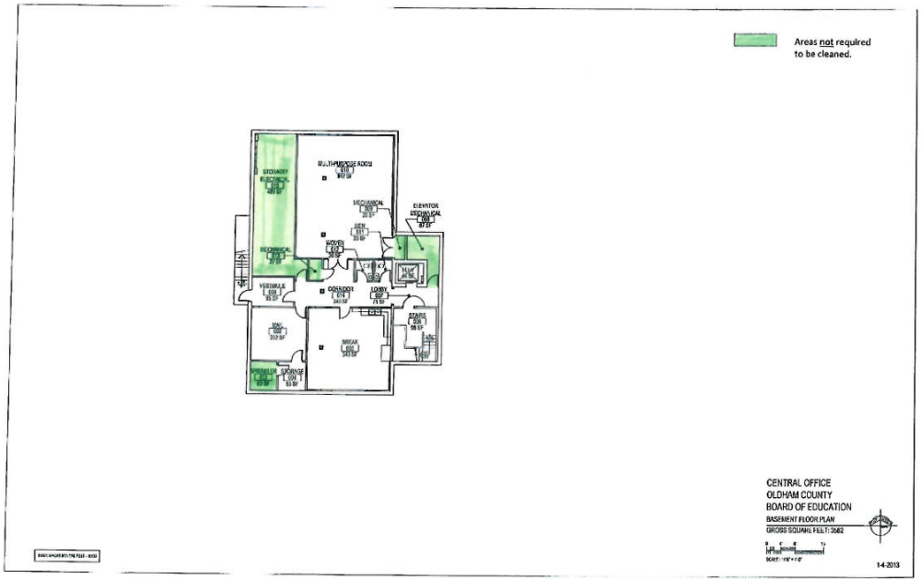

2 of 5

Specifications
Cleaning Services for Oldham County Schools Central Office, Administrative Annex, and Transportation Buildings – FY 26
DRAWINGS (NOT TO SCALE)

*Central Office

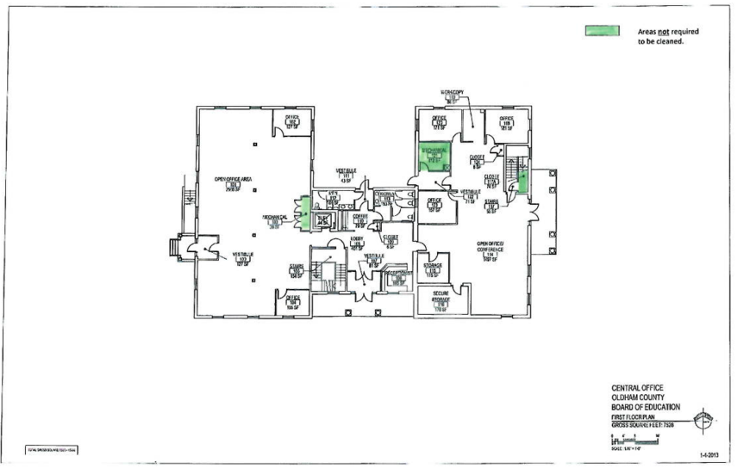

3 of 5

Specifications
Cleaning Services for Oldham County Schools Central Office, Administrative Annex, and Transportation Buildings – FY 26
DRAWINGS (NOT TO SCALE)

*Central Office

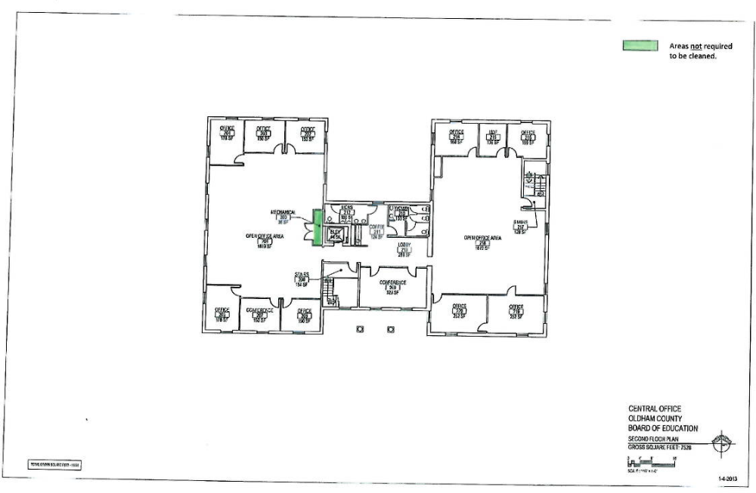

4 of 5

Specifications
Cleaning Services for Oldham County Schools Central Office, Administrative Annex, and Transportation Buildings – FY 26
DRAWINGS (NOT TO SCALE)

*Administrative Annex
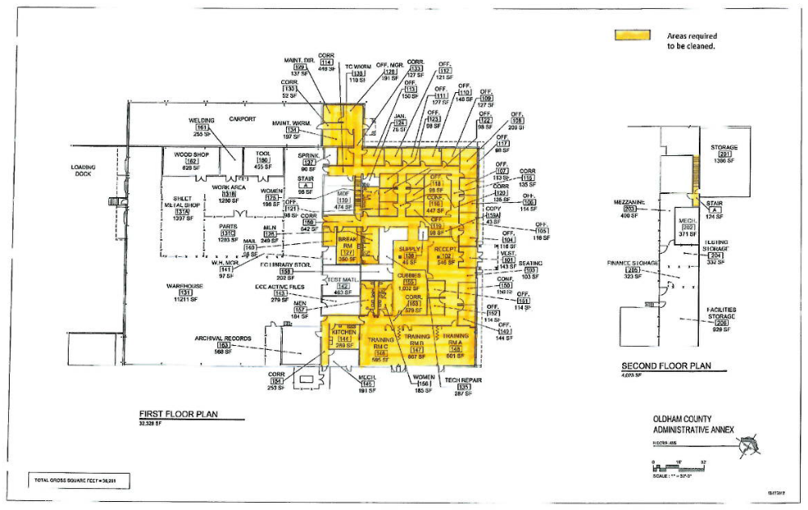

5 of 5

Specifications
Cleaning Services for Oldham County Schools Central Office, Administrative Annex, and Transportation Buildings – FY 26
DRAWINGS (NOT TO SCALE)

*Transportation Office

Required areas to be cleaned are shaded
