What is a
School-Family Compact?
A School-Family Compact for Achievement is an agreement that parents, students, and teachers develop together. It outlines how parents and students will work together to achieve our school and district goals.

Building Partnerships
Parent and Family Engagement

- Academic Parent Workshops
- Parent-Teacher Conferences-Compacts are discussed
- Volunteer Opportunities
- Classroom Observations by request
- Parent Resource Center
- Parent-Teacher Conferences

Revised August 2, 2025
Jointly Developed

The compact was jointly developed with Hapeville ES parents, students, teachers, and community stakeholders. Each group submitted strategies and ideas to help students achieve academic success. Meetings are held in spring 2025 to review and revise the student-Family Compact. Feedback is welcome throughout the school year.

Communication About
Student Learning
Hapeville ES is committed to frequent open two-way communication with parents and guardians about student learning.
Newsletters
Parent-Teacher Conferences-compact will be discuss
Progress Reports
Infinite Campus Parent Portal
School Website
ClassDojo

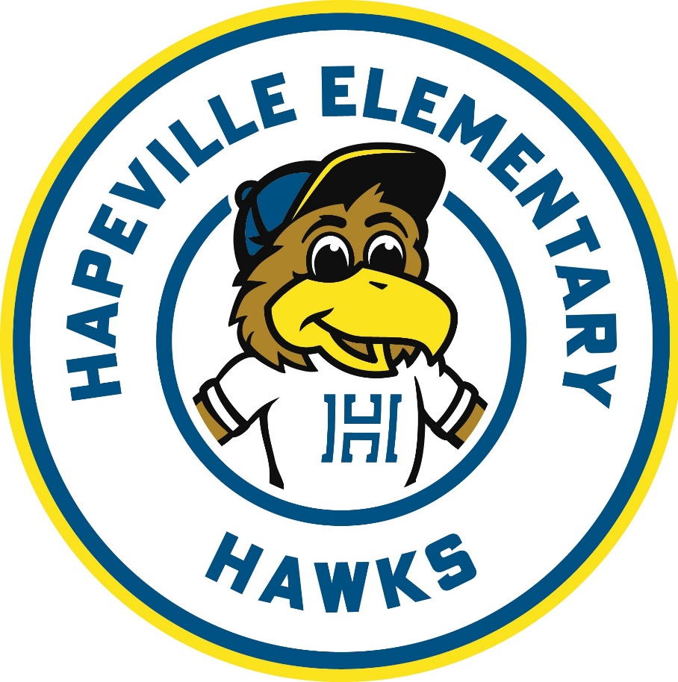
Hapeville Elementary
School
SCHOOL-FAMILY COMPACT
K-2
2026
3440 North Fulton Ave.
Hapeville, GA 30354
Phone: 470 – 254 - 8220

Dr. Christian Padgett, Principal
Tamara Whitaker, AP

Title I Parent Resource Center
Open Monday - Friday
8:30 a.m. – 2:00 p.m.
Parent Liaison
valenzuelacg@fultonschools.org
470.254.8220

Responsibilities

Our District Goals for
Student Achievement

Increase the percentage of all students scoring proficient or distinguished on Reading Milestones.

Increase the percentage of all students scoring proficient or distinguished on Math Milestones.

School Goals
Reading
Among K-2 graders, at least 35 percent of all full academic year students will make meet the stretch growth as measured by iReady Reading May 2026.

Focus Areas
Literary & Informational Comprehension, Morphology, Vocabulary, Fluency

Math
Among K-2 graders, at least 35 percent of all full academic year students will make meet the stretch growth as measured by iReady Math by May 2026.

Focus Areas
Addition, Subtraction, Multiplication, & Division Fluency, Solving Fractions, Geometry & Measurement

Math

School will:

Send phonics and high frequency word activities/strategies to ensure students understand what they are truly reading in class and at home.

Send home mathematics strategies related to counting, addition, and subtraction.

Parent and Family will:

Use phonics and high frequency word activities/strategies to ensure students understand what they are truly reading in class and at home.

Use mathematics strategies related to counting, addition, and subtraction.

- parent-teacher conferences as we work ld su
Student will:

Use phonics and high frequency word activities/strategies to ensure students understand what they are truly reading in class and at home.

Use mathematics strategies related to counting, addition, and subtraction.

For office use only:

_________________________________________________________Signature of Teacher or School Representative

Date ___________________________________
Keep a copy of the revised school-family compact at home.
Sign, date, and return this page to Bear Creek by October 27, 2018

