Que es un Compromiso Escolar-Familiar?

Un Compromiso Escolar-Familiar para el Logro Académico es un acuerdo que desarrollan conjuntamente los padres, los estudiantes y los maestros. Describe cómo los padres y los estudiantes trabajarán juntos para alcanzar las metas de nuestra escuela y del distrito.

Building Partnerships
Parent and Family Engagement

- Academic Parent Workshops
- Parent-Teacher Conferences-Compacts are discussed
- Volunteer Opportunities
- Classroom Observations by request
- Parent Resource Center
- Parent-Teacher Conferences

Revised August 2, 2025
Jointly Developed

The compact was jointly developed with Hapeville ES parents, students, teachers, and community stakeholders. Each group submitted strategies and ideas to help students achieve academic success. Meetings are held in spring 2025 to review and revise the student-Family Compact. Feedback is welcome throughout the school year.

Communication About
Student Learning

Hapeville ES is committed to frequent open two-way communication with parents and guardians about student learning.
Newsletters
Parent-Teacher Conferences-compact will be discuss
Progress Reports
Infinite Campus Parent Portal
School Website
ClassDojo

Title I Parent Resource Center
Open Monday - Friday
8:30 a.m. – 2:00 p.m.
Parent Liaison
valenzuelacg@fultonschools.org
470.254.8220

Hapeville Elementary
School
SCHOOL-FAMILY COMPACT
3-5 Grade
2026
3440 North Fulton Ave.
Hapeville, GA 30354
Phone: 470 – 254 - 8220

Dr. Christian Padgett, Principal
Tamara Whitaker, AP

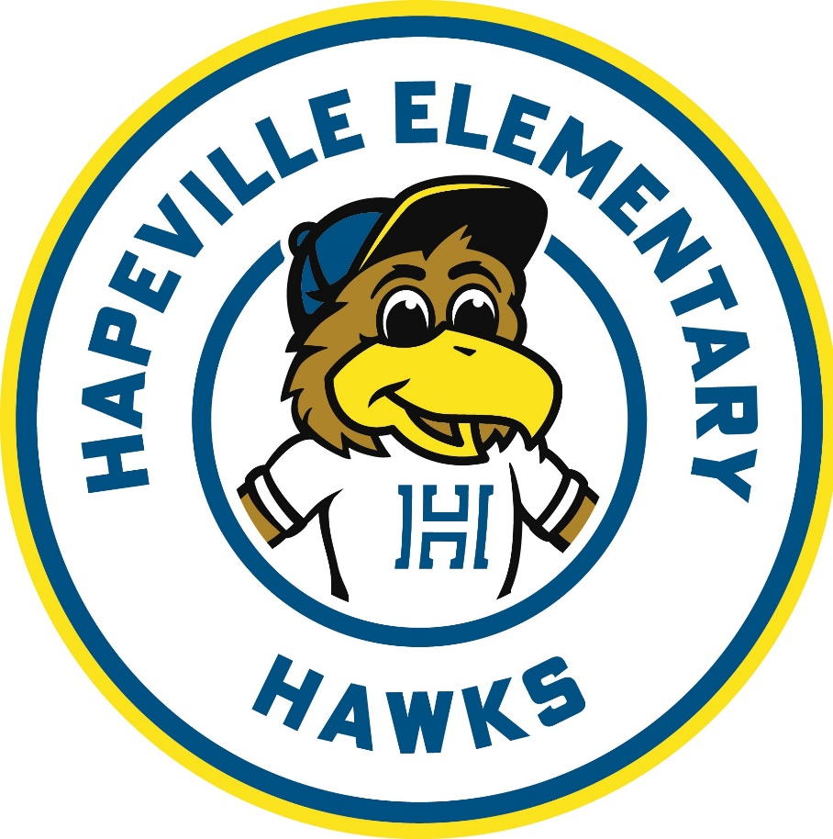

Our District Goals for
Student Achievement

Increase the percentage of all students scoring proficient or distinguished on Reading Milestones.

Increase the percentage of all students scoring proficient or distinguished on Math Milestones.

School Goals
Reading
Among 3rd - 5th graders, 70% of all full academic year students will score a level 2 or above in ELA on the 2025, 2026 GA Milestones & at least 47% of full academic year students will score a level 3 or 4 by May 2026.

Focus Areas
Literary & Informational Comprehension, Morphology, Vocabulary, Fluency

Math
Among 3rd - 5th graders, 70% of all full academic year students will score a level 2 or above in Math on the 2025 - 2026 GA Milestones & at least 51% of full academic year students will score a level 3 or 4 by May 2026.

Focus Areas
Addition, Subtraction, Multiplication, & Division Fluency, Solving Fractions, Geometry & Measurement

Math

Responsibilities

School will:

Send home vocabulary and/or phonics activities/strategies to ensure students understand what they are truly reading in class and at home.

Send home mathematics strategies related to addition, subtraction, multiplication, and division.

Parent and Family will:

Use vocabulary and/or phonics activities/strategies to ensure students understand what they are truly reading in class and at home.

Use mathematics strategies related to addition, subtraction, multiplication, and division.

- parent-teacher conferences as we work ld su
Student will:

Use vocabulary and/or phonics activities/strategies to ensure students understand what they are truly reading in class and at home.

Use mathematics strategies related to addition, subtraction, multiplication, and division.

For office use only:

_________________________________________________________Signature of Teacher or School Representative

Date ___________________________________
Keep a copy of the revised school-family compact at home.
Sign, date, and return this page to Bear Creek by October 27, 2018

