
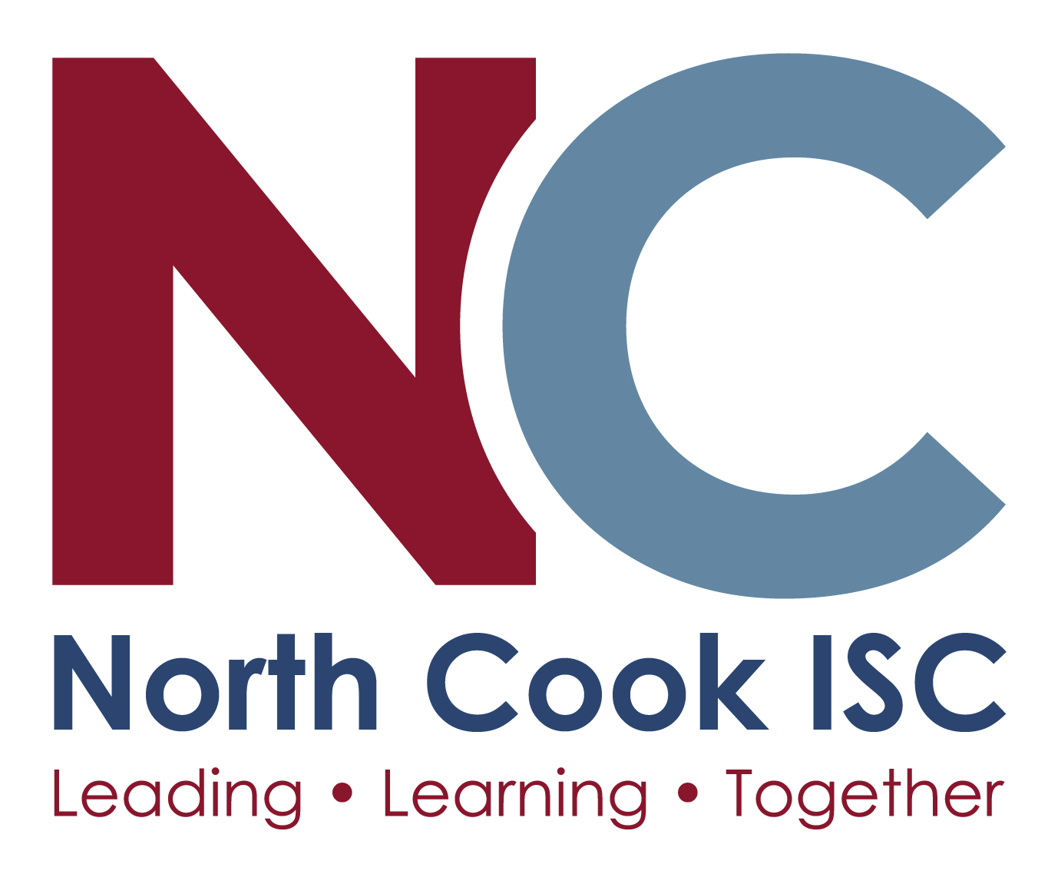
Mer Fenton, Communications Coordinator
847-803-6700
mfenton@ncisc.org
11/6/2025

North Cook Intermediate Service Center
Earns 2025 Great Place To Work Certification™
Des Plaines, Illinois — North Cook Intermediate Service Center (NCISC) is proud to be Certified™ by Great Place To Work®. The prestigious award is based entirely on what current employees say about their experience working at NCISC. This year, 79% of employees say it’s a great place to work – 22 points higher than the average U.S. company.
Great Place To Work® is the global authority on workplace culture, employee experience, and the leadership behaviors proven to deliver market-leading revenue, employee retention and increased innovation.
"Great Place To Work Certification is a highly coveted achievement that requires consistent and intentional dedication to the overall employee experience," says Sarah Lewis-Kulin, the Vice President of Global Recognition at Great Place To Work. She emphasizes that Certification is the sole official recognition earned by the real-time feedback of employees regarding their company culture. “By successfully earning this recognition, it is evident that NCISC stands out as one of the top companies to work for, providing a great workplace environment for its employees."

We have always strived to ensure that the human elements (Hu) are a part of our culture and workplace environment. As an Intermediate Service Center, service is absolutely at the heart of who we are and how we support students and school districts across our region. When you put people first, everything else follows; relationships, trust, and care. When people feel valued, seen, and heard they bring their best. I am so incredibly proud to work alongside my teammates at NCSIC! Together, we are leading learning. – Dr. April D. Jordan, Executive Director
This year we proudly celebrated our employees’ commitment to compassion and community as we set aside one work day to serve at a local organization dedicated to ending homelessness. Through preparing meals and organizing supplies, our team embodied the spirit of service that defines our stated values. Their efforts not only brought comfort and dignity to those in need but also strengthened the bonds that unite us as a caring community. We intend to make this an annual day of service since it was so successful. - Cheryl Moore, Director of Human Resources

According to Great Place To Work research, job seekers are 4.5 times more likely to find a great boss at a Certified great workplace. Additionally, employees at Certified workplaces are 93% more likely to look forward to coming to work, and are twice as likely to be paid fairly, and have a fair chance at promotion.

WE’RE HIRING!
Looking to grow your career at a company that puts its people first? Visit our careers page at: https://www.ncisc.org/about-us/employment

About North Cook Intermediate Service Center
North Cook Intermediate Service Center (ISC) is the liaison between the Illinois State Board of Education and local schools in our region. NCISC serves 41 educational organizations: 32 elementary districts, seven high school districts and two special education organizations. Our partnership with these member districts impacts 17,000 faculty and the education of more than 137,000 students; that work encompasses a range of areas, including comprehensive professional learning, operational & compliance resources, and a range of student services. We operate an alternative school, the North Cook Young Adult Academy, dedicated to providing a positive, safe, and inclusive learning environment for students.

About Great Place to Work Certification™
Great Place To Work® Certification™ is the most definitive “employer-of-choice” recognition that companies aspire to achieve. It is the only recognition based entirely on what employees report about their workplace experience – specifically, how consistently they experience a high-trust workplace. Great Place to Work Certification is recognized worldwide by employees and employers alike and is the global benchmark for identifying and recognizing outstanding employee experience. Every year, more than 10,000 companies across 60 countries apply to get Great Place To Work-Certified.
Learn more at ncisc.org and greatplacetowork.com, and connect with North Cook Intermediate Service Center on LinkedIn.

