Texas Bluebonnet Award Program
Individual Tracking Chart 2025-2026
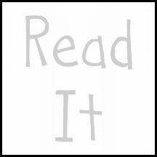  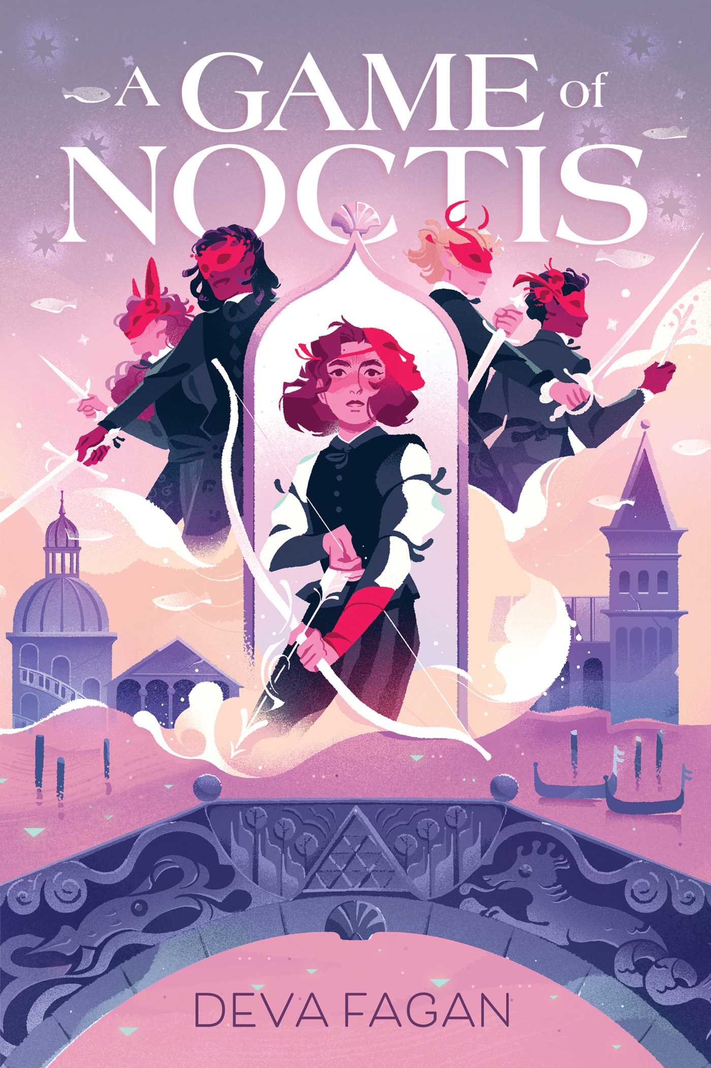  A Game of Noctis  by Deva Fagan | 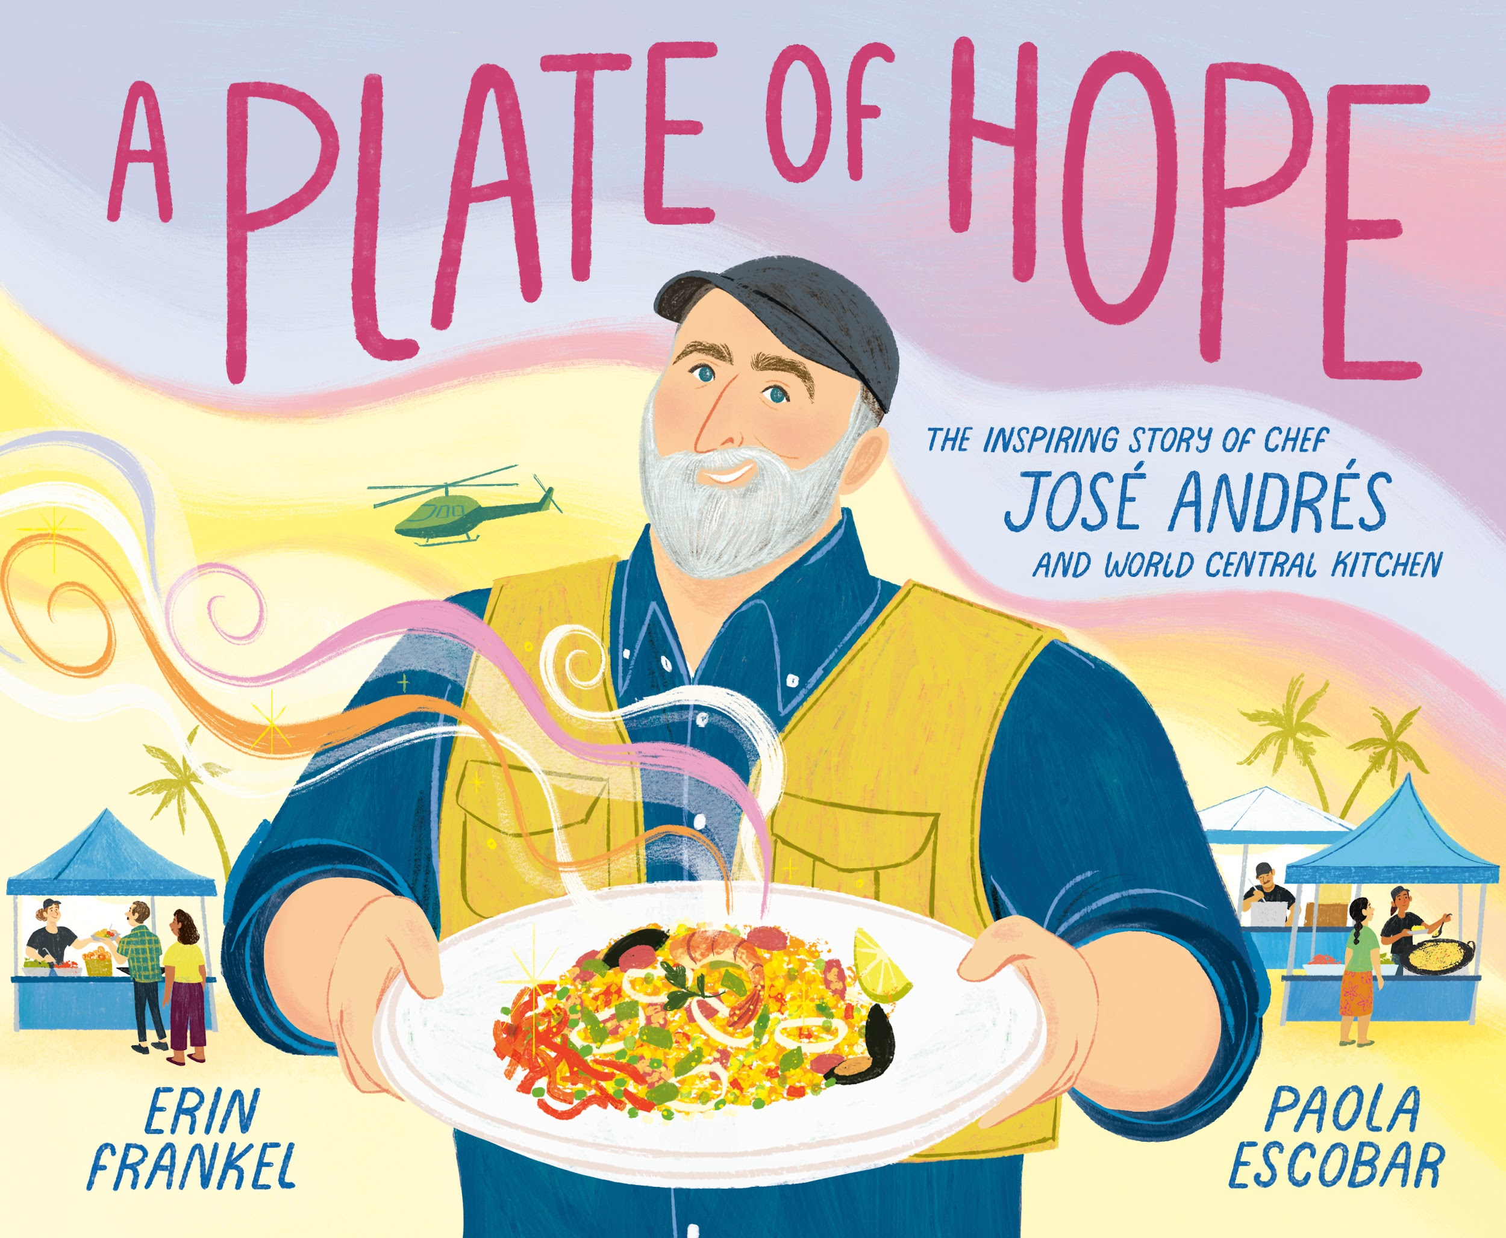  A Plate of Hope  by Erin Frankel | 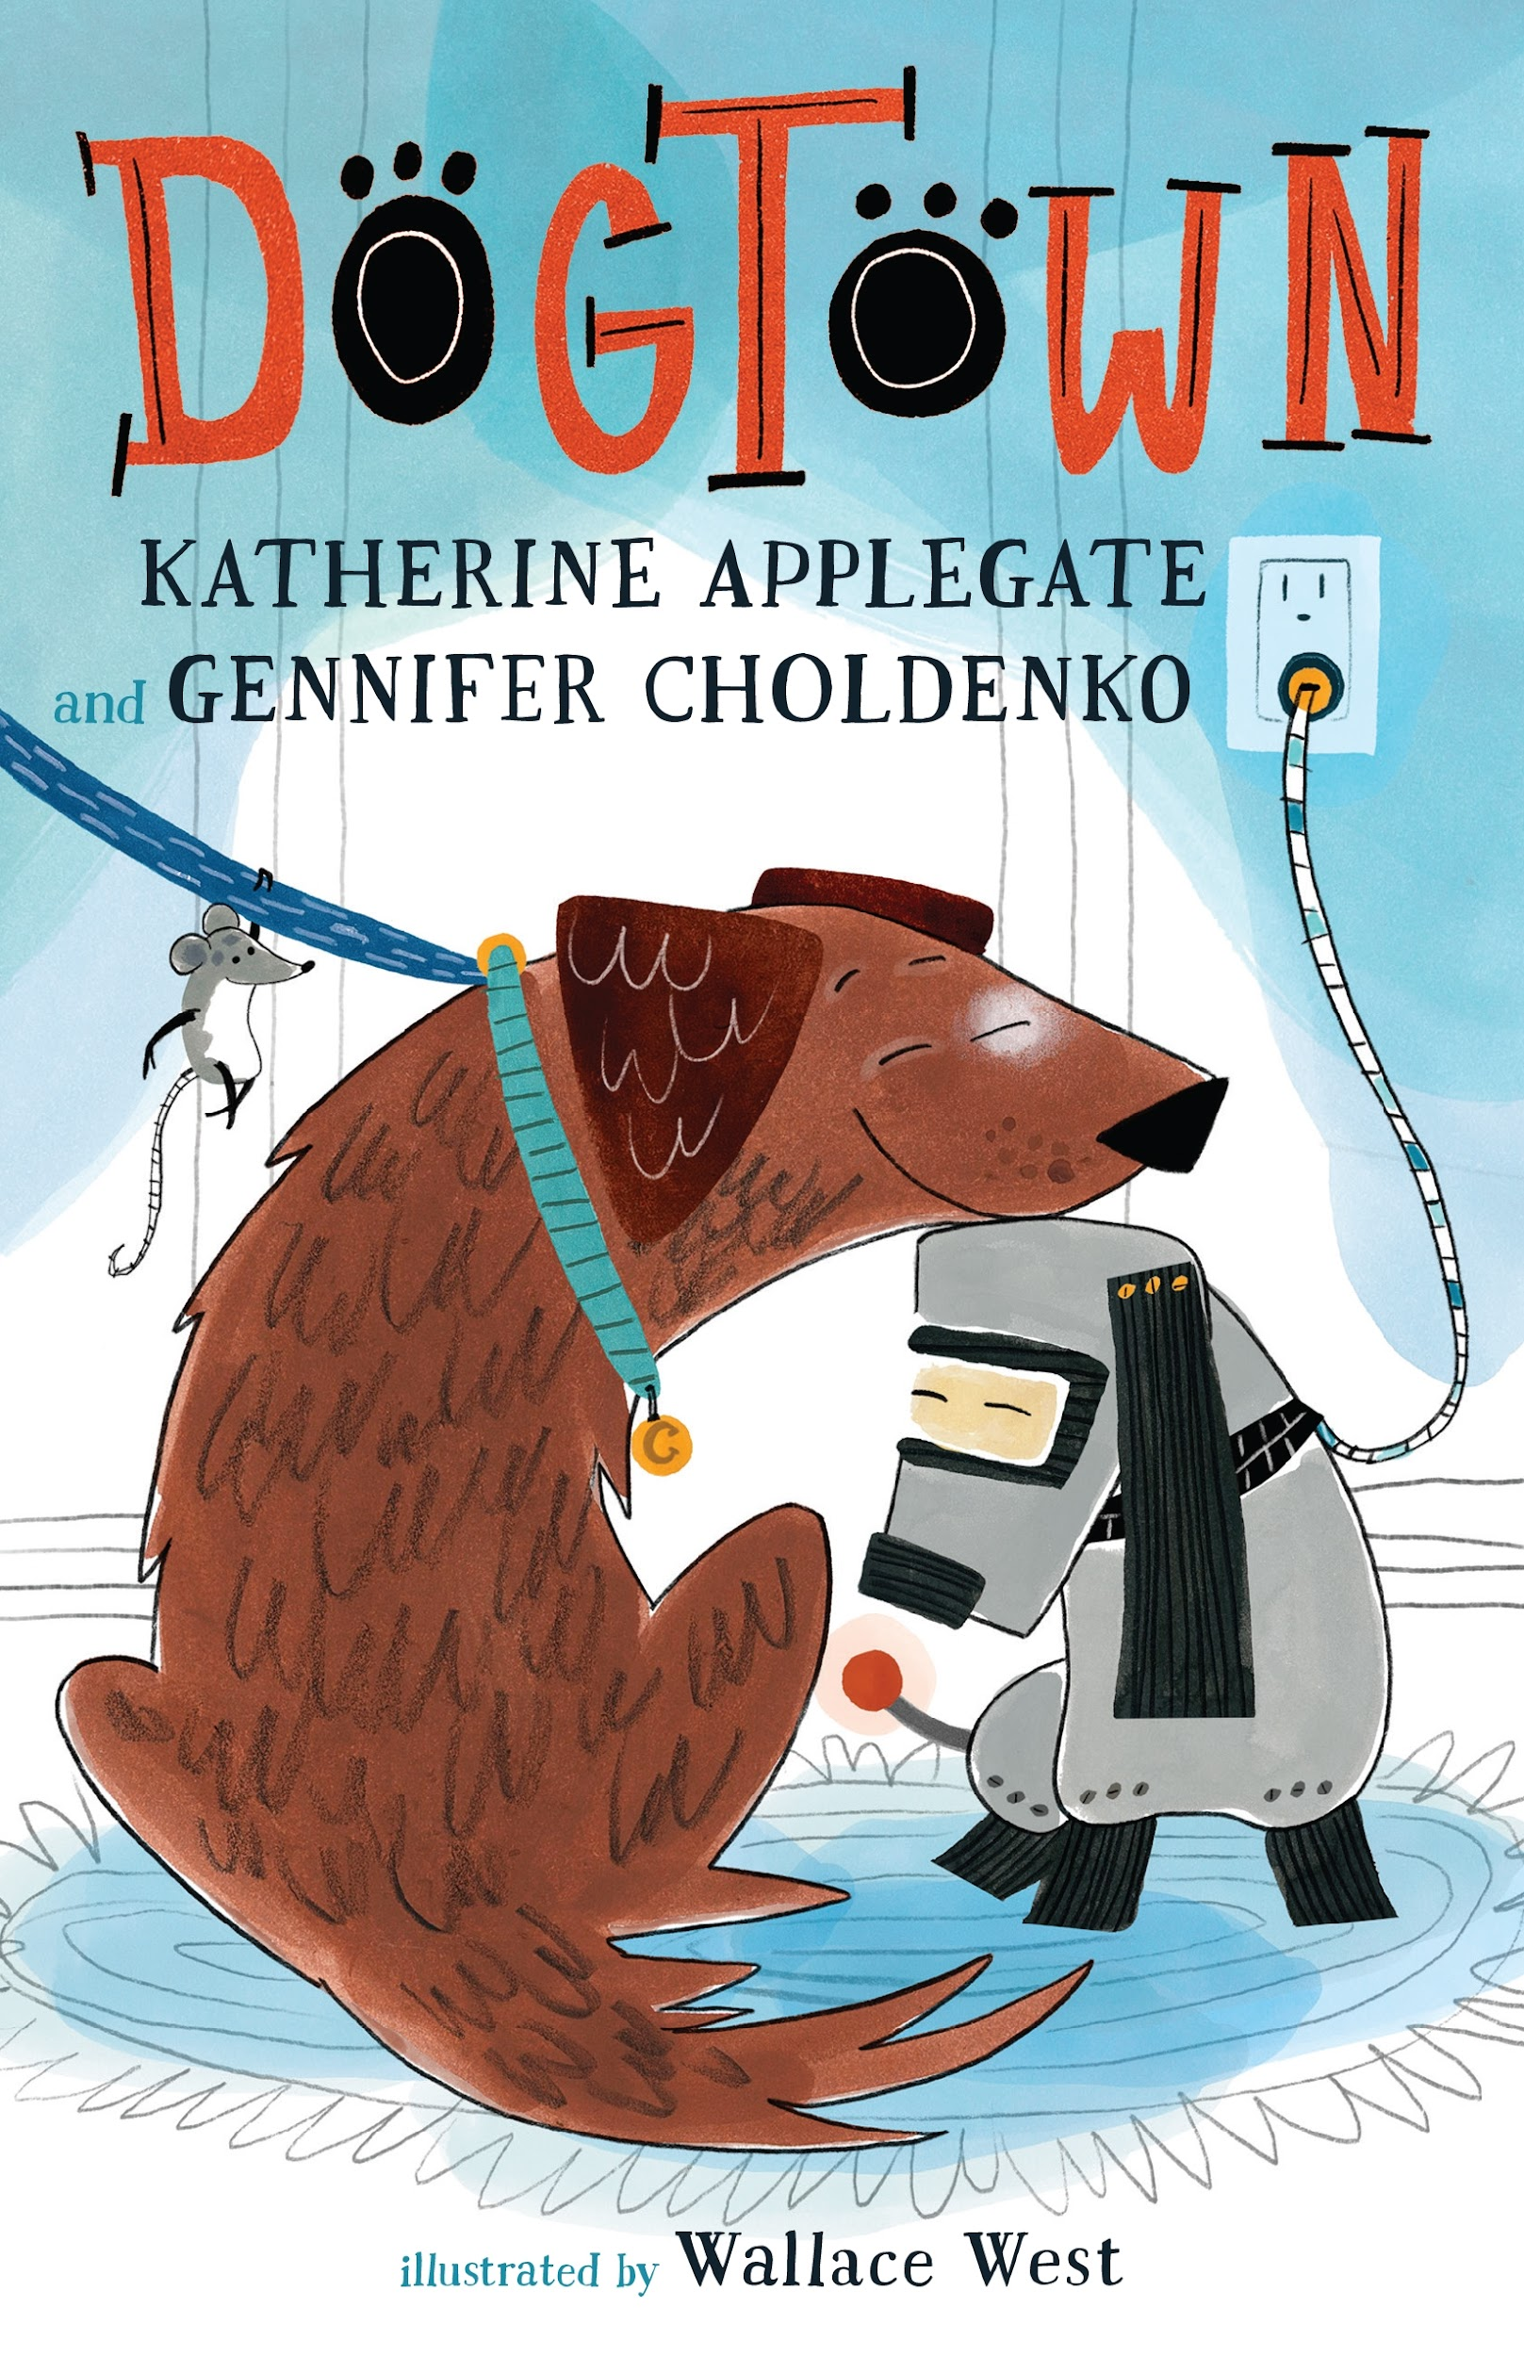  Dogtown  by Katherine Applegate | 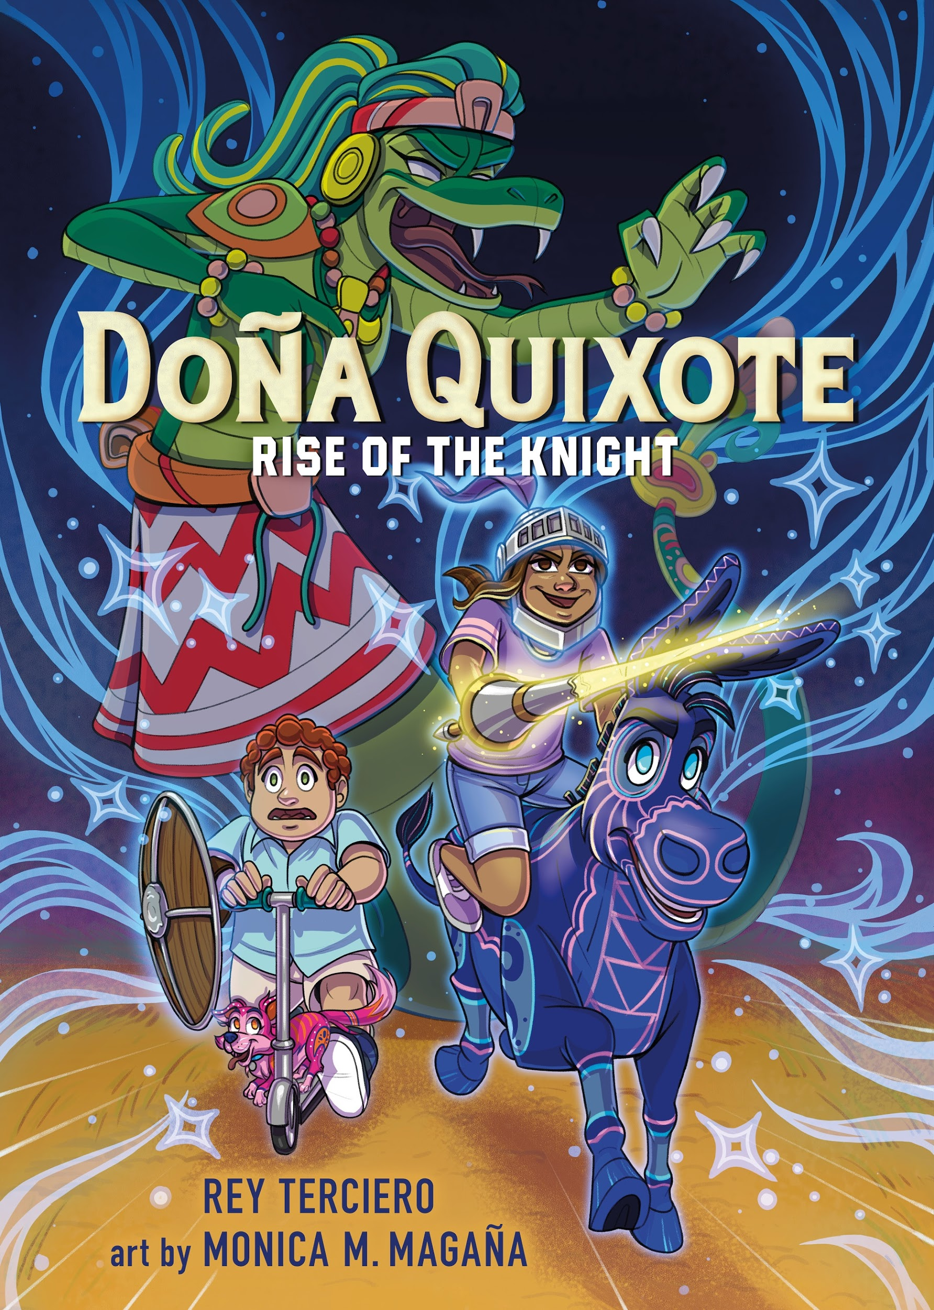  Doña Quixote: Rise of the Knight  by Rey Terciero
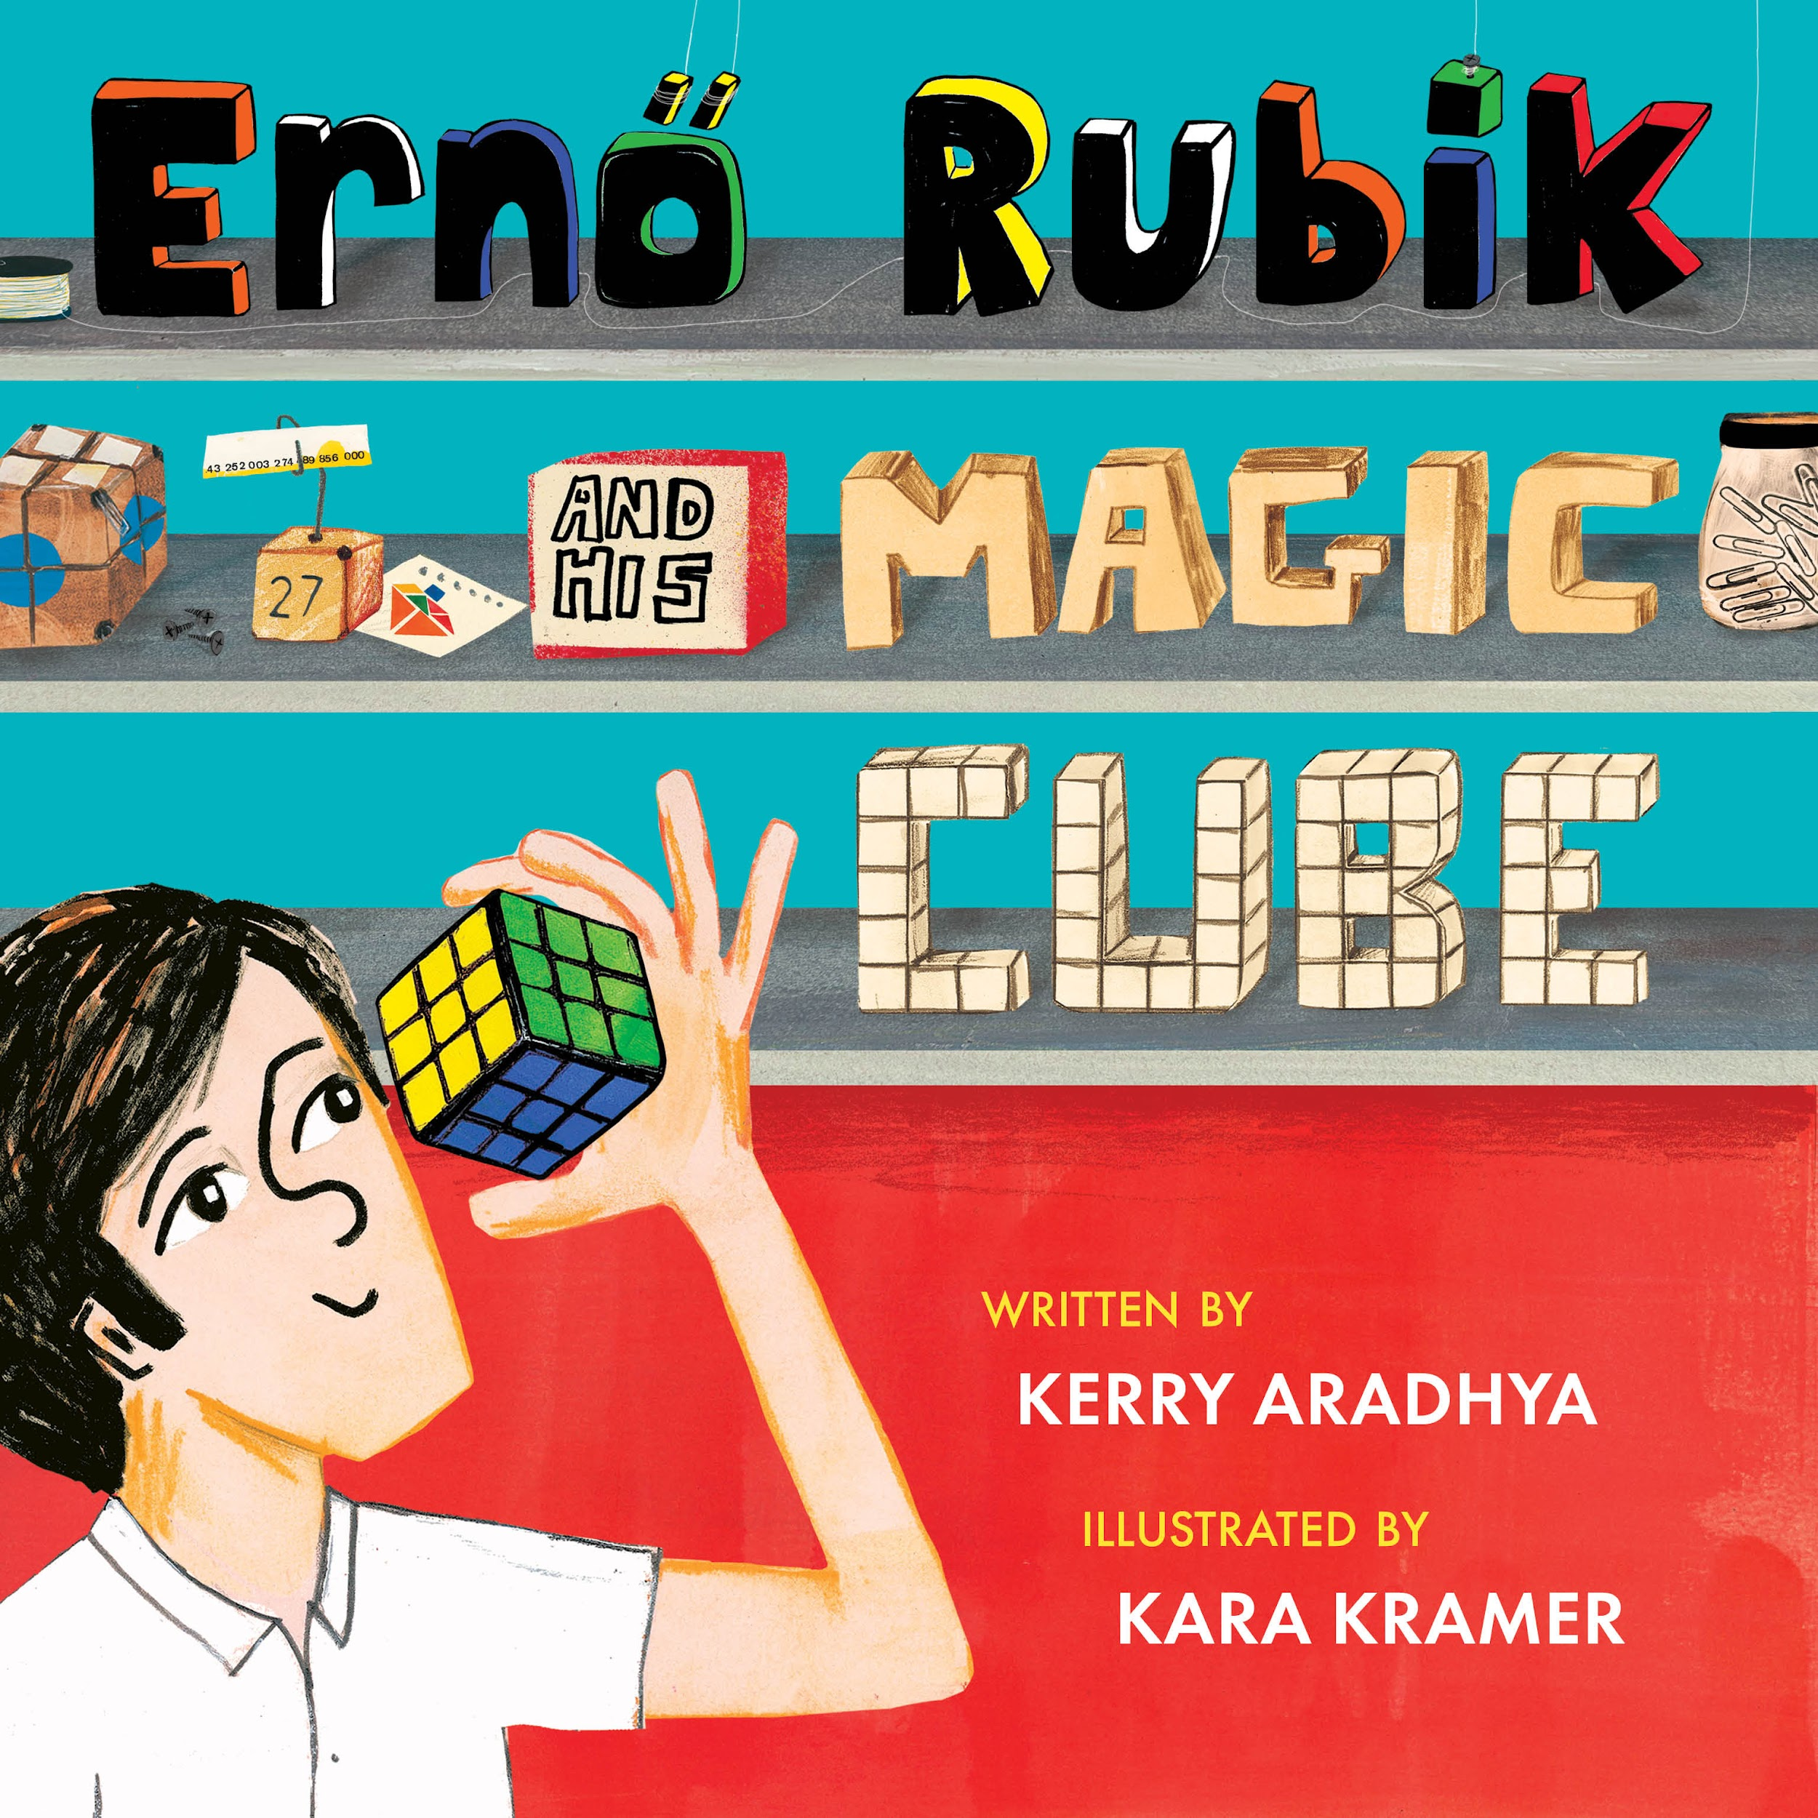  Ernö Rubik and His Magic Cube  by Kerry Aradhya | 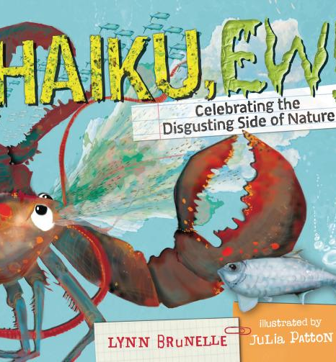  Haiku Ew! Celebrating the Disgusting Side of Nature  by Lynn Brunelle |   Hannah Sharpe, Cartoon Detective  by: Janet Tashjian | 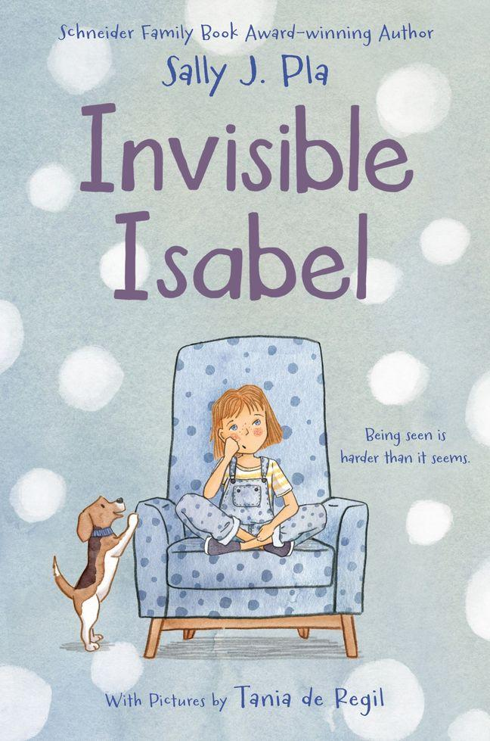  Invisible Isabel  by Sally J. Pla
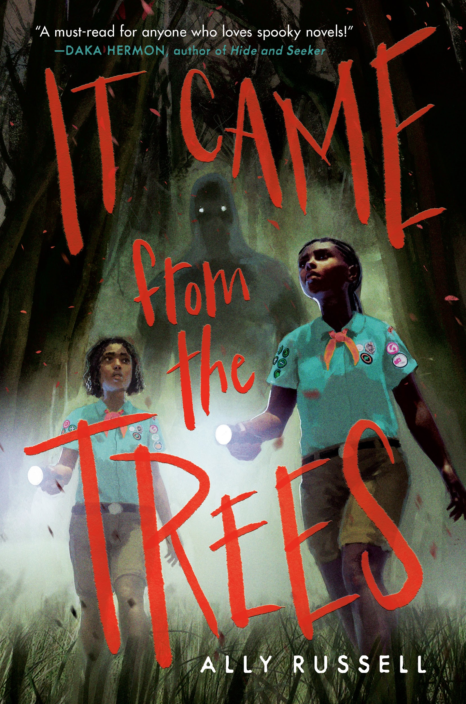  It Came from the Trees  by Ally Russell | 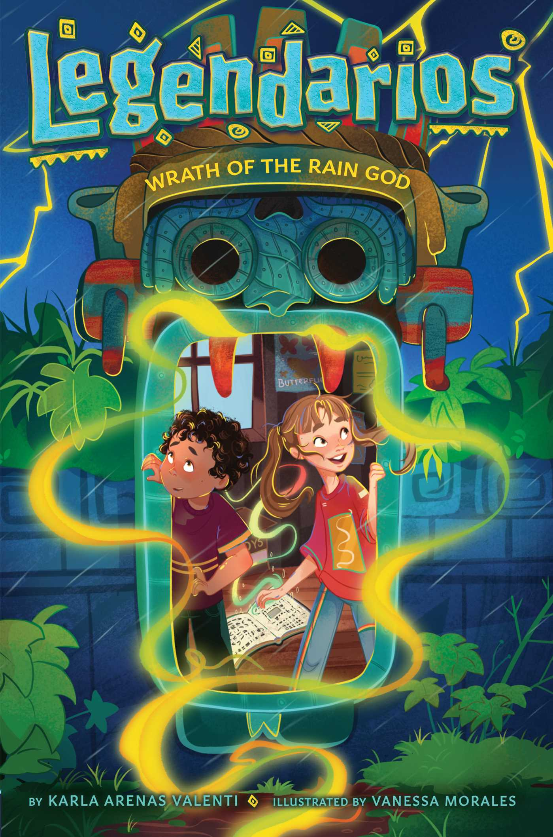  Legendarios: Wrath of the Rain God  by Karla Arenas Valenti |   Magnolia Wu Unfolds It All  by Chanel Miller | 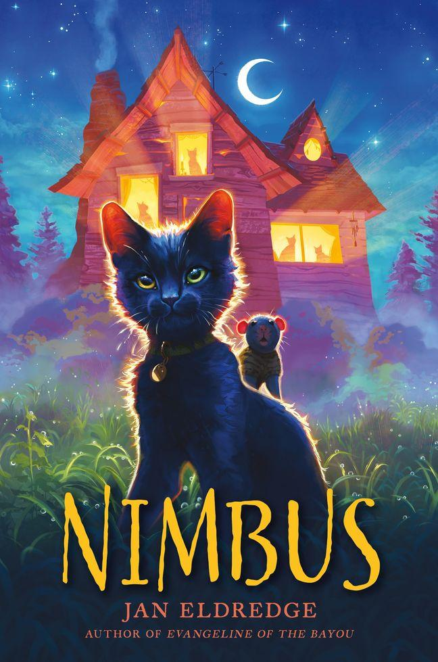  Nimbus  by Jan Eldredge
  Pedro’s Yo-Yos: How a Filipino Immigrant Came to America and Changed the World of Toys  by Rob Peñas | 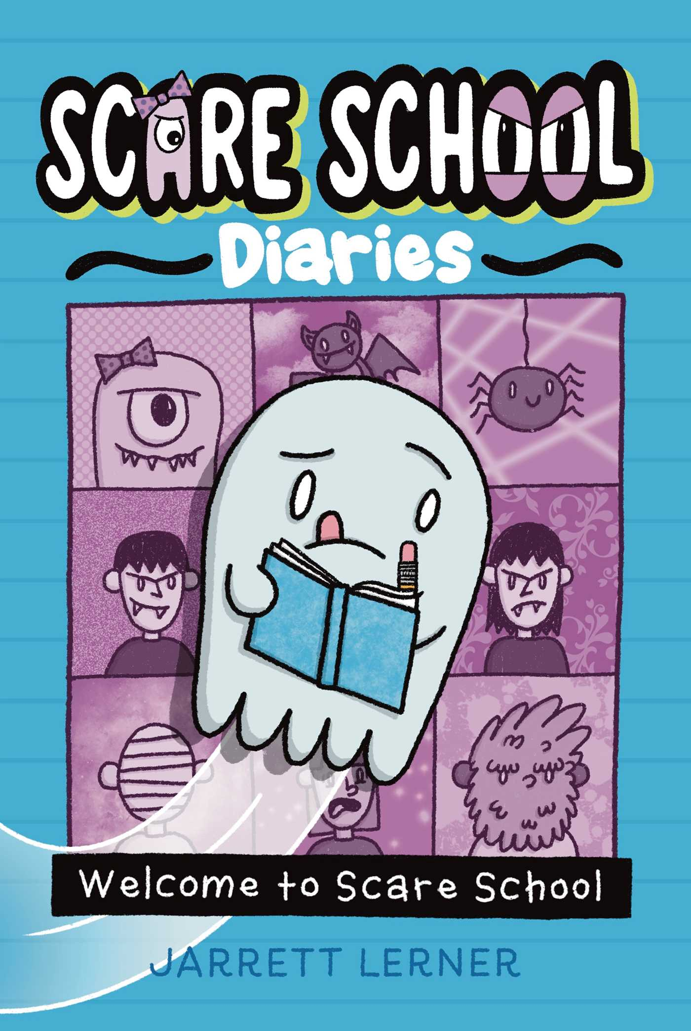  School Scare Diaries: Welcome to Scare School  by Jarrett Lerner | 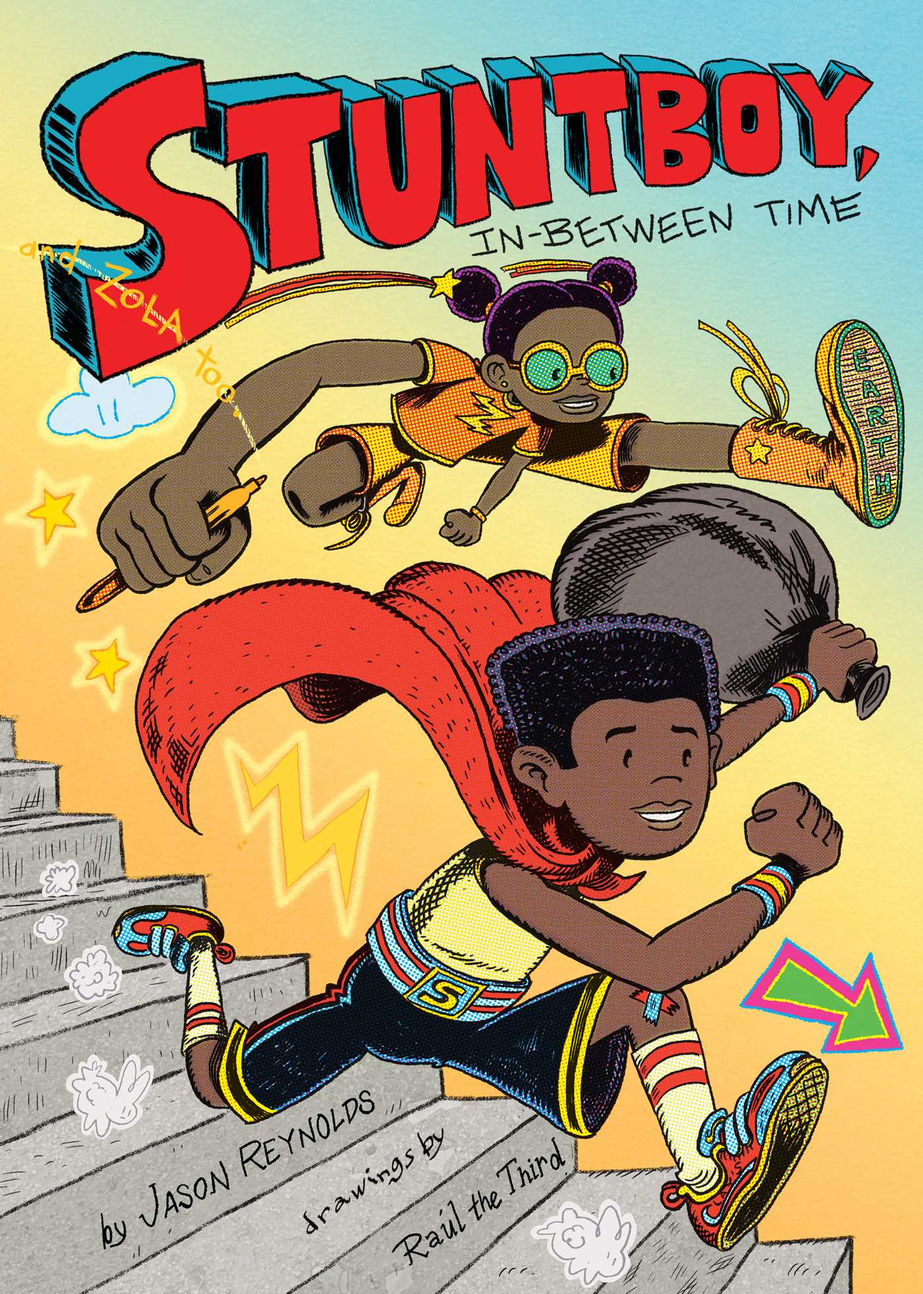  Stuntboy, In-Between Time  by Jason Renyolds | 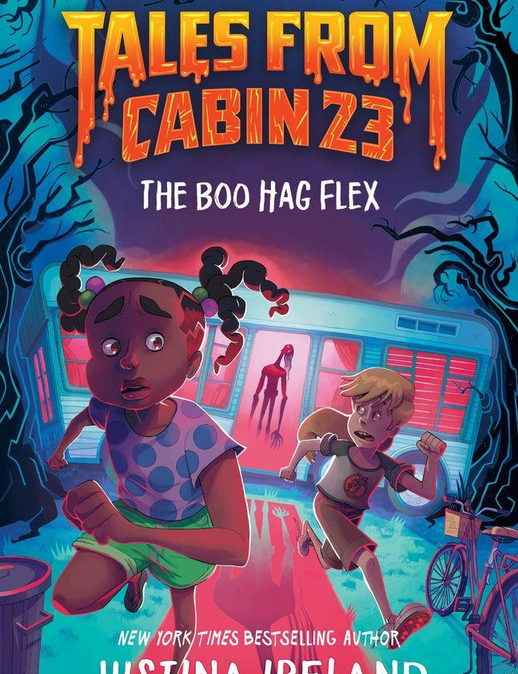  Tales from Cabin 23: The Boo Hag Flex  by Justina Ireland
  The Girl Who Figured It Out  by Minda Dentler | 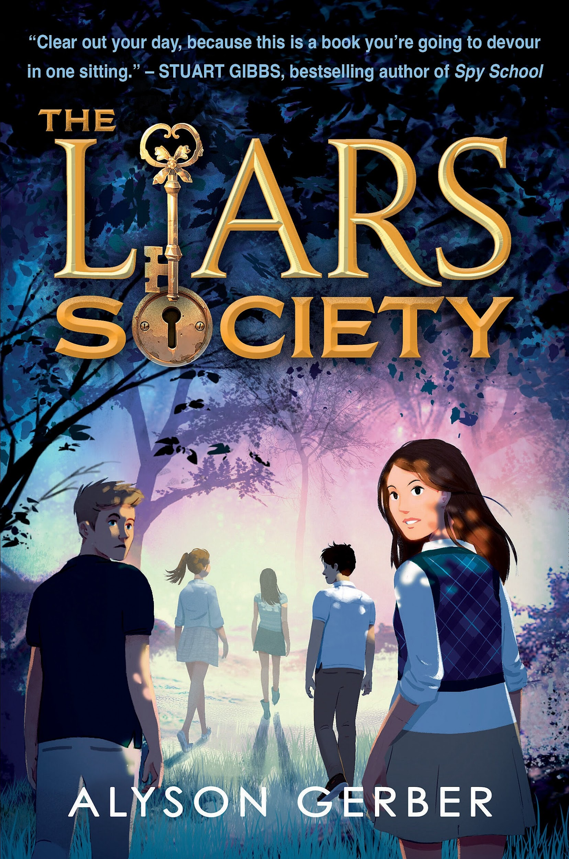  The Liars Society  by Alyson Gerber | 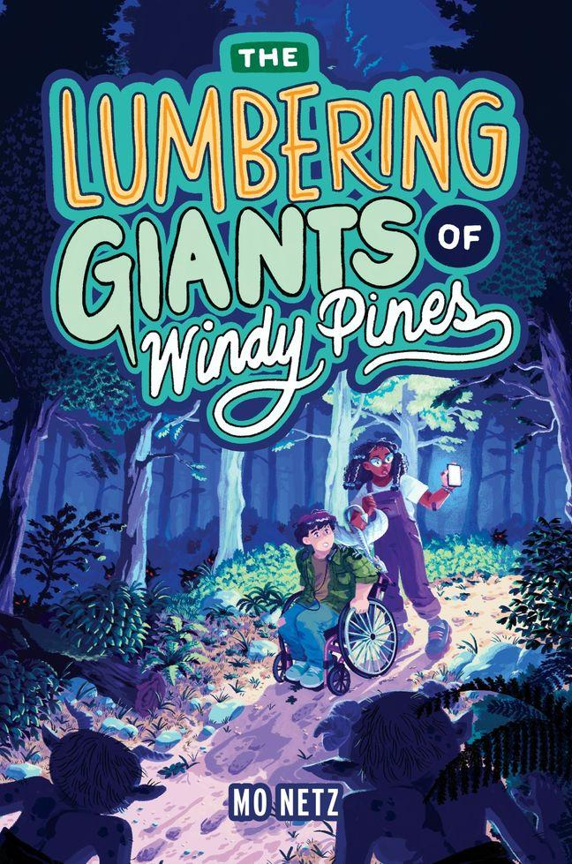  The Lumbering Giants of Windy Pines  by Mo Netz |   Volcanoes  by Nell Cross Beckerman

