Navy Junior ROTC Ribbons
 | 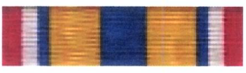  MERITORIOUS ACHIEVEMENT |  |   DISTINGUISHED UNIT
  DISTINGUISHED CADET |  |   HONOR CADET |  | 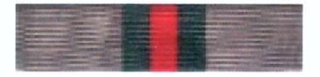  CADET ACHIEVEMENT |   UNIT ACHIEVEMENT
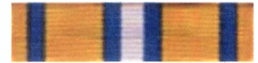  APTITUDE |  | 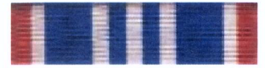  NS IV OUTSTANDING  CADET(S) |  | 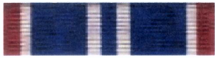  NS III OUTSTANDING  CADET (S) | 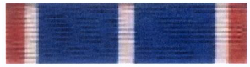  NS II OUTSTANDING CADET(S)
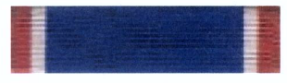  NS I OUTSTANDING CADET(S) |  | 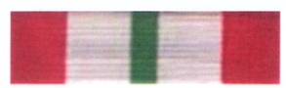  EXEMPLARY CONDUCT |  | 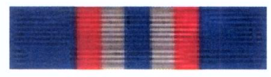  EXEMPLARY PERSONAL  APPEARANCE | 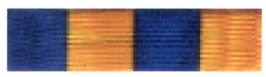  PHYSICAL FITNESS
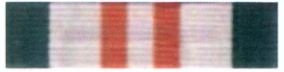  PARTICIPATION |  | 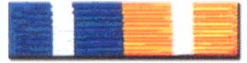  UNIT SERVICE |  | 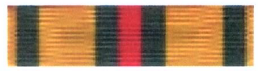  COMMUNITY SERVICE | 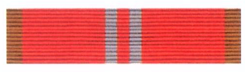  ACADEMIC TEAM
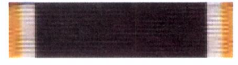  DRILL TEAM |  |   COLOR GUARD |  | 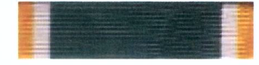  MARKSMANSHIP TEAM | 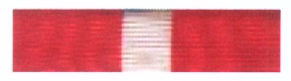  ORIENTEERING TEAM
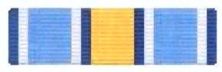  INTER-SERVICE COMPETITION |  |   RECRUITING |  |   LEADERSHIP TRAINING | 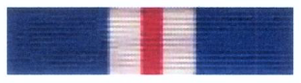  SEA CRUISE
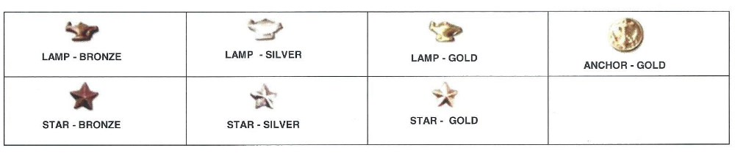

NSTC 5761 (Rev. 07/16)

