




Julie Frenz, BS…………......………….(585) 617-2380
Support Services Specialist
Kyrstin Farden, BSN, RN………….…(585) 617-2382
Health Support Specialist
Janet Fitzpatrick, BSN, RN…….…….(585) 617-2384
Health Services Specialist
Melissa Trau, MSN, BSN, RN…...…...(585) 617-2380
Director
Dr. Ron Marino
NYSCSH Medical Director Consultant
Shelly Budinski, MSEd…….…………(585) 617-2383
Health Education Specialist, School Health Profiles &
Youth Risk Behavior Survey Coordinator
Email: nyscsh@monroe2boces.org
www.schoolhealthny.com
160 Wallace Way, Rochester, NY 14624
NYSCSH Staff
Health Services
Health Education

Division of Vaccine Excellence
(518) 473-4437
School Immunization and Compliance Unit
Email: osas@health.ny.gov
NYC Department of Health
(347) 396-4100

Commerce Accounts Management Unit (CAMU)
Email: hinhpn@health.ny.gov...............(866) 529-1890
NYSDOH On-Line School Immunization Assessment Reporting Survey (OSAS)
Email: osas@health.ny.gov
Student Weight Status Category Reporting (SWSCR)
Email: schoolbmi@health.ny.gov..........(518) 473-7817
NYS Immunization Information System (NYSIIS)
Email: nysiishelpdesk@gainwelltechnologies.com
(866) 389-0371
NYC Citywide Immunization Registry (CIR)
Email: cir@health.nyc.gov……………..(347) 396-2400

Office of Children and Family Services (OCFS)
Email: info@ocfs.ny.gov.......................(518) 473-7793
Child Protective Services Hotline for Reporting
(800) 342-3720
Mandated Reporter Resource Center
www.mandatedreporter.org
Prevention Services (OCFS HEARS)
Help, Empower, Advocate, Research & Support
(888) 554-3277
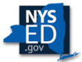
New York State Education Department
www.nysed.gov (518) 474-3852
Student Support Services
Email: studentsupportservices@nysed.gov
(518) 486-6090
Karen Hollowood
Supervisor of Student Centered Educational Policy Unit
Ann Lanoue, Associate in School Nursing
Andrea Vink, Associate in School Nursing
Office of Religious and Independent Schools
Email: oriss@nysed.gov........................(518) 473-8202
Office of Professions Board of Nursing
Email: nursebd@nysed.gov….….(518) 474-3817 x 120
Standards & Instruction
Email: P12standardsinstruction@nysed.gov
(518) 474-5922
Associate in Physical Education
Associate in Health Education
Facilities Planning
Email: emscfp@nysed.gov....................(518) 474-3906
Medicaid in Education
Email: medined@nysed.gov..................(518) 474-7116

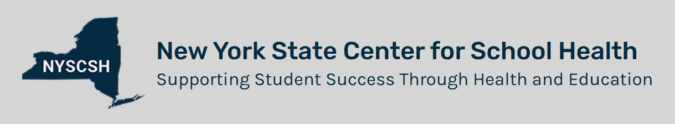





Follow Us
Keep up to date on trending information. Like and follow us on Facebook.

Learn With Us
Register for our Learning Management System and receive free, professional development courses and earn Professional Development credit.

Connect With Us
Subscribe to our email messaging system
(Health Information Portal) to stay up to date with critical information from NYSCSH and NYSED.

Stay Informed
Visit schoolhealthny.com for updated, evidence-based information to help you care for and educate NYS students.

