Fred Booth Elementary
School Culture Manual
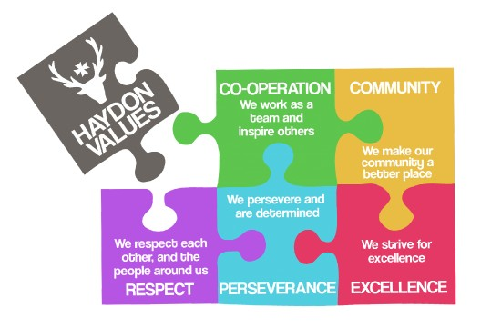
PBIS


BOBCAT
VALUES

CAMPUS VISION STATEMENT

The vision of Fred Booth Elementary is to be a high-achieving school and to set students on the path to the university.

CAMPUS MISSION STATEMENT

Fred Booth Elementary School will promote educational excellence and provide a quality education that encourages students to be confident, knowledgeable, responsible, and college, career, and workforce ready.

CAMPUS MOTTO

“If you believe it, you can achieve it.”

The following procedures are to be taught and practiced throughout the first week of school. The procedures must be reinforced daily all year. The students must understand all expectations. It is everyone’s responsibility to ensure that all students abide by the following procedures.


Uniforms

Students must be in uniform every day. If a student is not wearing the appropriate uniform, the teacher must call the parent immediately so a change of clothing can be brought to school. All shirts must be tucked in at all times while on school grounds (in or out of the classroom, including the ASP).

1st semester students may wear a Greyhound shirt on Fridays.

2nd semester students may wear a College shirt on Fridays.

*If students are not wearing a Greyhound or College shirt during the designated scheduled Fridays, they must wear their school uniform.

*Teachers are encouraged to participate.

RAK (Random Acts of Kindness)

Teach the students that when a staff member raises their hand with the RAK signal all students must STOP talking immediately and give their attention to the speaker.


This should be immediate and not require any talking from the speaker to get the whole group to quiet down and pay attention.
This must be practiced and enforced daily.

Cafeteria Procedures

The teachers will walk their class to and from lunch. This will ensure a safe entry and exit.

The students are to:

- enter quietly

- walk in a straight line with hands at their side
- look in the direction they are walking (face forward)

Once they begin entering the food line, students must make sure:

- they have all their food & paper items
- they face forward and sit correctly in the cafeteria
- they use their inside voice
- they remain in their seats unless they have permission to get up
- they use the restroom and/or water signal

During lunch dismissal students are to:

- wait for a staff member to signal them to get up
- clean up their area and pick up any item that might have fallen on the floor
- walk quietly in a straight line
- follow their teacher to class

Morning/Out of Class Transitions/Hallway

The teacher will stand at the doorway and greet each student:

- with a “Good Morning”
- with a “Smile” and eye contact

Announcements: No talking during this time

Pledge: All students and staff must recite the Pledge of Allegiance unless the parents have informed you otherwise. If they cannot recite the Pledge, they still must stand and remain silent during the announcement.

Moment of silence: All staff and students must stand and be silent during this time. Absolutely no talking during the moment of silence.

The teacher will be prepared with an assignment or activity to engage the students.

During transitions the students are to walk quietly in an orderly fashion and in a straight line with their hands by their sides. (This will be done at all times including fire drills). Students must understand these rules must be followed whether they are in a group or by themselves. All staff must enforce these rules at all times.

Students/faculty must walk on the side of the GREEN paw prints placed on the ceiling at all times.

In Class Transitions/Behavior

The teacher will develop their own in class procedures but will include the school signals for attention (RAK), restroom and water. Transition time between activities should be minimal. Students should be trained how to pick up and line up quietly. Systems and Procedures should be in place for students during all activities. For example:
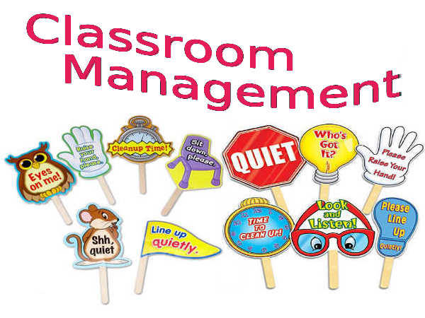
- what to do as soon as they walk into your classroom
- how to put their chairs in when leaving your classroom
- where to put their materials or personal items
- what to do with their assignments
- how to transition during classroom activities
- what are the procedures for dismissal at the end of the day
- pencils / erasers and/or other school supplies, etc.

Expectations and daily routines must be set and enforced daily. Students need and appreciate structure. Classroom procedures must be evident whether or not the teacher is present. Students must be taught to use good manners: “Please”, “Thank you”, “Excuse me”, etc.

Discipline referrals: Teacher is in charge of maintaining classroom management. Absolutely no referrals to the office unless the discipline management plan has been followed.

No students are to be placed in the hallway

No students are to be sent to the office for discipline. Please call the office for assistance.

Active monitoring: All teachers must be actively monitoring their class at all times.

After school line up procedures: 3 lines as follows:

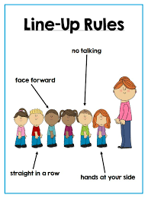
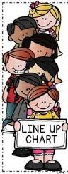

After School Bus/Daycare Pick-Up
Program

All students must be walked to their assigned area by designated staff. Teachers must actively monitor and assist in the dismissal and pick up process.

Restroom Procedures

All students will use the school signal for restroom and water break.



Only one girl and one boy will be allowed to leave the classroom to use the restroom during any given time unless there is an emergency.

Students must be taught appropriate restroom behavior.

- Go directly from the room to the restroom and back as quickly as possible.
- Stay inside your stall
- Only one person per stall
- Respect others privacy
- Do not stand on toilets, toilet paper holders, sinks, counters, or any other bathroom furniture
- Flush the toilet when finished
- Wash hands before leaving the restroom
- Keep restroom neat and clean

REMINDERS

LIBRARY / COUNSELOR RULES

STAY POSITIVE

WE ARE THE GOLD STANDARD
MAKE A DIFFERENCE IN THE LIVES OF CHILDREN

The San Benito Consolidated Independent School district does not discriminate on the basis of race, religion, color, national origin, sex, or disability in providing education or providing access to benefits of education services, activities, and programs, including vocational programs in accordance with Title VI of the Civil Rights Act of 1964, as amended; Title IX of the Educational Amendments of 1972; Section 504 of the Rehabilitation Act of 1973, as amended; and Title II of the Americans with Disabilities Act.


SCHOOL MASCOT
Bobcat
SCHOOL COLORS
Green and Gold

FIGHT SONG

Green and Gold forever, firm together stand
Comrades true and faithful,
Steadily we’ll face the world so fearlessly
And through the years to follow,

We’ll pledge our loyalty
For green and gold we’ll make
OUR GOALS A VICTORY!

ALMA MATER

Green and gold shall always be
Our guide to victory
United we shall stand
And help in all we can,
For the school and team we praise
We shall love for all our days
We’re comrades true and loyal to
Dear San Benito Booth

San Benito Consolidated Independent School District
Fred Booth Elementary
705 Zaragosa * San Benito, TX 78586 * (956) 361-6860
STUDENT DISCIPLINE DOCUMENTATION

Student’s Name: ____________________________ I. D. # ____________ Grade ______

LEVEL I - CONFERENCE WITH STUDENT / DOCUMENT INFRACTION
Infraction Date / Consequence
1.______________________________ ______________________________
2.______________________________ ______________________________
3.______________________________ ______________________________
4.______________________________ ______________________________

*School counselor available for assistance at all levels

LEVEL II - PARENT CONTACT (conference) Phone # ________________________
Date Signature / Parent’s Name
1.______________________________ ______________________________
2.______________________________ ______________________________
3.______________________________ ______________________________
4.______________________________ ______________________________

LEVEL III - MANDATORY PARENT / TEACHER (TEAM) CONFERENCE
Date Signatures
______________________________ ______________________________
______________________________
______________________________
______________________________

Date Signatures
______________________________ ______________________________
______________________________
______________________________
______________________________

Date Signatures
______________________________ ______________________________
______________________________
______________________________
______________________________

LEVEL IV - TEAM / TEACHER CONSEQUENCES
Consequence
1. In Team Suspension (I.T.S.)
2. Morning Detention – 24 hour notification to parents
3. After school Detention – 24 hour notification to parents
4. Other _______________________________________
_______________________________________
_______________________________________

Date Infraction Consequence #
1.________________ __________________ ________________
2.________________ __________________ ________________
3.________________ __________________ ________________
4.________________ __________________ ________________

LEVEL V – CAMPUS REFERRAL

1. Referral to Office with Documentation
a. Do Not send student to office with referral
b. Turn in referral during Conference
c. Administration will process referral (action taken is at the discretion of campus administration)
2. Immediate Referrals for Serious Infractions
a. Call front office for administrative assistance
b. Send student to office with referral (depending on infraction – wait for campus escort) – do not leave classroom unattended

Signatures Title
___________________________________________ ________________________

___________________________________________ ________________________

___________________________________________ ________________________

___________________________________________ ________________________

___________________________________________ ________________________

___________________________________________ ________________________

