Resources on MINDFULNESS

BrainPop Video: Mindfulness

Youtube Video: Fair is Fair by Sonny Varela

ELEMENTARY
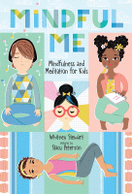

Mindful Me : Mindfulness and Meditation For Kids

By Stewart, Whitney

Clever/ MackinVia

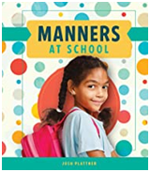

Manners at School
By Josh Plattner (book level – 1.3)

ABDO

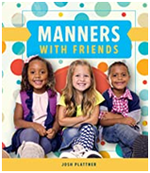

Manners with Friends
By Josh Plattner (book level – 1.3)

ABDO

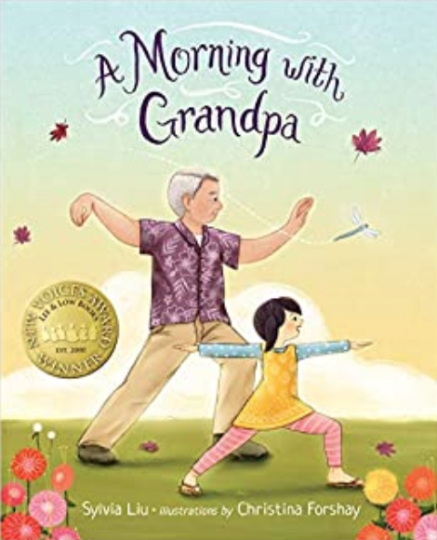

A Morning with Grandpa
By Liu, Sylvia (book level K-3) Topic: Yoga

Clever/ MackinVia

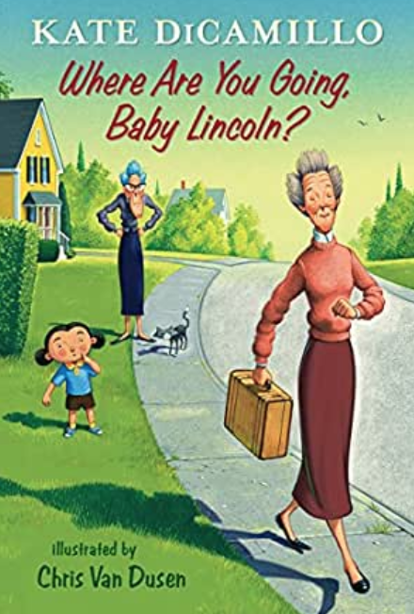

Where are you going, Baby Lincoln?
By DiCamillo, Kate (book level 1-3) Topic: Self Realization

Clever/ MackinVia

SECONDARY
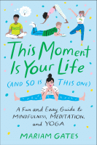

This Moment Is Your Life (And So Is This One) : A Fun and Easy Guide to Mindfulness, Meditation, and Yoga by Mariam Gates

Clever/ MackinVia

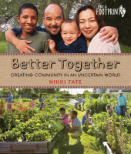

Better Together : Creating Community In an Uncertain World by Tate, Nikki

Clever/ MackinVia

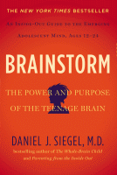

Brainstorm : The Power and Purpose Of the Teenage Brain by Siegel, Daniel J.

Clever/ MackinVia

