UDLS Parent and Family Engagement Plan 2025-2026

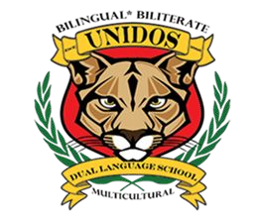

Unidos Dual Language School 4475 Hendrix Dr.
Forest Park, GA
Phone: 678-827-7947
Principal: Ms. Emma Brandy
Email: emma.brandy@clayton.k12.ga.us
Assistant Principal: Mr. Samuel Garcia Email: Samuel.garcia@clayton.k12.ga.us
What is Title I?

Unidos Dual Language School is identified as a Title I school as part of the Every Student Succeeds Act (ESSA) of 2015. Title I is designed to support state and local school reform efforts tied to challenging academic standards to improve teaching and learning for students. Title I programs include strategies to support parental involvement. All Title I schools must jointly develop a written Parent and Family Engagement Plan.

Revised October 29, 2025
What is it?
This is a plan that describes how Unidos Dual Language School will provide opportunities to improve parent engagement to support student learning. Unidos Dual Language School values parental contributions and involvement to establish an equal partnership for the common goal of improving student achievement. This plan describes the different ways Unidos Dual Language School will support parent and family engagement and how parents can help plan and participate in activities and events to promote student learning at school and at home.
How is it revised?
Unidos Dual Language School invites all parents to attend meetings to review and revise this parental involvement policy, as well as the school-wide plan, our school-parent compact, and the parental involvement budget. Parent input and comments regarding this plan are welcome throughout the school year through an online form. The plan is posted on our school website for parents to view and submit feedback. We also distribute an annual survey online (and paper-pencil) asking parents for suggestions on the school-wide plan and the use of funds for parental involvement. Parents can provide feedback during several meetings and activities held throughout the school year.

Who is it for?
All students participating in the Title I, Part A program and their families are encouraged and invited to fully participate in the opportunities described in this plan. Unidos Dual Language School will provide ample opportunities for participation, including for parents of English Language Learners, students with disabilities, migrant students, etc.

Where is it available?
We will send the plan to all parents and post it on the school website. Parents can also retrieve a copy of the plan in the Parent and Family Resource Center and the Virtual Parent and Family Resource Center.

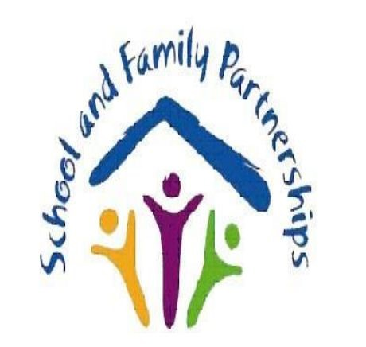
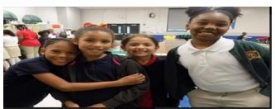
District Goals
The Board of Education sets goals for the entire district. The district goals for 2025-2026 are: The percentage of students scoring at Developing Learner or above on the Georgia Milestones (GMAS) English Language Arts End of Grade Assessment will increase by eight percentage points. The percentage of students scoring at Developing Learner or above on the GMAS Mathematics End of Grade Assessment will increase by eight percentage points.
School Goals
- KK-5th Grade: Increase
attendance by 3% to at least 98% by May 2026.
- KK-2nd Grade: Improve the percentage of students performing at or above grade level on the MAP Growth and Amira Assessments.
- 3rd-5th Grade: Increase the percentage of students performing at the proficient or distinguished level on the
Georgia Milestones by at least 8% (from 48% in 2025 to 56% in 2026) in ELA and Math.
School-Parent Compact
As part of this plan, Unidos Dual Language School and our families will develop a school-parent compact. The compact is an agreement that outlines how parents, teachers, and students will work together to ensure all students reach grade-level standards. These compacts are reviewed and updated annually based on feedback from parents, students, and teachers during meetings.

Let’s Get Together!
At Unidos Dual Language School, we have scheduled several events to build the capacity for strong parental involvement to support a partnership among the school, parents, and the community. Events include:

Open House - August 2025
Curriculum Night - September 2025
Annual Title I Meeting - October 2025
Academic Workshops – throughout the year
Parent Workshops – throughout the year
School Council Meetings - 2 per semester
Hispanic Heritage Celebration - October 2025
Principal’s Lunch and Learn - November 2025
Thanksgiving Luncheon - November 2025
Data Dinner Date – January 2026
Technology Workshops – Spring 2026
Black History Month Celebration - February
2026
Read Across America - March 2026
Spring Festival- April 2026
Parent Academy/Volunteer Celebration - April
2026
End of The Year Awards - May 2026

Parent & Family Resource Center
Come visit the Parent Resource Center, located in Modular #64. It offers books, study materials, and activities to use at home with your child. Computers are also available for parents. Open: Monday to Friday 7:30 AM - 2:30 PM by appointment only. Unidos Dual Language School is committed to helping our parents attend the parental activities listed in this plan. Please call or email us if you need assistance in order to participate in our programs. Contact Oscar Licon via the Front Office, in Modular 64, or at oscar.licon@clayton.k12.ga.us.
Parental and Family Engagement
Unidos Dual Language School believes that parental involvement means the participation of parents in meaningful two-way communication. This includes:
- Parents assisting their child’s learning.
- Parents being actively involved in their child’s education.
- Parents becoming full partners in decision-making and advisory committees.

Unidos Dual Language School is Branching Out!

Unidos Dual Language School will promote and support parents as a foundation of the school. We will:

- Ensure that all information related to school programs, meetings, and activities is published in both English and Spanish.
- Provide monthly trainings for staff on strategies to improve communication with parents and increase family engagement.
- Partner with parents and the community for a “Career Day” to help students plan for college.
- Offer parent workshops in English and Spanish to help parents support their children’s learning.
- Communicate regularly regarding school events via phone calls, ClassDojo, social media, face-to-face, take-home folders, and monthly calendars.
- Provide necessary materials and technological assistance for parents to help improve their child’s academic achievement.
- Use our Partners in Education and School-Community Team to raise awareness of school events.
- Offer monthly Infinite Campus/ClassDojo workshops for parents to remain connected.
- Collect feedback from parents through events, surveys, and communications.

