Communication of Student Learning:
Unidos Dual Language School is committed to frequent two-way communication with families about student learning. Some of the ways you can expect us to reach you are through
- Class Dojo, Canvas/infinite Campus
- Weekly Homework Folder
- Updates on School Website
- Parent Teacher Conferences
- Phone calls
- E -mails
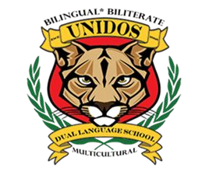
A School-Parent Compact for Achievement is a written agreement (plan of action) that is jointly developed to help students achieve in school. It explains how parents and teachers will work together to ensure all of our students succeed standards.
Unidos
Dual Language
School
School-Parent Compact
for
Achievement
2025-2026
Revised 10/29/2025
Collaboratively Working Together
- Describe how teacher helps students develop those skills using high-quality instruction,
- Share strategies parents can use at home,
- Explain how teacher and parents will communicate about student’s progress,
Jointly Development
- Describe opportunities for parents to volunteers, observe, and participate in the classroom.
Principal: Emma Brandy
Asst. Principal: Samuel Garcia
Parent Liaison: Oscar Licon
678-827-7947
What is a School-Parent Compact?
The parents, students, and staff at
Unidos collaborated to create this
School-Parent Compact for Achievement. Teachers suggested home learning strategies, parents provided specific ideas, and students shared what helps them learn. Annual meetings in the spring and fall review and update the compact based on student needs. Parents are welcome to submit comments at any time.

Activities for Partnership
Unidos offers numerous opportunities for parents to get involved and actively contribute to their child's education. We warmly invite you to join us at some of the upcoming events!
“We are Unidos. . . Where
excellence is the ONLY
standard.”
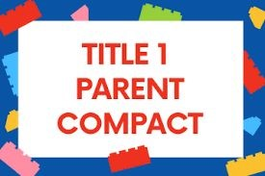

District Goals

District Goals
The Board of Education sets goals for the entire district. The district goals for 2025-2026 are:
The percentage of students scoring at Developing Learner or above on the Georgia Milestones (GMAS) English Language Arts End of Grade Assessment will increase by five percentage points. The percentage of students scoring at Developing Learner or above on the GMAS Mathematics End of Grade Assessment will increase by five percentage points.

Unidos Dual Language School Goals
By May 2026, Unidos DLS aims to achieve the following goals:
- KK-5th Grade: Increase attendance to at least 98%.
- KK-2nd Grade: Improve the percentage of students performing at or above grade level on the MAP Growth and Amira Assessments.
- 3rd-5th Grade: Increase the percentage of students performing at the proficient or distinguished level on the Georgia Milestones by at least 8% in ELA and Math to 56% in May 2026.
As a Dual Language School, we offer:
As a bilingual school, we offer parents and students the opportunity to learn and grow in both English and Spanish, helping students achieve academic success while fostering cultural understanding."
As students, we will:
Teachers, Parents, Students - Together for Success
As a school, we will work with students and their families to support success in Language Arts and Math by:
- Providing syllabus/curriculum information.
- Sharing weekly instructional videos on multiple platforms.
- Assigning homework to be completed at home.
- Sending home books and materials for reading and practice.
- Providing links to instructional websites.
- Maintaining open communication
through Class Dojo, emails, phone calls, and Infinite Campus.
- Offering parents monthly opportunities to engage with the principal (Principal’s Coffees and School Council).
- Attend school every day.
- Complete and submit assignments as requested. ●
- Ask for help when needed.
- Behave properly by
following rules and adult instructions; be kind to others.
- Share with my parents daily what I have learned.

As a Family we will,
Support students' success in Language Arts and Math by:
- Reading with children for at least 30 minutes a day.
- Assisting children with homework.
- Helping children practice math and reading skills they are learning in class.
- Encouraging children to practice their writing.
- Watching the instructional videos shared by the teacher.
- Attending parent conferences and school events for parents.

