iStation For Home Use
Instructions Through Chrome

- Open up Chrome

- Go to: https://chrome.google.com/webstore

- Type in “istation” on the Search screen

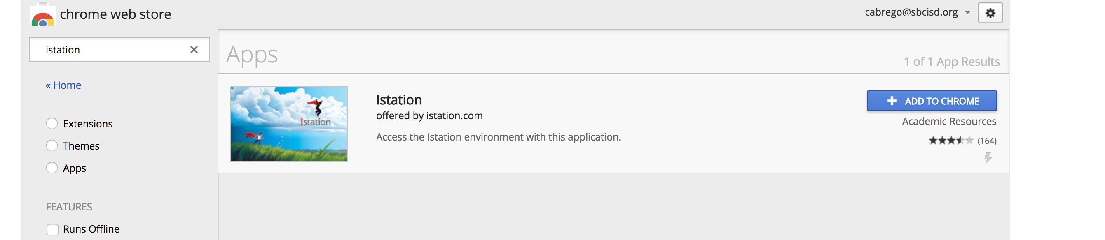
- Click “Add to Chrome”
  - Click “Add App”

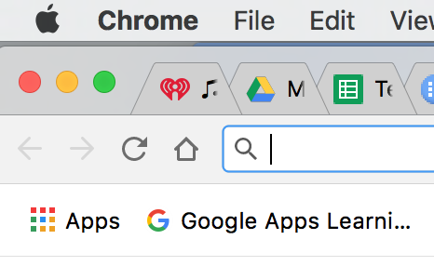
- To see this app again, while on Chrome, open up a “new tab” and click on the colorful “Apps” button. You should see all the Apps you have in addition to iStation.

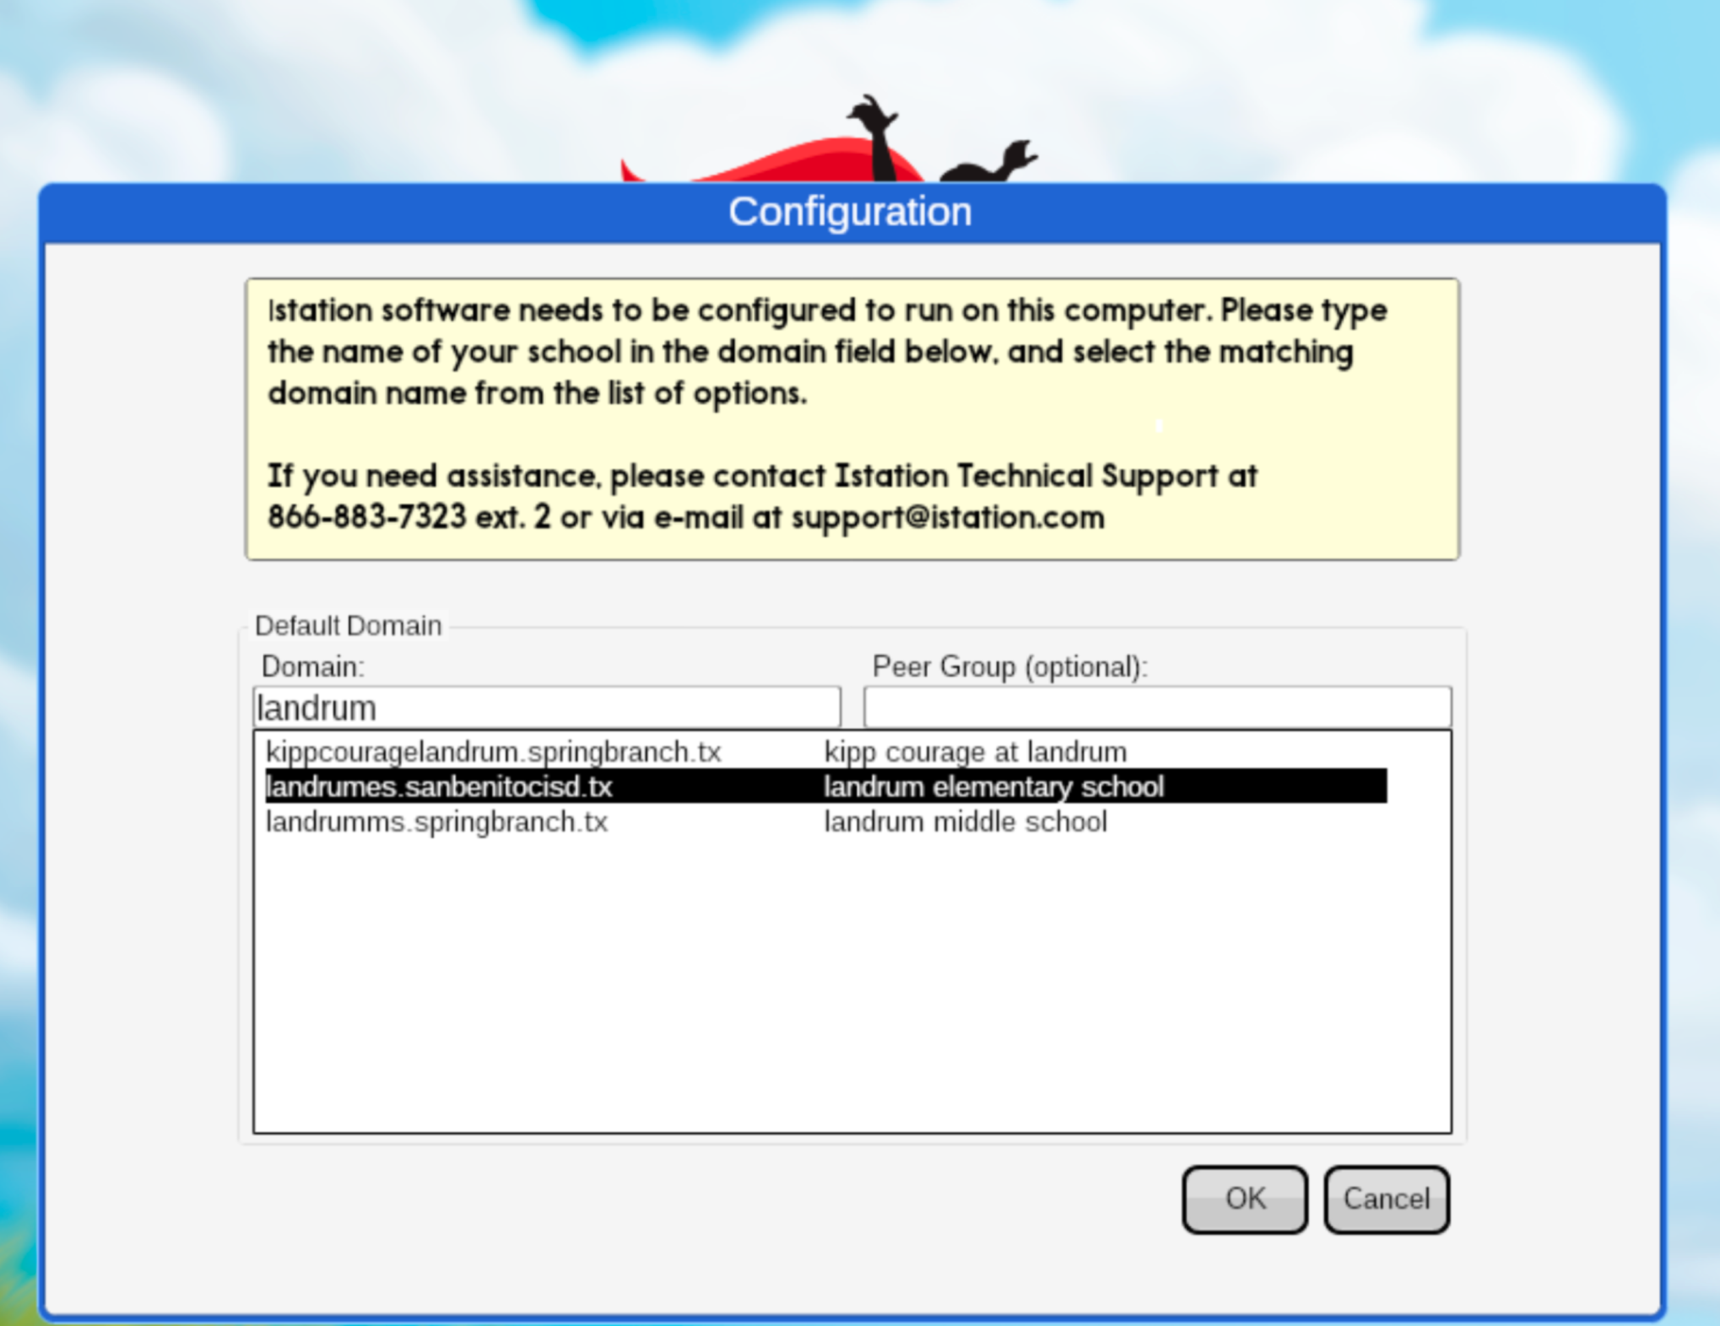

- Click on iStation app
- The first time, it will ask you to connect the app to a school.

- Type the name of the school that your child goes to and click “ok”

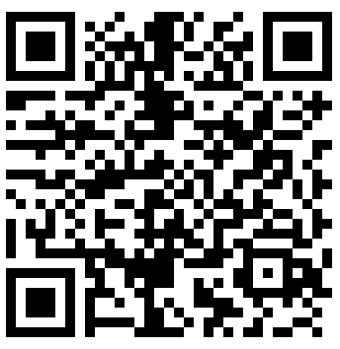

For a Video Link of the instructions above, click HERE

Video of this information.
iStation For Home Use
Instructions Through iStation

- Visit www.istation.com

- Click on “Services and Support”

- Scroll Down.
  - Depending on the device you have, you will follow the instructions provided.

For a Video Link of the instructions above, click HERE.

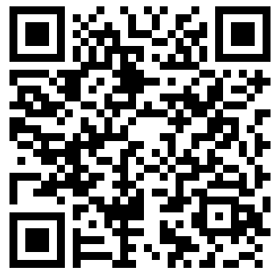
English Instructions for Windows click HERE.
Spanish Instructions for Windows click HERE.

English instructions for Mac click HERE.
Spanish Instructions for Mac click HERE.

Video of this information.

