School Improvement Plan
Meece Middle School
2025

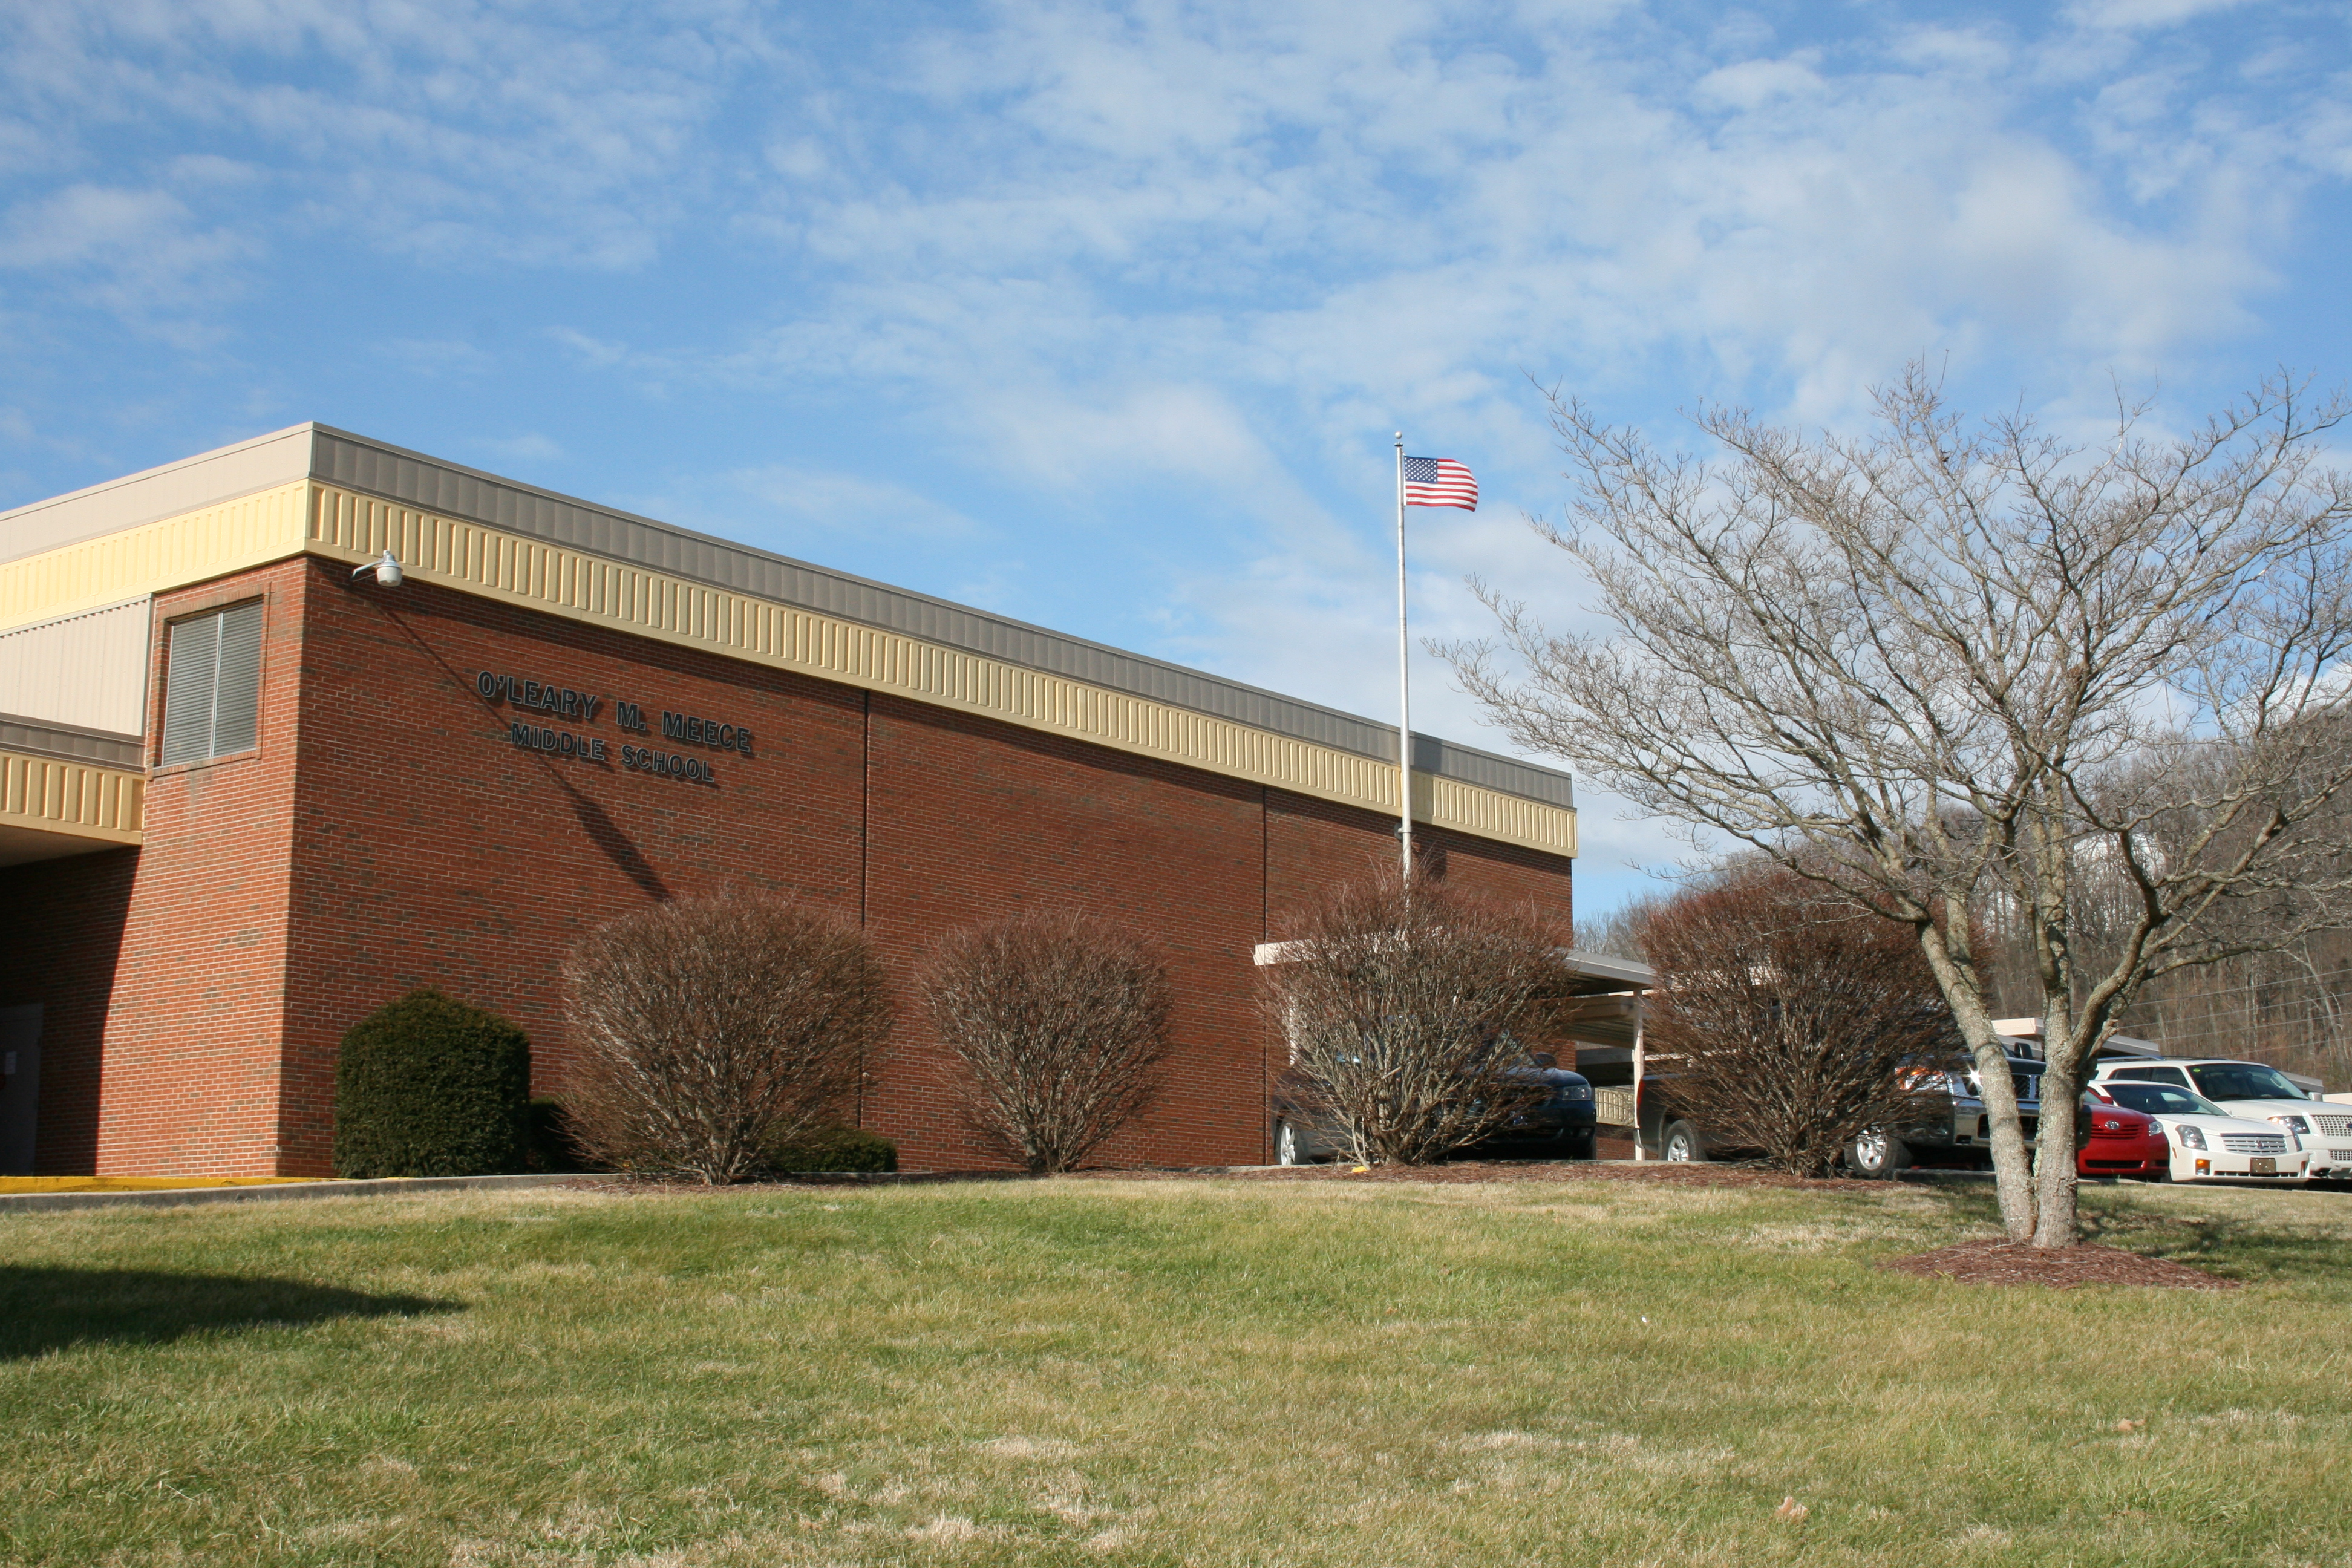

Rationale
​School improvement efforts are a collaborative process involving multiple stakeholders. Through the improvement planning process, leaders focus on priority needs, funding, and closing achievement gaps among identified subgroups of students. When implemented with fidelity, the Comprehensive School Improvement Plan (CSIP) cultivates an environment that promotes student growth and achievement.
While the focus of continuous improvement is student performance, the work must be guided by the aspects of teaching and learning that affect performance. An effective improvement process should address the contributing factors creating the learning environment (inputs) and the performance data (outcomes). Through the Needs Assessment for Schools, priorities were identified and processes, practices, and/or conditions were chosen for focus. This goal building template will assist your improvement team to address those priorities and outline your targets and the activities intended to produce the desired changes. Progress monitoring details will ensure that your plan is being reviewed regularly to determine the success of each strategy.
Please note that the objectives (short-term targets) set by your school under the Achievement Gap section of this planning template will be used by the district’s superintendent to determine whether or not your school met its targets to reduce the gap in student achievement for any student group for two consecutive years as required by KRS 158.649. Likewise, operational definitions for each required planning component can be found on page 2 of the planning template.

Requirements for Building an Improvement Plan
- The required goals for elementary/middle schools include the following:
  - State Assessment Results in reading and mathematics
  - State Assessment Results in science, social studies, and writing
  - Achievement Gap
  - English Learner Progress
  - Quality of School Climate and Safety

Alignment to Needs:
Results of the Phase Two needs assessment process should inform the development of the comprehensive school improvement plan. List the identified priorities below to be addressed in order to build staff capacity and increase student achievement.
Priorities/Concerns from Needs Assessment for Schools
List two or three of the greatest areas of weakness identified in question #5 of the Needs Assessment for Schools that will be thoroughly addressed in the strategies and activities outlined in this template.
At Meece Middle school our greatest focus area continues to be developing our students into leaders within our building and the community. Over the past few years students have faced many struggles both academically and emotionally, therefore it is hard to overlook the social and emotional needs of the students we work with every day. As a team at Meece we continue to work to help students face these emotional and social problems they encounter as well as help the students overcome other academic barriers which may hinder them achieving at their highest level.
Behavior trends continue to be a focus at our school. At the current time we are seeing similar behaviors trends this school year to years past. Last year at this time we had 130 office referrals and this year we have seen an increase in those and are setting at 214. We did see a downward trend last school year in referrals, but that number has started to increase again this school year.
Another priority is the student sub-group of students with disabilities (IEP). Even though we have moved out of the TSI label this is still a sub-group that we will continue to focus on and working closing the achievement gap between these students and their peers. At the current time we only have 15% of these students scoring in the proficient and distinguished range with 58% of those students scoring in the Novice range in the area of reading and in math we have 17% of these students scoring in the proficient and distinguished range with 53% scoring in the novice range.
Processes, Practices, or Conditions to be Addressed from Key Elements Template
List two or three of the processes, practices, or conditions identified on the School Key Elements Template that the school will focus its resources and efforts upon and thoroughly address in the strategies and activities outlined in this template.
All subject areas have been provided with high quality instruction materials and curriculums. RTI classes for Math and ELA have moved to I Ready as their key curriculum and have implemented a rotation to help students better get the instruction needed within these classes. Monthly PLC meetings to discuss high leverage practices teachers are using in classrooms and to monitor student achievement data. Monthly Assessment alignment meetings to check assessments to make sure they are aligned to state standards, are rigorous, and are mirroring the KSA assessment in forms of presentation.
We have classroom assessments for formative, our diagnostic and interim/benchmark would be our MAP assessments which we take in the Fall, Winter, and Spring. Then our summative assessment would be our KSA. Map and Classroom assessments are monitored and discussed during PLC meetings and our KSA data is analyzed during our district day and at a district level.
All students get Tier 1 instruction, we have 40 minutes of RTI time scheduled into each grade level in which students get Tier 2 instruction. Principal, assistant principal, and curriculum coach along with department heads monitor data to determine students who need these programs. We also have Tier 2 ELA and Math tutoring which is on Tuesdays and Thursdays after school.

Indicator Scores
List the overall scores of status and change for each indicator.
Indicator | Status | Change
State Assessment Results in reading and mathematics | 61.5 | -6.8
State Assessment Results in science, social studies, and writing | 57.4 | -6.7
English Learner Progress | NA | NA
Quality of School Climate and Safety | 71.1 | 0.5
Postsecondary Readiness (high schools and districts only) | NA | NA
Graduation Rate (high schools and districts only) | NA | NA

1: State Assessment Results in Reading and Math

Goal 1: By 2027, our school will increase the indicator score for reading to 60 and the indicator score for math to 55.
Objective | Strategy | Activities to Deploy Strategy | Measure of Success | Progress Monitoring Date & Notes | Funding
Objective 1:  By 2025, increase percentage of students scoring proficient and distinguished to 51% in reading and 46% in math. | Curriculum  KCWP 1: Design and Deploy Standards  KCWP 2: Design and Deliver Instruction | Continue the implementation of school-wide use of supplemental resources in-school and during after school tutoring to help close the learning gap in reading and math. | Increased KSA Scores |  | 12,000  ESS  Title V
 |  | Schedule to have teachers within the building to visit other school within the district and outside the district. | Increased Curriculum Alignment |  | 0
 |  | Conduct frequent walk-throughs and provide teachers with feedback so each may make informed instructional decisions. | Increased KSA Scores |  | 1,000  Title V
 |  | Ensure the daily content learning target in each class is communicated and understood by all students. (I can statement is written down daily in agenda books and goal setting discussions during the school year) | Increased KSA Scores |  | 0
 |  | Continue classroom activities and lessons based on student engagement strategies (i.e Thoughtful Education/KAGAN, Google classroom, computer based, hands-on, and/or small groups, instead of lecturing). | Increased KSA Scores |  | 0
 |  | Use new resources for math and ELA, (Reveal Math, Study Sync writing companion, Aleks, and simple solutions) | Increased KSA Scores |  | ESSER Textbook
 |  | Offer literacy night for students and their families (during Book Fair Week). |  |  | Gear Up
 |  | Meet in Professional Learning Communities and/or grade levels at least monthly or as needed to discuss students learning activities and analyze data to drive/change instruction to best meet student needs. | Increased KSA Scores |  | 0
 |  | I Ready to be used in RTI classrooms | Increase KSA Scores |  | ESSER Textbook
 | Assessment  KCWP 3: Design and Deliver Assessment Literacy  KCWP 4: Review, Analyze and Apply Data | Assess and analyze student data three to four times yearly with the universal screener and formative assessments (MAP, STAR Reading and monthly proficiency assessments). | Increased KSA Scores |  | Title V
 |  | Continue to assess and monitor student performance using Proficiency Measures and other classroom instruments giving teachers information to plan/revise instruction based on student needs. (Turn in assessments for standards congruency checks as needed). | Increased KSA Scores |  | 0
 |  | Monitor curriculum maps using checklist to ensure required components are present and teacher have a road map to guide to finish line. | Increase KSA Scores |  | 0
 |  | Implement technology for collection of student data in Proficiency Measures and other formative assessments (Aleks, Google classroom, Go Guardian, computer lab, etc). | Increased KSA Scores |  | 1,000  Title V  KETS
 |  | Provide student opportunities to communicate their knowledge through writing. (Extended response, short answer for reading and math, and other meaningful writing pieces throughout the year in all classes.) | Increased KSA Scores |  | 0
 |  | Monthly Assessment Alignment Meeting to ensure rigor of assessment and make sure they mirror KSA | Increase KSA Scores |  | 0
 |  | Include language mechanics items on English Language Arts Proficiency Measures and other classroom assessments. | Increased KSA Scores |  | 0
 | Professional Development  KCWP 5: Design, Align and Deliver Support  KCWP 6: Establishing Learning Culture and Environment | Provide on-going technology professional development for staff. | Increased technology skills |  | 1,000  PD
 |  | Provide on-going professional development for middle school best practices (Thoughtful Education, student engagement, differentiation classroom management, curriculum alignment, novice reduction strategies). | Increased student involvement in class |  | 1,000  PD  Title II

2: State Assessment Results in Science, Social Studies and Writing

Goal 2: By 2027, our school will increase content index scores- social studies score to 45; Science to 52 and writing to 57 .
Objective | Strategy | Activities to Deploy Strategy | Measure of Success | Progress Monitoring Date & Notes | Funding
Objective 1:  By 2025, increase percentage of students scoring proficient and distinguished to 38 in social studies, 42 in science and 48 in writing. | Curriculum  KCWP 1: Design and Deploy Standards  KCWP 2: Design and Deliver Instruction | Continue the implementation of school-wide use of supplemental resources in-school to help close the learning gap in social studies and science. | Increased KSA Scores |  | 12,000  ESS  Title V
 |  | Schedule to have teachers within the building to visit other school within the district and outside the district. | Increased Curriculum Alignment |  | 0
 |  | Conduct frequent walk-throughs and provide teachers with feedback so each may make informed instructional decisions. | Increased KSA Scores |  | 1,000  Title V
 |  | Ensure the daily content learning target in each class is communicated and understood by all students (I can statement is written down daily in the online agenda book goal setting discussions during the school year) | Increased KSA Scores |  | 0
 |  | Continue classroom activities and lessons based on student engagement strategies, for example Thoughtful Education/KAGAN, research based high yield instruction strategies, Google classroom, hands-on, and/or small groups, instead of lecturing. | Increased KSA Scores |  | 0
 |  | Have a STEM (Science, Technology, Engineering and Math) night for students and families. | Increased KSA Scores |  | Gear-Up
 |  | Meet in Professional Learning Communities and/or grade levels at least monthly or as needed to discuss students learning activities and analyze data to drive/change instruction to best meet student needs. | Increased KSA Scores |  | 0
 | Assessment  KCWP 3: Design and Deliver Assessment Literacy  KCWP 4: Review, Analyze and Apply Data | Assess and analyze student data three to four times yearly with the universal screener and formative assessments (MAP and monthly proficiency assessments). | Increased KSA Scores |  | Title V
 |  | Continue to assess and monitor student performance using Proficiency Measures and other classroom instruments giving teachers information to plan/revise instruction based on student needs. (Turn in assessments for standards congruency checks as needed). | Increased KSA Scores |  | 0
 |  | Monthly Assessment Alignment Meeting to ensure rigor of assessment and make sure they mirror KSA | Increased KSA Scores |  | 0
 |  | Implement technology for collection of student data in Proficiency Measures and other formative assessments (Google classrooms, Go Guardian, computer lab, etc.). | Increased KSA Scores |  | 1,000  Title V  KETS
 |  | Provide student opportunities to communicate their knowledge through writing. (Extended response, short answer for science, social studies and other meaningful writing pieces throughout the year in all classes.) | Increased KSA Scores |  | 0
 |  | Provide students with the opportunity to practice on-demand writing pieces (including stand alone and passage-based prompts) in English Language Arts classes. | Increased KSA Scores |  | 0
 | Professional Development  KCWP 5: Design, Align and Deliver Support  KCWP 6: Establishing Learning Culture and Environment | Provide on-going technology professional development for staff. | Increased technology skills |  | 1,000  PD
 |  | Utilize Digital Learning Coach within the building to help with technology needs | Increase technology skills |  | 0
 |  | Provide on-going professional development for middle school best practices (Thoughtful Education, student engagement, differentiation classroom management, curriculum alignment, novice reduction strategies). | Increased student involvement in class |  | 1,000  PD  Title II

3: Achievement Gap

Goal 3: By 2027, reduce the achievement Gap in reading and math proficiency rates for students with disabilities (IEP) compared to all students.
Objective | Strategy | Activities to Deploy Strategy | Measure of Success | Progress Monitoring Date & Notes | Funding
Objective 1:  By 2025 reduce the percentage of students from the subgroup “students with Disabilities (IEP)” scoring Novice to 52% in reading and 48% in math. | Student Support  KCWP 5: Design, Align and Deliver Support | Using data from various formative assessments, teachers will identify and implement differentiated instructional strategies with students who are not achieving proficiency. | Increased KSA scores |  | 0
 | Student Support  KCWP 5: Design, Align and Deliver Support | Utilize our PLC protocol to analyze student performance and to share high yield instruction strategies and monitor feedback to help reduce any learning gaps identified. | Increased KSA scores |  | 0
 | Student Support  KCWP 5: Design, Align and Deliver Support | Monthly Special Education PLC’s with special education director to discuss strategies to help student performance and novice reduction | Decreased Novice in Special Education |  | 0
 | Student Support  KCWP 5: Design, Align and Deliver Support | Continue to implement interventions for all grade levels to focus on math and/or reading skills for students that are not proficient (reduce novice) and to reduce any learning gaps identified. | Decreased Novice in Special Education |  | 1,000  Section 6  ESS
 | Student Support  KCWP 5: Design, Align and Deliver Support | Restructure PLC teams so that Special education teachers will start meeting with content area teachers during PLC (Professional Learning Communities) on a monthly basis to share instructional strategies/ activities with other teachers. | Decreased Novice in Special Education |  | 0
 | Student Support  KCWP 5: Design, Align and Deliver Support | Train all teachers on High Leverage Practices in Special Education. | Decreased Novice in Special Education |  | 0

4: English Language Learners

Goal 4: By 2027, increase the English Language scores of identified EL students.
Objective | Strategy | Activities to Deploy Strategy | Measure of Success | Progress Monitoring Date & Notes | Funding
Objective 1:  By 2025 increase the score of students on the ACCESS test. | KCWP 5: Design, Align and Deliver Support | Utilizing our Migrant staff to implement interventions and strategies to focus on improving the student’s reading comprehension and skills. | Best practice strategies implemented in class |  | Migrant (with PC)
 | KCWP 5: Design, Align and Deliver Support | Train teachers in best practice strategies to increase academic performance in all ESL students. | Best practice strategies implemented in class |  | 0
 | KCWP 5: Design, Align and Deliver Support | Utilize our PLC protocol to analyze student performance and to share high yield strategies and monitor feedback to help reduce any learning gaps identified. | Increased use of best practices observed in classes |  | 0
 | KCWP 5: Design, Align and Deliver Support | Provide ESL staff for small group instruction of English. | Increased ACCESS scores. |  | Title IV  ESSER

5: Quality of School Climate and Safety

Goal 6: Provide a safe and enriching environment for student learning.

Objective | Strategy | Activities to Deploy Strategy | Measure of Success | Progress Monitoring Date & Notes | Funding
Objective 1:  Provide a safe and enriching environment for student learning by reducing barriers to learning. | Student Support  KCWP 5: Design, Align and Deliver Support  KCWP 6: Establishing Learning Culture and Environment | Continue developing the mentoring program for students identified as being at-risk and those who have barriers to effective learning. | Increased KSA scores |  | 0
 |  | Continue to implement a school-wide incentive program that rewards students who maintain or increase academic achievement, attendance and/or good behavior. (Positive office referrals, no referrals rewards, leadership groups) | Increased Achievement  Increased Attendance |  | 500  SBDM
 |  | Continue monthly character salute program to recognize students and staff members for the character attribute of the month. | Increased Positive Behavior |  | 175  SBDM
 |  | Continue to focus staff and students on MMS expectation to provide a safe/engaging classroom and school environment. | Increased Positive Behavior |  | 0
 |  | Continue to provide expected teacher supervision of students during non-instructional time-periods: to and from exploratory classes, to and from lunch, between classes, recess or outside breaks, morning duty and evening student release. | Increased Positive Behavior |  | 0
 |  | Provide monthly guidance lessons for each grade, focused on respect and other positive character traits. | Increased Positive Behavior |  | 0
 |  | Continue parent/teacher communication and parent involvement in various aspects of school through grade level/classroom and school newsletters, teacher and school webpages, updated grades in Infinite Campus Portal, open house, parent-teacher conferences, and One-Call system. | Increased Involvement |  | 600  District  Section 6
 |  | Support and utilize Family Resource/Youth Service Center resources. | Increased Involvement |  | FRYSC
 |  | Monitor to ensure effective learning is occurring throughout the school. | Maintain a safe and effective learning environment for all students. |  | 0

