
BOARD AGENDA
TAB 3 – INFORMATION
APRIL 17, 2019

BALTIMORE CITY COMMUNITY COLLEGE
BOARD OF TRUSTEES

APPROVED OPEN SESSION MINUTES
April 17, 2019
4 p.m.
Liberty Campus
Board of Trustees
Board Room
Administration Building 140

Board Members Present: Kurt L. Schmoke, Esq. (Chair); Mr. Peter Nachtwey(via conference call) Dr. Rachel Pfeifer; Mr. Jason Perkins-Cohen; Mr. J.C. Weiss, III ; Maria Tildon, Esq.; Ms. Maricruz Abarca (Student Trustee).

Board Members Absent:
Dr. Rosemary Gillett-Karam (Vice Chair)
Mr. John D. Lewis

Chair Schmoke brought the meeting to order.

I. APPROVAL OF THE AGENDA

The Board unanimously approved the April 17, 2019 agenda with corrections to the March 20, 2019 agenda.

II. NEW BUSINESS

Professor Emeritus (Dr. Tonja Ringgold)

Dr. Ringgold presented, for Board approval, the recommendation for Professor Linda Benjamin as Professor Emeritus for 2019. Dr. Ringgold presented the criteria for nomination which includes;

Recommendations of four faculty or professional administrative staff including tow from nominee's department documenting excellence in teaching and outstanding college or community service.

Ten or more years of service to BCCC

Retirement from BCCC

The nomination of the candidate within three years of their retirement

Professor Benjamin was recommended by four faculty administrators from her department and seven from other departments. Professor Benjamin has served BCCC for eighteen years and retired in June 2018.

The Vice President of Academic Affairs endorsed the recommendation and forwarded the recommendation to the President for his review and recommendation to the Board.

If Board approved, privileges for Professor Benjamin as Professor Emeritus would encompass;

A Board Resolution, naming and honoring her as Professor Emeritus

Professor Emeriti will be listed in the College Catalog under that designation

Permanent library privileges and admissions pass to all BCCC athletic events

Lifetime membership in the Faculty Senate

Full participation in College commencements and convocations

A lapel pin that signifies the status of Emeritus.

The Board inquired if Professor Benjamin would have voting privileges in the Faculty Senate. Dr. Ringgold replied that she would not have voting privileges but could attend meetings.

The Board stated that they were very impressed by the recommendation and letters of and for Professor Benjamin and unanimously approved the recommendation of Professor Emeritus to Professor Linda Benjamin 2019.

A resolution will be presented at the May 15, 2019 meeting for the Board to sign and will be given to Professor Benjamin at the June 1, 2019, Commencement Ceremony.

Digital Marketing Certificate Proposal

Dr. Ringgold introduced a proposal for the Digital Marketing Certificate which is a stackable program to the existing Business Marketing AAS degree. Dr. Ringgold reported that this certificate is created in partnership with Facebook/Path stream and the rational as central to jobs of the future that are in short supply. Eighty percent of middle-skills jobs require digital skills.

Dr. Ringgold presented, via a PowerPoint presentation of, the sequences for a digital marketing certificate for the Boards review for approval at the May 15, 2019 Board of Trustees Meeting.

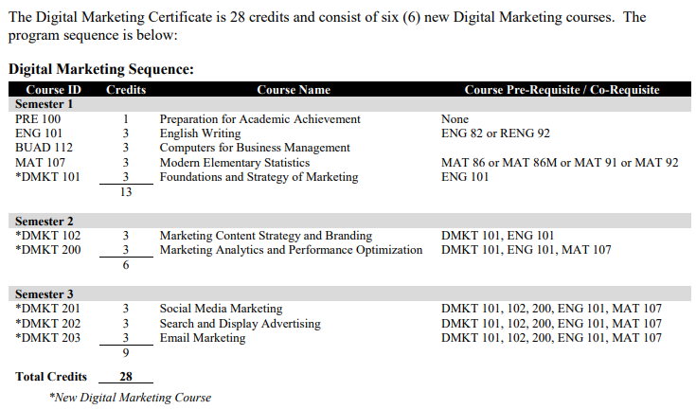

Dr. Ringgold stated that digital skills are central to good jobs of the future, yet they are desperately in short supply. The below denotes potential earnings of an individual who completes this program.

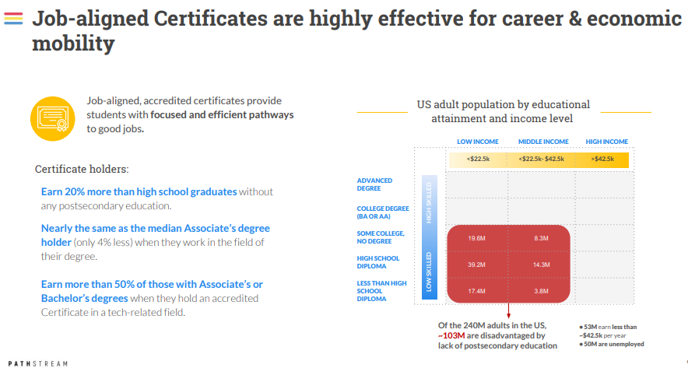

Dr. Ringgold stated Facebook has launched a national community partnership network and selected twenty colleges to work with and BCCC is one of the selected colleges. Facebook wants to promote digital marketing skills and have pledged to train 1 million people on the digital skills needed to compete in today's workplace.

.

The Board inquired if we promoted this into our marketing plan.

Dr. Ringgold responded no that she would go into more depth when she resubmits this program as an action item at the May 15, 2019 Board of Trustees meeting.

The Board inquired if this program offered any internship opportunities and if so, who would recruit employers. The Board also inquired if Facebook would be providing instruction.

Dr. Ringgold responded that these internship opportunities are built into the program and that Facebook would recruit employers and assist with the marketing. Dr. Ringgold also stated that BCCC faculty would provide the instructions for this program.

The Board inquired if research had been completed to ascertain student’s interest in this program to ensure that the program would be available.

Dr. Ringgold responded that this is an on-line program that Facebook will assist in the marketing of and that students could enroll in this program from around the world.

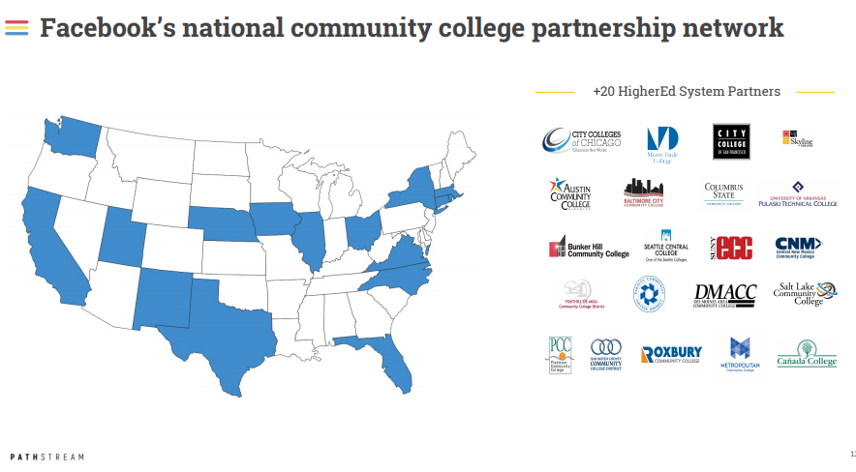

III. BOARD ACTIONS / CONSENT AGENDA (All actions requiring a vote)

Approval of the March 20, 2019 Minutes – Corrections Requested

College Contracts

Student Government Association (Mr. Victor Anokwuru (SGA)..…TAB 5

AFSCME Local # 1870 at BCCC ( Ms. Charlene Gray, President)…TAB 6

Faculty Senate Report…… (Dr. Chima Ugah)…..………………….…TAB 7

The Board unanimously approved the consent agenda with corrections to the March 20, 2019 Minutes regarding Board Member attendance and next meeting date.

IV. ITEMS REMOVED FROM THE AGENDA

College Contracts were removed from the agenda.

V. PUBLIC PRESENTATIONS
- Tuition Adjustment (VP Calvin Harris, Jr.)

VP Harris recommended the elimination of the "flat" tuition option, whereby credit students taking more than 12 hours per semester pay the same tuition amount as a student taking 12 hours for the fiscal year 2020, beginning with the fall 2019 semester.

VP Harris referred back to his presentation to the Board on March 20, 2019, regarding the recommendation of the Finance and Technology Committee to eliminate the flat fee tuition which would increase the tuition for students taking more than 12 credit hours.
The Board approved the recommendation with the request to have a discussion with student leadership regarding this recommendation.

The Board inquired if this matter had been discussed with students and what was heard from the students. The Board also inquired if the percentage of students that were taking 15+ credits was known.

VP Harris responded that the conversation yielded the student's concerns about the cost this increase would bring. VP Harris responded that he did not know the percentage but would find out and report at the next meeting.

Dr. Johnson responded that conversations were had with student leadership and it was found that this recommendation would indeed increase the cost of tuition to students taking more than 12 credit hours.

VP Harris requested that the Board rescind its approval of the recommendation of the March 20, 2019 approval.

The Board inquired if Dr. McCurdy was made aware of this matter.

Dr. Johnson responded that he has spoken with Dr. McCurdy and she is aware of this recommendation to rescind the flat tuition.

The Board suggested that an asterisk be placed against this topic in the March 20, 2019 minutes to reflect that the motion to approve was rescinded in the April 17, 2019 Board Meeting. All Board members agreed that this should be reflected in the minutes.

The Board unanimously agreed to rescind the March 20, 2019 approval of the elimination of the flat fee option and reinstate the following tuition fee structure.

- Reinstatement of the “flat” tuition option, whereby credit students taking more than 12 hours per semester pay the same tuition amount as a student taking 12 hours.

- Mayors Scholars Program

Dr. Debora Johnson-Ross reported updates of the Mayor’s Scholars Program.

Dr. Johnson-Ross reported that she has been visiting everyone on campus to ensure that she has a good understanding of the functional areas and to get an understanding of how these areas fit into MSP.

She stated that she discovered that the coaches, advisors, and others outside of the MSP program did not have a cohesive vision for what the goals of the program were. She has implemented a weekly professional development meeting for her staff that addresses best practices, study skills, and ensuring that all MSP staff are on the same page and have a clear understanding of what the MSP goals are. This will ensure success for the program and students.

Dr. Johnson-Ross reported that the Middendorf Foundation had awarded a $25,000 grant for textbooks.

Dr. Johnson-Ross’s presented a PowerPoint presentation that denoted data of the 2019 Spring semester as well as plans for the 2019 fall semester.

Goal
  - Retain as many students as possible from Spring 2019 to Summer 2019/Fall2019
Scope
  - Develop & implement enhancements
    - Student support model
    - Faculty partnership
    - Use of data
  - Assist Students with Summer 2019 plans
  - “Close out” the semester

Workforce:
- First MSP Workforce Completers on 3/15
  - 2 in Construction Apprenticeship – both are now working
  - Three scheduled to complete A+ Cybersecurity certification on April 25;
and they will continue to Network (pt 2) and Security (pt 3) certification
    - Example of stackable credentials
- Registration permitted through June 4 for current MSP participants that would like to move to the workforce.

251 MSP Students registered
  - For credit: 230
  - Non-Credit: 21

Dr. Johnson-Ross reported on the current semester midterm grades for all MSP students with Ds & Fs and students that are on academic warning. The below charts lets us know the students that are not doing well and require additional attention.
All MSP Students with Midterm Ds & Fs

Number of Ds or Fs | Number of MSP Students
1 | 85
2 | 37
3 | 9
4 | 2

Number of Ds or Fs  Academic Warning MSP Students with Midterm Ds & Fs | Number of Students on Academic Warning
0 | 8
1 | 52
2 | 14
3 | 5
4 | 2
Total | 81
The chart above denote students who were already on academic warning and where they are at the midterm period.

Dr. Johnson-Ross reported that no pattern between chronic absences and midterm grades were found. The numbers are not complete because there is not 100% reporting on absences. Of the courses that are MSP cohort about sixty-three percent of faculty are reporting absences and of non-MSP cohorts, about thirty percent of faculty are reporting attendance.

The Board inquired if attendance reporting was required by faculty.

Dr. Johnson-Ross responded that it is strongly suggested.
Dr. Johnson responded that all MSP classes were required to take attendance. Classes that have MSP students are required; however, classes that have non-MSP students are not required to take attendance.

Dr. Johnson-Ross reported that the Summer Bridge Program could have been improved with an intentional career assessment process. Planning updates for the Summer Bridge program are shown below.

- Orientation sessions will be held in May and early June
  - Purpose – ensure that MSP enrollment requirements are completed before the program start
  - Students will also
    - Be introduced to program requirements and expectations
    - Take BCCC ID photos
    - Create Canvas and e-Learning profiles
    - Attend a Student Services Meet and Greet
    - Parents will attend a parent-only session to create understanding and buy-in
    - A BCCC souvenir will be gifted to each student
- Pre-100 curriculum development is underway
- Math and English boot camp curricula are in development

The Board inquired who was the liaison of the MSP program in the Mayor’s Office. Trustee Jason Perkins-Cohen responded that Mr. Matt Garbett and Ms. Navarro of the Mayor’s office.

- Cultural Diversity Report (Mr. Andre Williams, Director of Judicial Affairs & Title IX, Co-Chair of the Diversity Equity and Inclusion Committee.)

Mr. Williams reported the college had established a Diversity, Equity, and Inclusion Committee to ensure the timely reporting and requirements. This committee has established five strategic goals to assist in efforts to move towards setting a high standard and model for other organizations.

GOAL 1 - Cultivate and sustain a diverse and multicultural student body that is reflective of a global community by recruiting, retaining, and graduating ethnic minority students that are under-represented in higher education.

GOAL 2 - To weave the principles of diversity, equity, and inclusion into all aspects of College life.

GOAL 3 - To identify impediments to creating a diverse and inclusive environment, propose solutions to overcome those impediments, and measure our progress at all levels of the College infrastructure.

GOAL 4 - Increase the recruitment of under-represented and minority faculty at all levels, including leadership positions through diversified hiring strategies.

GOAL 5 - Provide a supportive and nurturing learning environment to prepare students to collaborate with diverse communities locally and globally in a culturally sensitive manner.

Dr. Johnson reported that the Cultural Diversity Report would be presented for Board approval at the May 15, 2019 meeting and will be submitted to the Maryland Higher Education Commission (MHEC) by July 1, 2019, due date. Mr. Williams also added that BCCC would host the Maryland Community College Diversity Roundtable on May 10, 2019, on campus.

The Board inquires who were other members of this committee.

Mr. Williams responded that the committee was comprised of about 30 current members from across the college. The committee will usher the Cultural Diversity agenda forward to ensure the report is submitted promptly.

The Board inquired if the committee is also looking at data based on socioeconomic differences as well as other data, e.g., enrollment, age, gender, nationality, etc.

Mr. Williams responded that the committee would be looking at to collect data in all aspects.

The Board inquired what other population of students will the committee focus on and if so has this been communicated with the students.

Mr. Williams responded that the committee would work with and continue to recruit and work with students from all aspects

The Board added another report of the update of the Realignment Tasks and referred to Mr. Bryan Perry for an update.

Mr. Perry reported that we made it out of the last legislative session without any budget restrictions; however, there are several mandated reports.
- October 1, 2019 – Update of the status of the unfinished realignment tasks items.
- Review of the academic program offerings
- More clarity to the Workforce to academic pathways
- Procurement realignment task

The Board inquired if the SB254 Baltimore City Community College - Procurement Authority was heard.

Mr. Perry responded that the bill did get to a vote; however, it was not passed but will be resubmitted next session based upon the Governor’s recommendation to have all state procurement go through General Services.

VII. PRESIDENT’S REPORT

Dr. Johnson stated that his report would stand as is and if there are no questions, he motioned to move to the enrollment report.

- Enrollment Report (IVP Sylvia Rochester)

IVP Rochester reported an increase of 0.3 percent (12 students) from spring 2018.

The Board inquired if this increase was due to MSP students.
IVP Rochester responded not entirely, as the average age of BCCC students is still at 29 years of age; however, the MSP program has contributed to the overall enrollment.

CLOSING COMMENTS

Dr. Johnson shared his thanks to the Board and BCCC Faculty and Staff and stated that this would be his final Board meeting. Chair Schmoke thanked Dr. Johnson for his flexibility and leadership to the college when needed.

VI. MOTION FOR ADJOURNMENT

Chair Schmoke motioned to adjourn the meeting to reconvene into a closed session at 5:01 p.m.

VII. NEXT MEETING Wednesday, May 15, 2019

ATTENDANCE:
Dr. James H. Johnson, Jr., Interim President
Bryan Perry, Esq., Chief of Staff/General Counsel
Dr. Tonja Ringgold, VP of Academic Affairs
James Knighton, Esq., Director of Governmental Relations
Mr. Calvin Harris, Jr., VP of Business & Finance
Ms. Dawn Kirstaetter, VP of Advancement & Strategic Partnerships
Ms. Lyllis Green, Chief Internal Auditor
Ms. Michelle Williams, Director of Human Resources
Dr. Debora Johnson-Ross, Director of Mayor’s Scholars Program

BCCC Staff Present:

Tope Aje; Ola Akinkuowo; Elena Berrocal; Lorraine Brown; Dr. Pamela Burris; Hsin Yuen Chen; Quintin Davis; Edward Ennels; Charlene Gray; Alisha Green; James Green; Nana Gyesie; Wendy Harris; Eileen Hawkins; Kimberly Henderson; Joe Hutchins; Daniel Izume; Dr. Bob Iweha; Leslie Jackson; Davis Xudong Jin; Gloria Johnson; Alice Kimara; John T. McCoy, III; Valerie Leverette, Karen Mobley; Brian O’Connell; Shaunta Rao; Daviedra Sauldsberry; Scott Saunders; Benita Scott; Dr. Daphne Snowden; Adaria Sogbor; Gregory Tarver;, Dr. Chima Ugah; Eileen Waitsman; Leonard Willis, Brenda Wiley; Diana Zilberman.

Others Present:

CLOSED SESSION

The Board voted unanimously, under the Open Meeting Act, State Government Article, and Section 10-508, to convene in Closed Session on April 17. 2019, in the President’s Conference Room, to discuss real estate, personnel and to obtain legal advice.
*Full report on file in the President’s Office

Respectfully submitted,

James H. Johnson, Jr., Ph.D., P.E.
Executive Consultant

Debra L. McCurdy, PhD
President

Approved by the Board of Trustees, May 15, 2019

