

Aerial Lift Program
Created February 2017 / Reviewed October 2025

District Facilities Department
Environmental Services Group

Environmental Services Group |  |  | Applies to: ☐ ALL  ☐ FP ☒ ESG ☐ NAC ☐ SEM  ☐ FM ☐ Other | Number  001 |  |  | Rev.  1 |  | Page  1 of 1
Title: Aerial Lift Program
Type: ☐ Procedure ☐ SOP ☐ Contract ☐ Form  ☐ Specification ☐ Design ☐ Accounting ☐ Planning ☒ Program ☐ Other |  |  |  |  | Department Owner:  Environmental Services Group
REV |  | DESCRIPTION OF CHANGE |  |  |  | DOC  APPRV. |  | EFF.  DATE
1.0 |  | Written Program |  |  |  | TIS |  | 02/27/2017
2.0 |  | Review |  |  |  | NAB |  | 10/27/2018
3.0 |  | Review |  |  |  | MCS |  | 4/20/2020
4.0 |  | Review |  |  |  | ANM |  | 7/26/2022
5.0 |  | Review |  |  |  | MCS |  | 5/16/2023
6.0 |  | Review |  |  |  | MCS |  | 4/12/2024
7.0 |  | Review |  |  |  | MCS |  | 10/20/25
DISTRICT PROGRAM FOR DEVELOPMENT AND IMPLIMENTATION OF PROCESSES TO BE USED IN SAINT PAUL PUBLIC SCHOOLS OPERATIONS

PURPOSE

Aerial Lift
1910.66-1910.68

The following Aerial Lift is provided as a guide to assist employers and employees of Saint Paul Public Schools in complying with the requirements of OSHA’s Aerial Lift Program Standard, 29 CFR Subpart F 1910.66-1910.68, as well as to provide other helpful information. This program has been developed to reduce the risk of physical injury or property damage in areas where aerial lifts are in operation. It is not intended to supersede the requirements of the standard.

The District Environmental Services Group (ESG) will review the standard annually for particular requirements, which are applicable to the District and adjust this program accordingly.

This written plan is designed to be specific to the needs of users of Saint Paul Public Schools.

This written plan is intended to comply with the OSHA 1910.66-1910.68 standard.

If there are conflicts or discrepancies between this plan and the standard, the standard shall take precedence.

OBJECTIVE

The objective of the Saint Paul School District Aerial Lift Program is to minimize hazards associated with improper use and the District’s concern for the safety of individuals in and around aerial lifts. In addition, this program outlines general, operating, maintenance, inspection and training requirements governing safe aerial lift use at the District. A copy of OSHA’s Aerial Lift Program 29 Standard, CFR F 1910.66- 1910.68 can be obtained from Environmental Services Group. A copy of the standard will also be posted in areas with affected employees.

ASSIGNMENT OF RESPONSIBILITY

Management

Environmental Services Group (ESG)

- Review and update the Aerial Lift Safety Program as necessary.
- Provide orientation and initial training as requested by Saint Paul Public Schools departments and/or contractors.
- Provide the general safety training requirements for program.
- Monitor the effectiveness of program by receipt of copies of inspection checklists.
- Evaluate designated areas for aerial lift use.
- Define appropriate eyewash facilities for battery changing/charging areas.
- Observe the operation of aerial lifts, and report unsafe practices to the appropriate supervisor.

Staff

Employees

- Comply with the Aerial Lift Safety Program
- Complete the Daily Pre-Use Inspection Checklist before operating any aerial lift.
- At least annually review the procedures outlined in the Aerial Lift Safety Program.
- Observe the operation of the aerial lift, and report unsafe practices to your supervisor.

Supervisors

- Coordinate employee training, and certify that all operators receive annual training that includes, but is not limited to, everything covered in this Aerial Lift Safety Program.
- Ensure that only trained and qualified individuals use aerial lifts.
- Verify employee compliance with the principles and practices outlined in the Aerial Lift Safety Program.
- Provide specific operational training for each aerial lift.
- Observe the operation of aerial lifts, and correct unsafe practices.

Shops Utilizing Powered Industrial Trucks

- Must implement and administer the Aerial Lift Safety program.
- Review the Aerial Lift Safety program annually for compliance and effectiveness.
- Verify that all employees who operate or work near aerial lifts are properly trained.
- Maintain written records of operator training on each model of aerial lift and the name of the trainer.
- Maintain written records of all inspections performed by the aerial lift owner, including the date any problems found, the date when fixed, and the name of the person performing the repairs.
- Maintain written records of the name and purchaser of each aerial lift.
- Make recommendations for revisions if necessary.
- Establish expected operating conditions for aerial lift and send to OHS to review prior to operation

PROCEDURES

Pre-Use Inspection
- Any safety defects (such as hydraulic fluid leaks; defective brakes, steering, lights, or horn; and/or missing fire extinguisher, lights, seat belt, or back-up alarm) must be reported for immediate repair. They must also be locked and tagged, and taken out of service.

General Safe Work Practices
- Operators shall not wear any loose clothing or any accessory that can catch in moving parts.
- Before machine is started, the operator must walk completely around the machine to ensure everyone and everything is clear of the machine.
- Articulating boom and extendable boom platforms, primarily designed as personnel carriers, shall have both platform (upper) and lower controls. Upper controls shall be in or beside the platform within easy reach of the operator. Lower controls shall provide for overriding the upper controls. Controls shall be plainly marked as to their function. Lower level controls shall not be operated unless permission has been obtained from the employee in the lift, except in case of emergency.
- Modifications and additions that may affect the capacity or safe operation of an aerial/scissor lift are strictly prohibited without the manufacturer’s written approval. Capacity, operation, and maintenance instruction markings will be changed as necessary if the manufacturer approves a modification.
- The insulated portion (if applicable) of an aerial/scissor lift shall not be altered in any manner that might reduce its insulating value.
- Any signs, plates, or decals which are missing or illegible must be replaced.
- If the aerial/scissor lift becomes disabled, a “out of service” tag or equivalent shall be attached to the controls inside the platform in a conspicuous location.
- Aerial/scissor lift devices with noted, reported deficiencies shall not be operated until repairs are made and equipment is authorized for use.
- Operators must report all accidents, regardless of fault and severity, to their Supervisor.

Safe Work Practices Before Operation
- Consideration shall be given to the amount of wind. Follow the manufacturer’s instruction regarding operation in windy conditions. As a general rule, aerial lifts shall not be operated in winds exceeding 25 mph although this can vary depending on the model of equipment
- At 20mph wind speeds or anticipated gusts, lifts will be lowered to a maximum height of 20 feet
- At 25mph wind speeds or anticipated gusts, lifts will be grounded.
- Lift shall never be operated within 10 ft of a live overhead power line. In the case that work needs to be done within the 10 ft clearance, the power company must be called to turn off service to the area being worked on. Power lines must also be checked to ensure they are inactive before proceeding with the work.
- If at any time, person operating lift feels unsafe, they may make decision to ground the lifts
- Guardrails must be installed and access gates or openings must be closed before raising the platform.
- Boom and platform load limits specified by the manufacturer shall not be exceeded.
- Before moving an aerial lift for travel, the boom(s) shall be inspected to see that it is properly cradled and outriggers are in stowed position (if equipped).
- Consideration shall be given to the protection of bystanders via barricading, having another employee keep bystanders at a safe distance or by other means.
- Aerial lifts shall not be operated from trucks, scaffolds, or similar equipment.

Safe Operation During Operation
- Attention shall be given towards the direction of travel, clearances above, below and on all sides.
- Employees shall not sit or climb on the guardrails of the aerial lift.
- Employees shall wear fall protection in compliance with the Fall Protection Program in the boom truck bucket.
- Planks, ladders, or other devices shall not be used on the work platform
- An aerial lift shall not be moved when the boom is elevated in a working position with employees in the basket.
- Aerial lift shall not be placed against another object to steady the elevated platform.
- Aerial lift shall not be used as a crane or other lifting device.
- Aerial lift devices shall not be operated on grades, side slopes or ramps that exceed the manufacturer's recommendations.
- The brakes shall be set and outriggers, when used, shall be positioned on pads or a solid surface.
- Speed of aerial lift devices shall be limited according to the conditions of the ground surface, congestion, visibility, slope, location of personnel and other factors that may cause hazards to other nearby personnel.
- Stunt driving and horseplay shall not be permitted.
- Booms and elevated platform devices shall not be positioned in an attempt to jack the wheels off the ground.
- The area surrounding the elevated platform shall be cleared of personnel and equipment prior to lowering the elevated platform.
- All equipment must be secured on the inside of the aerial lift
- Operators are to call for assistance if the platform or any part of the machine becomes entangled.

Safe Work Practices After Operation
- Safe shutdown shall be achieved by utilizing a suitable parking area, placing the platform in the stowed position, placing controls in neutral, idling engine for gradual cooling, turning off electrical power, and taking the necessary steps to prevent unauthorized use.
- Aerial lifts shall be shut off prior to fueling. Fueling must be completed in well ventilated areas free of flames, sparks or other hazards which may cause fires or explosions.

Changing and Charging Batteries

- Battery charging installations must be located in areas designated for that purpose
- Facilities must provide for flushing and neutralizing spilled electrolyte, fire protection, protection of charging apparatus from damage by trucks, adequate ventilation for dispersal of fumes from gassing batteries.
- Precautions must be taken to prevent open flames, sparks, or electric arcs in battery charging areas.
- Employees charging and changing batteries shall be authorized to do the work, trained in the proper handling, and required to wear protective clothing, including face shields, long sleeves, rubber boots, aprons, and gloves.

Maintenance
- Any aerial lift not in safe operating condition must be removed from service. Authorized personnel must make all repairs.
- Repairs to the fuel and ignition systems of aerial lifts that involve fire hazards must be conducted only in locations designated for such repairs.
- Aerial lifts in need of repairs to the electrical system must have the battery disconnected before such repairs.
- Only use replacement parts that are currently recommended by the manufacturer.

Employee Training

- Employees who are authorized to operate aerial lifts must receive training prior to engaging in their duties, and at least every three years thereafter. The training is to ensure that the Aerial Lift Safety Program is understood.
- Operational training will consist of a combination of general safety instruction, practical/operational training (demonstrations performed by the trainer, and practical exercises performed by the trainee), and evaluation of the operator's performance in the workplace. All operational training must be conducted under close supervision.

Initial Training
- Receive instruction on the intended purpose and function of each control.
- Be informed of the Aerial Lift operating limitations and restrictions as defined by the manufacturer.
- Understand by reading or having a qualified person explain all decals, warnings, and instructions displayed on the Aerial Lift.
- During operational training, trainees may operate an aerial lift only under the direct supervision of authorized trainers, and where such operation does not endanger the trainee or other employees.
- All training and evaluation must be completed before an operator is permitted to use an aerial lift without continual and close supervision.

Training Records

Each department must maintain a record of all individual training, including:
- Subject of training.
- Date of training.
- Name of individual trained.
- Name of supervisor or Occupational Health and Safety person providing the training. Training records must maintained by the department for a minimum of 3 years.

RECORDKEEPING REQUIREMENTS

Management
Recordkeeping requirements outlined in 29 CFR F 1910.66-1910.68 shall be maintained by ESG and available upon request or on the District Facilities Department web site.

Program Evaluation
The aerial lift program shall be evaluated on an annual basis utilizing the protocols set forth by Occupational Health and Safety. The evaluation team will consist of a department representative and a designee from Occupational Health and Safety. Occupational Health and Safety will define the scope of the evaluation. The final report will be developed by the department representative and OHS utilizing the information received during the evaluation. The deficiencies determined in the report will be documented and corrective action plans will be developed.

Contact Information

Any questions, concerns, comments, or other information regarding the District Aerial Lift Program can be directed to:

- The Environmental Services Group
- Phone: 651.744.1800
- Email: ESG@spps.org

RESOURCES & APPENDIX

Resource 1:
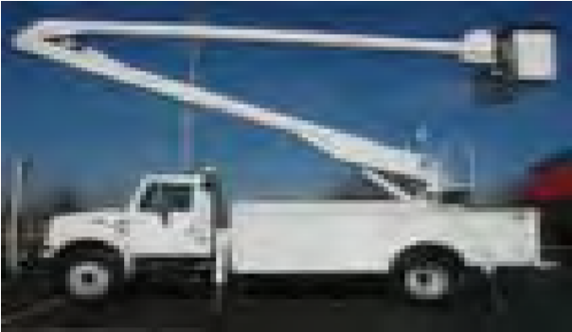 | Vehicle Mounted Aerial Lift / Bucket Truck The lift platform is an integral part of an over the road vehicle.
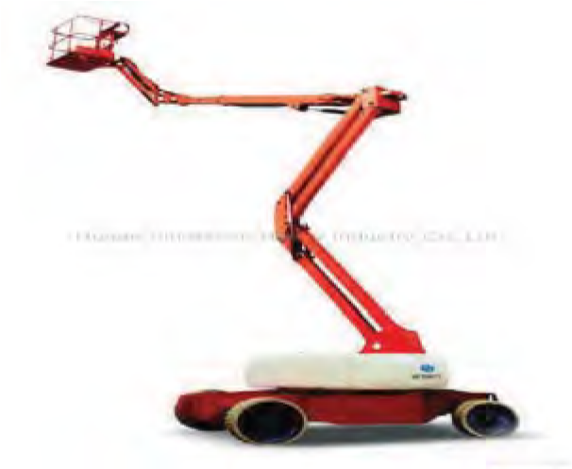 | Articulating Boom Aerial Lift This aerial lift has at least 2 hinged sections which are used to increase mobility.
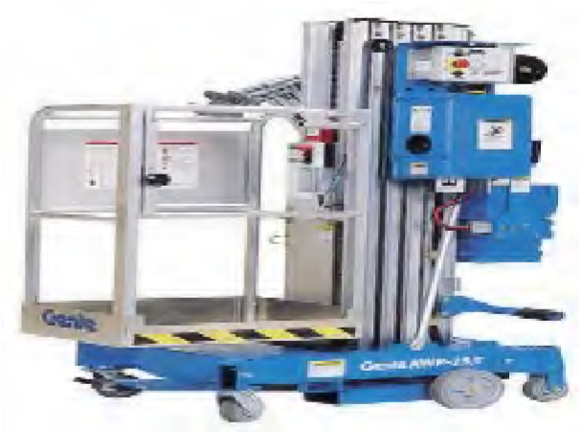 | Man Lift / Cherry Picker This piece of equipment lifts personnel vertically, but not horizontally.
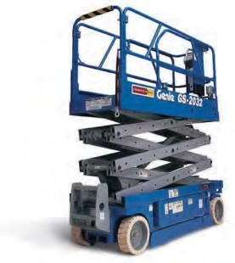 | Scissor Lift This piece of equipment lifts personnel vertically, but not horizontally.
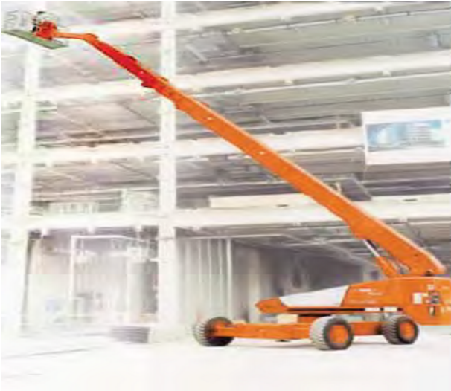 | Extendable / Telescoping Aerial Lift This aerial lift has a boom that extends horizontally and vertically.

