

Bloodborne Pathogen &
Infectious Waste Program
Created 1994 / Reviewed July 2025

District Facilities Department
Environmental Services Group

Environmental Services Group |  |  | Applies to: ☐ ALL  ☐ FP ☒ ESG ☐ NAC ☐ SEM  ☐ FM ☐ Other | Number  003 |  |  | Rev.  1.0 |  | Page  1 of 1
Title: Bloodborne Pathogen Infectious Waste Program
Type: ☐ Procedure ☐ SOP ☐ Contract ☐ Form  ☐ Specification ☐ Design ☐ Accounting ☐ Planning ☒ Program ☐ Other |  |  |  |  | Department Owner:  Environmental Services Group
REV |  | DESCRIPTION OF CHANGE |  |  |  | DOC  APPRV. |  | EFF.  DATE
1.0 |  | Written Program |  |  |  |  |  | 1994
2.0 |  | Review |  |  |  |  |  | 1999
3.0 |  | Review |  |  |  | TIS |  | 4/19/2013
4.0 |  | Review |  |  |  | CDN |  | 4/12/2017
5.0 |  | Review |  |  |  | BK |  | 8/24/2018
6.0 |  | Review |  |  |  | MCS |  | 4/22/2020
7.0 |  | Review |  |  |  | ANM |  | 7/7/2022
8.0 |  | Review |  |  |  | MCS |  | 5/30/2023
9.0 |  | Review |  |  |  | MCS |  | 7/10/25
DISTRICT PROGRAM FOR DEVELOPMENT AND IMPLIMENTATION OF PROCESSES TO BE USED IN SAINT PAUL PUBLIC SCHOOLS OPERATIONS

PURPOSE
Bloodborne Pathogen Infectious Waste Program
29 CFR 1910.1030

The following written program, which includes an Exposure Control Plan (ECP) is provided as a guide to assist administration and staff employees of Saint Paul Public Schools in complying with the requirements of OSHA Standard 29 CFR 1910.1030, Occupational Exposure to Bloodborne Pathogens. It also provides other helpful information. This Program is not intended to supersede the requirements of the standard.

The District Environmental Services Group (ESG) will review the standard annually for particular requirements, which are applicable to the District and adjust this program accordingly.

This written plan is designed to be specific to the needs of users of Saint Paul Public Schools.

If there are conflicts or discrepancies between this plan and the standard, the standard shall take precedence.

DEFINITIONS

Blood Human blood, human blood components, and products made from human blood.

Bloodborne Pathogens Pathogenic microorganisms that are present in human blood and can cause disease in humans. These pathogens include, but are not limited to, hepatitis B virus (HBV) and human immunodeficiency virus (HIV).

Clinical Laboratory A workplace where diagnostic or other screening procedures are performed on blood or other potentially infectious materials.

Contaminated The presence or the reasonably anticipated presence of blood or other potentially infectious materials on an item or surface.

Contaminated Laundry Laundry which has been soiled with blood or other potentially infectious materials or may contain sharps.

Contaminated Sharps Any contaminated object that can penetrate the skin including, but not limited to, needles, scalpels, broken glass, broken capillary tubes, and exposed ends of dental wires.

Decontamination means the use of physical or chemical means to remove, inactivate, or destroy bloodborne pathogens on a surface or item to the point where they are no longer capable of transmitting infectious particles and the surface or item is rendered safe for handling, use, or disposal.

Engineering controls Controls (e.g., sharps disposal containers, self-sheathing needles, safer medical devices, such as sharps with engineered sharps injury protections and needleless systems) that isolate or remove the bloodborne pathogens hazard from the workplace.

Exposure Incident A specific eye, mouth, other mucous membrane, non-intact skin, or parenteral contact with blood or other potentially infectious materials that result from the performance of an employee's duties.

Handwashing Facilities A facility providing an adequate supply of running potable water, soap and single use towels or hot air drying machines.

Licensed Healthcare Professional A person who is legally permitted scope of practice allows him or her to independently perform the activities required by paragraph (f) Hepatitis B Vaccination and Post-exposure Evaluation and Follow-up.

HBV Hepatitis B Virus.

HIV Human Immunodeficiency Virus.

Needleless systems A device that does not use needles for: (1) The collection of bodily fluids or withdrawal of body fluids after initial venous or arterial access is established; (2) The administration of medication or fluids; or (3) Any other procedure involving the potential for occupational exposure to bloodborne pathogens due to percutaneous injuries from contaminated sharps.

Occupational Exposure Reasonably anticipated skin, eye, mucous membrane, or parenteral contact with blood or other potentially infectious materials that may result from the performance of an employee's duties.

Other Potentially Infectious Materials (OPIM)
OPIM include:
- The following human body fluids: semen, vaginal secretions, cerebrospinal fluid, synovial fluid, pleural fluid, pericardial fluid, peritoneal fluid, amniotic fluid, saliva in dental procedures, any type of body fluid that is visibly contaminated with blood, and all body fluids in situations where it is difficult or impossible to differentiate between body fluids;
- Any unfixed tissue or organ (other than intact skin) from a human (living or dead), and;
- HIV-containing cell or tissue cultures, organ cultures, and HIV- or HBV-containing culture medium or other solutions; and blood, organs, or other tissues from experimental animals infected with HIV or HBV.

Parenteral Piercing mucous membranes or the skin barrier through such events as needlesticks, human bites, cuts, and abrasions.

Percutaneous Passed, done, or effected through or by means of the skin.

Regulated Waste Liquid or semi-liquid blood or other potentially infectious materials; contaminated items that would release blood or other potentially infectious materials in a liquid or semi-liquid state if compressed; items that are caked with dried blood or other potentially infectious materials and are capable of releasing these materials during handling; contaminated sharps; and pathological and microbiological wastes containing blood or other potentially infectious materials.

Source Individual Any individual, living or dead, whose blood or other potentially infectious materials may be a source of occupational exposure to the employee.

Sterilize The use of a physical or chemical procedure to destroy all microbial life including highly resistant bacterial endospores.

Universal Precautions An approach to infection control. According to the concept of Universal Precautions, all human blood and certain human body fluids are treated as if known to be infectious for HIV, HBV, and other bloodborne pathogens.

Work Practice Controls Controls that reduce the likelihood of exposure by altering the manner in which a task is performed (e.g., prohibiting recapping of needles by a two-handed technique).

OBJECTIVE

Saint Paul Public Schools is committed to providing a safe and healthy work environment for all users of District facilities. In pursuit of this endeavor, the following Bloodborne Pathogen Infectious Waste Program is intended to eliminate or minimize occupational exposure to bloodborne pathogens and other infectious agents and waste. Reference should also be made to the District’s Safe Use of Bleach Standard Operating Procedure.

A central component required by the standard is the development of an Exposure Control Plan (ECP). The ECP is outlined in detail within this program.

The information contained in this program is not considered a substitute for the OSHA standards or any provisions of OSHA standards. It provides general guidance on the particular standard related to the topic of this written program and is intended to fulfill the compliance requirements of the OSHA regulations.

A copy of this program and OSHA standard 29 CFR 1910.1030, "Occupational Exposure to Bloodborne Pathogens,” can be obtained from Environmental Services Group.

ASSIGNMENT OF RESPONSIBILITY

Management
Environmental Services Group (ESG)
- Use engineering and administrative controls to limit employee exposure.
- Provide employees with appropriate Personal Protective Equipment (PPE) and other controls, as needed.*
- In conjunction with the specific department heads/supervisors of effected employees, determine which job classifications, or portions thereof, have job duties that expose the individual to blood or other potentially infectious materials resulting from the performance of an employee's duties; take appropriate actions as outlined in this program.
- Make appropriate decisions for ensuring that all medical actions required (e.g., hepatitis vaccinations) are performed.
- Administrate the responsibilities for all District requirements of the Post Exposure Evaluation and Follow-up section of this program.
- Manage and maintain contracted services for all infectious and blood waste products (2025 contractor is Stericycle), and handle all necessary disposals.
- Maintain all appropriate employee health and OSHA records.
- Provide required training for any employee who has daily or occasional contact with blood or infectious waste and maintain documentation of such training.
- Responsible for developing and maintaining all facets of this plan including full authority to make necessary decisions that ensure its success.
- Review OSHA, EPA, and industry data annually or whenever changes in procedures create new occupational exposures; update the program as needed.
* Student Wellness will maintain and provide, for District nurses to use for students, all necessary personal protective equipment (PPE), engineering controls (e.g., sharps containers), labels, and red bags as required by the standard.

Staff
Department Heads/Supervisors
  - Work with ESG to help determine which job classifications, or portions thereof, have job duties that expose employees to blood or other potentially infectious materials.
  - Ensure that appropriate PPE is readily accessible at the worksite and/or is issued to employees.
  - Identify employees who need bloodborne pathogen infectious waste training outlined in this program; communicate needs to ESG; verify that employees attend/receive the training.
  - Ensure employees comply with ALL provisions of this safety program.

Employees
  - Obtain and properly use appropriate personal protective equipment (PPE) provided by the District by wearing such PPE in all occupational exposure situations. Request new protection when needed.
  - Take responsibility for decontamination of PPE, at no cost, by adhering to the care and decontamination procedures outlined in this program.
  - Attend all required training related to this program and follow prescribed teaching.
  - Read, understand, and adhere to the Bloodborne Pathogen Infectious Waste Program.

PROCEDURES

Covered Employees
OSHA’s Bloodborne Pathogen Standard covers the following range of employees:
- Any employee who has occupational exposure to blood or other potentially infectious material will be included within the scope of this standard.
  - Occupational exposure means reasonably anticipated skin, eye, mucous membrane, or parenteral contact with blood or other potentially infectious materials that may result from the performance of an employee’s duties.
- Part-time, temporary, and healthcare workers known as “per diem” employees are covered by this standard; this includes the following:
  - All employees who are full time, contractual, part-time, seasonal, temporary, and provisional;
- Students and volunteers (if they receive any type of compensation) per the above criteria.

Exposure Control Plan
Purpose
  - The Exposure Control Plan (ECP) is a key provision of OSHA’s "Occupational Exposure to Bloodborne Pathogens” standard. It requires employers (the District) to identify employees and individuals who have potential risk exposure and to provide such individuals with training, protective equipment, vaccination(s), and other protections required by the standard. At a minimum, the plan must include the following elements:
  - Identify job classifications where there is exposure to blood or other potentially infectious materials
  - Explain the protective measures currently in effect.
  - Establish procedures for evaluating the circumstances of an exposure incident.
  - The ECP must be reviewed and updated at least annually or whenever changes in procedures create new occupational exposures.

Employee Exposure Determination
- Each employer who has employees with occupational exposure [ref. definitions above or 1910.1030(b)] shall prepare an exposure determination.
- Employees include any individuals who have potential exposure to bloodborne pathogens and; therefore, must be protected.
- The exposure determination is based on the definition of occupational exposure without regard to the use of personal protective clothing and equipment.
- The exposure determination shall contain the following lists:
- All job classifications in which all employees in those job classifications have occupational exposure;
- Job classifications in which some employees have occupational exposure, and
- All tasks and procedures (or groups of closely related tasks and procedures) in which occupational exposure occurs and are performed by employees in job classifications listed in #2, above.

- List of job classifications within the District in which all employees have occupational exposure:

Job Title | Department
Nurse | Student Wellness
Health Assistant | Student Wellness
Plumber | Maintenance
Wrestling Coaches | Athletics
Lifeguards | Athletics
All Custodial / Engineers | Maintenance
Facility Service Workers | Maintenance
Teacher's Assistant | Special Education
Educational Assistant | Special Education

- List of job classifications in which some employees may have occupational exposure.

Job Title | Department / Location
Teacher's Assistant | Special Education
Educational Assistant | Special Education
Electrician | Maintenance
Pipefitter | Maintenance
Painter | Maintenance
Sheet metal | Maintenance
Carpenter | Maintenance
Bricklayer | Maintenance
Glazer | Maintenance
Machinist | Maintenance
Coaches | Athletics
Bus Aid | Transportation

Hepatitis B Vaccination
- ESG will provide training to employees on hepatitis B vaccinations, addressing the safety, benefits, efficacy, methods of administration, and availability.
- The hepatitis B vaccination series will be made available at no cost after training and within 10 working days of initial assignment to employees identified in the exposure determination section of this plan. Vaccination is encouraged unless:
- documentation exists that the employee has previously received the series,
- antibody testing reveals that the employee is immune, or
- medical evaluation shows that vaccination is contraindicated.
- Following the medical evaluation, a copy of the health care professional's Written Opinion will be obtained and provided to the employee. It will be limited to whether the employee requires the hepatitis vaccine and whether the vaccine was administered.
- The vaccination is a series of three (3) injections in the upper arm. The first injection is followed one (1) month later by the second. The third injection is administered six (6) months after the first injection.
- If an employee chooses to decline vaccination, the employee must sign a declination form (see Appendix: Exhibit A-01). Employees who decline may request and obtain the vaccination at a later date at no cost. Documentation of refusal of the vaccination is kept by ESG.

Engineering Controls and Work Practices
- Engineering controls and work practice controls will be used to prevent or minimize exposure to bloodborne pathogens.
- Engineering controls shall be reviewed and maintained or replaced on a regular schedule to ensure their effectiveness
- All District employees will utilize Universal Precautions to prevent contact with blood or other potentially infectious materials.
- This is a method of infection control such that under circumstances in which differentiation between body fluid types is difficult or impossible, all body fluids (e.g., HIV, HBV, and other bloodborne pathogens) shall be considered potentially infectious materials.
- The District’s “Student Wellness Universal Precaution Protocol for Infectious Disease” includes the following requirements regarding students:
  - Cannot share any student infectious disease status with staff or public.
  - May not know accurate status of student.
- The District has identified the following specific engineering controls and work practice controls, and employees are responsible for adhering to the respective instructions listed below:
- Wash hands immediately or as soon as feasible after removal of gloves or other personal protective equipment;
- Wash hands immediately or as soon as feasible following contact of such body areas with blood or other potentially infectious materials;
- Use the hand washing facilities provided by the District and made readily available for effected employees.
- Ensure that contaminated needles are immediately containerized in appropriate containers until proper disposal. Appropriate containers shall be puncture resistant, labeled and color-coded in accordance with the standard and leak proof on the sides and bottom.
- Contaminated needles and other contaminated sharps shall not be bent, recapped or removed.
- If it can be demonstrated that no alternative is feasible or that such action is required by a specific medical procedure then such bending, recapping or needle removal must be accomplished through the use of a mechanical device or a one-handed technique.
- Injured persons should administer SELF-CARE where feasible. Other employees and/or staff members must not provide hands on care for a bleeding injury when the injured individual can care for themselves.
- Eating, drinking, smoking, applying cosmetics or lip balm, and handling contact lenses are prohibited in work areas where there is a reasonable likelihood of occupational exposure.
- Food and drink shall not be kept in refrigerators, freezers, shelves, cabinets or on countertops or bench tops where blood or other potentially infectious materials are present.
- All procedures involving blood or other potentially infectious materials shall be performed in such a manner as to minimize splashing, spraying, spattering, and generation of droplets of these substances.
- Equipment which may become contaminated with blood or other potentially infectious materials shall be examined prior to servicing or shipping and shall be decontaminated as necessary, and a label shall be attached to the equipment stating which portions remain contaminated.
- Training on situations and proper use of PPE.
  - Use appropriate clean-up procedures, which include the following:
- Close off the area;
- Use gloves and eye protection;
- Remove fluids by using absorbent and/or disposable towels;
- Clean area with soap and water, rinse;
- Disinfect the area with bleach and water solution, and air dry;
- Ten percent bleach in water solution is used in cleaning and sanitizing situations. Solutions are mixed daily, labeled clearly, and secured when not in use. Reference the District’s Safe Use of Bleach Standard Operating Procedure for further requirements.
- If clothing become saturated to the point of dripping with an infectious waste, the employee is to remove and discard of the clothing on site. Under no circumstances is clothing to be taken home and laundered in this situation.
- Dispose of all materials in a plastic bag, seal and place in dumpster;
- Always wash hands.

Personal Protective Equipment (PPE)
Access and Training
- The District will provide PPE to employees at no cost and that is appropriate for the tasks and/or procedures the employee performs.
- Department heads shall ensure that appropriate personal protective equipment in the appropriate sizes is readily accessible at the worksite and/or is issued to employees.
- Personal protective equipment will be considered "appropriate" only if it does not permit blood or other potentially infectious materials to pass through to or reach the employee's work clothes, street clothes, undergarments, skin, eyes, mouth, or other mucous membranes under normal conditions of use and for the duration of time that the PPE will be used.
- Appropriate protective clothing such as, but not limited to, gowns, aprons, lab coats, clinic jackets, or similar outer garments shall be worn in occupational exposure situations. The type and characteristics will depend upon the task and degree of exposure anticipated.
- The District shall repair or replace PPE as needed to maintain its effectiveness, at no cost to the employee.
- ESG will provide training on the use of the appropriate PPE for the tasks and/or procedures employees will perform.
Usage, Decontamination, and Disposal Procedures
- Disposable (single use) gloves such as surgical or examination gloves shall be replaced as soon as practical when contaminated or as soon as feasible if they are torn, punctured, or when their ability to function as a barrier is compromised. Disposable (single use) gloves shall not be washed or decontaminated for re-use.
- Utility gloves may be decontaminated for re-use if the integrity of the glove is not compromised. However, they must be discarded if they are cracked, peeling, torn, punctured, or exhibit other signs of deterioration or when their ability to function as a barrier is compromised.
- Gloves shall be worn when it can be reasonably anticipated that the employee may have hand contact with blood, other potentially infectious materials, mucous membranes, and non-intact skin; and when handling or touching contaminated items or surfaces.
- Masks in combination with eye protection devices, such as goggles or glasses with solid side shields, or chin-length face shields, shall be worn whenever splashes, spray, spatter, or droplets of blood or other potentially infectious materials may be generated and eye, nose, or mouth contamination can be reasonably anticipated.
- If a garment(s) is(are) penetrated by blood or other potentially infectious materials to the point of dripping, the garment(s) shall be removed immediately or as soon as feasible and discarded.
- All PPE shall be removed prior to leaving the work area.
- When PPE is removed, it shall be placed in an appropriately designated area or container for storage, washing, decontamination or disposal.
- The employee shall be responsible for decontamination of PPE at no cost to the employee. ESG shall provide training on care and decontamination procedures for all PPE. Any blood contaminated gloves, rags, towels and clothing shall be placed into a plastic bag, sealed and disposed of in the general trash.

Housekeeping
- Department heads and staff shall ensure that their worksite is maintained in a clean and sanitary condition by performing any or all of the following procedures:
  - Clean and decontaminate all equipment and environmental and working surfaces as follows:
    - after contact with blood or other potentially infectious materials;
    - immediately or as soon as feasible when surfaces are overtly contaminated; or
    - after any spill of blood or other potentially infectious materials; and
    - at the end of the work shift if the surface may have become contaminated since the last cleaning.
  - Contaminated work surfaces shall be decontaminated with a ten percent bleach solution after completion of procedures (reference the District’s Safe Use of Bleach Standard Operating Procedure for details);
  - Protective coverings, such as plastic wrap, aluminum foil, or imperviously-backed absorbent paper used to cover equipment and environmental surfaces, shall be removed and replaced as soon as feasible when they become overtly contaminated or at the end of the work shift if they may have become contaminated during the shift.
  - All bins, pans, pails, cans, and similar receptacles intended for reuse which have a reasonable likelihood for becoming contaminated with blood or other potentially infectious materials shall be inspected and decontaminated on a regularly scheduled basis and cleaned and decontaminated immediately or as soon as feasible upon visible contamination.

Sharps Containers and Injury Log
Sharps Containers
- Nurse’s Sharps disposal containers must be inspected by respective department heads and/or staff and maintained and/or replaced at least every twelve months or sooner when necessary to prevent overfilling.
- Requests for new containers should be made two weeks prior to disposal of existing containers and/or when the sharps container is nearing capacity.
- Container requests are made by using the District’s online Service Request Form titled, Stericycle Container Request, which is found on the Facilities website home page.
- Each school will receive a pre-paid mail back 1-quart sharps container. (Note: if more capacity is needed, a one (1) gallon container may be requested).
- When the new container(s) is(are) received, properly package the old container and follow the shipping instructions provided by Stericycle.
Sharps Injury Log
- The District has established and maintains a sharps injury log for the recording of percutaneous injuries from contaminated sharps (see Exhibit A-02: Sharps Injury Log in the Appendix
- All information in the sharps injury log shall be recorded and maintained in such manner as to protect the confidentiality of the injured employee.
- The Sharps Injury Log shall contain, at a minimum:
- The type and brand of device involved in the incident,
- The department or work area where the exposure incident occurred, and
- An explanation of how the incident occurred.
- The Sharps Injury Log must be retained for five years following the end of the year to which it relates.

Infectious Waste Containers
- Each junior and senior high will receive a one (1) gallon infectious (Stericycle) waste pre-paid mail back container.
- Requests can be made for an additional container, or by sites other than a junior or senior high, by using the District’s online Stericycle Container Request (reference site location above).
- If a regulated body fluid or blood clean up event occurs that generates infectious waste, place all materials in the container and follow the directions provided by Stericycle. Follow the steps above to request a new container.

Post Exposure Evaluation and Follow-up

First Report of Injury (FROI) Form
- Within 24 hours or as soon as possible, the employee’s supervisor must complete the District’s First Report of Injury Form as follows:
  - Access the official FROI Form (see Exhibit A-07: First Report of Injury Form in the Appendix) via the District website: Office of Business and Financial Affairs > Workers Compensation;
  - Complete all applicable portions of the form being as specific as possible with details of the incident;
  - Fax all completed FROI Forms directly to the Facilities Department for processing (Fax: 651.744.1867)
*** IMPORTANT: Do not send any forms directly to the State ***

Medical Provider
- Post-Exposure Evaluations will be provided by:
Concentra Clinics
570 N Asbury St Suite 101
St Paul MN 55104

Exposure Follow-up
- Following a report of an exposure incident notification, which should be reported using the online FROI, the District shall make immediately available to the exposed employee a confidential medical evaluation and follow-up, including at least the following elements:
- Documentation of the route(s) of exposure, and the circumstances under which the exposure incident occurred;
- Identification and documentation of the source individual, unless the employer can establish that identification is infeasible or prohibited by state or local law;
- Collection and testing of blood for HBV and HIV serological status;
- The exposed employee's blood shall be collected as soon as feasible and tested after consent is obtained;
- Post-exposure prophylaxis, when medically indicated, as recommended by the U.S. Public Health Service;
- Counseling; and
- Evaluation of reported illnesses.
- The District shall ensure that the healthcare professional responsible for the employee's Hepatitis B vaccination is provided with a copy of this regulation.
- The District shall ensure that the healthcare professional evaluating an employee after an exposure incident is provided the following information:
- A copy of this regulation;
- A description of the exposed employee's duties as they relate to the exposure incident;
- Documentation of the route(s) of exposure and circumstances under which exposure occurred;
- Results of the source individual's blood testing, if available; and
- All medical records relevant to the appropriate treatment of the employee including vaccination status are the employer's responsibility to maintain.
- The District shall obtain and provide the employee with a copy of the evaluating healthcare professional's written opinion within 15 days of the completion of the evaluation. The healthcare professional's written opinion for Hepatitis B vaccination shall be limited to whether Hepatitis B vaccination is indicated for an employee, and if the employee has received such vaccination.
- The healthcare professional's written opinion for post-exposure evaluation and follow-up shall be limited to the following information:
- That the employee has been informed of the results of the evaluation; and
- That the employee has been told about any medical conditions resulting from exposure to blood or other potentially infectious materials which require further evaluation or treatment.
- All other findings or diagnoses shall remain confidential and shall not be included in the written report.

Administration Requirements for Post Exposure Evaluation and Follow-up
- Following an exposure incident, ESG will perform the following activities:
- Document the routes of exposure and how the exposure occurred.
- After obtaining consent, have exposed employee's blood collected by a medical provider as soon as feasible after exposure incident, and test blood for HBV and HIV serological status.
- If the employee does not give consent for HIV serological testing during collection of blood for baseline testing, preserve the baseline blood sample for at least 90 days; if the exposed employee elects to have the baseline sample tested during this waiting period, perform testing as soon as feasible.
- Perform and Exposure Evaluation consisting of:
- Engineering controls in use at the time;
- Work practices followed;
- A description of the device being used (including type and brand) protective equipment or clothing that was used at the time of the exposure incident (gloves, eye shields, etc.);
- Location of the incident (gym, woodshop, patient room, etc.); and
- Procedure being performed when the incident occurred.

Employee Training
- The District shall ensure that all employees with occupational exposure participate in a training program which is provided by ESG during working hours at no cost to the employee.
- Identification of employees who require training, registration, and attendance in the training class(es) is the responsibility of the department head/supervisor and respective employees.
- Training shall be provided as follows:
- At the time of initial assignment to tasks where occupational exposure may take place;
- Within 90 days after the effective date of the standard; and
- At least annually thereafter.
- Annual training for all employees shall be provided within one year of their previous training.
- The District shall provide additional training when changes such as modification of tasks or procedures or institution of new tasks or procedures affect the employee's occupational exposure. The additional training may be limited to addressing the new exposures created.
- The training program shall contain at a minimum the following elements:
- An accessible copy of the regulatory text of this standard and an explanation of its contents;
- A general explanation of the epidemiology and symptoms of bloodborne diseases;
- An explanation of the modes of transmission of bloodborne pathogens;
- An explanation of the district’s exposure control plan and the means by which the employee can obtain a copy of the written plan;
- An explanation of the appropriate methods for recognizing tasks and other activities that may involve exposure to blood and other potentially infectious materials;
- An explanation of the use and limitations of methods that will prevent or reduce exposure including appropriate engineering controls, work practices, and personal protective equipment;
- Information on the types, proper use, location, removal, handling, decontamination and disposal of personal protective equipment;
- An explanation of the basis for selection of personal protective equipment;
- Information on the hepatitis B vaccine, including information on its efficacy, safety, method of administration, the benefits of being vaccinated, and that the vaccine and vaccination will be offered free of charge;
- Information on the appropriate actions to take and persons to contact in an emergency involving blood or other potentially infectious materials;
- An explanation of the procedure to follow if an exposure incident occurs, including the method of reporting the incident and the medical follow-up that will be made available;
- Information on the post-exposure evaluation and follow-up that the employer is required to provide for the employee following an exposure incident;
- An explanation of the signs and labels and/or color coding required; and
- An opportunity for interactive questions and answers with the person conducting the training session.
- The person conducting the training shall be knowledgeable in the subject matter covered by the elements contained in the training program as it relates to the workplace that the training will address.

RECORDKEEPING REQUIREMENTS

Management

Recordkeeping requirements outlined in 29 CFR 1910.1030 and specifically addressed by 29 CFR 1910.1020 with further reference to 29 CFR 1913.10 shall be maintained by ESG and available upon request.

Medical Records
- The District shall establish and maintain an accurate record for each employee with occupational exposure in accordance with 29 CFR 1910.1030(h)(1) and 29 CFR 1910.1020. This record shall include:
- The name and social security number of the employee;
- A copy of the employee's hepatitis B vaccination status including the dates of all the hepatitis B vaccinations and any medical records relative to the employee's ability to receive vaccination (1910.1030(f)(2));
- A copy of all results of examinations, medical testing, and follow-up procedures (1910.1030(f)(3));
- The employer's copy of the healthcare professional's written opinion (1910.1030(f)(5)); and
- A copy of the information provided to the healthcare professional (1910.1030(f)(4)(ii)(B)(C) and (D)).
- The District shall ensure that employee medical records are kept confidential and not disclosed or reported without the employee's express written consent to any person within or outside the workplace except as required by this section or as may be required by law (1910.1030(h)(1)).
- The District shall maintain the records for at least the duration of employment plus thirty (30) years (1910.1030(h)(1)(iv) and 1910.1020(d)(1)(i)).
- The medical records of employees who have worked for less than one (1) year for the employer need not be retained beyond the term of employment if they are provided to the employee upon the termination of employment (1910.1020(d)(1)(i)(C)).
- ESG shall maintain all required records for this program.

Training Records
- Training records shall be maintained for three (3) years from the date on which the training occurred (1910.1030(h)(2)).
- Training records shall include the following information:
- The dates of the training sessions;
- The contents or a summary of the training sessions;
- The names and qualifications of persons conducting the training; and
- The names and job titles of all persons attending the training sessions.

Availability of Records
- The District shall ensure that the records required to be maintained by this section shall be made available as follows:
- All records shall be provided upon request to the Assistant Secretary of Labor for Occupational Health and Safety (Assistant Secretary) for examination and copying.
- Employee training records shall be provided upon request for examination and copying to employees, to employee representatives, to the Director, and to the Assistant Secretary.
- Employee medical records shall be provided upon request for examination and copying to the subject employee, to anyone having written consent of the subject employee, and to the Assistant Secretary in accordance with 29 CFR 1910.1020.
- Transfer of Records. The employer shall comply with the requirements involving transfer of records (1910.1030(h)(4) and 1910.1020(h)).
- Rules of agency practice and procedure governing OSHA access to employee medical records are contained in 29 CFR 1910.1020(e)(3)(i) and 29 CFR 1913.10.

Contact Information

Any questions, concerns, comments, or other information regarding the District’s Bloodborne Pathogen Infectious Waste Program can be directed to:

- The Environmental Services Group
- Phone: 651.744.1800
- Web Site: https://www.spps.org/Page/3470
- Email: ESG@spps.org

RESOURCES & APPENDIX

APPENDIX A

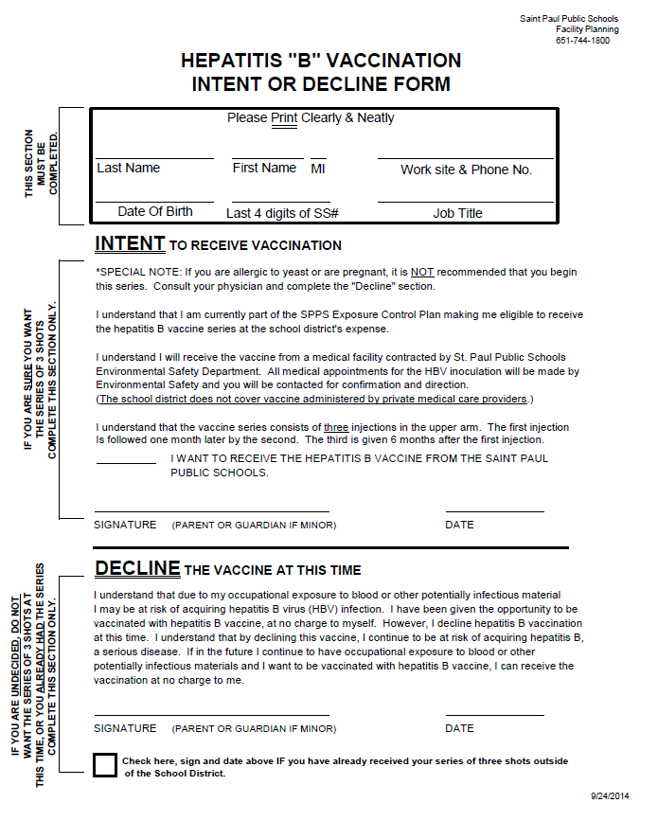
Exhibit A-01: Hepatitis “B” Vaccination Intent or Decline Form
Exhibit A-02: Sharps Injury Log

St. Paul Public Schools
Sharps Injury Log
Date | FROI # | Type of Device | Brand Name of Device | Work Area where Injury occurred | Brief description of Incident
29 CFR 1910.1030, OSHA's Bloodborne Pathogens Standard, in paragraph (h)(5), requires an employer to establish and maintain a Sharps Injury Log
for recording all percutaneous injuries in a facility occurring from contaminated sharps. The purpose of the log is to aid in the evaluation of devices
being used in healthcare and other facilities and to identify problem devices or procedures requiring additional attention or review. The log must
be kept in addition to the injury and illness log require by 29 CFR 1904. The Sharps Injury Log should include all sharps injuries occurring in a calendar year. The log must be retained for five years following the year to which it relates. The log must be kept in a manner that preserves confidentially of the affected employee.

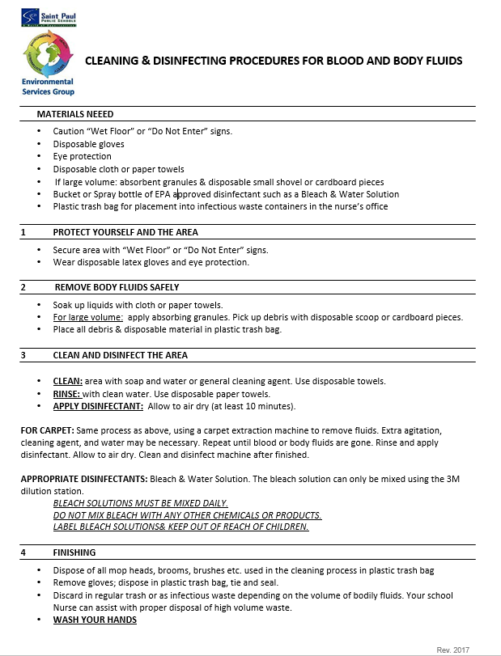
Exhibit A-03: Cleaning & Disinfecting Procedures for Blood and Body Fluids
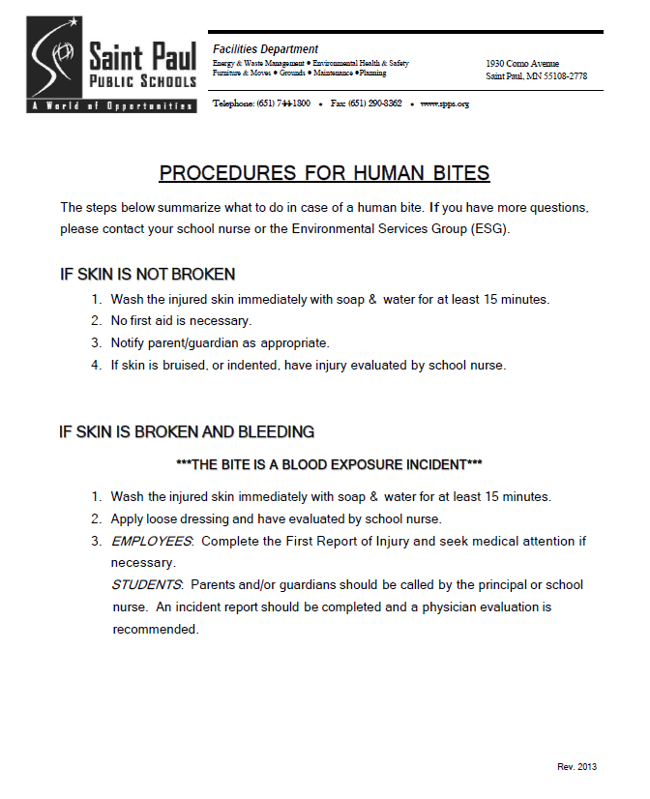
Exhibit A-04: Procedures for Human Bites

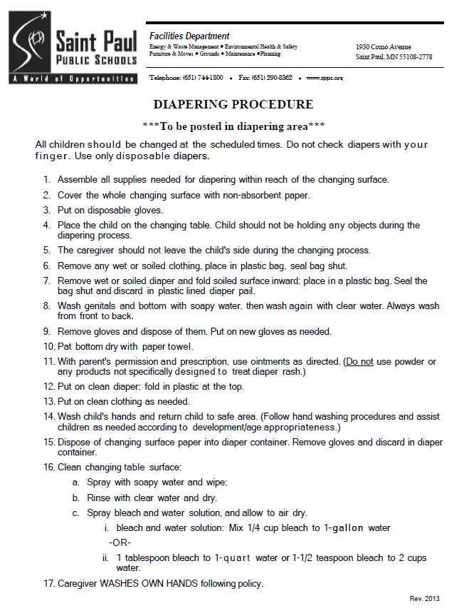
Exhibit A-05: Diapering Procedure

Exhibit A-06: Hand Washing Procedure
