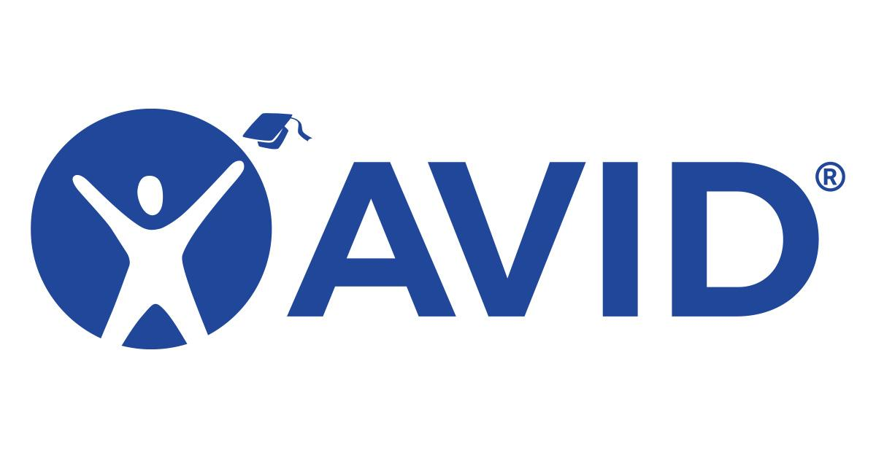
Isbell AVID Site Team Meeting
Tuesday, October 21, 2025

Attendees: Mark Lopez, Mark Robertson, Angela Hicks, Sydney Gomez,Maria Ortiz, Shauna Catalano, Zecariah Murray, Darren Hicks, Angela Nguyen, James Jenkins

1.) Professional Development & Department Strategy
- The staff presentation on Sept. 22nd was fantastic. Thank you Mr. Robertson & Mr. Murray
  - Each department was asked to choose 1 AVID strategy & attempt to implement it in their classrooms each Quarter for a total of 3.
  - Student examples will be collected & shared during Collaboration.

2.) Collaboration with SPHS
- Emailed a reminder again yesterday. Hoping for a response if we are a go for November.
- 9:42 am to 11:48 am (8th Grade - Period 2 to Period 4) (7th Grade - Period 2 to Period 5)
- 7th Graders will eat lunch with 8th graders

3.) AVID Weekly (No Contract Yet-District Working on It Still?)
- Emailed Melissa yesterday asking if we are renewing our contract again. It’s a great resource, but $ may be an issue.
- Lopez will send out an email informing staff that they can have access to it.
- We can start with the AVID Site Team.

4.) Survey Creations
- Parent Survey if student organization improves (Thiellemann)
- Grade Check Form (Angie)

5.) AVID DATA Collection
- Isbell General Data Forms
  - Mark Lopez completed October 1st.
- Secondary Site DATA Collection Form (CCI)
  - Opened October 6th. Will discuss today how we would like to complete.
  - We have a survey we gave all staff from 23-24 SY. We can update & change to this SY.

Next meeting: Tuesday, December 9th, 2025 @ 7:15 AM

