How to Place a Web Request

Process overview
WebOrder allows you to manage shipping and contact information, student information, and material requests all in one place. You can review past requests at any time, and even monitor the status of pending requests.
This overview will walk you through the process of submitting a request to receive materials (including textbooks and equipment) through the WebOrder site; see the following steps for more detailed instructions.
- Access and log into WebOrder: https://webopac.klas.com/_____/weborder
- Click the Find Student/Districts link and select a student.
- Click the Add Material Request link and select the request type.
- Enter keywords or the ISBN of the item you are looking for and click the Search button.
  - From the Search Results, mark the check box for the items you wish to order, and click the Add Selected Lines to Material Request button.
  - The line will be added to the Material Request box on the right of the screen.
  - If necessary, use the Refine Search option to search for more items, and continue adding materials to the request.
- When done adding lines, use the Back to Material Request link to review your request, then click the Next Step button.
- Verify the mailing address.
  - If you are placing an order that will need to be shipped to a new school or to an address that has not been used in the past, a new address will need to be added.
  - Click the Complete Request button to finalize the request.
  - Review your newly created materials requests on the Material Requests screen.
Additional instructions
I – Change your password 7
II – Check the status of a request 7
III – Verify or add a shipping address 8
IV – Add a new Student 9
V – Add a Temporary Title 9

Step One – Access and log into the WebOrder site
- Open any web browser (such as Internet Explorer, Chrome, or Safari) and enter this URL:
https://webopac.klas.com/_____/weborder
- Enter your username and password. If you are logging in for the first time, contact __IRC__ to receive your username and a link to set your password.
- Use the Log In button to submit the info.
Note: if you are ordering for the first time, or if materials will need to be sent to a new address, go to the Verify or add a shipping address section of this document before beginning the Material Request.

Step Two – Select your Student
- Click the Find Student/Districts link in the Main Menu on the left.
- Enter a blank search to see the full list of accounts associated with yours, or search for the first or last name of the student who will be using the materials.
- Click on the student’s name in the search results.
  - Make sure that the student’s status is Active; if not, you will need to contact the __IRC__ to proceed.
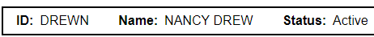
  - If the student is listed twice (for example, if there is an entry for both “Bill Smith” and “William Smith”), contact the __IRC__ to merge the accounts.
  - If the student is not listed, contact the __IRC__ or see the Add a new student section of this document.
- Ensure that all of the information listed on the Main Details page is correct. Make any needed changes, and enter a note to explain and verify the information. Click the Save Changes button when you are finished.
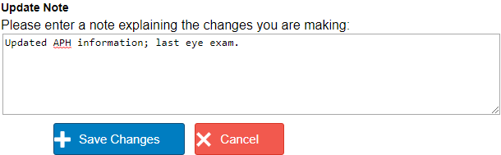

Step Three – Create the Material Request
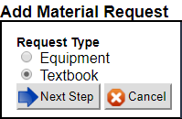
- Click the Add Material Request link in the Student/Districts Menu. Note that you will need to create a separate material request for each student that you wish to order materials for.
- Select the Request Type that best describes the materials:
  - Equipment – equipment, learning aids, or supplies.
  - Textbook – text materials such as a book or textbook, including braille or audio materials.
- After you have made the Request Type selection, click the Next Step button.

Step Four – Search for the materials
- On the Catalog Search screen, use the Query field to search any of the following ways:
- ISBN number – enter the International Standard Book Number.
- APH number – enter in the APH number from the catalog.
- Title – enter keywords or the full name or title, or the name of the equipment.
- Subject – enter subject keywords for text searches.
- Choose the Sort type you prefer, then click the Search button.
- The Search Results page will show the total number of results, followed by a list of titles or equipment. Use the Filters on the left side of the screen to narrow the search results as needed to find the right item.
  - Limit search by filter – Click on a filter link to limit the search results to only items that match that filter. For example, clicking the Since Last Year link will display only the titles added during that time frame.

  - Exclude filter from search – Click on the red X next to a filter to remove items of that type from the search results. For example, clicking the X beside “Large Type” will show everything except items in Large Type.

  - Notice that your search statement will change to reflect the filter options you are using. To remove filters, click on the furthest-left link. Example, clicking on “Searching for math” below would reset the results back to the initial search.
- There may be catalog entries that are very similar. Double-check that you are selecting the format and edition that your student needs.
- When you find an item you want to request, click the box next to the title of the item to check it. Multiple titles on the same page can checked and will all be added to the request.
- Click either of the Add Selected Lines to Material Request buttons, located at the top and the bottom of the search results.

- Selected materials will be listed as line items on the left side of the screen as they are added to the Material Request.

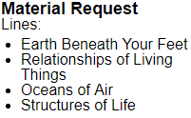

- To search for additional materials, enter new keywords in the Refine your query field. You can search for and enter as many lines as you need on a single request, but remember to only include items for that specific student.
- If you need any materials that you are unable to find in the catalog, click the Add temp title link. See the Add a temporary title section of this document for more detail.

Step Five – Review the Material Request
- When you are finished adding lines, use the Back to Material Request link below your requested items to review and submit the request.
- The Review Lines screen will show the item or items that you added. From here:
  - Use the Search Catalog button to go back and add additional lines.
  - Use the Remove link beside any line item to delete it from the request.
  - Use the Cancel button to cancel the entire request and delete it from the system.
  - Proceed using the Next Step button.
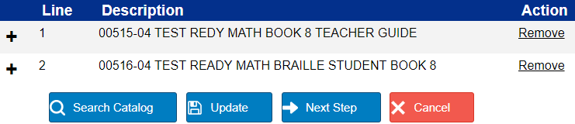

Step Six – Select the shipping information
- On the next screen, ensure that the following values are correct:
- Select School – The district or consortium responsible for the order.
- Select Teacher – You, the teacher/requestor
- Select Student – The individual student who will be using this material.
- Shipping Information –The address where the item will be shipped.
- Address From: Choose which account to pull the address from.
- Address: Select which address on that record to use for this request.
- Once you have verified the information, click the Complete Request button.

- You will be taken to the Confirmation screen where you can see the newly added request or requests. Your Material Request is now complete and submitted! You will receive an automatic email confirming the request.
  - To review the order, including shipping address and items included, click the Request ID. If you spot any errors, don’t panic! Just contact the ___IRC___ as soon as possible so that they can correct the Material Request before any action is taken on it.
  - To review a list of all Material Requests for that district, click its ID and then click the Material Requests link in the Student/Districts Menu.
  - To review your information, including all of the Material Requests you have made, click your ID and then use the Menu links.
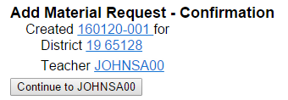
a.
b.
c.
- Repeat this process for each student who needs materials.

I – Change your password
If you would like to change your password, you may do so at any time.
- Once logged into WebOrder, select the Account button in the header.
- Enter your current password and desired new password, then click the Change Password button.
- If you no longer know your current password, or if your account is locked out from failed log-in attempts, contact the ___IRC___ to reset your password.

II – Check the status of a request
- Find and select your name to review all the requests that you have submitted through WebOrder, or select the name of the student associated with that request.
- In the lower section of the Student/Districts Menu, click the Material Requests link. Each request will be listed, including how many items were included, when it was submitted, and the status.
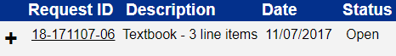
- If all items in the request were shipped, the status will be Closed; otherwise, it will be Open.
  - Click the plus sign to the left of the Request ID for more details, including the items included in the request, what was the last action taken on each line, and the date of that action.
  - Click on the Request ID to see the full request, including the information above as well as the selected shipping address.
- The last action taken will be listed for each line item. Common action codes are:
Action | Description | Action | Description
SHC | Shipped (complete) | SHP | Shipped (partial)
ASG | Assigned / ready to ship | CAN | Cancelled
MCRQ | Media Consent Required | MCRV | Media Consent Received
OLD | Out of Adoption | PO | Purchase Order issued
POB | PO on Back-order | REQ/RES | Reserve / expected back in stock
UASG | Unassigned / not in stock | SRC | Sourcing

III – Verify or add a shipping address
Follow this set of instructions before placing a Web Request to verify or add a shipping address. You can also add new contact information or set a default address.
- On the Find Student/Districts page, enter your name or a blank search.
- Select your name in the results. If desired, you can also select the district and add a district address using these same steps.
- Under the Student/Districts Menu, click the Address/Contact link.
- Review the addresses that are listed. If the address information is correct, you can follow the instructions above starting from Step Two to add the Web Request. If the address needs to be changed or a new address needs to be added, continue below.
- Click on the Add Address link, located below the existing addresses.
  - Select the Address Type that best describes the entry. (Facility/School will be the most common.)
  - Enter in a short but specific description of the address. This description is displayed at the time the address has to be selected for the Web Request, and will help you ensure that materials are sent to the correct location.
Example: “South High School” or “District Office”
  - Enter in the Street Address, City, State, and Postal ZIP Code.
  - Click the Save New Address button. You will now be able to select that address for any future Material Request.

- To switch which address is the default for new Material Requests, click the Select Preferred Address link.
  - In the list of addresses, click the Save icon beside the desired default.
- Use this same procedure to add new contact methods (such as an email or phone number) or change your preferred contact method.

IV – Add a new Student
If a student is not yet listed for your district and you know that they were registered in a previous district, you can contact the ___IRD___ to add your district to the existing record. However, if you believe that they are a new student or want to enter a request for them right away, you can create a record for them in WebOrder.
- Click the Add Student link in the Main Menu.
- Fill in the student’s information.
  - To help prevent or resolve duplicate accounts, please use the student’s full name and ensure that you are including an accurate Date of Birth.
  - Include all APH Census information.
  - Include a note for any other information that should be on record, and/or with the student’s previous district or teacher to help connect duplicate records.
Example: “Student moved February 2016; previously attended Henry County.”
- Click the Add Student button to save the record.

- You can now add a Material Request for this student starting from Step Three above.

V – Add a Temporary Title
If material that your student needs is not listed in the catalog, you can add a temporary title record in order to include it in your request.
- If you have not already, find the student record and add the Material Request.
- Click the link to Add a temp title in the left column.

- A blank record will open, allowing you to fill in information about the item you are requesting. Please include as much information as possible to help ___IRC___ locate and evaluate the item.
  - If requesting a non-book item, leave the ISBN field blank
  - If requesting an item with an APH catalog number, please include it in the Description field.
- When you are finished, click Save. The record will be created and the item will be added to your request.

- Continue your Material Request from Step Five above.

