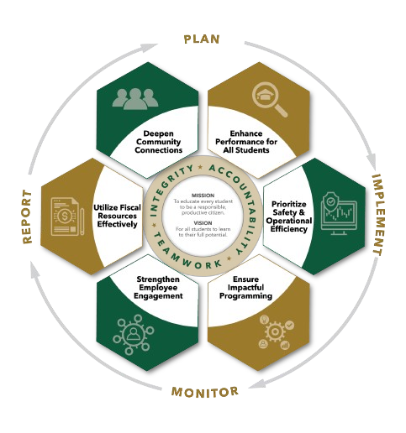


November agenda
Autrey Mill Middle School Governance Council
Date | time November 10, 2025| 7:45 am | Location Room A130

SGC Members: Trey Martin, Principal | Emma Cornwall, Teacher |Maud de Groot, Teacher | Ashley Perry, School Employee | Matthew McNamara, School Employee |Kathleen Newquist, Parent | Jessica Saszi, Parent |Beth Zampieri, Parent| Korina Calbay, Community Member | Jacob Marmer, Community Member
Time | Item | Owner
7:45am | Call to Order | Cornwall
7:46am  7:47am | Action Item: Approve Agenda  Action Item: Approve October Minutes | Cornwall  Cornwall
7:48am  7:55am | Public Comment  Informational Item: District 5 update | All Members  Kristin McCabe
8:05am  8:10am  8:15am | Discussion Item: Strategic Plan  Discussion Item: Charter Proposals  Action item: Charter Dollar Proposals | All Members  All Members  Cornwall
8:20am | Informational Item: Principals Update | Mr. Martin
8:30am  8:35am | Discussion Item: Draft Next Meeting Agenda  Action Item: Meeting Adjournment | All Members  Cornwall

Meeting Norms
Silences Phones | Be Respectful of Others’ Opinions | Work for the Good of All Students

