

Educator Effectiveness Evaluation Handbook

Board Approved
April 19, 2022
Revised June 10, 2025

Table of Contents

Table of Contents 2

Senate Bill 10-191 3

Performance Ratings 4

Components and Timelines of Evaluation 5

Evaluation System 6

Probationary Status for Teachers
Non-Probationary Status for Teachers
Colorado Revised Statute: 22-63-203(4)(a) and 22-63-203(I)

Educator Effectiveness Model 7

Earning or Losing Non-Probationary Status 8

Appeal Process 9

Senate Bill 10-191

Senate Bill 10-191 is the requirement to evaluate all licensed personnel annually. Senate Bill 10191 changes the way all educators (principals/assistant principals, teachers, and special services providers) will be evaluated in Colorado with the goal of continuously supporting educators' professional growth and, in turn, accelerating student results.
The evaluation requirements include opportunities for reflection, review, professional development, and growth. S.B. 10-191 requirements include:
- Annual evaluations for all principals/assistant principals, teachers, and special services providers.
- Evaluation based on statewide Quality Standards defining what it means to be an effective teacher, principal or special services providers, the professional practice Quality Standards account for seventy percent of an educator's annual evaluation.
- The other thirty percent of an educator's annual evaluation is based on Measures of Student Learning/Outcomes.
- Non-probationary status is earned after three consecutive years of demonstrated effectiveness, and the employee begins a fourth consecutive contract with District 70.
    - Non-probationary status is granted if:
      - Example: a teacher is contracted for three consecutive years at a school in Pueblo County School District 70 and has Effective or Highly Effective ratings on the annual evaluation for all three years and begins a fourth consecutive contract in Pueblo County School District 70.
- Non-probationary status is lost after two consecutive years of less than effective ratings.

Senate Bill 10-191 requires that seventy percent of an educator’s evaluation in Colorado be based Measures of professional practice (Quality Standards I-IV) selected by the district that meet state technical guidelines.
- Professional Practices are the behaviors, skills, knowledge, and dispositions that educators should exhibit.

Senate Bill 10-191 requires that thirty percent of an educator’s evaluation in Colorado be based on educator impact on student learning determined by using multiple measures in relationship to the Colorado Academic Standards.

- Teachers in Colorado will also be evaluated on measures of student learning.

PERFORMANCE RATINGS

Performance Rating Levels describe performance on professional practices with respect to Colorado’s Quality Standards. Professional Practices are the behaviors, skills, knowledge, and dispositions that educators should exhibit.

Professional practices are evaluated using the following rating levels:
- Basic: Educator’s performance on professional practices is significantly below the state quality standard.
- Partially Proficient: Educator’s performance on professional practices is below the state quality standard.
- Proficient: Educator’s performance on professional practices meets the state quality standard.
- Accomplished: Educator’s performance on professional practices exceeds the state quality standard.
- Exemplary: Educator’s performance on professional practices significantly exceeds the state quality standard.

  - Level 1 Practices: Foundational level of professional practices that should be occurring daily.
  - Level 2 Practices: Level of professional practices that build on the foundational level practices.
  - Level 3 Practices: Level of professional practices necessary to meet state quality standard.
  - Level 4 Practices: Outcomes of educator’s practices exceed state quality standard.
  - Level 5 Practices: Outcomes of educator’s practices significantly exceed state quality standard.

Measures and Artifacts are the documents, materials, processes, strategies, and other information that result from educators’ normal and customary day-to-day work. S.B. 10-191 requires that some non-observable evidence of performance (required measures) be discussed every year.

COMPONENTS OF EVALUATION

Educators should be trained on the system’s processes, tools, and materials to ensure foundational knowledge needed to implement the system.

ORIENTATION:

- Within the first 30 days of each school year, schools and districts provide an orientation on the evaluation system. This orientation should include measures to which educators will be held accountable, new system features, and process changes.

SELF-EVALUATION:

- By September 30 of each school year, each educator should complete a self-assessment. This provides an opportunity for educators being evaluated to reflect on their ability and the measures to which they will be held accountable, student needs and their professional growth plan. The educator may choose to share the self-assessment with the evaluator or not.

PROFESSIONAL GROWTH PLAN:

- By September 30 of each school year the evaluator and educator being evaluated should review annual school goals to ensure the goals stated in the educator's professional growth plan and measures of student learning/outcomes are aligned. This allows the educator to consider the context for that year with respect to school culture, student body, community issues and changes in district initiatives, and to adjust professional goals.

MID-YEAR REVIEW:

- By January 15 of each school year the educator being evaluated, and the evaluator should review progress toward achieving professional goals and measures of student learning/outcomes. o Discuss barriers to complete goals/measures and refine existing goals/measures as needed. o Throughout the school year, evaluators should monitor educator performance and record data collected toward the rubric. The evaluator should complete an initial Evaluator Assessment for the educator being evaluated to discuss during the midyear connection. o Evaluators and the educator being evaluated discuss the use of artifacts and any other evidence needed.
As a result of this review, every educator should have a clear understanding of what needs to be accomplished to achieve performance goals by the end of the year.

END OF YEAR REVIEW:

Two (2) Weeks prior to the last day of school, assign a rating for each element and standard to determine overall professional practices rating, MSL/O rating, and final effectiveness rating for the year.
- Review all evaluation materials with person being evaluated.

EVALUATION SYSTEM
PROBATIONARY AND NON-PROBATIONARY TEACHERS

Probationary Teachers:
- Each year probationary teachers receive at least two informal and two formal documented observations and a final evaluation documented in the RANDA Educator Evaluation System.

Non-Probationary Teachers:
- Each year non-probationary teachers receive at least one informal and one formal documented observation and a final evaluation documented in the RANDA Educator Evaluation System.

Probationary Status, Non-Probationary Status and Induction According to SB 10-191, teachers who are new to the teaching profession, new to the state of Colorado, or new to a Colorado school district shall be probationary for a minimum of 3 years. Additionally, teachers with probationary status are subject to non-renewal as per Colorado School Law (§ 22-63-203 (4)(a), C.R.S.). A probationary licensed teacher must receive three (3) years of consecutive effective summative evaluations to earn non-probationary status. A licensed teacher must teach for at least 120 days prior to the end of a school year in order for the year to count toward the three years. Board approved leaves do not count against the 120 days of teaching. There can be no breaks in service/employment while earning non-probationary status; leaves of absence are exceptions and are handled case by case - contact the Director of Personnel Services to discuss leaves of absence and implications for evaluation. If a probationary licensed teacher does not teach 120 days or more during the school year (leaves of absence notwithstanding), they will begin the following school year at probationary year one status. If a probationary licensed teacher does not receive an effective, or higher, summative evaluation in year one, two or three of their probationary status, they shall be moved back to probationary year one status and will need to demonstrate three consecutive years of effective summative evaluations to move to non-probationary status. According to the Colorado Revised Statutes (§ 22-63-203 (I)) licensed employees who are part of an Alternative Licensure Program are eligible to earn years toward probationary status.

EDUCATOR EFFECTIVENESS
CDE MODEL

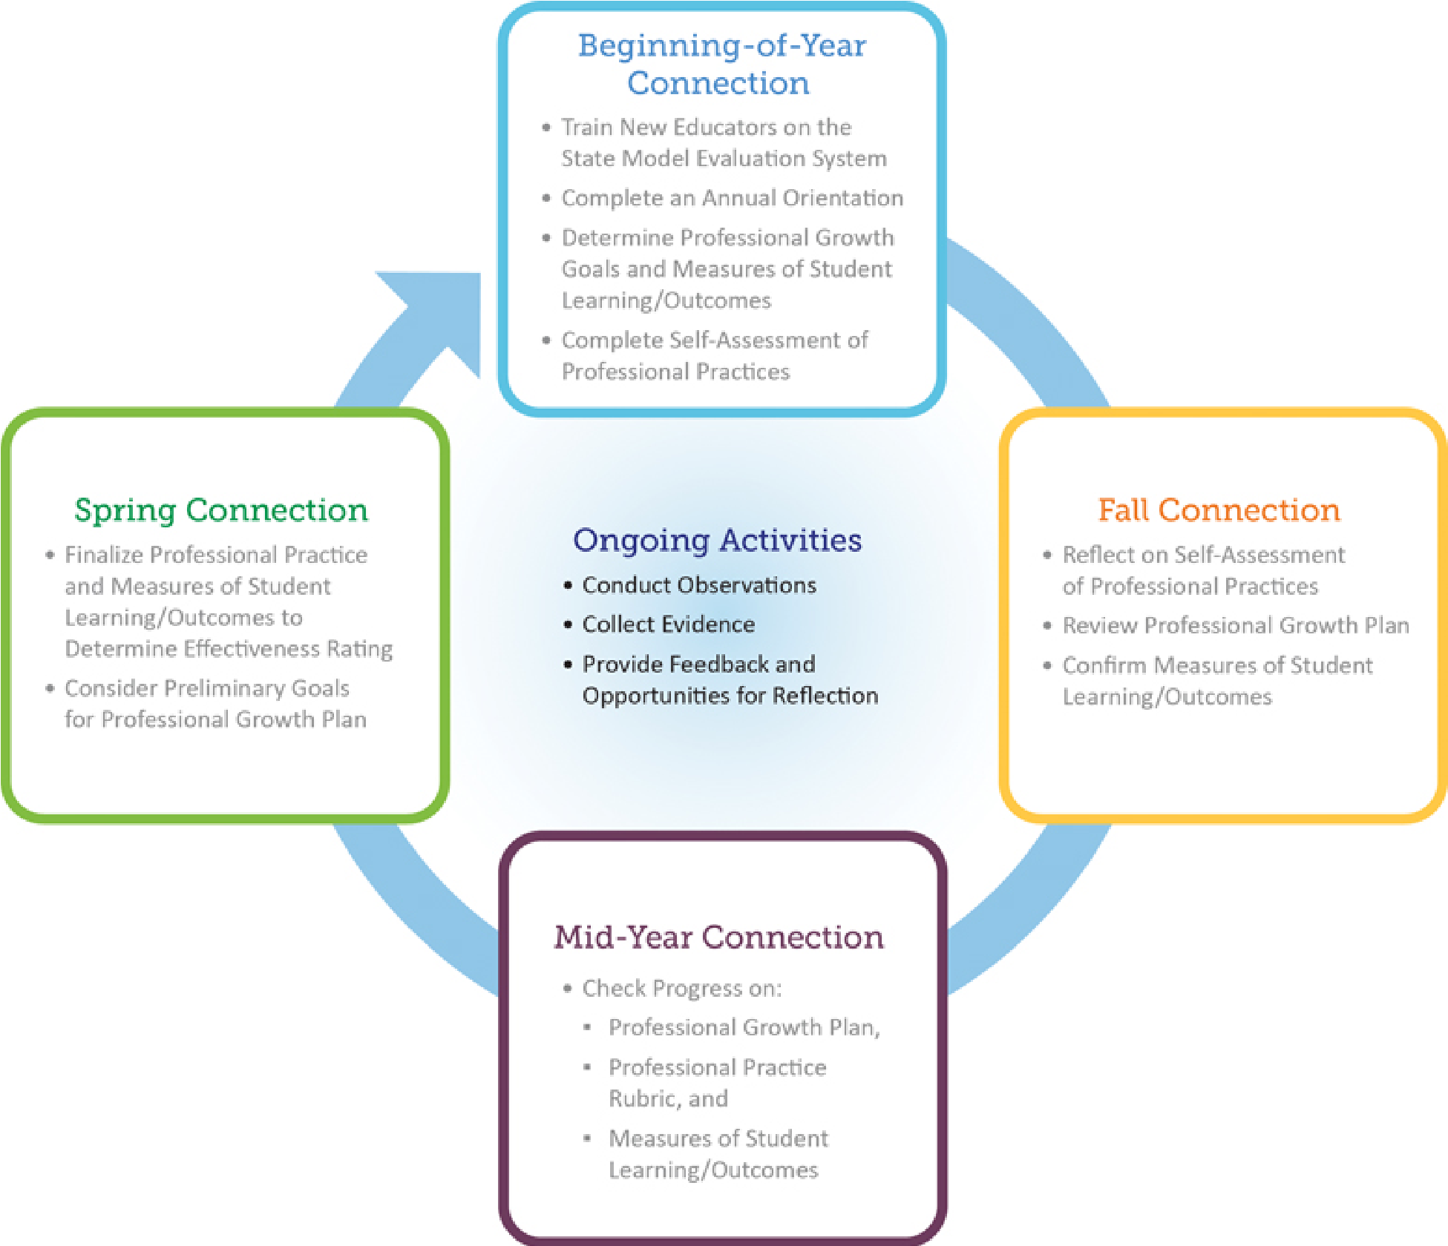

Earning or Losing Non-Probationary Status by Performance
Evaluation Rating

- Ineffective non-probationary teacher who is rated as ineffective for two consecutive years shall lose non-probationary status. A teacher whose performance is deemed ineffective shall receive written notice that his or her performance evaluation rating shows a rating of ineffective, a copy of the documentation relied upon in measuring his or her performance and identification of deficiencies.

- Partially Effective for a non-probationary teacher, a rating of partially effective shall be considered the first of two consecutive years of ineffective performance that results in loss of non-probationary status.

- Effective for a probationary teacher shall receive a rating of effective (or highly effective) for three consecutive years and begin a fourth contract with District 70 to earn non-probationary status.

o Two consecutive ratings below effective shall result in the loss of non-probationary status.

o Highly Effective for the purposes of gaining or losing non-probationary status shall have the same status as effective.

Portability of non-probationary status:

- It is the responsibility of the candidate to provide proof of non-probationary status to be ported to Pueblo County School District 70.
  - Request portability at time of application
  - Submit required evaluation documents with application
  - Verification from current employer of non-probationary status
  - Candidate will have 30-days post offer to submit all required documents

- In Pueblo County School District 70, working for Villa Bella Charter School or Swallows Charter Academy do not count towards non-probationary status. Non-probationary status is not earned at those Charter schools, as employees are “At Will” and employed on a one-year Letter of Employment.

APPEAL PROCESS

Colorado State Board of Education:

RULES FOR ADMINISTRATION OF A STATEWIDE SYSTEM TO EVALUATE THE
EFFECTIVENESS OF LICENSED PERSONNEL EMPLOYED BY SCHOOL DISTRICTS AND BOARDS OF COOPERATIVE SERVICES1 CCR 301-87 0.0

STATEMENT OF BASIS AND PURPOSE:
The statutory basis for the addition of section 5.04 to these rules is found in Colorado Revised Statutes section 22-2-107 (1) (c), section 22-9-104 (2) and section 22-9-105.5 (10), which requires the State Board of Education to promulgate rules concerning a process by which a non-probationary teacher may appeal his or her second consecutive performance rating of ineffective. These rules are promulgated pursuant to Colorado Revised Statutes section 22-2-107 (1) (c), section 22-9-104 (2) and section 22-9-105.5 (10). Senate Bill 10-191, codified at section 22-9101, C.R.S., et seq. creates a system to evaluate the effectiveness of licensed personnel in school districts and boards of cooperative services throughout the state as a means of improving the quality of education in Colorado. The basic purposes of the statewide system to evaluate the effectiveness of licensed personnel are: To ensure that all licensed personnel are evaluated using multiple, fair, transparent, timely, rigorous, and valid methods, fifty percent of which evaluation is determined by the academic growth of their students; To ensure that all licensed personnel receive adequate feedback and professional development support to provide them a meaningful opportunity to improve their effectiveness; and To ensure that all licensed personnel are provided the means to share effective practices with other educators throughout the state.

APPEAL PROCESS LANGAUGE
1) The appeals process will provide the opportunity for all education stakeholders to identify deficiencies in the evaluation system; resolve differences among stakeholders; refine and improve the system in a meaningful way that will benefit our students; and foster a shared responsibility for improving educator effectiveness.
2) The appeal process shall allow for a final determination of the appealing Teacher’s Performance Evaluation Rating and a final determination of whether that Teacher retains non-probationary status; it shall not serve the purpose of determining employment and/or termination.
3) The teacher has 15 workdays after receiving the evaluation to file an appeal of an evaluation. The appeal shall be filed in writing with the Evaluator. The evaluator, in turn, shall notify the Superintendent. The Superintendent shall then notify the Association President and H.R.
4) The Appeals Process shall be completed within 45 workdays. This limit may be waived or changed by mutual agreement of the teacher and the District. The appeals process and results shall remain confidential.
5) A panel of Five Individuals shall convene to review the teacher’s appeal. The panel shall consist of two teachers chosen by the Association, two administrators chosen by the Superintendent, and a mutually agreed upon fifth member of the committee. These individuals shall not be related to the appealing Teacher or his/her Evaluator, nor have knowledge of the appealing Teacher’s evaluation. These individuals shall complete training by CDE, or a mutually agreed upon third party, in the evaluation process. The District and Association shall maintain a list of qualified panelists to serve on the Appeals Panel. Panelists’ term shall be limited to 3 years.
6) Should the Panel convene during contracted hours, the District shall provide a substitute for the Teacher Panelists and Appealing Teacher. Should the Panel convene outside of contracted hours, the Teacher Panelists shall be compensated at the teacher’s per diem rate.
7) The Appealing Teacher shall present a variety of documentation to the Panel to dispute their Evaluation Rating. The Panel shall consider all such documentation in reaching a decision. Documentation shall be relevant to the professional practice standards.
8) The Panel shall make a decision regarding the rating in the evaluation and the non-probationary status of the Teacher. The Superintendent shall review the Panel’s recommendation. The Superintendent shall reserve the right to overturn the panel’s decision based on the process of the panel. The Superintendent shall give written rationale for his/her final decision to the Appealing Teacher.
9) In the event the Panel is unable to reach a unanimous finding the minority opinion shall be presented to the Superintendent along with the majority opinion in a manner decided upon by the Superintendent. In this case, the Superintendent and the Association President shall reach a decision regarding the Appealing Teacher’s Evaluation Rating and Non-Probationary status. The Superintendent shall give written rationale for his/her decision to the Appealing Teacher.
20.3 Evaluation Timeline
PCEA and District 70 agree to the following timeline for the evaluation of teachers.

Within the first 30 days of each school year - The evaluator will meet with the employee, individually or in a general meeting, to authorize the evaluation process, timelines, and review the District 70 Effective Teacher Standards, Elements, and Professional Standards. The teacher shall acknowledge through signature that the evaluation process has been reviewed with them.
September 30 of each school year- Each teacher shall meet collaboratively with their evaluator to discuss their evaluation plan which shall include goals, outcomes, plans for collecting data and student growth, and for measuring goals and student growth. If the Self-Assessment is used, it should be completed by this meeting but is considered confidential on the part of the teacher.
January 15 of each school year- Each teacher shall meet with their evaluator to discuss mid-year progress and to provide a written progress report to the teacher. Any concerns shall be addressed, and a plan of action shall be developed with teachers who are not effective in any of the standards. Teachers shall be encouraged to collect additional documentation to support meeting the Educator Effectiveness Standards, if needed
Two (2) weeks prior to the last day of school - End-of-Year review and reflections shall be completed, signed, and a written copy provided to the teacher, the evaluator, and the Human Resources Office. Any teacher rated partially effective or lower shall work with the evaluator to develop a reasonable plan for improvement of instruction for the following year. This plan shall be in place by the last day of the school year for the following year. (6/21)
Timeline for Teachers placed on Improvement Plan
August 30 of each school year - Any teacher placed on an improvement plan the previous school year shall review their plan with their evaluator.

January 15 of each school year- Any teacher on an improvement plan shall discuss their mid-year progress with their evaluator. At that point, the teacher shall be removed from the improvement plan if the teacher shows adequate growth and progress. In the event the teacher does not show adequate growth and progress the teacher shall be placed on a Remediation Plan. The Remediation Plan will be created collaboratively and have reasonable expectations for the teacher. This plan shall be created as soon as possible, but not longer than 10 workdays after January 15.
April 15 of each school year- The Remediation plan shall be reviewed with the Teacher. The evaluator will discuss with the employee the three options: adequate growth and removal of the plan, continuation of the plan, or dismissal.
20.4 Pueblo County Education Association (PCEA) and Pueblo County School District 70 agree to the following language:
Teachers whose final rating on their Summative End of Year Evaluation is borderline between Highly Effective and Effective, Effective and Partially Effective, or Partially Effective and Ineffective may be able to exclude a student(s) from their Measures of Student Learning rating if two of the three following criteria are met by the student(s):
- The student has less than 85% attendance in the teacher’s class or is facing truancy proceedings with District 70.
- The student is failing 2 or more classes at the school
- The student has not met growth goals on local assessments Testing for the class.
A class comprised of at least 50% of students on a plan can be taken into consideration in determining exclusion of student scores in the final evaluation rating. The decision for exclusion shall be made with the Principal/Evaluator and the teacher and shall be limited to only teachers on the borderline of ratings. Should exclusion of a student score meet these criteria, the Evaluator shall remove the student’s score from reports used for the Summative Evaluation. If local assessments reports are used in the Summative Evaluation, the Director of Instruction or his/ her designee shall be contacted to remove the student’s score from local assessment reports. (03-2024)

