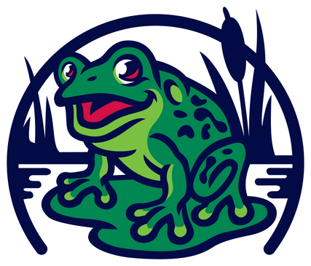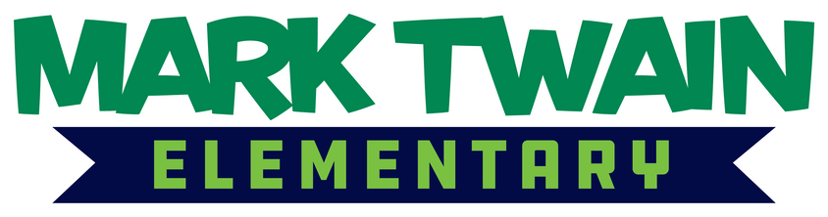

School Improvement Plan Summary 2025-2026

If you would like more information about the school improvement plan, please contact the principal.

Signature Strategies

Goal 1: The Early Years
Teaching and learning behaviors reflect anti-racist and culturally responsive instructional practices (i.e. Universal Design for Learning (UDL)/Sheltered Instruction Observation Protocol (SIOP) strategies) and norms aligned to the instructional framework and systemwide guaranteed and viable curriculum.
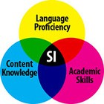
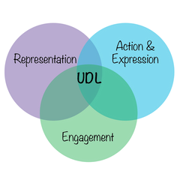
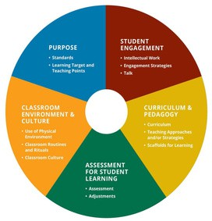




Engage Professional Learning Communities (PLC's) in a cycle of inquiry using multiple measures to inform and adjust instruction while disaggregating data through an equity lens (interim common assessments).


Goal 2: The Whole Child
Collaborate with families in authentic ways (e.g., Parent Advisories, Family Academies, Family Nights, translated materials, videos in multiple languages, home visits) across languages and cultures to integrate family funds of knowledge into school systems and help families understand available services, advocate for their scholar's needs, and support their scholar's learning.








Implement structures (e.g. effective Success Criteria) in every classroom, to support consistent use of data by our student-scholars to assess their own learning, determine learning goals, and monitor progress over time.

Academic SMARTIE Goals
English Language Arts (ELA) Proficiency Target
Increase the percentage of scholars scoring proficient or advanced on the state ELA assessment from 29% to 40%, Multilingual scholars from 42% to 60%, and scholars with IEPs from 17% to 35% by the end of the 2025-2026 academic year.

Increase the percentage of K-2 scholars meeting their stretch goal on the iReady reading diagnostic assessment from 30% to 60% and Multilingual scholars from 28% to 60% by the end of the 2025-2026 academic year.

Math SBA Proficiency Target
Increase the percentage of scholars scoring proficient or advanced on the state math assessment from 16% to 36%, Multilingual scholars from 37% to 57%, and scholars with IEPs from 9% to 20% by the end of the 2025-2026 academic year.

Increase the percentage of K-2 scholars meeting their math stretch goal on the iReady diagnostic assessment from 32% to 52% and Multilingual scholars from 35% to 55% by the end of the 2025-2026 academic year.
