Guardian: Overview of SchooLinks Account Features
SchooLinks provides a variety of tools designed to help guardians track their student's progress and support their journey toward post-secondary success.
Guardian: Overview of SchooLinks Account Features 1
Guardian Dashboard 2
Top Navigation Bar 3
Side Navigation Bar 4
Student Casefile 5
Student Activities 6
Planning 6
College 6
Career 6
Finance 7
Other Casefile Sections 7
Manage Meetings with Staff 7

Guardian Dashboard
Upon logging in, you will be brought directly to the Guardian Dashboard. To return to the dashboard after visiting another page, click the SchooLinks icon in the upper left corner.
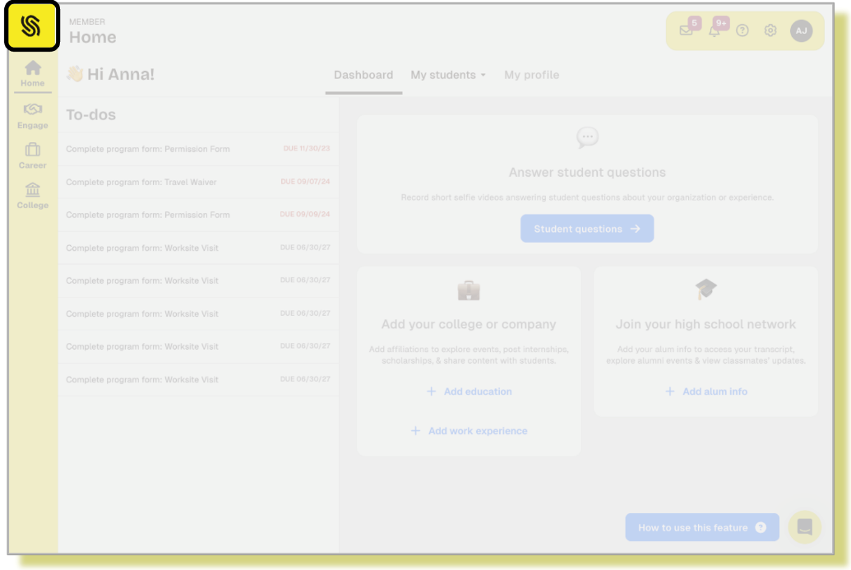
The dashboard provides a list of guardian To-Dos assigned by school staff to assist you in staying updated with your student's needs.
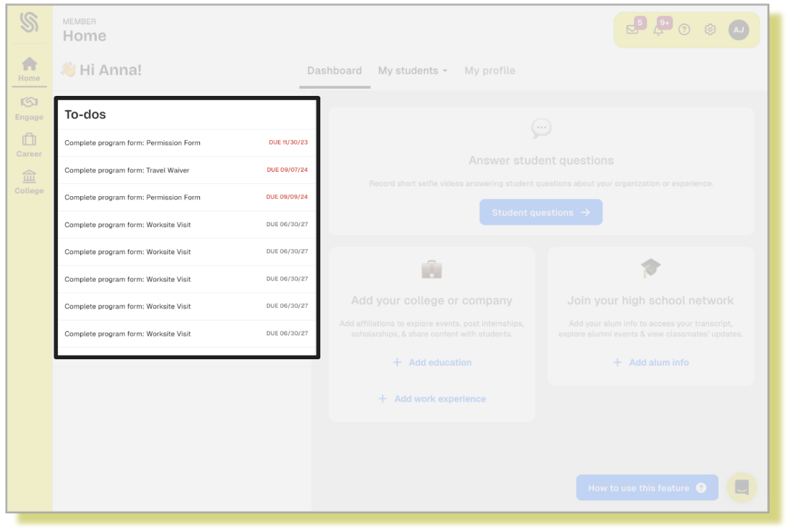

Top Navigation Bar
Use the top navigation bar to access the following features:
- Selected Mode: If enabled by your district, guardians who are also staff members can switch between their guardian and staff accounts via the selected mode dropdown.
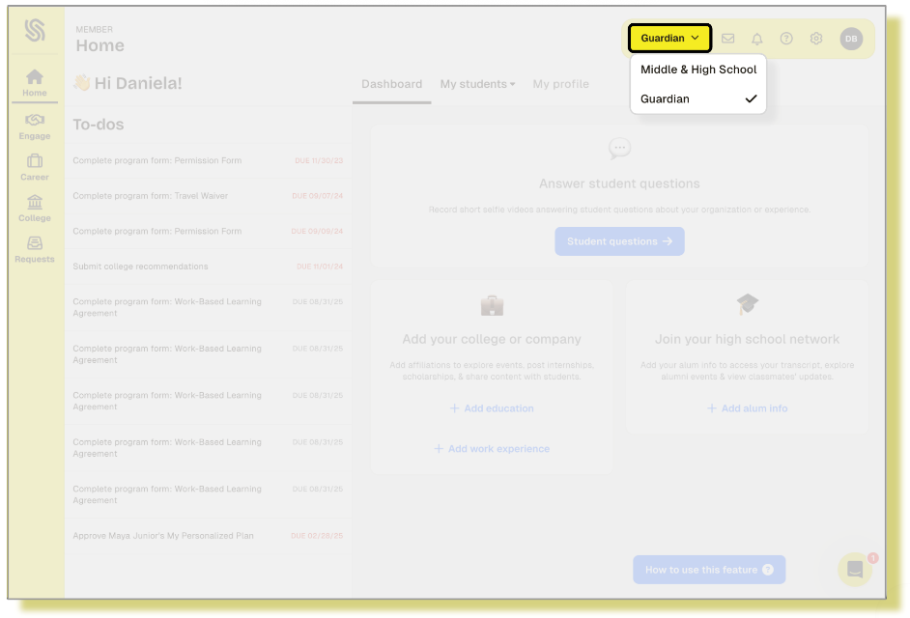
- Messages: Send and receive messages from your student’s counselor. Click the plus sign, select the appropriate student, then select the school contact you wish to send a message to.
  - Reply to a message from the Add message box at the bottom of the screen.
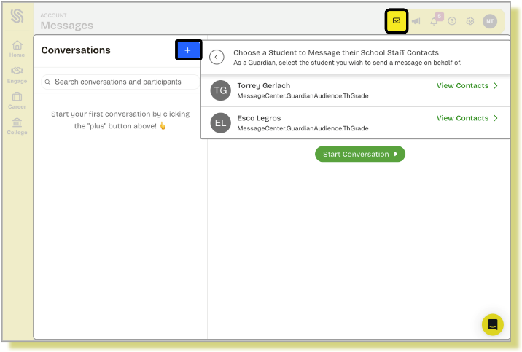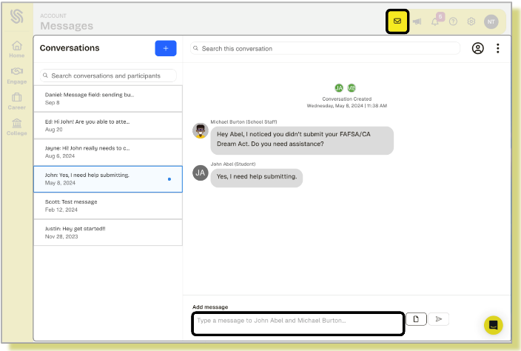

- Announcements: View your current and past announcements. Click the three-dot menu to pin an important announcement or send a message to the poster.
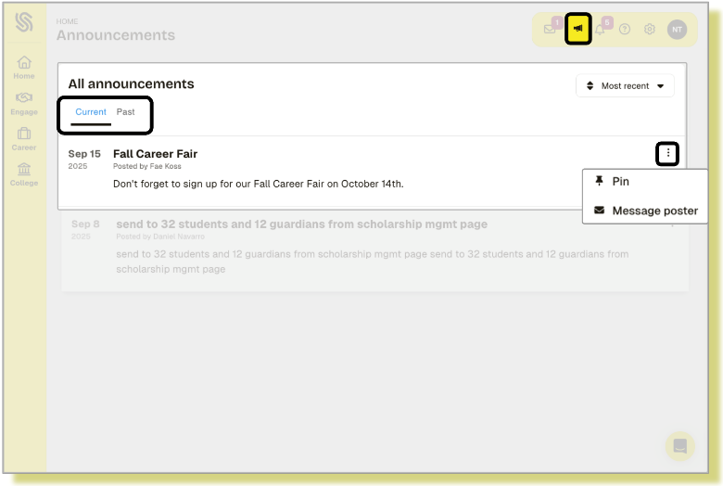
- Notifications: Receive notifications about any action items.
- Help Center: Access SchooLinks help articles.
- Account Settings: Adjust account settings, manage affiliations, and access the language translation feature.
- Guardian Profile: Access your guardian profile settings and features.
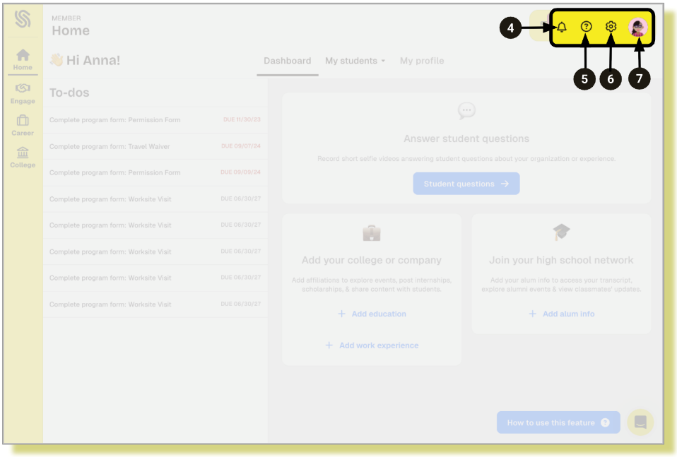

Side Navigation Bar
Use the side navigation bar to access the SchooLinks features and pages available to Guardians:
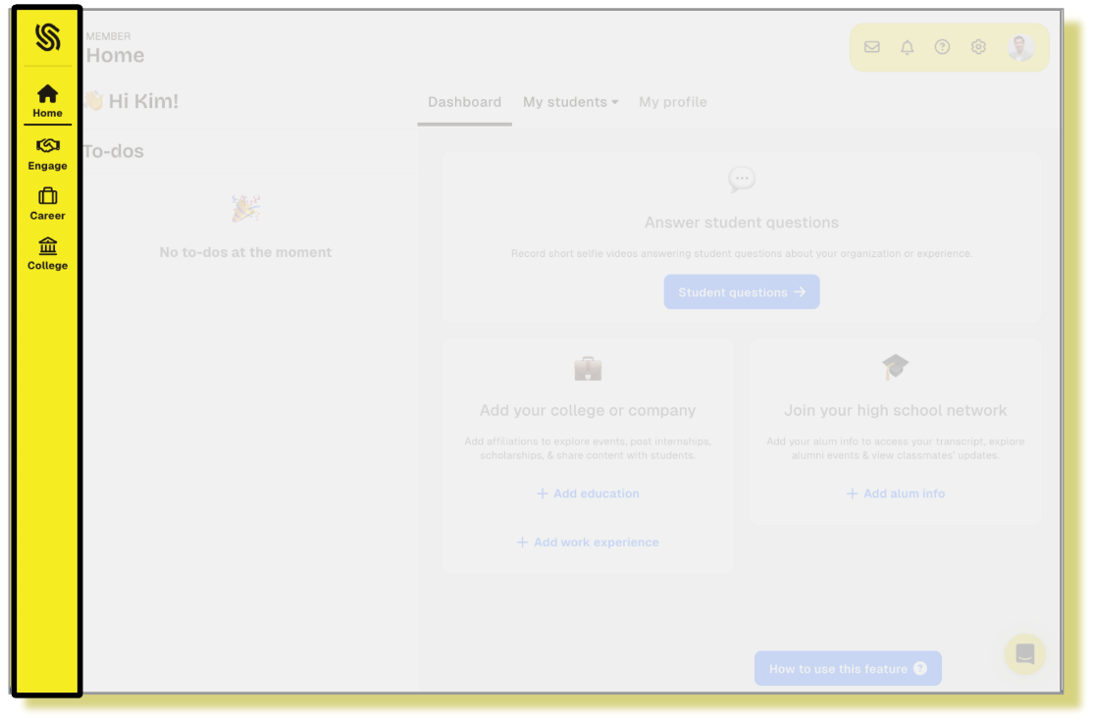
- The Engage category provides Guardians with access to the Opportunity Board.
  - The Opportunity Board allows you to view current opportunities—such as internships, volunteer positions, and part-time jobs—that your student can apply for. It's a helpful way to stay informed and support your student in exploring real-world experiences.

- The Careers category provides a comprehensive view of career exploration and real-world opportunities available to your student. Guardians can explore career profiles, virtual workplace tours, and district-specific career pathways.
  - Employer Showcase: Browse various organizational videos, photos, and text highlighting each company's strengths, mission, programs, and initiatives that might appeal to students considering a career in the field. This information helps students envision where they might fit into the industry and the various skills and knowledge they might need to succeed.
  - Career Center: Review comprehensive data on each of the careers recognized by the U.S. Bureau of Labor Statistics, search by region/state, cluster, hot jobs, or specific career titles.
  - District Pathways: Discover the programs (CTE programs, endorsements, enrichment programs) offered at schools across the district.
    - Each pathway will list out the schools in the district where the pathway is available, course options that fulfill the pathway, and related career clusters.
- The Colleges category gives Guardians access to the following pages:
  - School Search: Search for colleges and learn about them from the school’s profile page
    - Search and filter by location, school type, degree type, and more
  - Scholarship Matching: Access to a scholarship matching profile
    - Build the profile based on eligibility, interests, specific colleges
    - View scholarships by filtering, searching the list by title or provider

Student Casefile
The student casefile provides guardians with insights into the various activities their students are completing in SchooLinks. While most casefile sections are view-only, there are a few sections that do allow for guardian action. These sections are outlined in this video.
- To access your student's casefile, click the My Students tab, then select the student's name.
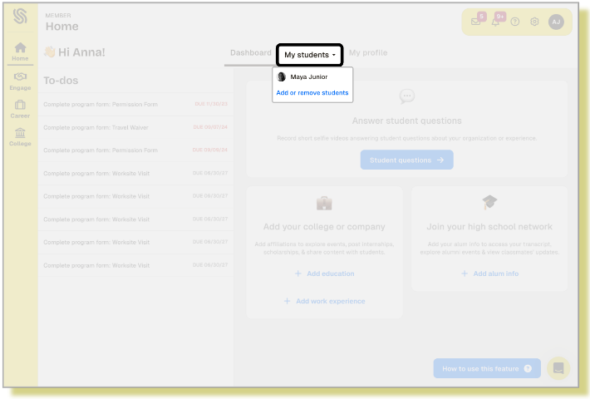

- Click the Casefile section dropdown to view the available sections. Click on a section to navigate to that area of your student's casefile.
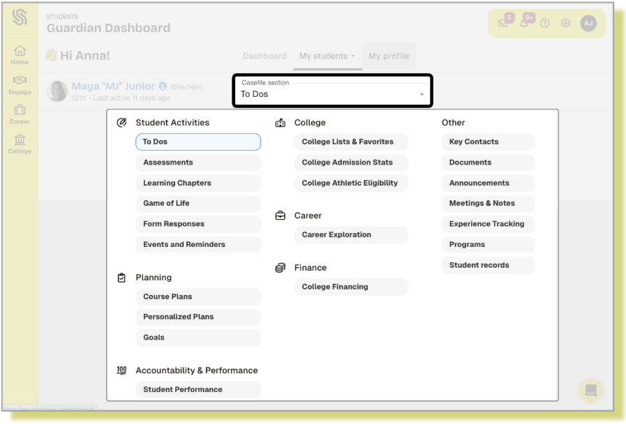

Student Activities
- To-Dos: By default, the student's casefile opens to the Student To-Do list. You can also find your guardian To Dos in this section.
- Assessments: View student assessment results
- Learning Chapters: View student learning chapters activity and progress
- Game of Life: View Game of Life scenarios
- Form Responses: View student survey responses.
- Events and Reminders: View events available to both you, the guardian, and the student, as well as any events previously registered for.

Planning
- Course Plans: View and comment on the student's course plan.
- Personalized Plans: View and approve the student's personalized plan.
- Goals: View student career, college, and SMART goals.

College
- College Lists & Favorites:
- View favorited schools, programs, school lists, the counselor list of recommended colleges
- View and comment on a student's Final List
- Make a college recommendation (Guardian's List)
- College Admission and Stats: Compare the student's test scores and GPA to all enrolled students at their colleges of interest.

Career
Career Exploration: View the student's career goals, Would You Rather assessment results, and favorited careers.

Finance
College Financing: View estimated and actual costs for colleges of interest or colleges the student has been accepted into.

Other Casefile Sections
- Key Contacts: Access the profile of the student's counselor or any staff member assigned to the student. You can also access the student's messages with those staff members from here.
- Documents: View and upload documents in the student's document center
- Announcements: View your student's current and past messages and announcements.
- Meetings & Notes: View student notes or meeting logs that have been made visible to guardians
- Experience Tracking: View the student's experience entries and activity. *Note: This feature is only available if purchased by the district.
- Programs: View the student's Work-based Learning program applications and placement information. *Note: This feature is only available if purchased by the district.
- Student Records: View the historical record of requested transcripts and the status of each. You can also download an unofficial transcript from this page.

Manage Meetings with Staff
If staff members have the meeting scheduler configured in SchooLinks, they can generate available time slots for guardians to sign up for.
- Click Key Contacts under Other from the Casefile section dropdown
- Click Schedule Meeting in the row of the counselor or teacher you want to schedule a meeting with
- Select the type of meeting and view the description
- Select an available day from the calendar
- Choose an available time slot for that day
- Leave an optional note
- Click Schedule Meeting
- To view your meeting, it will be displayed in the Reminders section of your Guardian dashboard.
  - You will receive automated reminders: one day prior and five minutes before the scheduled time.
Guardians may also be invited to meetings directly by staff members. Whether a guardian books a time slot themselves or is invited by staff, the meeting will appear in the To Do section of the student’s case file for easy tracking and management. The alert for a meeting booked by a staff member will be visible from the Notifications icon and will appear in the Needs Action section of the Reminders tab.
- Click Respond to view pending meeting details
- Click Accept or Decline at the bottom of the meeting details panel
- Click View to open the meeting details panel any time after responding
Note: Guardians can only schedule meetings with, or accept invitations from, staff members assigned to their student in SchooLinks.

