Grade 7 ELA
Year-at-a-Glance (DRAFT)
2024-2025
Module A  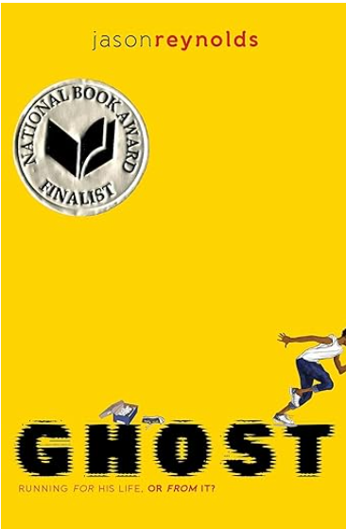  August 12-September 13  24 Days | Conflicts and Clashes  Essential Question: How do you find out what you are really made of?  Anchor Text: Ghost, excerpt from Stargirl - StudySync, “We Beat the Street” StudySync, “Choices” StudySync, “Why Run?—A Sonnet”, “Be Gentle with Yourself—A Villanelle”  Writing Focus: Narrative | Focus Benchmarks  ELA.7.R.1.1  ELA.7.R.1.2 ELA.7.R.1.3 ELA.7.R.1.4 ELA.7.R.3.1 ELA.7.V.1.3  ELA.7.C.1.2
Module B  September 16-October 11  19 Days | Myriad of Emotions  Essential Question: Do we control our emotions or do our emotions control us?  Anchor Text: “Sonnet 18” BEST, “the Sonnet-Ballad" BEST, “Mad”, “You Have More Control Over Your Emotions than You Think”, StudySync, “Your Emotions are a Sign of Strength. Here’s Why”, excerpt from The Skin I’m In - StudySync, “Reality TV and Society” StudySync, “How Inside Out Explains the Science of Memory”, “The Yearling” StudySync, “How Animals Grieve” StudySync, Music & Emotions Text Set  Writing Focus: Expository | Focus Benchmarks  ELA.7.R.1.2  ELA.7.R.1.4  ELA.7.R.2.1  ELA.7.R.2.2  ELA.7.R.2.4  ELA.7.R.3.1  ELA.7.R.3.3  ELA.7.R.3.4  ELA.7.C.1.4
Module C    October 15-November 8  19 Days | Eerie Stories  Essential Question: How do your own fears and experiences influence your response to eerie stories and real-life mysteries?  Anchor Text: “The Monsters are Due on Maple Street” StudySync, “The Eyes Have It” StudySync/BEST, “An Occurrence at Owl Creek Bridge” StudySync/BEST, “The Tell-Tale Heart” StudySync/BEST, “Harrison Bergeron” StudySync, “Annabel Lee” StudySync, National Geographic Kids’ History’s Mysteries: Freaky Phenomena  Writing Focus: Expository  DISTRICT WRITING ASSESSMENT: Week of November 4 | Focus Benchmarks  ELA.7.R.1.1  ELA.7.R.1.3  ELA.7.R.1.4  ELA.7.R.2.1  ELA.7.R.2.2  ELA.7.R.2.3  ELA.7.R.2.4  ELA.7.C.1.3
Module D    November 11-December 20  24 Days | Extreme Environments (Book Clubs)  Essential Question: How do extreme environments push the boundaries of human exploration and innovation?  Anchor Text: “Woodsong” StudySync, “Exploring the Life of the Congo Basin Rain Forest”, “The Desert” StudySync, “Living and Working in Space”, “What We Know About the Ocean’s Depth”, Book Clubs TBD  Writing Focus: Argumentative/Expository | Focus Benchmarks  ELA.7.R.1.1  ELA.7.R.1.2  ELA.7.R.1.3  ELA.7.R.2.1  ELA.7.R.2.2  ELA.7.R.2.3  ELA.7.R.3.1  ELA.7.R.3.3  ELA.7.C.1.3  ELA.7.C.1.4
Module E  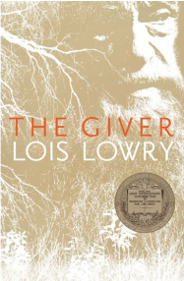  January 7 – February 7  23 Days | Power of One  Essential Question: How does the pursuit of control and sameness impact human experience?  Anchor Text: The Giver, “Do Not Go Gentle into That Good Night” BEST, “Conformity”, “Drones: Putting Eyes in the Sky”, excerpt from The Curse of the People who Never Feel Pain, “Some People Never Experience Stress: Are They Happier?”, Red Scarf Girl” StudySync, “Whispers of Sameness—A Villanelle”  Writing Focus: Argumentative/Expository | Focus Benchmarks  ELA.7.R.1.1  ELA.7.R.1.2  ELA.7.R.1.3  ELA.7.R.1.4  ELA.7.R.2.1  ELA.7.R.2.2  ELA.7.R.3.1  ELA.7.R.3.3  ELA.7.R.3.4  ELA.7.C.1.3  ELA.7.C.1.4
Module F  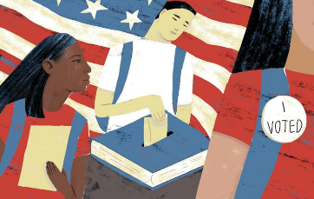February 10 – March 14  24 Days | Rise Up  Essential Question: What risks are required to lead a revolution?  Anchor Text: excerpt from Citizenship & Leadership BEST, “Address Before a Joint Session of the Congress” BEST, “The Words We Live By” StudySync, “On Women’s Right to Vote” BEST, “The Destructive Male” BEST, “Give Me Liberty or Give Me Death” BEST, “The Hill We Climb”, George vs. George: The American Revolution as Seen from Both Sides BEST, “Red Scarf Girl” StudySync  Writing Focus: Argumentative/Expository | Focus Benchmarks  ELA.7.R.2.3  ELA.7.R.2.4  ELA.7.R.3.1  ELA.7.R.3.3  ELA.7.R.3.4  ELA.7.C.1.3  ELA.7.C.1.4
Module G  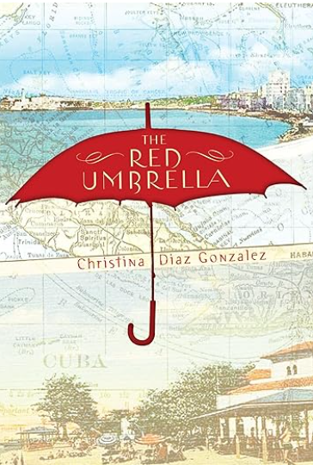  March 24 – April 25  23 Days | Charge On  Essential Question: What drives one forward when there is no turning back?  Anchor Text: The Red Umbrella BEST, excerpt from Flesh and Blood so Cheap - StudySync, “Barrio Boy” StudySync, Nothing to Envy – Reading StudySync, “Pedro Pan: A Children’s Exodus from Cuba”, “The New Colossus” BEST, “The Boy Who Harnessed the Wind” StudySync, “Project Sunlight” (a villanelle)  Writing Focus: Argumentative/Expository | Focus Benchmarks  ELA.7.R.1.1  ELA.7.R.1.2  ELA.7.R.1.4  ELA.7.R.2.1  ELA.7.R.3.1  ELA.7.R.3.3  ELA.7.C.1.3  ELA.7.C.1.4
Module H  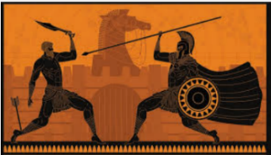April 28 – May 29  23 Days | Test of Time  Floating Five: Strategic Reading Days (prior to FAST PM 3)  Essential Question: Why do we still read myths and folktales?  Anchor Text: “On First Looking into Chapman’s Homer” BEST, “Aesop’s Fables” StudySync, “The Other Side of the Sky” StudySync, “The Story of Anniko” StudySync, “Icarus and Daedalus” StudySync, “The People Could Fly” StudySync, “excerpt from: The Hunger Games” StudySync, “The Classic Roots of The Hunger Games” StudySync, “The Cruel Tribute” StudySync  Writing Focus: Myths | Focus Benchmarks  ELA.7.R.1.1  ELA.7.R.1.2  ELA.7.R.1.3  ELA.7.R.1.4  ELA.7.R.2.1  ELA.7.R.2.2  ELA.7.R.2.3  ELA.7.R.2.4  ELA.7.R.3.1  ELA.7.R.3.3  ELA.7.R.3.4  ELA.7.C.1.2
*Benchmarks ELA.7.V.1.2, ELA.7.V.1.3, and ELA.7.R.3.2 are embedded in each module.

