Elsie Allen High School
Student Handbook

2025/2026 School Year



Casey Cunningham - Principal
D.J. Brookshire - Vice- Principal
Kath Cuéllar Jiyan - Vice Principal

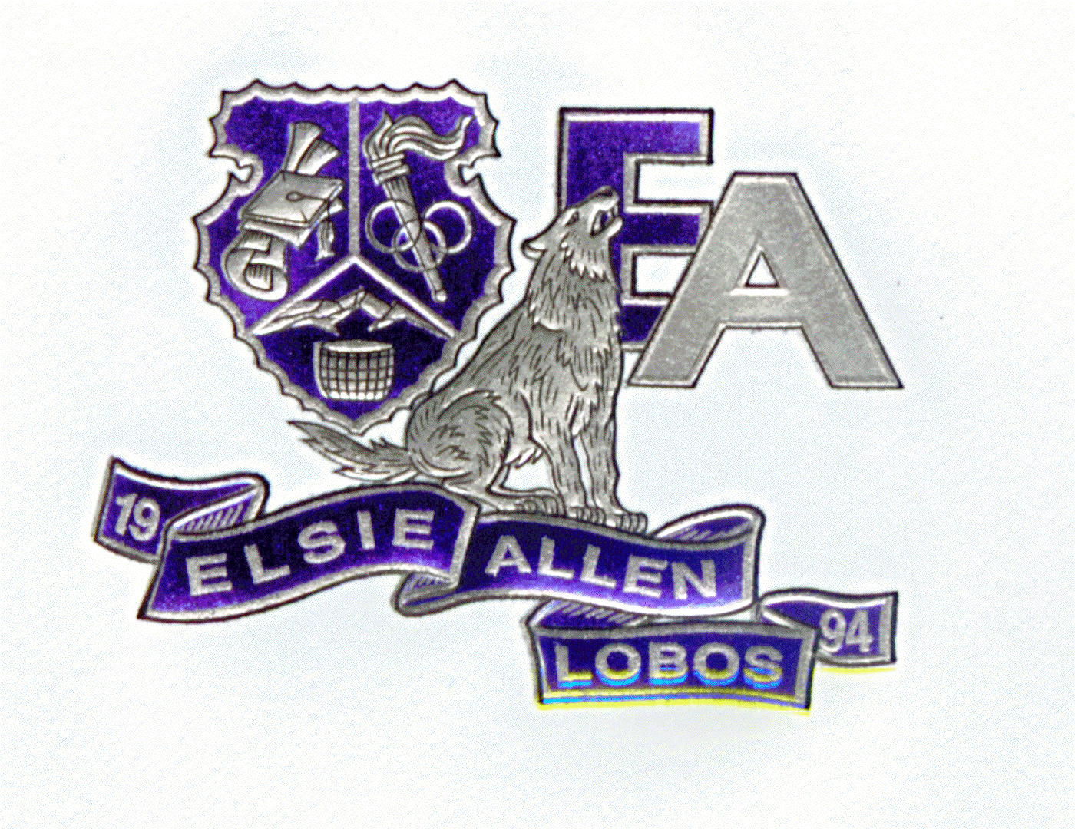
MISSION:
Elsie Allen High School provides a dynamic academic curriculum to prepare all students for college and career success in partnership with our families and community
VISION:
Elsie Allen High School is an inclusive community that challenges and supports students to achieve their personal, academic, and career potential.

EAHS Graduate Student Profile

Resilient Learners | I am motivated to overcome obstacles and reach my goals.
Goal Oriented Achievers | I am able to navigate educational and job opportunities so that I feel empowered to reach my goals.
Global Aware Citizens | I can embrace global ideas and experiences in the community and world around me.
Effective Communicators | I am able to communicate effectively.
Financially Empowered Individuals | I am educated so that I can be financially empowered.

Elsie Allen Contact Information

Elsie Allen High School:
(707) 890-3810
(please dial extension listed)

Attendance Office x53110/x53111
Bev Perez, Attendance Tech
Angel Ortega, Attendance Tech
Absences
Truancy
Permission to leave campus
Homework
Messages to students

Counseling Office x53119
Rosalia Gonzalez, Counseling Secretary
Enrollment
Shadowing
Name/address/phone changes
Free & reduced lunch forms

Health Office x53136
Christa Nash, Health Tech
Pick up ill students
Emergency cards
Student medications/injuries
Immunizations

Library x53126/x53127
Thalia Gomez, Library Tech
Crys Gray, Library Tech

Family Engagement x53284/x53129
Lizabeth Moreno
Mayra Sosa

Restorative Specialist x53296
Mayra Gonzalez

Athletic Director x53123
Ry Basham- Mintz Athletic Director
Sports schedules
Sports information
Athletic Packets

Business Office x53137
Mariz Lopez, School Accounts
Parking permits
Work Permits
Purchases
Dance Permits
Bus Passes
Locks/Lockers

Campus Safety x53150
Ryan Halverson

Vice Principal’s Office x53118
Sally Gonzalez, Registrar/VP Secretary
D.J. Brookshire, Vice Principal
Diplomas
Transcripts
Grades/Report Cards
School Records
Curriculum

Principal’s Office x53101
Kathy Hayes, School Secretary
Casey Cunningham, Principal

Elsie Allen Important Information and Reminders

Emergency Cards - Emergency cards for all students must be on record. The information must be kept current, as a student cannot be dismissed from school prior to the end of the school day unless a parent/guardian or designated person is notified.

Lockers - Lockers should be kept clean and free of stickers, food, and graffiti at all times and should never be left unlocked. The school assumes no responsibility for the loss of any items left in a locker. LOCKERS ARE THE PROPERTY OF THE SCHOOL AND MAY BE OPENED BY SCHOOL PERSONNEL AT ANY TIME.
Backpacks - Student backpacks should never be left unattended as the school is not responsible for lost or stolen backpacks.
Bikes - Always lock your bike securely as the school cannot guarantee the security of bikes.
Parking – A vehicle must have a parking placard. See the Business Office to obtain a placard. Students may only park in the parking lot with solar panels. Parking in other locations may result in your car being towed. Driving to school is a privilege, not a right. Please obey the law and follow safety guidelines:
- Lock your vehicle at all times. The school assumes no responsibility for loss, theft, or damage.
- Speeding or reckless driving is prohibited and may result in a SRPD citation, loss of parking privileges, and your car towed off campus.
- Students are not permitted in cars and parking lots during the school day.
Textbooks/Chromebooks/Library Books - Student ID Numbers are required to check out books and Chromebooks. Students are responsible and in the event a textbook or Chromebook is lost or damaged, the student will either be charged for damages or the full replacement cost.
Library: - (707) 890-3810 ext 53126/53127 The library is open to students between the hours of 7:30 AM and 3:30 PM.

Health Office: (707) 890-3810 x53136 - If a student becomes ill during the school day, he/she must check out through the Health Office. Any student who needs to take medication at school should bring a current statement from his/her physician.

Santa Rosa Community Health Center: (707) 583-8777 - Elsie Allen Health Center, EAHC, is located in the G building. The EAHC is owned by Santa Rosa Community Health and offers a variety of services.. A signed parent consent form is required.

ACTIVITIES

Clubs - We offer a variety of clubs and after-school activities. Listen for meeting details during the school bulletin and attend club sign up day in the quad.

Dances - All school-sponsored dances are for high school students only and require a dance clearance form each school year. Guest passes will not be issued to anyone in 8th grade or below, or over the age of 20. Students on the loss of privilege list may not attend dances.
Yearbook - The yearbook provides a wonderful record of your high school experiences. Buy early, supplies are limited.

ATHLETICS - District Approved Sports
Fall Season Winter Season Spring Season
Football Basketball Baseball
Girls Tennis Wrestling Softball
Cross Country Soccer Badminton
Volleyball Track & Field
Girls Golf
Girls Flag Football Boys Tennis
Swimming
Boys Golf

Eligibility - In order to be eligible to participate in sports activities in the Sonoma County League, the student must meet minimum requirements set forth by the California Interscholastic Federation, North Coast Section, Santa Rosa City Schools, and Elsie Allen High School. These include, but are not limited to:
- Proof of physical taken after July 1 (appointments may be scheduled through the Elsie Allen Health Center).
- Minimum 2.0 GPA, passed 20 credits during the previous grading period, and is currently enrolled in at least 4 classes. Students must also be on track to graduate.
- Completed Student Athletic Clearance packet
- Student has no outstanding fines
- Concussion Testing completed
Transferring from one school to another school may affect your eligibility under the North Coast Section and/or CIF rules. It is your responsibility to see your school principal or athletic director for a copy of the rules. See the athletic director(s) for more information regarding athletics and athletic eligibility.

ATTENDANCE – (707) 890-3810 x53110/x53111

It is the Law! - California law requires students to attend school through the age of 18 or until they graduate from high school. Elsie Allen High School is a CLOSED CAMPUS.

• Excused Absences:

- Illness
- Medical, dental, legal appointments
- Religious observances
- Death in the immediate family
- School business
- Authorized field trips

- Checking out of school through the nurse or attendance office

• Unexcused Absence/Cut:
- Willful absence from school without parental knowledge; truancy.
- Absence from school without acceptable cause, with parental permission.

Tardy/Cut Policy

Number of Tardies/Cuts | Consequence
3 tardies/cuts | Detention
4 and 5 tardies/cuts | Call home/Meeting with Vice Principal
6+ tardies/cuts | In-Person Meeting with Parents, Students and Administration to determine consequences.

ACADEMIC INFORMATION

Counseling Services - The student support services focus on the following:

- Educational planning
- Career planning
- Strategies for post-secondary education/vocational institutions

- Financial aid/vocational counseling
- Personal/special counseling

A student entering school is assigned a counselor who helps plan his/her academic program and keeps track of all necessary graduation credits. A student and parent/guardian may make an appointment to see a counselor at any time.

Career Courses:
Agriculture – These courses prepare students for careers in Veterinary Science, Landscaping and Agriculture Mechanics.
Public Safety - These courses prepare students for careers in law enforcement, fire safety, and emergency medical response.
Health Science - These courses prepare students for a career in a variety of health care positions.
Education - These courses prepare students for a career in education.
Specialized Program:
The University Center at Elsie Allen High School, UC@ EA - The University Center at Elsie Allen High School is a partnership with Sonoma State University and offers a rigorous and innovative curriculum and enrollment in university courses to motivated students. This talent development program supports students through the college preparation process with a series of seminars that provide participants with the skills they will need to be successful at the university level. Topics include academic and personal success skills, essay and composition, how to research colleges for the “best fit,” and the college and scholarship application process. You can:
- Save thousands of dollars in college tuition.
- Enroll in Sonoma State University courses for $25.00 per semester.
- Take additional courses in your freshman and sophomore years, which allow you to complete core requirements sooner, pursue elective areas of interest and take SSU courses in your junior and senior year.
- Receive time management, study skills, SAT preparation, postsecondary planning, and college and career exploration support.
- Work with a dedicated counselor who will provide guidance in the college application process and knowledge of a wide range of colleges and universities throughout the country.
- Visit college campuses.

Students interested in the University Center, call: Katie Chesbro @ (707) 975-1659.

BEHAVIOR GUIDELINES AND POLICIES

Personal Property - Please do not bring personal property, valuable items (ie: headphones, electronics), or large amounts of money to school. THE SCHOOL IS NOT RESPONSIBLE FOR THE LOSS OR THEFT OF MONEY OR VALUABLES.

Deliveries – No deliveries of food items are allowed.

Visitors – All visitors must check into the main office, sign in, and wear a “visitors” badge at all times.

Dress Code - A student dress code should accomplish several goals:
-Maintain a safe learning environment in classes where protective or supporting clothing is needed, such as lab classes (eye or body protection), dance (bare feet, flexible clothing), or PE (PE clothing/shoes).
-Allow students to wear clothing of their choice that is comfortable.
-Allow students to wear clothing that expresses their self-identified gender.
-Allow students to wear religious attire without fear of discipline or
discrimination.
-Prevent students from wearing clothing with offensive images or language, including profanity, hate speech and pornography.
-Prevent students from wearing clothing with images or language depicting or advocating violence or the use of alcohol or drugs.
-Ensure that all students are treated equitably regardless of gender/gender identification, sexual orientation, race, ethnicity, body type/size, religion, and personal style.
Rule 1. Clothes must be worn in a way such that genitals, buttocks, and nipples are covered with opaque (cannot be seen through) material. All items listed in the “must wear” and “may wear” categories below must meet this basic principle.
Rule 2: Students Must Wear:
*A Shirt.
*Bottom: pants/sweatpants/shorts/skirt/dress/leggings.
*Shoes; activity-specific shoes requirements are permitted (for example, for sports).
*High-school courses that include attire as part of the curriculum (for professionalism, public speaking, and job readiness) may include assignment-specific dress for that day of presenting, but should not focus on promoting culturally-specific attire.
Rule 3: Students Cannot Wear:
*Violent language or images.
*Images or language depicting drugs or alcohol (or any illegal item or activity) or the same use. This includes name bands drug and alcohol associated logos such as, but not limited, to Backwoods, Cookies, etc. (If we google and it comes back associated with drugs or alcohol you will not be allowed to wear it.)
*Hate speech, profanity, pornography.
*Images or language that create a hostile or intimidating environment based on any protected class.
*Visible underwear. Minimal visible waistbands or minimal straps on undergarments worn under other clothing is not a violation.
*Bathing suits.
*Helmets or headgear that obscures the face (except as a religious observance) or in the instance of mandated health and safety rules around wearing masks.
*Red or Blue Rosaries
Rule 4: Students May Wear: *Hats, Hair Wraps, Nets, Do-rags, religious headwear. *Hoodie sweatshirts (overhead is allowed). *Fitted pants, including leggings, yoga pants and “skinny jeans”. *Midriff-baring shirts. *Pajamas. *Ripped jeans, as long as underwear is not exposed. *Tank tops, including spaghetti straps, halter tops, and “tube” (strapless)tops. *Athletic attire. *Clothing with commercial or athletic logos provided they do not violate Rule 3 (see above).
Fighting - Elsie Allen High School has a zero tolerance for fighting. The consequence for being involved in a fight, defined as an exchange of physical blows (e.g. hitting, slapping, pushing, shoving, punching, kicking, flicking, etc.) will be suspension and possible expulsion. Any student who is being threatened or intimidated or who is involved in a fight should report the incident immediately to any staff member and not take matters into his/her own hands. Students who instigate a fight but are not actively involved (e.g. spreading or carrying rumors, encouraging others to fight, carrying information back and forth between other individuals who subsequently fight, arranging for a fight to occur, etc.) may also be suspended from school.

Closed Campus - Elsie Allen High School is a closed campus. Once students arrive at school, they must receive permission to leave campus from the attendance office and exit through the administration building. Students who leave without permission may be subject to search and may require a parent meeting with school administration.

STOP!t APP- Students can anonymously report: Bullying/Cyberbullying, Inappropriate student/teacher relationships, Violence/Threats, Hazing, Weapons, Possession Drugs/Alcohol, Substance Abuse, Intolerance/Discrimination

Security Cameras - We have installed security cameras throughout our campus to help deter vandalism and to create a safer environment for our students.

Dogs - Use of contraband dogs by the Santa Rosa Police Department and approved by the Board of Education will be used as a deterrent to drugs and alcohol. Support dogs with valid documentation are permitted on campus.

Cell Phones/AirPods/Watches - All Cell Phones, Tablets, Airpods and Apple Watches must be turned off and put away during academic time including: In class, during class time in the halls, bathroom breaks, passing periods, and free periods. EAHS is not responsible for lost or stolen cell phones or other electronic devices. Electronic devices (including, but not limited to iPods, cameras, flying drones, remote controlled vehicles and PSPs) are not to be seen or heard during academic time. Laser Pens/pointers are not permitted. Amplified music (portable speakers) are not allowed at any time. Refusal by a student to give the electronic device to a staff member may result in suspension.

Internet Access - Internet access is available to students. The District has taken precautions to restrict access to controversial materials. However, on a global network it is impossible to control all materials. We firmly believe that the valuable information and interaction available on this worldwide network far outweighs the possibility that users may procure material inconsistent with the educational goals of the District. There are a Terms and Conditions of Use Agreement that must be signed by the student and parent in order for the student to be given the privilege of using the Internet at school. When signed, the student understands that he/she will abide by the provisions and conditions of the contract. The student also agrees that a violation of the regulations may result in disciplinary action, the revoking of the user account, and appropriate legal action.
Weapons - No student shall possess, handle, or transmit any object anywhere on the campus or to any school related activity, event, or function that can be reasonably considered a weapon or dangerous object. Swiss Army knives, Leatherman's tools, slingshots, toy guns, squirt guns and pocket knives are all examples of weapons or dangerous objects and will not be tolerated on any school campus. Possession of any weapon will result in suspension, police action and possible expulsion.
Search and Seizure - Searches of students, lockers, student vehicles and other student property may be conducted if reasonable belief exists that some materials or matter is detrimental to the health, safety and welfare of students or staff, or is in violation of school policy or law. Property that is a threat to the safety and security of students and/or staff may be seized. Items used to disrupt or interfere with the educational process may be removed from a student's possession and returned to parents or given to law enforcement officials.

Skateboards/Rollerblades/Motorized scooters and bicycles - Skateboards and roller blades are not to be ridden on campus. Safe keeping of skateboards and rollerblades is the student's responsibility. Motorized scooters and bicycles must be locked in the designated parking area. THE SCHOOL IS NOT RESPONSIBLE FOR THE LOSS OR THEFT OF PERSONAL PROPERTY.
Tobacco - Santa Rosa City Schools is a Tobacco-Free School District effective August 14, 1994. Tobacco products and all vaping accessories including vape batteries are not allowed on campus. This policy applies to school and district employees, students and visitors at any school or school-sponsored activity or athletic event.
School Bus Transportation - Riding the bus to and from school is a privilege, not a right. It is important to remember that the bus drivers are in complete charge of the pupils on their buses and their instructions must be followed at all times. There are consequences for inappropriate behaviors on the bus.
Restorative Practices – Elsie Allen High School responds to conflicts in a restorative practice manner. When responding to a conflict, a restorative approach consists in asking the following key questions.
What happened, and what were you thinking at the time of the incident?
- What have you thought about since?
- Who has been affected by what happened and how?
- What about this has been the hardest for you?
- What do you think needs to be done to make things as right as possible?

Restorative Specialist at Elsie Allen High is Mayra Gonzalez

