STMA
Knights Academy
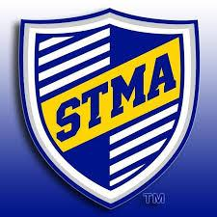
Student Handbook
2025-2026
60 Central Ave West, St. Michael, MN 55376
763-497-6575

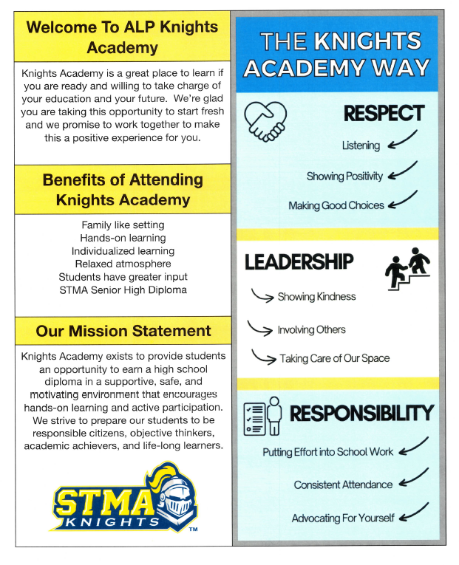

KNIGHTS ACADEMY STAFF
Mark Jansen……………………………………………………..Principal
markja@mystma.org 763-497-6500 ext. 95214

Marjorie Conigliaro…………………………………………….Teacher/Advisor
marjoriec@mystma.org 763-497-6500 ext. 95302

Andrew Hutter…………………………………………………..Teacher/Advisor
andrewh@mystma.org 763-497-6500 ext. 95301

Laura Lundberg …………………………………………………Teacher/Advisor
laural@mystma.org 763-497-6500 ext. 95303

Pao Chang……………………………………………………….Teacher/Advisor
xiongc@mystma.org 763-497-6500 ext. 95306

Heather Halstead……………………………………………………… Office Assistant
heatherha@mystma.org 763-497-6500 ext. 95337

COUNSELING STAFF
Northwest Family…………………………………………Group Facilitator/Therapist

CONTACT INFORMATION
Address 60 Central Avenue West, St. Michael, MN 55376
Phone : (763) 497-6575 Fax: (763) 497-6581

PARENT INVOLVEMENT
We work as a team at Knights Academy. For students to find success here it is critical that the staff, students, and parents work together as a team. Please work with us by attending parent nights and conferences, sharing concerns, and calling if your student will be absent.
CONFERENCES
Conference days this year will be on the following dates:
Thursday, October 2, 2025
Thursday, January 8, 2026
Thursday, April 9, 2026
Conference time is from 4:00-7:00 pm. Every parent is expected to attend these three conferences. We will contact you prior to each conference. It is so important for us to team together to help each student be successful here.
2024-2025 Monday-Friday Schedule
8:30-8:40 | Breakfast
8:40-9:45 | Period 1
9:45-10:50 | Period 2
10:50-11:50 | Period 3
11:50-12:20 | Lunch
12:20-12:55 | Period 4
12:55-1:55 | Period 5
1:55-2:55 | Period 6

CREDIT REQUIREMENTS
Students must earn 55 credits in order to graduate with an STMA diploma
English 8 Fine Arts 2
Social Studies 8 Physical Education 2
Math 6 Health 2
Science 6 Electives 21
*Students must have 16 hours of Community Service (4 per year).
Credit Earning Potential per term: 1-6th hour= 2.75, with Credit Recovery an extra .5 = 3.25

TERMS
Term 1: 9/3/25-10/10/25
Term 2: 10/13/25-11/25/25
Term 3: 12/1/25-1/23/26
Term 4: 1/26/26-3/5/26
Term 5: 3/9/26-4/24/26
Term 6: 4/27/26-6/4/26

NON-SCHOOL DAYS
Non-School Days:
- October 16-17 (MEA)
- November 4
- November 26-28
- December 22-January 2
- January 19
- February 5-6
- March 6
- March 30-April 3(Spring Break)
- May 25

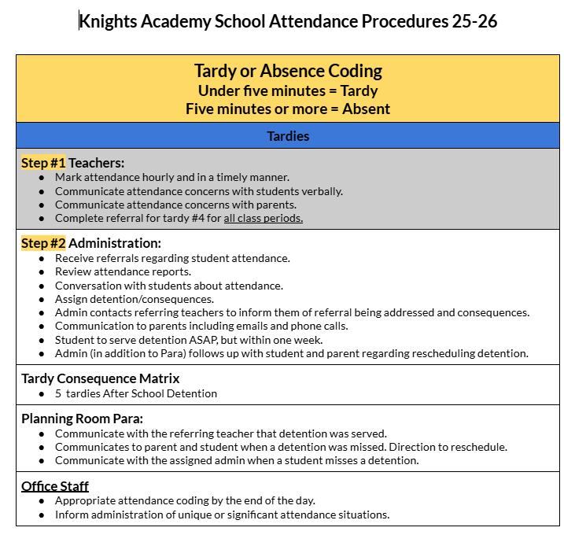
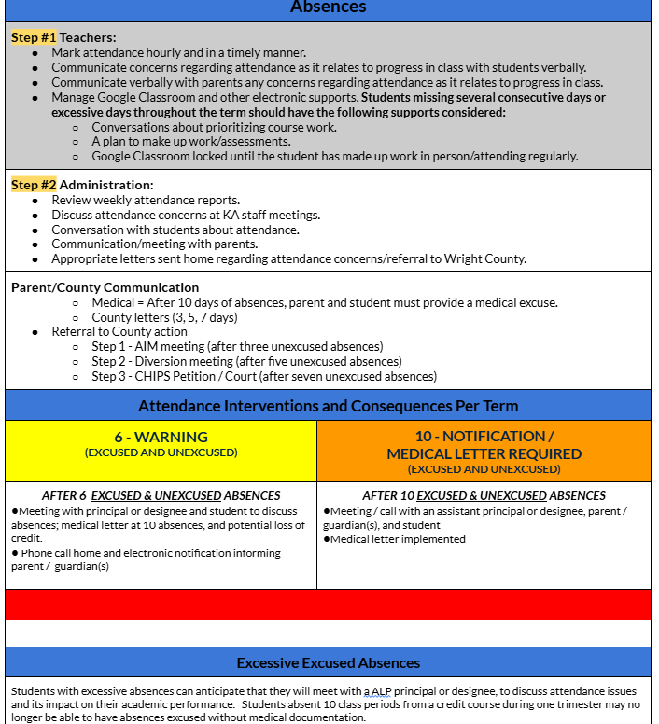

ABSENCES
An excused absence is considered something that is beyond a student’s control. Illness is considered an excused absence only if a parent calls the Knights Academy office (763-497-6575 or through ParentVue) on the day of the absence to verify. Excessive absences due to illness may require a doctor’s verification. Knights Academy reserves the right to determine whether absences are excused or unexcused. We encourage you to make appointments outside the school day, but in the event that you need to make an appointment during the school day, we ask that you bring a note from the doctor’s office, dental office, etc.
TARDIES
Please be on time to class. See above chart.
SIGN IN PROCEDURE
Students must sign in and indicate whether they want school lunch or breakfast. If they are late, students will need to sign in and get a pass to class.
ABSENCE LINE: 763-497-6575 or through ParentVue
Students are expected to verify all absences with the principal, Mark Jansen. Parents must contact Knights Academy the day of the absence. An absence will be considered unexcused until it is verified by a parent. Please schedule appointments outside the school day.

CONTINUAL LEARNING PLAN
Each student is required by the State to have a CLP signed by the student and parent(s). This plan will focus on goals and objectives necessary to reach graduation. The CLP will be completed upon entrance to Knights Academy and will be updated in advisory throughout the year.

COMPUTER/ INTERNET USAGE
Students receive a copy of the computer and internet usage agreement upon entrance to the program. Inappropriate Internet use will result in loss of computer privileges. Knights Academy computers are available to students for school work only.

STUDENT GUIDELINES
In order to maintain an environment that is safe and inviting for everyone, we do not allow the following actions:
- Physical aggression – physical contact that has not reached the fighting stage (tripping, pushing, etc.)
- Physical assault – fighting, punching, hitting, kicking, etc.
- Verbal assault - verbal exchanges including swearing, and/or yelling directed at another person.
- Bullying or Cyberbullying – intimidating, threatening, abusive, or harming conduct that is offensive and materially and substantially interferes with a student’s educational opportunities or performance or ability to participate in school functions or activities or receive school benefits, services, or privileges.
- Threats of violence
- Harassment – participating in, or conspiring with others to engage in harassing acts which threaten, embarrass, or degrade others. Racial, sexist, or otherwise discriminatory language will not be tolerated.
- Theft
- Vandalism
- Gang representation or activity
- Insubordination – refusal to follow reasonable requests of staff
- Consistent disruptive behavior
- Leaving the building during the school day without permission from a staff member
- Plagiarism or any form of cheating.*

*CHEATING & PLAGIARISM
Students who have been determined to have plagiarized or cheated on either their daily work or tests may be given a zero for the work involved. Classroom teachers directly involved with the violation will notify the parent/guardian of the violation as soon as possible. Teachers will also report the situation to an administrator.
Plagiarism is the intentional or unintentional use of another person’s words or ideas without giving proper credit to that person. When students complete writing assignments, it is important that they be aware of plagiarism issues. Plagiarism includes all of the following:
- Turning in a paper that the student didn’t actually write (often downloaded from the internet)
- Using smaller bits of information from the internet (cutting and pasting) without giving credit
- Copying another student’s paper
- Writing a paper that uses other outside sources without giving credit to those sources

If the student is deemed guilty of plagiarism, the student may not receive credit for the assignment. Depending on the scope of the assignment, this may put the student in danger of failing the course. It is the student’s responsibility to be aware of plagiarism issues.
  - STMA has a practice of using the website www.turnitin.com or other similar websites to check for student originality. Students may be expected to submit their work to one of these sites for credit.
- Use of cell phones during class without permission of the teacher. Teachers may let you use the internet for class research purposes, but permission must be obtained.
In order to maintain an environment that is conducive to learning and free from distraction, we do not allow the following items:
- Inappropriate attire – this includes sunglasses, sagging pants, blankets, bathrobes, low cut shirts, and coats or any clothing that displays obscenities, racism, profanity, or illegal substances.

- Weapons – 10 day suspension with the possibility of expulsion.

CELL PHONE POLICY
APPROPRIATE USE OF CELL PHONES INCLUDES:
• Cell phones must be turned off or in airplane mode and put in appropriate cell phone holders at the beginning of class and can only be used before school, during breaks and lunch. Phones may not be taken when leaving for the bathroom or nurses office while in class.
• When instructed to do so by a teacher, phones and airpods can be used for a class activity.
• Listening to music during work time can be done on a chromebook. Music must not be audible to anyone in the room but yourself. It is NEVER appropriate to listen to music during class discussions or when a teacher is addressing the class.
Note: At no time are students to record pictures or videos of students or adults without consent. If an electronic device is being used in a way that may be potentially breaking a school policy, administration may look at the pictures, messages or other content (see District Policy 502).

CLASSROOM EXPECTATIONS/POLICIES:
• Cell phones must be put on airplane mode and in the appropriate cell phone holder at the beginning of class and can only be used when directed by the teacher, before school, during breaks and lunch.
• Therefore, during class, you may not text, answer a call, be on social media, be on the internet, or cause a disruption with your phone.

PROCEDURES IN THE EVENT OF BREAKING CELL PHONE POLICIES:
STEP 1: Classroom teacher will ask you to bring it up, place it on their desk or in a designated area for you to pick up at the end of class. If you refuse to do so, you will advance to step 2.
STEP 2: The school administrator will take your phone for the remainder of the school day. You may pick up at the end of the school day. If you refuse to do so it will be treated as insubordination. You will advance to step 3.
STEP 3: You will be sent home and will lose the privilege of having your phone at school for the remainder of the term or a three-week minimum.

CHEMICAL HEALTH POLICY
Chemical use is a threat to the wellbeing of students—both their safety and health. Every student at Knights Academy has a right to learn. The misuse of chemicals may interfere with the learning environment as well as the welfare of the entire alternative program.
1. Students are expected to come to school free from the influences of drugs, alcohol, or other controlled substances. The use, possession, or transference of any controlled substance or paraphernalia associated with the use of controlled substances is a violation of school policy. Students may not have prescription or over the counter medications in their possession. This policy applies to the school building and school grounds (parking lots are on school grounds). Suspicion of being under the influence of chemicals will be written up and brought to the attention of the Program Director and Advisor. Reasonable suspicion may result in dismissal from school.
2. Students may not engage in discussion about drug use unless it is part of a discussion led by a teacher.
3. Students may not use tobacco or nicotine of any kind in the school building, on school grounds, or at school functions. This includes cigarettes, chewing tobacco, e-cigarettes, or any other product containing tobacco or nicotine.

SUPPORT TEAM
The Knights Academy Support Team is a system designed to effectively deal with concerns regarding student behaviors. The staff would like to work with you, rather than against you, to solve problems. Together, we will come up with a solution to make your experience at Knights Academy more successful. There may, however, be instances in which we will determine that staying at Knights Academy is not an option and we will help you find a more suitable school.
ACADEMIC PROGRESS
Maintaining academic progress is the responsibility of each Knights Academy student. A student is expected to earn a minimum of 2 credits each term. If a student fails to maintain academic progress at Knights Academy, earning fewer than 2 credits in a term, he/she may be placed on academic probation for the next term. Academic probation may result in dismissal from the program if a student fails to meet expected academic progress for two consecutive terms. Students must maintain a daily average grade of 60% or higher to receive credit for a class.
LATE WORK POLICY
Please turn your assignments in on time. Upon teacher discretion, late work will be deducted 20%. Further deductions for significantly late work is at the teacher’s discretion. Since we have a much lighter homework load than the high school, and we give you time in class to complete most assignments, our expectation is that you turn your work in on time.
LOCKERS
Lockers are the property of ISD 885 and are on loan to the students. Students receive and sign a locker agreement form at registration. A student is expected to use the locker assigned to him/her.
DRIVING/PARKING
Student drivers are expected to drive responsibly and safely and must have a parking permit in your vehicle ($1). The Wright County Sheriff will be notified of persistent reckless driving habits and driving privileges may be revoked. We have preschool children and moms coming in and out of the building so it is critical that you drive safely and slowly.
Student parking is located in the lower parking lot at the Community Education building. Students must only park in the designated student parking areas. Students may not park in the visitor’s parking spots (first 4 spots in each row). Any student vehicle parked anywhere other than the student lot during school hours may be towed at the owner’s expense.
Patrols, Inspections and Searches
School officials may conduct routine patrols of school district locations and routine inspections of the exteriors of the motor vehicles of students. If we suspect that a search of the interior of a student vehicle will uncover something illegal or against school policy, we may, without notice conduct a search, without a search warrant.
GUESTS
Unless special permission is granted, guests are not allowed during the school day at Knights Academy.

ENTERING AND LEAVING THE BUILDING
Students must enter and exit the building using door C.

MEDICATIONS
If students are on a prescription medication, it needs to be in the original marked container and kept in the program office. Parents need to deliver the prescription medication to the Knights Academy office. We are not allowed to give aspirin or Tylenol to students without a parent’s permission. Students are not allowed to have any over the counter medications in their possession.

CLOSING OF SCHOOL
Please watch local news stations in the morning if the weather is questionable. If the St. Michael/Albertville Schools are closed, it will be posted on local stations.

PARENT GUIDE AND REFUSAL FOR STUDENT PARTICIPATION IN STATEWIDE TESTING
