OCTOBER
VOL . 14 | ISSUE 2 | OCTOBER 1, 2025

LINCOLN ELEMENTARY NEWSLETTER

PRINCIPAL: Audrey McKell | 435.245.6442 | audrey.mckell@ccsdut.org
PTA PRES.: BriAnne Thomson | lincoln.elementary.pta.ut@gmail.com

A MESSAGE FROM OUR PRINCIPAL
Hello Lincoln Families!
What an amazing start to the school year! We’re thrilled to see our students and teachers settling into their routines and diving into some incredible learning experiences here at Lincoln. We’re also grateful to our wonderful parents who are following the drop-off and pick-up plan. A quick reminder: please use the designated drop-off/pick-up loop just off 100 W to keep traffic moving smoothly. The streets in front of the school are reserved for our buses, and your cooperation helps keep our kiddos safe as they come and go.

October is here, and it’s packed with fun!
Here’s what’s coming up:
- Parent Teacher Conferences – October 2 & 3
- Walk and Roll to School Day – October 8
- Fall Break – October 9 & 10
- STEAM Fest & Reflections Display – October 16
- Red Ribbon Week – The last week of October
- And of course... Halloween!
Our Halloween classroom parties will be held on Friday, October 31. Get ready for our annual Halloween Costume Parade around the City Square, starting at 1:00 pm! Parents, you’re invited to join the fun — feel free to dress up and cheer on your little ones!

A few quick reminders for costumes:
- No full-face masks, weapons, or look-alike weapons.
- Anything that covers a student’s head and blocks their vision is not allowed.
- Face paint is okay — just keep it light! We want to make sure teachers can recognize everyone for safety.
Thank you for continuing to support your students and their amazing teachers. Have a fantastic October, Lincoln families!
Mrs. McKell



UPCOMING EVENTS
OCT 1 – PTA Meeting
12:25 - 1:05 – Mrs. Frenzel’s Room

OCT 2 & 3 – Parent Teacher Conferences

OCT 2 – Early Release at 1:00 PM (Busses will run early)

OCT 3 – No School

OCT 8 – Walk and Roll to School Day!

OCT 9 & 10 – Fall Break

OCT 16 – STEAM Night &
Reflections Display

OCT 30 – Vision Screenings

OCT 27-31 – Red Ribbon Week

OCT 31 – Class Halloween Parties & Halloween Parade at 1:00 PM

NOV 11 – Veteran’s Day Program at 2:30 PM


JOIN THE LINCOLN ELEMENTARY PTA!
Did you know there is no time commitment needed to be a member of the Lincoln PTA? Members can volunteer to help as little or as much as they would like. Scan the QR code or email lincoln.elementary.pta.ut@gmail.com to get involved!


FROM THE PTA

We need help on our PTA board!
We are looking for board members to take the lead on Appreciation Weeks, Parent Teacher Conference Meals, Grants, and Red Ribbon Week. If you’d be interested in learning more about these positions, please contact our PTA president, BriAnne Thomson at: lincoln.elementary.pta.ut@gmail.com

Walk & Roll to School Day — October 8th
Get Healthy — Stay Cool... Ride or Walk to School!
Walk and Roll to school day is October 8. Dress up in bright colors like an 80s punk rocker or like your favorite band or rockstar. If your child rides the bus, get your permission form in and they will be dropped off at 200 W. Near Main Street so they can walk the rest of the way to school with PTA parents and Lincoln Leaders.
This whole week will be focused on healthy eating, good hydration and bike safety. Chat with your kids about these important topics and get them active.

Halloween Class Parties — October 31st
If you’d like to help with the Halloween Class Party in your child’s classroom, please reach out to our room parent coordinator, Tessa Thornley at tessthornley88@gmail.com to sign up as a room parent.

HALLOWEEN SEEK & FIND

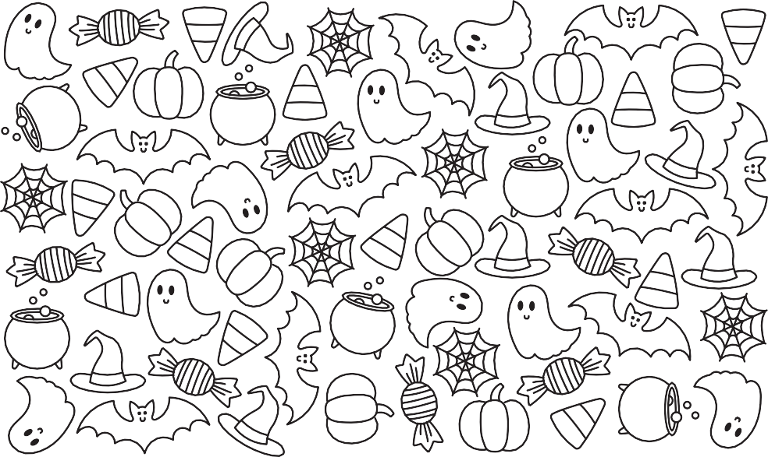





 STUDENT SPOT

Last call for Reflections entries! Entries are due on Friday, October 3rd.
Come see all the entries on Thursday, October 16th at our school’s STEAM night.

GET TO KNOW YOUR TEACHER!
Did you know the Lincoln website has spotlights on every teacher and staff member at our school?
You can read about them and see some of their favorite
things. (Parents, this might be helpful at teacher appreciation time!)
Go to: lincoln.ccsdut.org Tap: About Us
Choose: Our Teachers
And have fun learning more about your favorite Lincoln staff members!

If you’d like to submit information for this newsletter, please email Elise
Egbert at elisecreates@gmail.com by the 27th of the month.

