Teacher Incentive Allotment (TIA)
Faith Family Academy 2025-2026
Faith Family Academy is now a TIA “Application Accepted” District

What is TIA? The Teacher Incentive Allotment (TIA) originated in Texas House Bill 3 (HB 3) in 2019. TIA provides additional compensation to highly-effective teachers through a Designation System. Teachers can earn a Designation on their teaching certificate of Recognized, Exemplary, or Master. TIA has sustainable funding: there is no cap on TIA allotment funds or the number of teachers who may earn a designation. TEA determines campus allotment amounts annually based on campus location and demographics. Greater funding is assigned for designated teachers who serve in rural or high-need schools.

FFA Average Campus Allotment | Campus Allotment – Oak Cliff  (2025 Actual) | Campus Allotment – Waxahachie  (2025 Actual) | Qualifying  Statewide Default %
Recognized ($3K-$9K) | $7,396.00 | $7,340.00 | 13% of teachers earn
Exemplary ($6-$18K) | $14,792.00 | $14,680.00 | 15% of teachers earn
Master ($12K-$32K) | $26,653.00 | $26,467.00 | 5% of teachers earn

Who is Eligible to Earn a Designation?
Eligible Teaching Assignments at FFA in 2025-2026
- Teachers from both Oak Cliff and Waxahachie Campuses are Eligible.
- 2024-2025 Eligible Teaching Assignments include: PreK3/PreK4; ELAR & Math Grades 3-8, and Science 5th & 8th Grade. (These were the Teaching Assignments approved by TEA).
- Teacher must be in an 087 PEIMS Classification (State Requirement) (Non-Certified are Eligible).

Cohort A  2025-2026 | Student Assessment  (60%) | T-TESS Appraisal  (10%) | Local Criteria  (30%)
PreK3/PreK4 | CIRCLE | T-TESS Domains 2 & 3 | T-TESS Domains 1 & 4
ELAR & Math Grades 3-8 | IOWA | T-TESS Domains 2 & 3 | T-TESS Domains 1 & 4
Science Grade 5 & 8 | IOWA | T-TESS Domains 2 & 3 | T-TESS Domains 1 & 4

How do Teachers Earn a Designation?
All TIA designation systems must include a student growth measure (CIRCLE/IOWA) and teacher observation measure (T-TESS Domains 2 & 3) for determining teacher designations. FFA’s TIA Designation System also includes local designation criteria (T-TESS Domains 1 & 4). Teachers must meet student growth minimum requirements and teacher observation minimum requirements to earn designation levels.

FFA’s Designation System
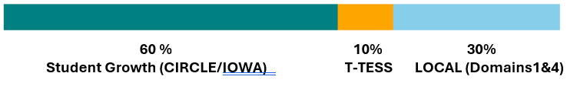

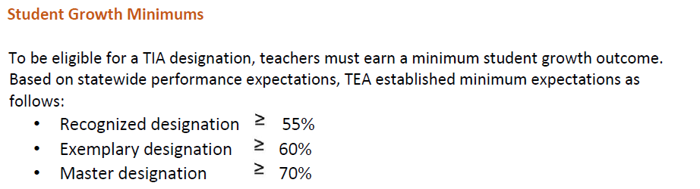

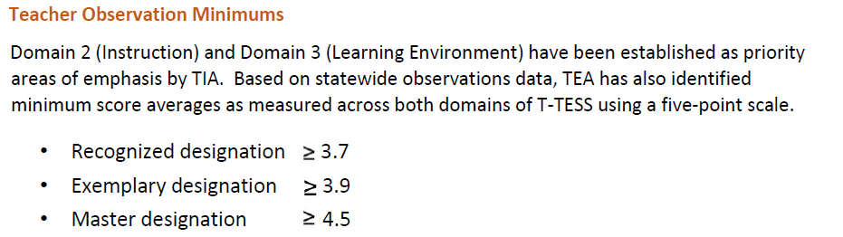

Spending Plan: 90/10
Teachers who earn a TIA Designation (Recognized, Exemplary, Masters) will receive 90% of the amount associated with the designation. 10% reserved at the district level will be used to cover standard deductions for designated teachers. The TIA Allotment Payout is TRS eligible and subject to Federal, State, local fees and taxes.

When will Designations and the TIA Allotment be Finalized?
The initial program is a 2 year process. Designations will be finalized in SPRING 2027 for data collected during the 2025-2026 school year. 2025-2026 is FFA’s first Data Capture Year (Student Performance & Teacher Appraisal). By the fall of 2026, FFA will send proposed TIA designations to TEA. 2026-2027 is the Data Validation Year. During this year, Texas Tech will review FFA’s data from the 2025-2026 school year, to determine if the data is reliable and valid, and finalize which FFA teachers earn a designation. TEA releases the TIA Allotment to districts near the end of April each year.

When will the first TIA Payouts occur?
Assuming the district’s data from the 2025-2026 school year validates, FFA teachers will earn a designation in Spring 2027. The first payout will be in Summer 2027.

PLEASE COMPLETE THE TIA Teacher Survey from Texas Tech: Texas Tech will be sending you a survey regarding TIA beginning August 25. Please fill this out by the deadline September 19! This impacts whether or not payouts will happen in 2027!

Where can I find more information? FFA TIA Handbook & FFA TIA Website (Coming Soon); https://tiatexas.org/

Questions? Send us your questions through this link: _____________________; Email: _____________________________________

PRESENTER QUESTIONS

Check for Understanding:
1. Which grade level teachers and subjects are eligible to try to earn a designation in the 2025-2026 school year?
2. When will the first payouts occur if we are validated?

More Eligible Teaching Assignments will be added in Upcoming School Years

