World-Famous Gaia Earth installation comes to asia, at UNIS Hanoi
Hanoi, Vietnam, 5 October, 2025 – The internationally acclaimed Gaia installation by British artist Luke Jerram will make its first school appearance in Asia when it is unveiled at the United Nations International School of Hanoi (UNIS Hanoi) on 5 October.
Suspended in UNIS Hanoi’s newly renovated Sports Centre, the seven-metre illuminated Earth installation features 120dpi detailed NASA imagery of the Earth’s surface to recreate the view of the planet from space.
By hosting Gaia, UNIS Hanoi will become the first institution in Asia to present this celebrated work, underscoring Vietnam’s rising profile in global culture and sustainability.
Bringing Gaia to UNIS Hanoi has been made possible through the generous support of LPBank. Thanks to the UNIS–LPBank Endowment, Gaia’s powerful message will resonate across our community while underscoring UNIS Hanoi’s commitment to excellence, sustainability, and meaningful global engagement. Together with LPBank, we are shaping a future where education sparks action and creates lasting impact worldwide.
UN@80 & Vietnam@80
The timing of Gaia’s debut in Hanoi carries historic significance. The exhibition opens as the world commemorates UN@80, celebrating the United Nations’ 80th anniversary, and Vietnam@80, marking the nation’s independence and resilience since 1945.
A series of almost 140 curated events and tours will be hosted at UNIS Hanoi for local partners including Vietnamese schools, NGOs, embassies, businesses and government representatives, connecting diverse communities in dialogue around sustainability and shared responsibility.
Thousands of Hanoi residents and visitors will have the opportunity to share in this cultural and educational experience when Gaia moves to Hoa Binh Park. Sponsored by UNIS Hanoi, the installation will be open to the public from 29 October to 1 November.
“As the United Nations marks 80 years of global cooperation, it is deeply meaningful to see Gaia in Vietnam for the very first time,“ Pauline Tamesis, United Nations Resident Coordinator to Vietnam (UNRC), said. “This exhibition is more than art, it is a living classroom for the UN’s Sustainable Development Goals, brought to life through UNIS Hanoi’s powerful interpretation.”
“Hosting Gaia during the 80-year anniversaries of both the United Nations and Vietnam is a profound reminder of our shared responsibility,” added Dr Elizabeth M. Gale, Head of School at UNIS Hanoi. “The SDG Experience shows how we prepare young people not only to imagine a more sustainable world, but to lead in creating it. It is a truly transformative experience that connects our students directly to the planet they will inherit.”
Art, Education, and Vietnam’s Net-Zero Goals
For its display at UNIS Hanoi, Gaia is paired with the Gaia SDG Experience, an interactive showcase that demonstrates how the School integrates the United Nations’ Sustainable Development Goals (SDGs) into its teaching and community life.
By linking global challenges with local action, the exhibition highlights sustainability values for Vietnam’s youth—reinforcing the nation’s commitment to achieve net-zero emissions by 2050. It reflects how education and art can work hand-in-hand to inspire urgent climate action and empower the next generation of leaders.
Artist Luke Jerram shared: “I hope the opportunity to see the Earth in its full splendour will be a humbling, inspiring and unifying experience for everyone who encounters it. Knowing that Gaia is being hosted by UNIS Hanoi, a UN school interpreting the United Nations’ Sustainable Development Goals through education and community, makes this installation especially powerful.”

About UNIS Hanoi
The United Nations International School of Hanoi (UNIS Hanoi) is a non-profit, co-educational English language day school founded in 1988. It is one of only two UN schools in the world, the first IB (International Baccalaureate) World School in Asia and the first international school in Vietnam. UNIS Hanoi provides an internationally recognised education for students from Early Years (age 3) to Grade 12 (age 19). Committed to its mission of inspiring passionate, lifelong learners who are responsible global citizens, UNIS Hanoi fosters a diverse and inclusive learning environment.

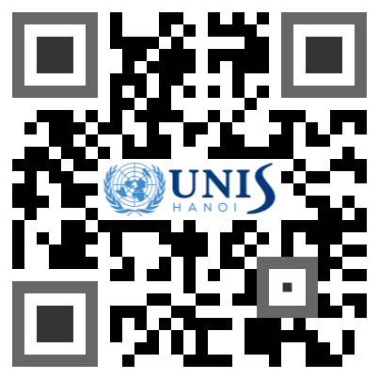
Media CONTACT
For media inquiries, interview requests, or high-resolution images, please contact:
Linh Le
Communications Manager, UNIS Hanoi
Email: ltlinh@unishanoi.org
Phone: +84 97 658 6885

