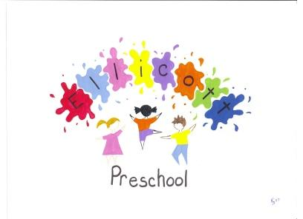
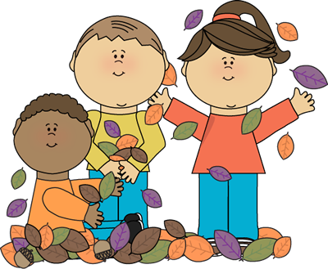
October 2025 Newsletter
Reminder:  Thursday folders need to come back each Monday so we can prepare them with notes for home and your child’s work for that week.  Have you signed up for Class Dojo with your child’s teacher? This is the primary way for communication between home and school!  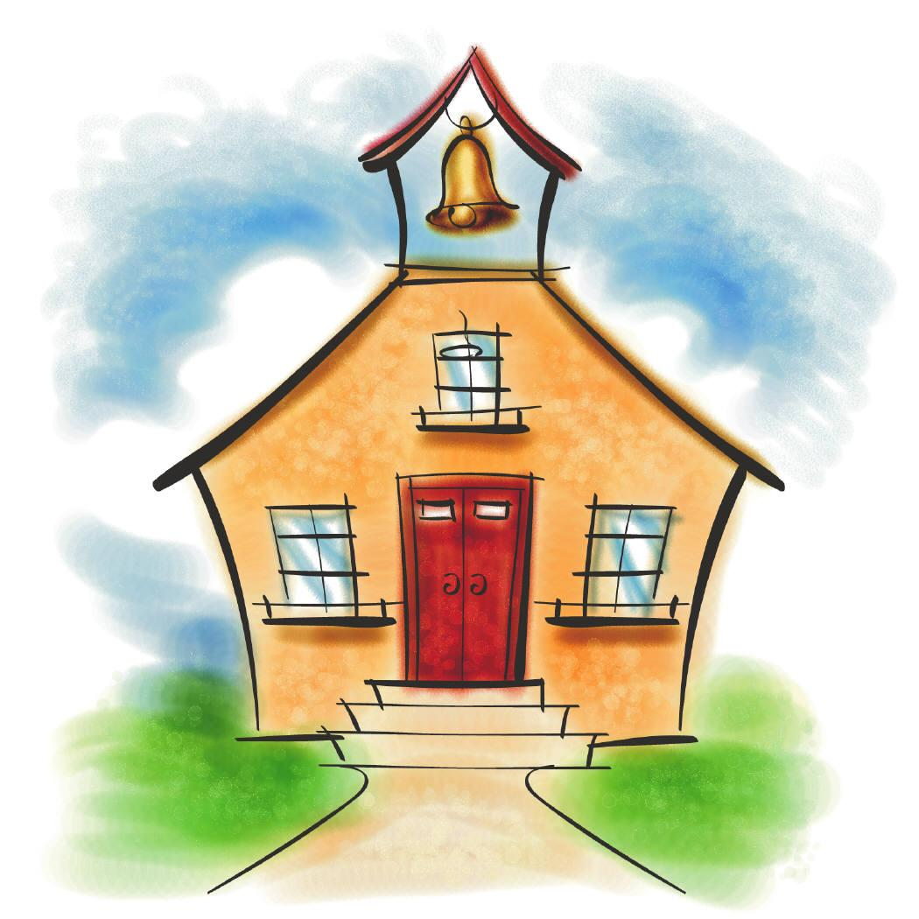  Fall Break October 13: No school this day  Picture Retakes will be on October 22, 2025  Mobile dental screenings on November 3 (with parent consent)  Preschool Conferences Nov. 5-6 | October Themes:  Mrs. Allen’s class: Our theme this month is farm. We will be learning what lives on a farm, who works on a farm, and what grows on the farm. We will also be studying fall: what is fall, what kind of weather in fall, the colors of fall, what we wear in fall. We will have a mix of farm & Fall projects/art that we will be doing this month. We will continue to do our numbers and letters of the week. Our new curriculum study will be pets.  Mrs. Manyik’s: Our theme for this month is “zoo.” We will learn the names of different zoo animals, what they eat, and where they are from, and we will make art projects related to zoo animals. If you have any zoo pictures you would like to send in for us to hang around the classroom, they will be greatly appreciated! We will also be learning more about fall and discussing the weather changes. We will continue to work on the correct way to hold our crayons when writing and learning our letters of the week.  Mrs. Sprowes’ class: Our theme this month is Ocean. We will be learning about what an ocean is, what animals live in the ocean, and what plants grow in the ocean. We will also be learning many things about fall. The changing of leaves in fall, types of clothes worn in fall, and fall projects. We will continue working on learning our names, letters, shapes, and numbers. We are also beginning a new study about Pets! Students will be sharing with classmates about which pets they have at home!  Mrs. Whitney’s class: Our theme for the month will be “Occupations”. We will be talking about what occupations our families work at. We will also be starting a new study that I am super excited about. The unit we will be starting is Pets and I hope that the students will share a lot about the pets they have at home. We will be working hard on recognizing and writing our name with a correct crayon/pencil grip and continuing to learn our letters, letter sounds, shapes, colors, and numbers.
Second Step Social Emotional Curriculum Lessons-Students will be learning:
Unit 2: Empathy
Students will identify their own and other’s feelings. Learn to take other’s perspectives and show concern and care for others
**Watch for “Home Links” to be coming home in Thursday folders**
Preschool classes will be having Pumpkin Parties on Thursday, October 30th. We will be contacting parents about times, and about providing goodies as the time gets closer.
Due to limited space in the classrooms, we are asking that no more than 2 families members per child attend the parties.
Please check in at the Preschool office and have ID ready to be scanned through the Raptor System for a visitor pass. We will start scanning all visitors at 9:30 and 1:45. Please be patient as we go through this safety process. Thank you!
We will also be doing a costume parade through the middle school before the parties start.
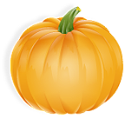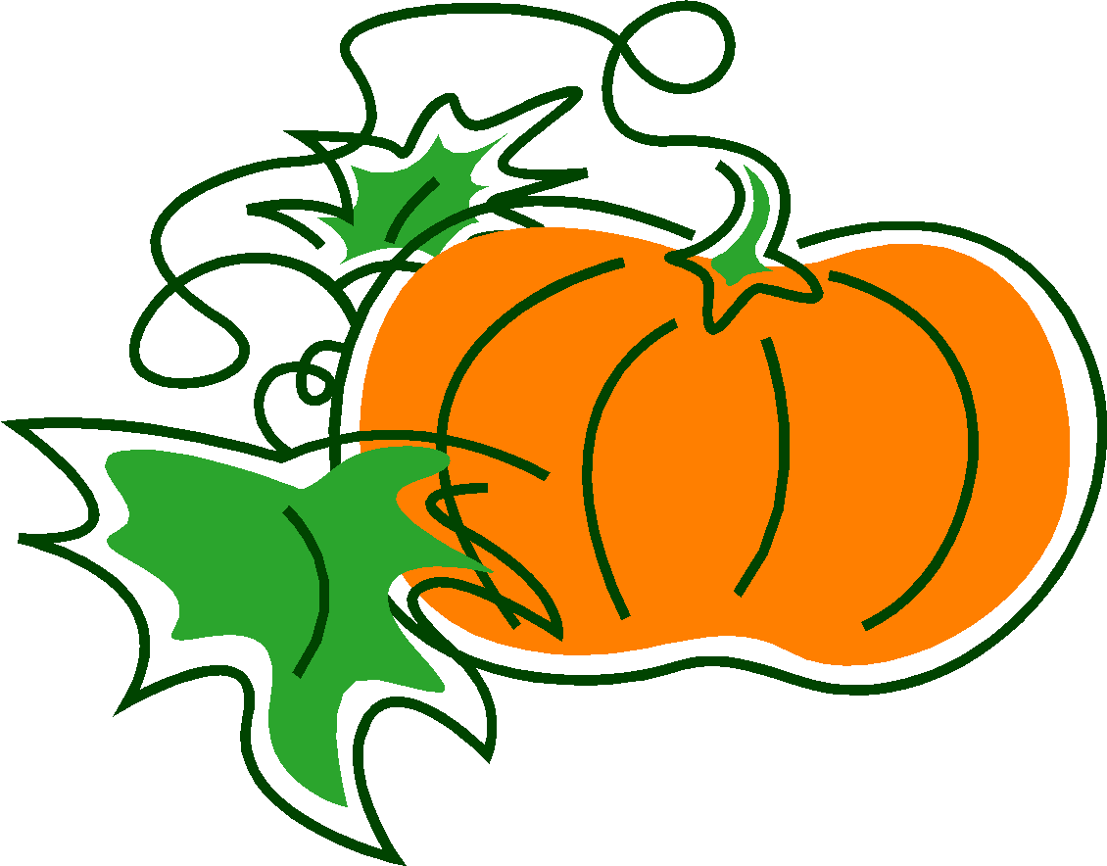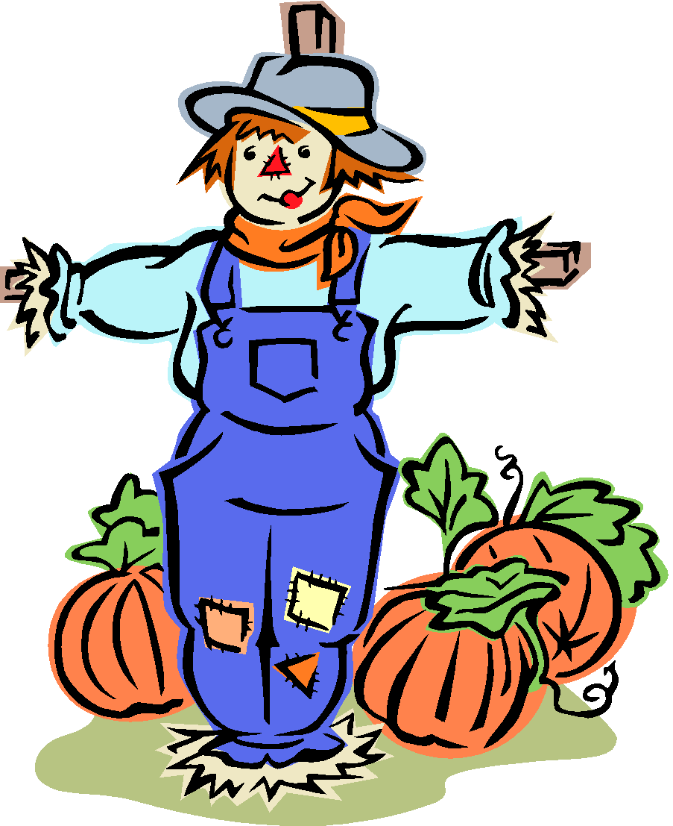
********************************************************************** Parent Corner:
Set clear limits on your child’s behavior: Sit with your child and have a family discussion about rules and what the consequences are if the rules are broken. Rules should be few, fair, easy to follow, and enforceable.
Don’t forget to take care of yourself: It’s difficult to be a calm and relaxed parent if you are stressed, feeling anxious, or down. Try to find time to let yourself unwind and do something you enjoy. It can be difficult to do, but give yourself permission to take time for yourself.
No Cook Playdough Recipe
- 2 cups of flour.
- 1/2 cup of salt.
- 1 cup of hot water (possibly a 1/2 cup more)
- 2 tablespoons of cooking oil.
- 2 tablespoons of cream of tartar.
- food coloring (A sprinkle of dry seasoning such as pumpkin spice can also be used for a scent)

