
Cheyenne Site Council
Minutes
September 22, 2025

Cheyenne’s Mission: To guide and challenge learning for all students through a learning environment that gives priority to basic traditional skills and values.
Cheyenne’s Vision: To create a culture of shared and active leadership so that each member brings their own areas of expertise and works collaboratively to sustain improvements in teaching, in learning, and throughout the community.
Cheyenne’s Cornerstones:
1. School of Choice
2. Focus on Academics
3. Linear Sequential Curriculum
4. Teacher-Directed, Textbook-Based Instruction
5. Elevated Grading Scale
6. Maximum Use of Academic Time
7. Parent Commitment, Involvement, Support
8. High Expectations for All
9. School Uniforms

Cheyenne Site Council Purpose: The purpose of the Cheyenne Site Council is to ensure that individuals are provided the opportunity to share in the decision-making process. The Site Council supports the vision and develops and monitors the Campus Improvement Plan (CIP) with a focus on student achievement and school climate.

Members:
· Principal/Administrator - Shawnee Baca
· Assistant Principal - Jill Frey
· Classified Staff Member – Kathleen Baldus
· Teacher Rep. K-5 - Natalie Kearns
· Teacher Rep. Middle School - Gina Morgan
· Parent Representative- Sara Solem
· Parent Representative- Lisa Sagstad
· PTO Representative - Karinna Holland
· Community Representative – Sarah Lombardi

AGENDA:
- Principal Baca call the meeting to order:
  - Date/Time: Principal Baca called the meeting to order: September 22, 2025 at 2:32 pm
- Principal Baca welcomes all members to the 25-26 Site Council.
  - Reviews Site Council objectives; Principal Baca reviewed the below with Site Council Members
    - Purpose Is to support the mission, vision, cornerstones, and overall purpose as stated above:
    - Roles-
      - Principal Leads Site Council- non-voting member
      - All members vote- the majority takes the vote
      - Robert's Rules of Order are followed
      - Classified Member - minutes (Minutes/Agenda posted on CTS Website monthly)
      - Classified Member- communicates to the community on behalf of Site Council and shares decisions with individuals or groups who have brought requests to the Site Council.
    - Support SUSD Guidelines- Facilities/Campus Safety/WIG’s/CTS Way
    - Vote on how we spend Tax Credit Extra Curricular Funds- supporting CTS
    - Review Dress Code and Parent Student Handbook/first 24 pages of student planner- yearly.

Review Wildly Important Goals for 25-26: Principal Baca reviewed the below with Site Council Members
- WIG 1 : By the end of the 2025-2026 school year, Cheyenne Traditional School will increase the percentage of students performing above grade level in MATH from 25% (May 2025) to 28% (May 2026) as evidenced by the end-of-year Math IXL benchmark assessment.
- I.T.M. 5 or more days missed. Form signed by Principal Baca- get work ahead of time.
- IXl: Sara Sollem reviewed process: Can IXL not take -9 when a student gets a incorrect answer? IXL Review in October- Middle School Recap.
- WIG 2 : By the end of the 2025-2026 school year, Cheyenne Traditional School will decrease the percentage of students nearly chronically absent/chronically absent students from 19.16% (May 2025) to 16.16% (May 2026) as evidenced by attendance records.
- Principal Baca reviewed definitions.
CTS Way- Character Counts: Principal Baca reviewed the below with Site Council Members

October - Trustworthiness
November - Responsibility
January - Respect
February - Fairness
March - Caring
April - Citizenship

A definition of the trait will be shared on the CTS News.

Homeroom positive acknowledgement - Grade levels will be assigned a week on the news. Each teacher will have a day M-Th to acknowledge a student that exemplifies the trait with a certificate.

Breakfasts/Incentives - At this time, the breakfasts are not on the calendar. I will create a Character Counts prize box for students. Kathleen will double check that breakfasts are off the calendar. Kathleen will begin the process of creating PO’s to purchase student awards.

Poster Outside Cafeteria - This will be the Golden Spoon Award board. This will allow the Lunch team to choose a homeroom class each month for the cleanest and best class that exhibits the character trait. We will take a picture of each student in that class to post on that board. This will allow students that may not get recognition on their own to receive positive recognition.

Middle School Incentives - “Clear Comm Card" entered into a raffle.

Review Clear Bag and Water Bottle Policy: Principal Baca reviewed the below with Site Council Members- signs all here and up in Gym, Front Office, Cafe, Front of Campus, Fences, Field area.
- All campus events- gym, cafe, fields, sports, PTO Events, CTS Events

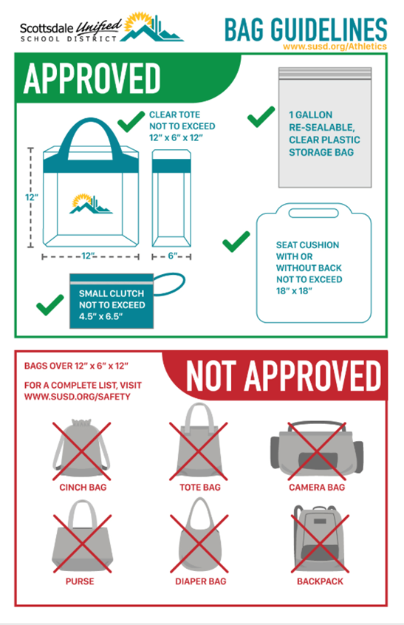
Facilities: Principal Baca reviewed the below with Site Council Members
- No use of Cheyenne Campus unless reserved through District Facilities or Scottdale Parks and Rec. (CTS Events/Athletics/PTO- work with Kathleen Baldus and Pam Watson)
- No Cheyenne or other SUSD or Non-SUSD students participating in outside vendor activities can use the campus grounds. after or before school, while our students are on campus. (practicing, during games or other planned CTS/PTO activities) SUSD and the city of Scottsdale require outside vendors to have insurance and to pay for the use of our facilities.
- Outside Club Soccer Vendor on campus after school practicing- Pam Watson has shared that this is not allowed, covered under SUSD or City of Scottsdale Insurance. District will follow up- as needed.
Votes Needed:
- PTO Fundraising:
  - Fundraising items donated by staff/teachers: No academic items like Book Reports, Projects, or homework passes can be donated as auction items.
  - Need clarification for PTO/Staff regarding Teacher’s Corner at Harvest Festival:
    - Can teachers provide a homework pass as part of their teacher’s corner experience? N
    - eed a motion to vote on if homework passes can be used as part of HF Teacher’s Corner?
    - Gina Morgan: Motion to eliminate academic rewards (homework pass, no book report pass etc) from all PTO fundraising avenues.
    - Karina Holland 2nd the motion.
    - Yes ___All________ No____________ Vote Resuluts: _Motion Passed

- PTO Veterans Day Event:
  - Can Students wear plain red t-shirts to school on November 14th, the day of our Veterans Day Event?
  - Need a motion to vote on if students can wear plain red shirts to support the Veterans Day Event?
  - Karinna Holland: Motion to all students/staff to wear solid red shirts at every Veterans Day Event held yearly at Cheyenne.
  - Sara Sollem 2nd the motion
  - Yes_All__________ No________________ Vote Results:_Motion Passed___

- WIG 1 : By the end of the 2025-2026 school year, Cheyenne Traditional School will increase the percentage of students performing above grade level in MATH from 25% (May 2025) to 28% (May 2026) as evidenced by the end-of-year Math IXL benchmark assessment.
  - Can students participate in dress-down day: for example, a sports jerseys or causal Wednesday- cts sweats and spirit shirt.
  - Need a motion to vote on if students can wear plain red shirts to support the Veterans Day Event?
  - Karinna Holland: Motion to allow a “Dress Down Day” when student population meets the incremental goals in Skills Mastered IXL, by Principal Baca. (untucked shirt day, Jersey Day, College T-Shirt Day etc)
  - Sarah Sollem 2nd the motion
  - Yes__All___________ No________________ Vote Results:__Motion Passed__

Staffing Needs:
- Middle School Spanish updates- Karinna Holland sub Spanish
- 7-8 Spanish
- 6-7 Spanish- have long-term sub for Oyuky Galaz’s leave
- Noon Aide- if you have leads, please let us know
- Crossing Guards- if you have leads, please let us know
Enrollment Recap:
- This year as of 9/19/25: 950 Students & Last Year as of 9/19/24: 959 Students (capacity 1040)
- Wait lists: Kdg: 55 students, 5th: 10 students, 7th: 4 students

Updates/Review Items from last year: Review by all:
- Clubs/Activities/Field Trips funded by Site Council
  - 1 Field Trip per grade, Gifted, Band, Strings, NJHS- on track
  - NJHS Tutoring- Renee Wilson & Christina Najera
  - Tier 1 Volleyball Coach- Alexis Davis
  - Buddy Readers- Jen Clawson- continuing the club this year.
    - After school club that Middle School students participated in to support K-2 readers who were below grade level. (30+ 1st/2nd Graders 30+ Middle School Students- participated) Starts after Fall Break and ends mid way thru 4th quarter. Clubs meets weekly.

- Theater- Molly Gluzinski & Kim Ho
  - Site Council Staff Stipend and PTO covers Parent Stipend.
  - Site Council (approved SUSD vendors) $2500 and PTO covered items (Non-SUSD vendors) from Goodwill, Savers etc. Site Council is open to requests for additional funds. PTO is still working on their budget for their supplies- stay tuned.
  - Charros' donation for Theater Program from 24-25 application. Michelle Irvin, District Fine Arts, is getting us a quote for lavalier microphones for our actors- stay tuned.
  - New lights were purchased for our stage, and 2 new microphones were purchased for the cafe. 35 students participated last year. Will increase to allow up to 50 students to participate. Meeting weekly and then twice a week as the performance approaches. Molly is connected with District Drama teachers and hopes to borrow some items for the stage and costumes.
- Ambassadors- Victoria Markowicz & Andreana Meeks
  - New Staff Leaders this year. Will work to support all CTS events on campus.
  - Last year, 60+ students signed up, but not all participated. This year's plan is for 40 students who participate in an event each quarter.
  - Q2- Q4 - Club meets monthly but will support at events using Google Classroom -stay tuned.
- STUGO- Alexis Davis
  - Will plan to attend Site Council Meetings starting in October- request or suggestions on behalf of our students.
  - Alexis Davis is looking into planning a field trip, as requested- stay tuned.
- NJHS- Renee Wilson
  - Application Process and GPA requirements announced at Parent Orientation, in the PTO newsletter, on the CTS News, and via Parent Square.
  - Site Council request to have students help other students with the process: The application must be completed by the applicant, and if students have questions, they must reach out to Renee Wilson, NJHS Advisor.

- Meeting closed: Principal Baca 3:21 pm

- Next Meeting October 20th, 2:30-3:30 Room #104
Tax Credit Balance and Planned Expenditures 25-26
· General Extracurricular - $121,756.24
· Tax Credit Field Trips -$3,576.58
· Tax Credit Fine Arts - $40,077.13
· Tax Credit Gifted - $36,953.94

