LAGRANGE ELEMENTARY SCHOOL
SBDM Meeting
September 22, 2025| 2:30 p.m.| SBDM Council
______________________________________________________________________________

Council Members
Heather Thomas, Chair| Melinda Hadley, Teacher| Brittany Stephens, Teacher| Jamie Parker, Teacher| Danielle Barnes, Parent| Kylie Walker, Parent|
______________________________________________________________________________
Agenda Item Lead
______________________________________________________________________________

Welcome, Review Norms & Roll Call H. Thomas
- Council discussions stay within the group until the action item has been approved by the Council
- Start on time and end on time
- Maintain a focus on ensuring the learning of all students
- Be willing to share ideas and open to new learning
Approval of Agenda H. Thomas

Approval of Minutes from — Meeting H. Thomas

Council Action Items
- School Report Card H. Thomas
- Policy Review H. Thomas

Comprehensive School Improvement Plan (CSIP) Update
- Executive Summary H. Thomas

Public Comment

Principal’s Report
- Afterschool Clubs R. Grattan

Adjournment H Thomas

La Grange Elementary
School-Based Decision-Making Council
August 25, 2025
The La Grange Elementary School Site Based Decision Making Council met at LaGrange Elementary for the regularly scheduled SBDM meeting with the following members in attendance: Kiley Walker – Parent Rep, Jamie Parker – Teacher Rep, Melinda Hadley – Teacher Rep, and Heather Thomas - Chair. Carter Kelly, classroom teacher & STC, also attended the meeting.
Mrs. Thomas called the meeting to order at 2:42 am.
1) A motion was made by Jamie Parker and seconded by Melinda Hadley to accept the agenda. The motion was approved with no opposition. A motion was made by Kiley Walker and seconded by Melinda Hadley to accept minutes from previous meetings. The motion was approved with no opposition.
2) Carter Kelly briefly updated the Council regarding technology funds that have been allotted to the district and how those funds will be used in the 2025-2026 school year. No action was necessary by the Council at this time.
3) Mrs. Thomas reviewed the LaGrange Elementary SBDM Bylaws. No changes were made to Articles I & II – Purpose and Mission. The Statement of Ethics was reviewed, and all Council members signed said acknowledgement form. Article III – Membership was reviewed, and no changes were made. Article IV -Duties of Officers and Council Members was reviewed. A motion was made by Kiley Walker to nominate Melinda Hadley to serve as the Vice Chair of the Council. The motion was seconded by Jamie Parker and the motion was approved with no opposition. Articles V, VI & VII were reviewed, and no changes were made. Article VIII – Minutes and Other Records was reviewed, and one change was made under Policy Areas. “The Council shall approve its goals at a regularly scheduled meeting in October. A motion was made to approve the Bylaws with changes made by Jamie Parker. The motion was seconded by Melinda Hadley and passed unanimously.
4) Mrs. Thomas reviewed Policy #9001 – Student Behavior. No changes to the policy were made and no action was necessary by the Council.
5) Mrs. Thomas reviewed Policy #4005 – Monitoring of Student Computer Network Access. No changes to the policy were made and no action was necessary by the Council.
6) Liz Dant, Elementary Level Director for OC Schools joined the meeting at 3:07 pm. She and Mrs. Thomas discussed with the Council our Title I Parent and Family Engagement Policy as well as briefed the Council on how Title I funds are allocated throughout the district and spent. One of the topics discussed was a training that assists with morphology and how that builds on the foundation of reading and understanding what is being read that is taught in K, 1st & 2nd grade and expands from learning to read to reading to learn. A motion was made by Kiley Walker to send one teacher from grades 3, 4 & 5 to a training in the anticipation that those three teachers come back and train other teachers within those grades. The motion was seconded by Melinda Hadley and the motion passed unanimously.
7) Mrs. Thomas also explained how she budgets out how Title I funds allocated to LaGrange Elementary are spent. No action was necessary by the Council regarding her summary.
8) Mrs. Thomas gave the Council a brief update on the CSIP (Comprehensive School Improvement Plan) and no action was necessary by the Council.
9) With no further business to discuss, a motion was made by Jamie Parker to adjourn. The motion was seconded by Kiley Walker. The meeting adjourned at 3:37 pm.

August 27, 2025
The La Grange Elementary School Council met in a special-called session with the following members in attendance: Melinda Hadley (teacher), Jamie Parker (teacher), Kiley Walker (parent) and Heather Thomas (chair), called the meeting to order.
1. The meeting was called to order at 7:13 AM
2. The Council reviewed and approved the agenda.
3. The Council entered a closed session to discuss certified personnel selection as
provided by KRS 61.810 (1)(f) at 7:13 AM.
4. The Council resumed open session at 7:16 AM.
5. With no further business, the Council adjourned.

September 12, 2025
The La Grange Elementary School Council met in a special-called session with the following members in attendance: Melinda Hadley (teacher), Jamie Parker (teacher), Kiley Walker (parent) and Heather Thomas (chair), called the meeting to order.
1. The meeting was called to order at 7:12 AM
2. The Council reviewed and approved the agenda.
3. The Council entered a closed session to discuss certified personnel selection as
provided by KRS 61.810 (1)(f) at 7:15 AM.
4. The Council resumed open session at 7:16 AM.
5. With no further business, the Council adjourned.

September 22, 2025
Enclosure A

La Grange Elementary School Council
Oldham County Schools

CONCERN:

The School Report Card (SRC) is published annually and provides information about key topics and accountability at the school, district and state levels. ​​​​​​Kentucky School Report Card Dashboard (SRC) ​highlights key topic areas and performance indicators at the school, district, and state levels. The SRC Dashboard provides a collection of resources to help school districts collect, validate and submit required data.).

DISCUSSION:

The timeline for entering SRC started with the school collector tools opened on August 18, 2025. Public release of new SRC Suite Dashboards is slated for release in mid-to-late November. The School Report Card populates information from the School Profile Report to create the Report Card. Mrs. Reed will be sharing our current School Profile Report for the 24-25 school year.
School Profile Report

RECOMMENDATION: Approve the current School Report Card by signing
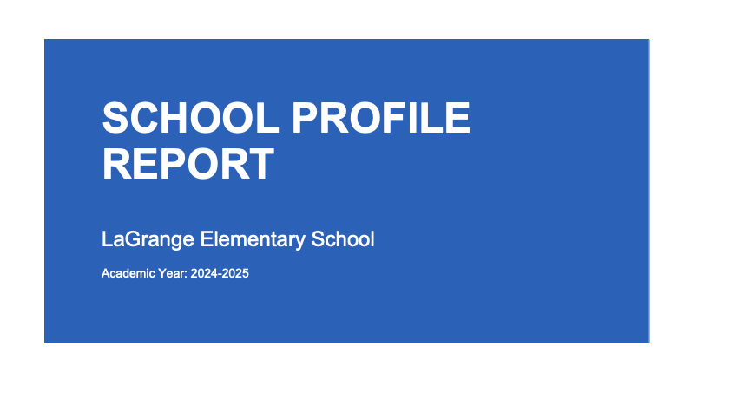
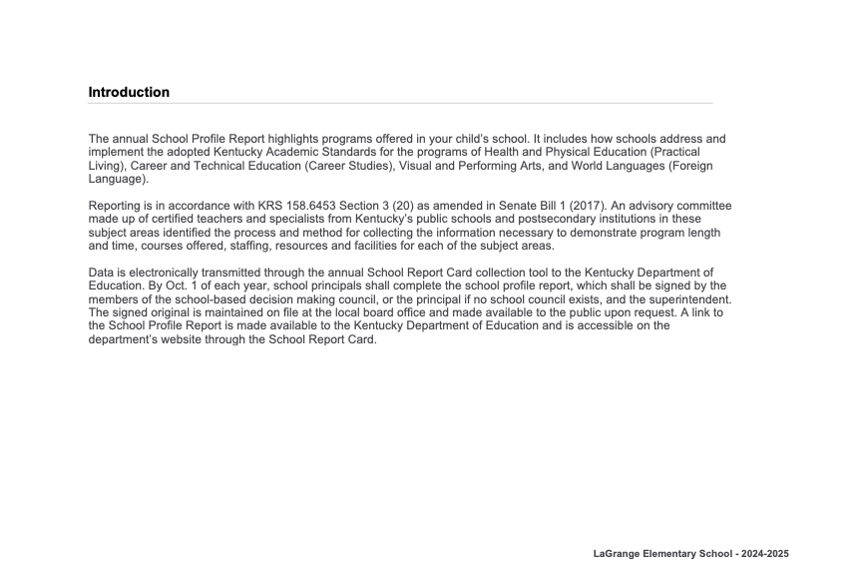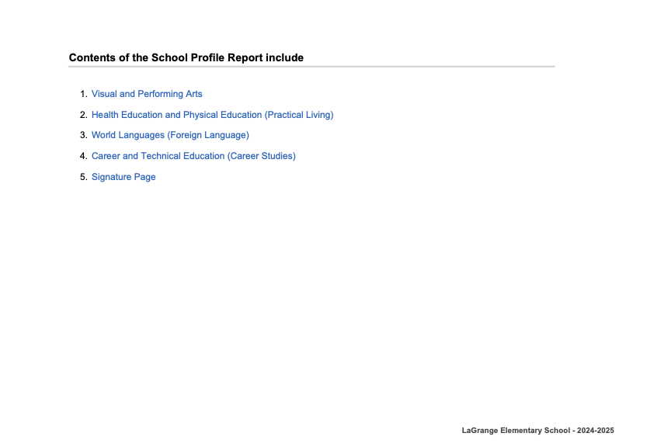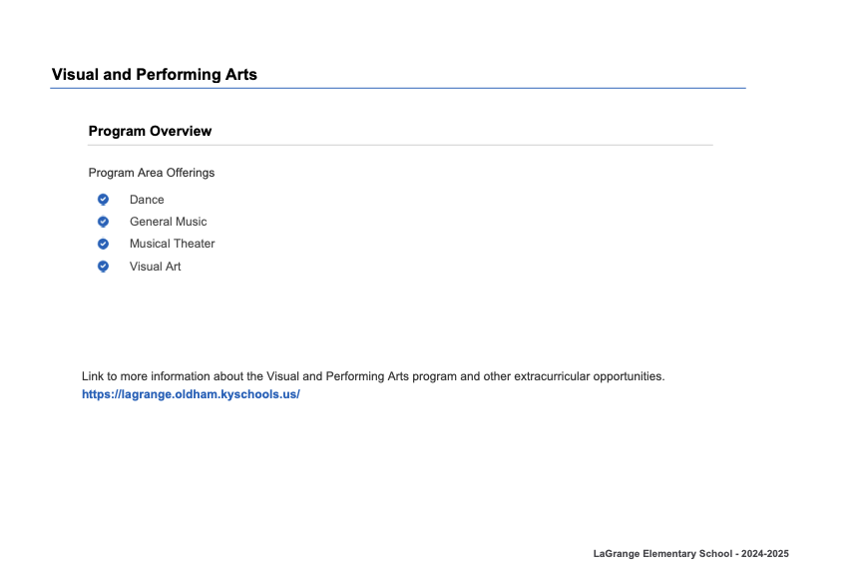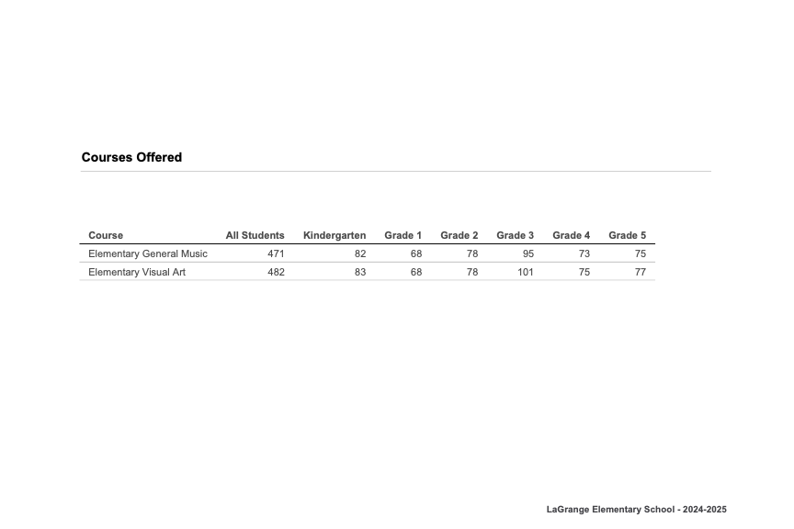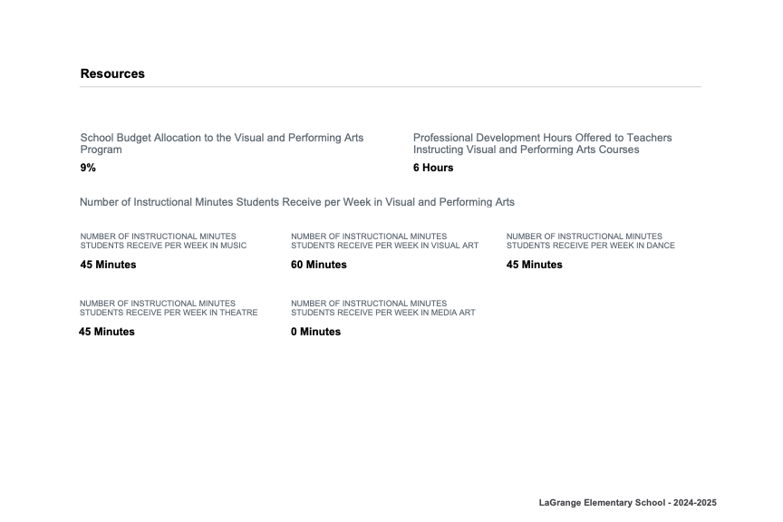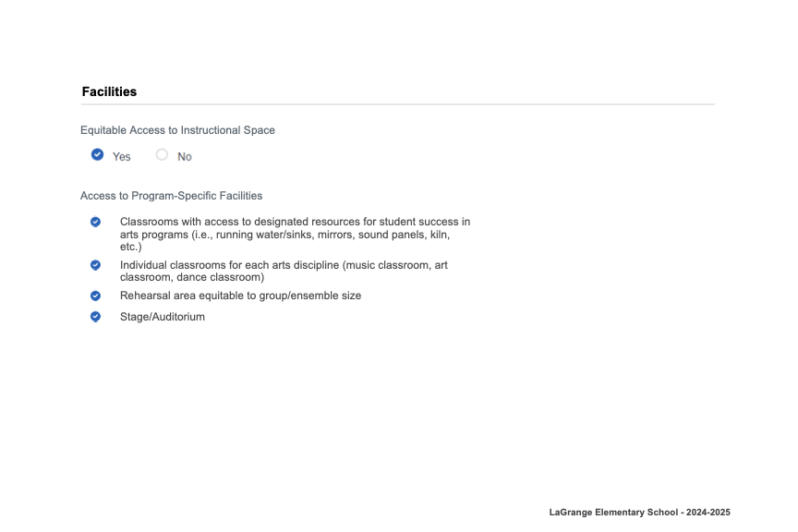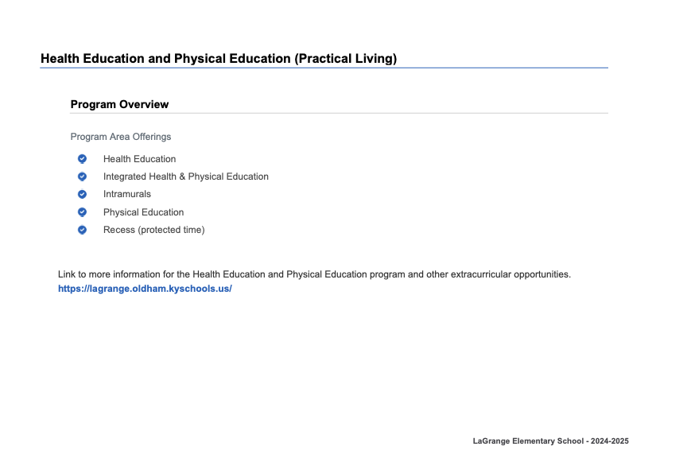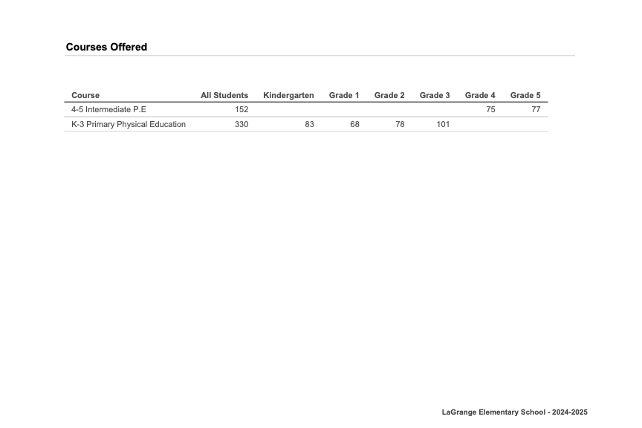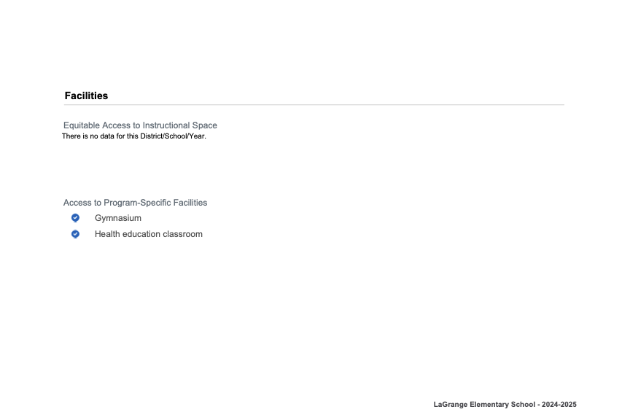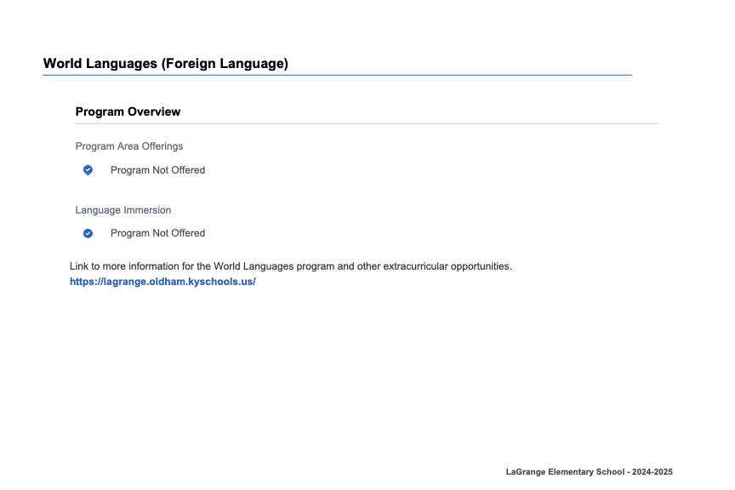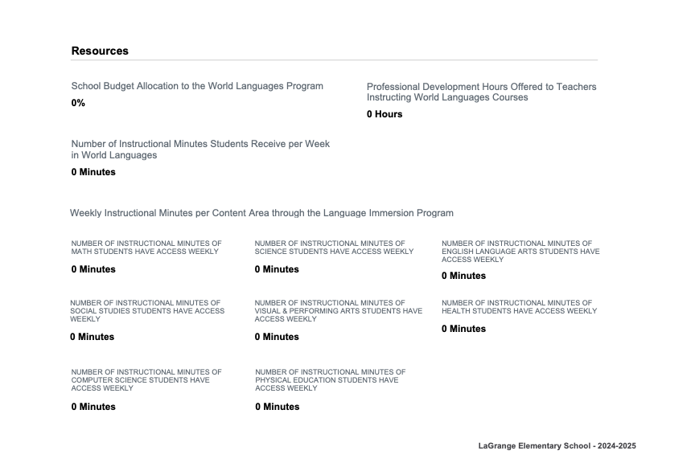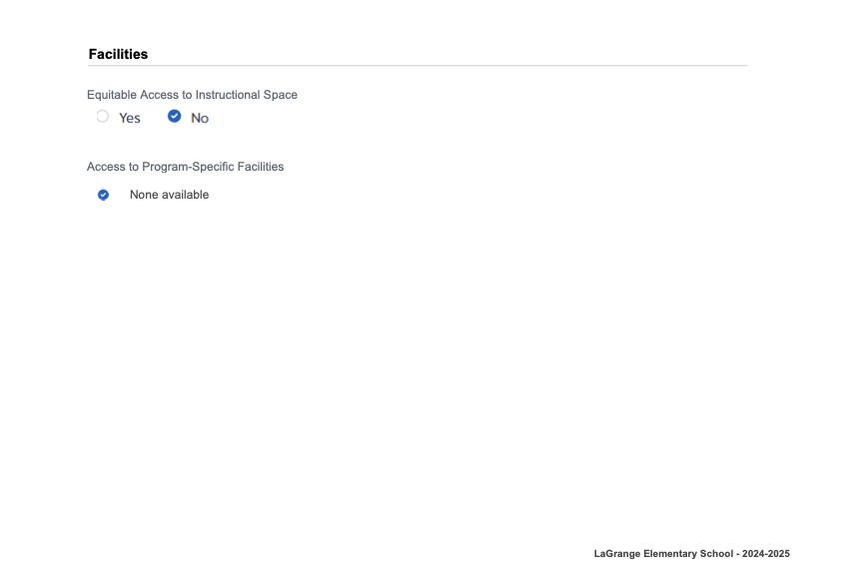
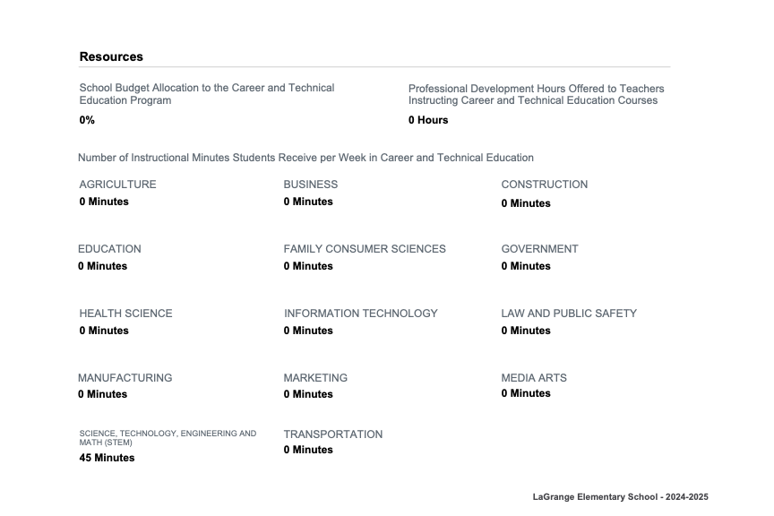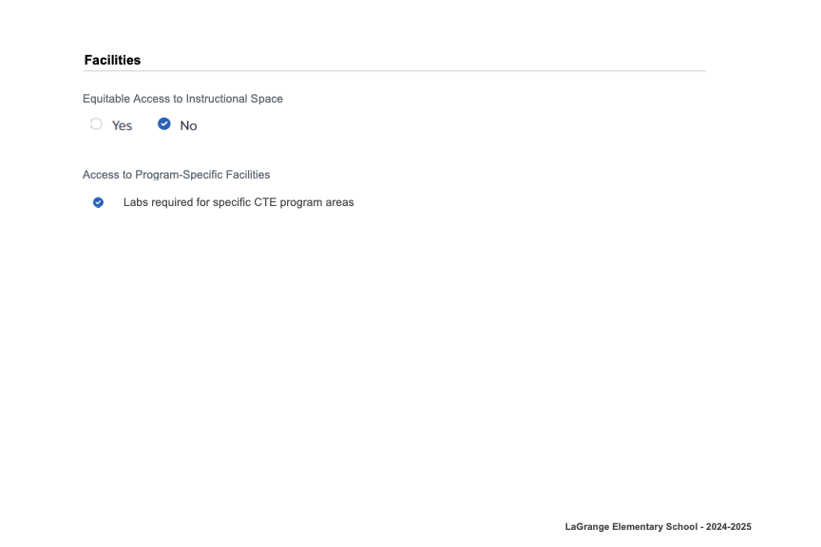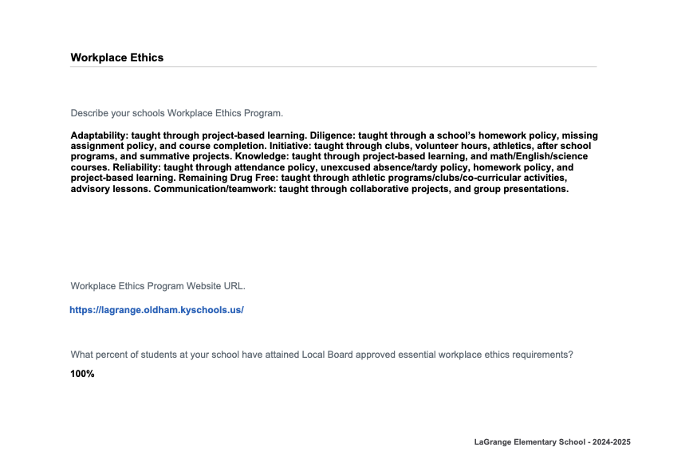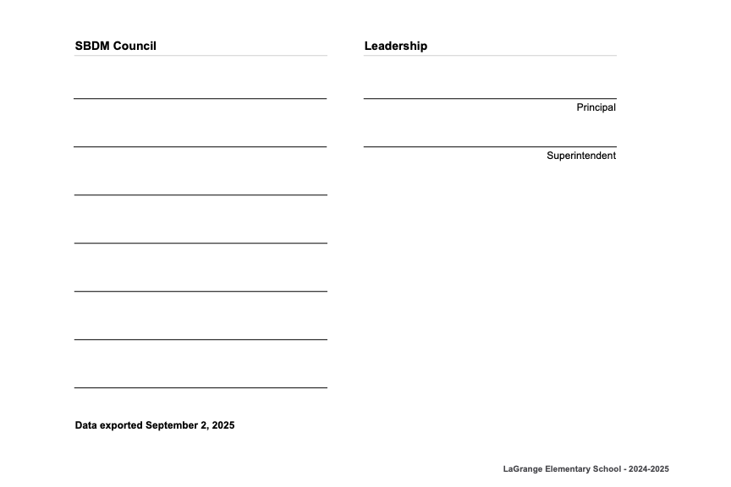

September 22, 2025
Enclosure B

La Grange Elementary School Council
Oldham County Schools

CONCERN:

The phrase council policies refer to what the school council develops and adopts concerning how the school operates. This includes such items as curriculum development, determining school schedules and technology use in schools. Policies are the rules, guidelines and procedures for school operations.

DISCUSSION:

School council policies need to contribute to raising student performance and keep a focus on achieving our mission and goals. As our goals and procedures evolve, the council needs to review our policies to determine if and how they need to be revised.
With the passage of KRS 160.345, Section 2(g), “the local superintendent shall determine which curriculum, textbooks, instructional materials, and student support services shall be provided in the school after consulting with the local board of education, the school principal, and the school council and after a reasonable review and response period for stakeholders in accordance with local board of education policy." Based on the law, policy 2002 needs to reflect that as a council, we are making a possible recommendation to the district. As a council, we need to ensure our policy aligns with the significant changes at the state level.
Both our current policy and the multi-step state process have been included for discussion.

RECOMMENDATION:

Discuss council policy 2002 make revisions, ask questions and seek additional information if needed as a first reading. Pending no additional questions, approve policy revision as presented.

LAGRANGE ELEMENTARY SCHOOL COUNCIL POLICY

SELECTION OF TEXTBOOKS AND/OR INSTRUCTIONAL ALIGNMENT MATERIALS 2002
TOPICS STATEMENT

a. Instructional Materials
Instructional materials shall mean commercial materials, media, and
software used by teachers to deliver instruction.

B. Committee
A committee shall develop a plan for the acquisition of instructional materials and/or technology.

The committee shall make recommendations and report to the Council. The school librarian/media specialist could assist in the development of
the recommendations. The recommendations shall be developed with a focus on the overall needs of the instructional program. Selection of materials shall be based on the alignment of the selected school curriculum and upon needs identified in the School Improvement Plan.

The committee shall be responsible for:
1. Surveying the teachers to determine their instructional material needs/technology and preferences.
2. Studying instructional material samples/technology and identifying instructional materials to be used in the instructional program.
3. Developing a written plan

From the point of a school recommendation shared with the Board of Education, superintendent shall determine which curriculum, textbooks, instructional materials, and student support services shall be provided in the school after consulting with the local board of education, the school principal, and the school council and after a reasonable review and response period for stakeholders in accordance with local board of education policy.

C. Budget The budget developed by the committee shall not exceed the available building
funding. The Council shall approve the budget.

Adopted – La Grange Elementary School School-Based Decision-Making Council – April 30, 1997;
Revised- July 8, 1997; March 16, 1999; April 18, 2000; September 26, 2000; September 25, 2001;
March 27, 2006; August 1, 2007; June 30, 2011; August 27, 2013, September 2018, December 14,
2020, September 25, 2023; September 30, 2024

Topic | Description
- Selection Process | Based on district needs, the superintendent begins the process of selecting materials that are aligned with the Kentucky Academic Standards (KAS).
- Consultation with stakeholders | Before a decision is finalized, the superintendent must consult with the following groups:  The local board of education, which provides input based on district policies and goals.  The school principal, who offers insights into the school's specific needs.  The SBDM council, which provides feedback representing the school community.
- Stakeholder review and response period | A "reasonable review and response period" is offered, during which stakeholders can examine proposed materials. This often includes community forums and opportunities for parents to provide input.
- Final decision | After reviewing all feedback, the superintendent makes the final determination and communicates the rationale to stakeholders.
- Managing Implementation | While the superintendent selects the materials, the school principal, after consulting with the SBDM council, determines how to allocate funds from the local board of education for implementation and budgeting.

Executive Summary-

- Description of the School Describe the school's size, community/communities, location, and changes it has experienced in the last three years. Include demographic information about the students, staff, and community at large. What unique features and challenges are associated with the community/communities the school serves?

La Grange School opened in January of 1912 as a K-12 school. With additions and renovations, La Grange Elementary remains a small town school with a century-old history. Generations of families have attended La Grange, giving it a rich history with families in the community. Just like their parents and grandparents, many of our students walk or ride their bikes to school. While we love the history and community feel of our school, the age of the building presents unique challenges related to easy accessibility due to five sets of stairs and classroom sizes dating back to the 50s.

La Grange (LES) is a K-5 school that serves an economically and ethnically diverse population. Our students live roughly within a two-mile radius of the school. La Grange is identified as a school-wide Title I program school, with 56% of the population qualifying for free or reduced lunch. Our school received a grant to provide free breakfasts and lunches to all students. During the summer, La Grange also offers free breakfasts and lunches to any child under 18 in our community, Monday through Friday. We participate in the Blessings in a Backpack program, funded by Covenant United Methodist, for students whose families sign up for their elementary children to receive extra food to take home for the weekend/breaks because their child might otherwise go hungry. Many of our students also receive needed holiday support from our community and church groups, such as Southeast Christian Church, Northeast Christian Church, La Grange Baptist Church, Red Cross, and HighPoint Ministries. LES has a Family Resource Center Coordinator, a Hispanic Liaison, a counselor, and a school psychologist who work to build families' capacity and remove any additional barriers beyond the school. These programs help bridge the socioeconomic gap for our students and their families by removing barriers to learning, promoting academic success, and providing strategies that strengthen family engagement.

Our largest ethnicity (excluding white) is Hispanic at 26%. The diversity among the student population includes 24% Disability, 22% English Learners, and less than 1% Gifted & Talented.

- School Stakeholders: Identify and describe the school’s stakeholder groups. How does the school ensure stakeholder involvement and engagement in improving planning?

Stakeholders include staff, students, families, and administrators. For continuous data analysis, each Admin team member is assigned to a grade to attend weekly PLC meetings. Formative data and next steps are determined during PLC meetings and then shared with the rest of the Admin team. Our Admin Team works to support PLCs in addressing concerns based on formative data.

PTA meetings generate parent involvement and ideas. The PTA also posts parent involvement activities on their Facebook page and our eSpot electronic newsletter. Parent surveys following each family event are analyzed and presented to our Title I planning committee to initiate discussion and changes related to school events. Parent involvement is welcomed and encouraged at all events, including our Back to School Night, school social events, family night events, and PTA fundraisers based on compliance with district restrictions.

In terms of social and emotional needs, we continuously collaborate with internal and external partners to support our students and families. Our team members include our school psychologist, mental health consultant, Family Resource Coordinator, School Resource Officer, and counselor. We also partner with various outside agencies, including mental health providers, local churches/places of worship, and community charities.

School's Purpose- Provide the school’s purpose statement and ancillary content such as mission, vision, values, and beliefs, including the year they were last reviewed or revised. Describe how the school embodies its purpose through its program offerings and expectations for students and how stakeholders are involved in its development.
School Purpose Statement & Supporting Content
As a school community, we have been intentionally focusing on strengthening our culture. Together, we read The FISH! Philosophy and used its principles to guide conversations about who we are, what we believe, and what we want for our students. This process has helped us begin to establish a shared identity and clarify our core purpose.
Our mission and supporting statements are still evolving as we refine them collaboratively, but our current guiding purpose is expressed through:
#studentsfirst – “Creating the situations to ensure learning for all students.”
- Mission (in progress): To provide a safe, engaging, and supportive environment that empowers all students to grow academically, socially, and emotionally.
- Vision: We envision a school where every child feels valued, challenged, and prepared to contribute positively to their community.
- Core Values and Beliefs:
  - All students are capable of high levels of learning with the right support in place.
  - Positive relationships and a strong sense of belonging are essential to student success.
  - High expectations, equity, and respect guide our work with students and families.
  - Collaboration among staff, families, and community partners strengthens our ability to serve students well.
- Last Review/Revision: Our purpose and mission are being reviewed and are currently under revision as part of our cultural reset and identity work.
Embodying Our Purpose
We live out our purpose through both program offerings and clear expectations for students. This includes:
- Standards-based instruction with tiered supports to ensure all students can achieve growth.
- Intervention and enrichment opportunities designed to meet diverse learning needs.
- Social-emotional learning programs, positive behavior supports, and restorative practices that foster a safe and inclusive school environment.
- Opportunities for student leadership, creativity, and extracurricular engagement that extend learning beyond the classroom.
Our expectations for students are rooted in our belief that every child can succeed. We encourage responsibility, perseverance, respect, and a growth mindset as essential skills for lifelong learning.
La Grange Elementary School is located in the heart of Oldham County, Kentucky, but its population does not mirror that of our neighboring schools. We take pride in our diverse student body, with almost 27% of our students identifying as Hispanic, many of whom settle in our area to work on local horse farms and speak very little English. In contrast, 64% of our students identify as White, and the remaining 9% are Black or Mixed Races. This diversity allows LES staff members to serve various cultures and viewpoints, making every student feel included and valued.

LES educates its students in a structure that was built in 1912. While many additions and renovations have occurred, one fact remains the same - our unwavering commitment to traditional quality education. This commitment is vital and rooted in the center of the community. LES shares its vision with stakeholders through social media, weekly student-produced newscasts, and recap video productions to celebrate students and inform working parents of achievements. A regularly scheduled newsletter and grade-level communication efforts are used as the focal point to display learning objectives, student goals, and overall community love.

Programs are designed to welcome all parents and students, regardless of the language barriers within our school community. All school information is delivered in English and Spanish to households, whether it be via paper, digitally through our weekly eSpot Newsletter, or on social media posts. LES embraces the different languages and cultures that make up our Leopard student body. Our decision table comprises individuals from various building departments and community stakeholders to ensure all viewpoints and voices are addressed.

The LES Mental Health Team, which includes our counselor, school psychologist, and mental health consultant, utilizes a comprehensive approach to offer Tiered Counseling Interventions to all students. Social Emotional Learning is integrated into daily classroom routines. The LES school counselor supports teachers by integrating Conscious Discipline classroom management strategies, Purposeful People Character Education, and Sanford Harmony community-building routines into their classrooms. Homeroom and resource classrooms are equipped with materials to implement a Safe Place station, a self-regulation learning center available to all students. The school counselor facilitates Tier 1 classroom guidance lessons for all students, focusing on building social-emotional skills. Homeroom teachers have a scheduled time of the day to complete Class Meet-Ups, a structured community-building opportunity to establish and monitor classroom expectations, connect, solve problems, and share experiences.

Small group and individual counseling are offered as Tier 2 and Tier 3 responsive services, facilitated by all members of the Mental Health Team. Students are selected for small group counseling utilizing a behavior screener, teacher referral, parent referral, or counselor referral. Sample small group topics include managing stress and anxiety, building emotional regulation skills, or building friendships. Individual Counseling services are available to all students on an as-needed basis. Referrals may come from the individual student, parents, or any staff member. The counselor guides students through a solution-focused approach to problem-solving. Furthermore, the counselors work collaboratively with district Mental Health Consultants to appropriately refer students to outside services as needed.

The social-emotional well-being of each student is paramount and impacts every area of a student’s education. Through a collaborative approach, La Grange Elementary’s Mental Health Team supports all staff in building emotional capacity in themselves and, in turn, in all students.

Notable Achievements and Areas of Improvement- Describe the school’s notable achievements and areas of improvement in the last three years.
La Grange offers unique programming, like our Family Resource Center, to meet the needs of individual learners by removing barriers through the combined efforts of faculty, staff, and parents. As a schoolwide Title I program, we have worked towards helping parents know more about Title I and becoming involved in parent events. According to our 24-25 Title I annual survey, 94% of parents acknowledged receiving a copy of the Parent Involvement Policy during registration or our family Title I meeting. 97% of our parents felt their parent-teacher or student-led conference answered their questions and concerns, and 97% thought they were offered information or helpful suggestions to help their child learn.

Like many schools, the PTA is a vital partner in our mission to serve our school community beyond our classroom walls. Our PTA comprises parents who know the ins and outs of our families' struggles at home. LES is also blessed to have several staff members who volunteer their time after school to assist the PTA as they have children in the building. The PTA sponsors holiday events throughout the year, fundraising efforts that support student learning, and provides volunteers for school events. Additionally, the PTA collaborates with our Family Resource Center regularly to support family literacy nights and other opportunities that remove barriers for our families. The PTA is a vital partner with La Grange.

La Grange continues to support all students by using co-teaching, small groups, and individualized instruction based on data. One of the areas in which we continue to see dramatic increases in student success is writing with a structured student support system and training all the 3rd-5th grade teachers. As a result, 68 of our 5th graders from 2023-24 scored proficient or distinguished.

Another area of notable achievement is technology. We met our goal of becoming a 1:1 technology device educational program a few years ago. We currently have 1:1 Chromebooks in 1st-5th grade and 1:1 iPads in kindergarten. Our staff ratio is also 1:1. We even have a set of devices dedicated to our afterschool enrichment program. Our instructional classrooms contain an interactive SMART Board panel (co-teaching classrooms have two interactive Smart Boards) and an audio microphone system to help integrate technology into instruction, make instruction more visually engaging, and provide audio support for all students. We have created a sustainable replacement plan with our district technology staff.

During the 2024-2025 school year, our school Grant Writing Committee obtained funding to support our 5th grade History Center unit through the Daughters of the American Revolution. We also received grant funding to provide books for PreK-12th grade attendees of our Summer Food Program. At the end of the 2024-2025 school year, staff members (or staff partnerships) were awarded 10 Pyramid Award grants from Oldham County Educational Foundation (OCEF) covering classrooms, library, related arts programming, social-emotional learning, and English Language learning.

- Areas of Improvement- Describe areas for improvement that the school is striving to achieve in the next three years.

Based on our 2024-25 CSIP, La Grange has three areas for improvement: 1) Even though La Grange is showing growth over time, our overall percentage of proficiency is hovering at roughly the same level with 53.4% in 21-22, 54.4% in 22-23 and 52.5% in 2023-24. Reading scores declined 2.0 percentage points which indicates a Maintained on our Change Cut Scores. Our first area of improvement is to decrease the % of students scoring novice in Reading from 18% based on 2023-24 KSA data to 13%; 2) Science scores declined 5.3 percentage points, from 32.1% to 24.6% which indicates a decline in our Change Cut Scores. Our second area of improvement is to decrease the % of students scoring novice and apprentice in Science from 75% based on 2023-24 KSA data to 40%. 3) Math, even though our scores improved during the 2023-24 school year, needs to show a significant decrease in the % of students scoring novice in Math from 21% based on 2024-25 KSA data to 16%.

Additional Information
Please provide any additional information you would like to share with the public and community that was not prompted in the previous sections.

