Campus Improvement Plan
2025-2026

Submitted for Board Approval on _____________ 2025
Board Approved Date: __________ 2025
Vision

Every PSJA student is prepared to participate, compete, and excel in a global society to foster multi-generational prosperity.

Mission

As educational leaders, the PSJA team is engaged and empowered to connect all students with innovative instruction, outstanding facilities, technology, skills, and social- emotional support while prioritizing health and safety for all – from early childhood through their chosen career.

As one PSJA family, we build on our legacy of academic excellence, renowned college and career readiness, biliteracy and extracurricular programs, and our multicultural heritage to ensure every student has the experiences and resources necessary to achieve the highest levels of success.
Adopted June 22, 2020, by the PSJA School Board of Trustees

Texas Accountability System


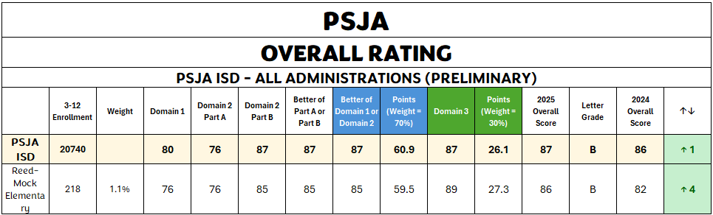

B

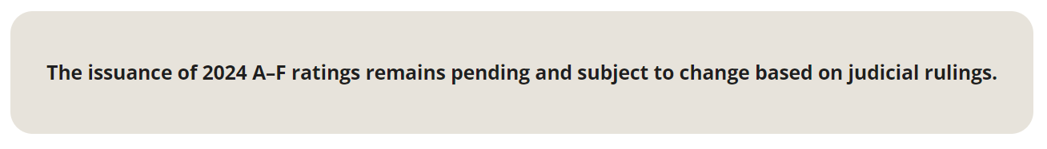
Retrieve on Nov. 11, 2024 from: Texas School Report Cards | Drs Reed - Mock Elem | Accountability Overview

Strategic Direction
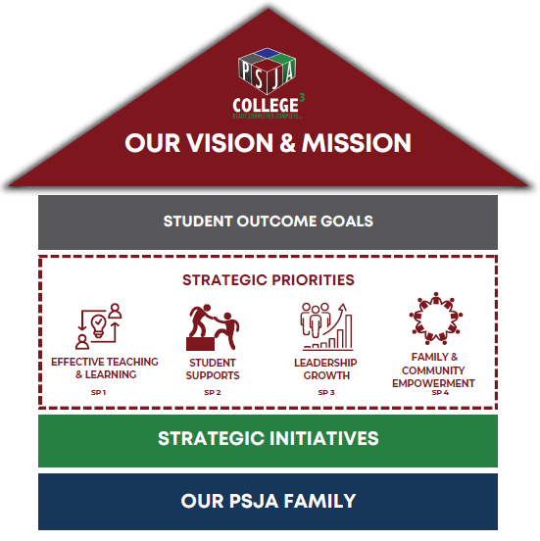

PSJA School Board
Diana Serna, President
Ricardo Rodriguez, Vice-President
Griselda Quintanilla, Secretary
Ramona Barron, Assistant Secretary
Yolanda Castillo, Member
Cynthia A. Gutiérrez, Member
Carlos G. Villegas, Jr., Member
Superintendent's Cabinet
Dr. Alejandro Elias, Superintendent of Schools
Rebecca Gonzales, Chief Financial Officer
Dr. Rebecca Garza, Assist. Supt. Human Capital Development
Ranulfo Marquez, Assist. Supt. for Academics
Dr. Lauro Davalos, Assist. Supt. For Technology
Rafael Gonzalez, Assist. Supt. for Operations

Senior Staff
Dr. Susana Arredondo, Executive Officer for Elementary Schools
Dr. Virna M. Bazan, Executive Officer for Elementary Schools
Mario Bracamontes, Sustainability Administrator
Dr. Nora Cantu, Executive Officer for Academics
Alfredo Carrillo, Executive Officer for Human Resources
Dr. Yolanda Gomez, Executive Officer for Learning Acceleration
Dr. Claudia Gonzalez, Executive Officer for Elementary Schools
Dr. Iris Guajardo, Executive Officer for Secondary Schools
Dr. Nora Rivas-Garza, Executive Officer for Secondary Schools
Dr. Linda Uribe, Executive Officer for College Readiness
Campus Executive Summary

Demographics:
Drs. Reed & Mock Elementary School serves students from the Pharr-San Juan-Alamo area, who share similar backgrounds, cultures, and ways of life.

The student body at PSJA is predominantly Hispanic, with the following student population breakdown:

Drs. Reed & Mock Special Populations Breakdown Matrix

Drs. Reed & Mock | Male | Female | Sped | Lep | Migrant | Gt | ECD
 | 261 | 238 | 76 | 174 | 8 | 11 | 450
 | 52.3% | 47.7% | 15.2% | 34.9% | 1,6% | 2.2% | 90.2%

With the district’s proximity to Mexico, 35 % of the students are considered Emergent Bilingual (EBs) with Spanish being the language spoken at home.

Student Performance:
Using preliminary student performance data, Drs. Reed and Mock have been rated a "B" Campus on the 2024 Accountability. In Domain I, Student Achievement component score of 48 (76), STAAR School Progress Domain 2A was at a component score of a 68 (76), Domain 2B Relative Performance component score 48 (85), and Domain III component score 73 (89). Drs. Reed and Mock earned a grade of 85.

Executive Summary Continued

Student Performance:
Student Performance:

For the 2025-2026 school year, the Student Performance goals are the following:
- The percentage of all students that score meets grade level or above on STAAR combined Reading, Mathematics, and Science will increase from 48% in May 2025 to 60% by June 2026.
- The percentage of students who perform at MEETS grade level or above on 3rd grade STAAR Reading will increase by four percentage points by June 2026.
- The percentage of students who perform at MEETS grade level or above on 3rd grade STAAR Mathematics will increase by six percentage points by June 2026.
- The percentage of students who perform at MEETS grade level or above on 4th grade STAAR Math will increase by four percentage points by June 2025.
- The percentage of students who perform at MEETS grade level or above on 4th grade STAAR Reading will increase by two percentage points by June 2026.
- The percentage of students who perform at MEETS grade level or above on 5th grade STAAR Mathematics will increase by four percentage points by June 2026.
- The percentage of students in Domain 2A who perform at MEETS grade level or above on 5th grade STAAR Mathematics will increase by four percentage points by June 2026.

Vision
Our vision for Drs. Reed & Mock Elementary School is to educate children through a collaborative effort among parents, faculty, students, and the community. We aim to create a school environment that encourages students to become future leaders, take creative risks without fear of failure, and build a strong foundation in social-emotional development. Through cooperation and unity, challenges become opportunities, and achievements are recognized and celebrated.

Mission​
The mission of Drs. Reed & Mock Elementary is to provide all learners with a high-quality, stimulating academic environment that integrates 21st-century skills and a research-based curriculum. We ensure a highly qualified staff delivers instruction using effective, up-to-date teaching methodologies while setting high standards for all students.

Campus Educational Improvement Committee Member

Name | Title
Robert Sanchez | Principal
Cynthia Gonzalez | Assistant Principal
Kayla Rodriguez | Counselor
Lorena Cardenas | CLL
Ana Warkentine | Reading Coach
Alba Ramirez | Special Ed Teacher
Laura Treviño | Lead Teacher
Sanjuanita Loredo | Lead Teacher
Mrs. De Leon | Parent Representative

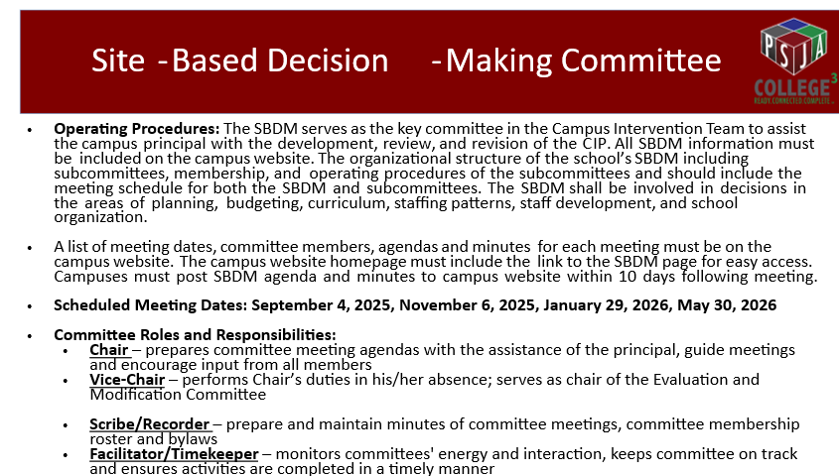

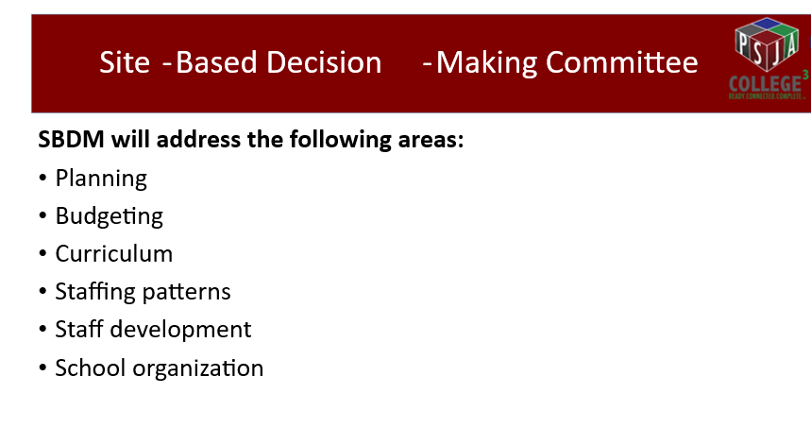

2024-2025 STAAR (PRELIMINARY)
OVERALL RATING
ELEMENTARY SCHOOLS
 | Domain 1 | Domain 2 | Domain 2 | Better of | Better of Domain 1 or Domain 2 | Points | Domain 3 | Points | Overall Score | Letter Grade
 | Domain 1 | Part A | Part B | Part A or | Better of Domain 1 or Domain 2 | (Weight = 70%) | Domain 3 | (Weight = 30%) | Overall Score | Letter Grade
 | Domain 1 |  |  | Part B | Better of Domain 1 or Domain 2 |  | Domain 3 |  | Overall Score | Letter Grade
PSJA ISD | 75 | 82 | 85 | 85 | 85 | 59.5 | 90 | 27 | 87 | B
Anaya Elementary | 77 | 88 | 86 | 88 | 88 | 61.6 | 92 | 27.6 | 89 | B
Arnold Elementary | 80 | 92 | 88 | 92 | 92 | 64.4 | 92 | 27.6 | 92 | A
Cantu Elementary | 72 | 76 | 81 | 81 | 81 | 56.7 | 81 | 24.3 | 81 | B
Carman Elementary | 77 | 87 | 86 | 87 | 87 | 60.9 | 91 | 27.3 | 88 | B
Chavez Elementary | 86 | 93 | 91 | 93 | 93 | 65.1 | 92 | 27.6 | 93 | A
Clover Elementary | 74 | 90 | 82 | 90 | 90 | 63 | 85 | 25.5 | 89 | B
Doedyns Elementary | 11741 | 73 | 78 | 78 | 11741 | 8219 | 77 | 23.1 | 8242 | A
Dr Long Elementary | 74 | 81 | 82 | 82 | 82 | 57.4 | 77 | 23.1 | 81 | B
Escobar Elementary | 88 | 82 | 91 | 91 | 91 | 63.7 | 92 | 27.6 | 91 | A
Farias Elementary | 67 | 71 | 75 | 75 | 75 | 52.5 | 73 | 21.9 | 74 | C
Ford Elementary | 71 | 75 | 80 | 80 | 80 | 56 | 74 | 22.2 | 78 | C
Garcia Elementary | 82 | 90 | 90 | 90 | 90 | 63 | 92 | 27.6 | 91 | A
Garza Elementary | 76 | 91 | 85 | 91 | 91 | 63.7 | 91 | 27.3 | 91 | A
Garza-Pena Elementary | 76 | 80 | 85 | 85 | 85 | 59.5 | 88 | 26.4 | 86 | B
Guerra Elementary | 78 | 85 | 88 | 88 | 88 | 61.6 | 92 | 27.6 | 89 | B
Kelly-Pharr Elementary | 69 | 63 | 75 | 75 | 75 | 52.5 | 74 | 22.2 | 75 | C
Livas Elementary | 73 | 73 | 82 | 82 | 82 | 57.4 | 83 | 24.9 | 82 | B
Longoria Elementary | 75 | 89 | 84 | 89 | 89 | 62.3 | 91 | 27.3 | 90 | A
McKeever Elementary | 74 | 78 | 82 | 82 | 82 | 57.4 | 90 | 27 | 84 | B
Palacios Elementary | 86 | 89 | 91 | 91 | 91 | 63.7 | 92 | 27.6 | 91 | A
Palmer Elementary | 77 | 85 | 86 | 86 | 86 | 60.2 | 84 | 25.2 | 85 | B
Ramirez Elementary | 65 | 75 | 73 | 75 | 75 | 52.5 | 72 | 21.6 | 74 | C
Reed-Mock Elementary | 76 | 79 | 86 | 86 | 86 | 60.2 | 91 | 27.3 | 88 | B

2024-2025 STAAR/STAAR ALT
SCHOOL PROGRESS - STUDENT GROWTH
ELEMENTARY SCHOOL (SNAPSHOT) (PRELIMINARY)
 | ANNUAL GROWTH |  |  |  |  |  | Raw Score | Scale Score | Letter Grade
 | # of | # of students |  |  |  | Earned | Raw Score | Scale Score | Letter Grade
 | Tests | 0 | 0.5 | 1 | 0.25 | Points | Raw Score | Scale Score | Letter Grade
PSJA ISD | 7689 | 2061 | 747 | 4881 | 999 | 5504.3 | 72 | 81 | B
Reed-Mock Elementary | 272 | 78 | 29 | 165 | 24 | 185.5 | 68 | 76 | C
Grade 4 Mathematics | 74 | 15 | 6 | 53 | 7 | 57.75 | 78 | 88 | B
Grade 4 Reading | 74 | 20 | 6 | 48 | 10 | 53.5 | 72 | 81 | B
Grade 5 Mathematics | 62 | 24 | 8 | 30 | 3 | 34.75 | 56 | 60 | D
Grade 5 Reading | 62 | 19 | 9 | 34 | 4 | 39.5 | 64 | 71 | C

2024-2025 STAAR/STAAR ALT
STUDENT ACHIEVEMENT
ELEMENTARY SCHOOL (SNAPSHOT) (PRELIMINARY)
 | Number of Tests | Approaches |  | Meets |  | Masters |  | Raw Score | Scale Score | Letter Grade
 | Number of Tests | Grade Level |  | Grade Level |  | Grade Level |  | Raw Score | Scale Score | Letter Grade
 | Number of Tests | Met Std | % Points | Met Std | % Points | Met Std | % Points | Raw Score | Scale Score | Letter Grade
PSJA ISD | 13260 | 9806 | 74% | 6239 | 47% | 2746 | 21% | 47 | 75 | C
Reed-Mock Elementary | 490 | 376 | 77% | 237 | 48% | 98 | 20% | 48 | 76 | C
Grade 3 Mathematics | 74 | 50 | 68% | 23 | 31% | 6 | 8% | 36 | 61 | D
Grade 3 Reading | 73 | 54 | 74% | 35 | 48% | 16 | 22% | 48 | 76 | C
Grade 4 Mathematics | 77 | 58 | 75% | 47 | 61% | 25 | 32% | 56 | 85 | B
Grade 4 Reading | 77 | 66 | 86% | 43 | 56% | 17 | 22% | 55 | 83 | B
Grade 5 Mathematics | 63 | 49 | 78% | 32 | 51% | 8 | 13% | 47 | 75 | C
Grade 5 Reading | 63 | 50 | 79% | 31 | 49% | 17 | 27% | 52 | 79 | C
Grade 5 Science | 63 | 49 | 78% | 26 | 41% | 9 | 14% | 44 | 73 | C
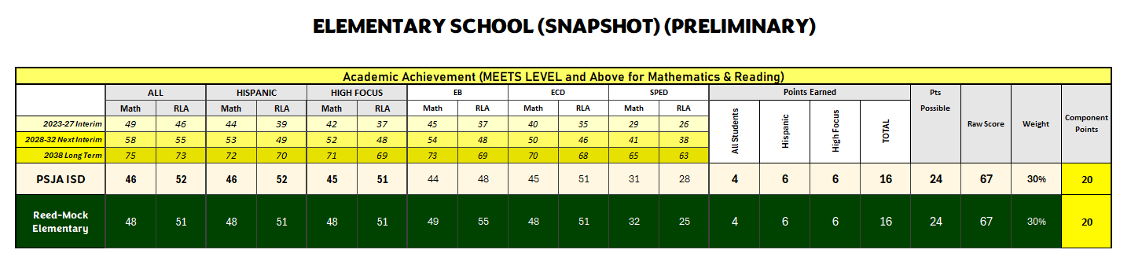
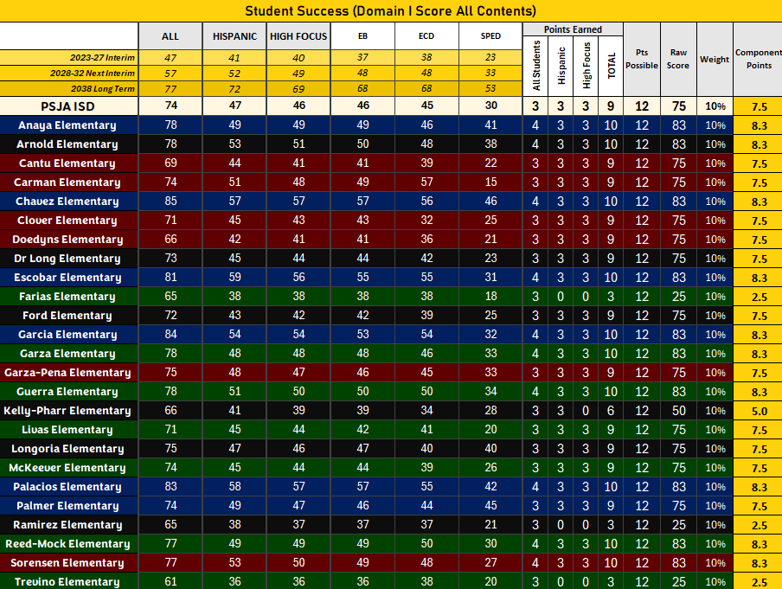
2024-2025 STAAR/STAAR ALT
STUDENT ACHIEVEMENT
GRADE 3 READING (SNAPSHOT) (PRELIMINARY)
 | Number of Tests | Approaches |  | Meets |  | Masters |  | Raw Score | Scale Score | Letter Grade
 | Number of Tests | Grade Level |  | Grade Level |  | Grade Level |  | Raw Score | Scale Score | Letter Grade
 | Number of Tests | Met Std | % Points | Met Std | % Points | Met Std | % Points | Raw Score | Scale Score | Letter Grade
PSJA ISD | 1755 | 1296 | 74% | 818 | 47% | 358 | 20% | 47 | 75 | C
Reed-Mock Elementary | 73 | 54 | 74% | 35 | 48% | 16 | 22% | 48 | 76 | C
ENGLISH | 57 | 42 | 74% | 28 | 49% | 11 | 19% | 47 | 75 | C
SPANISH | 16 | 12 | 75% | 7 | 44% | 5 | 31% | 50 | 77 | C

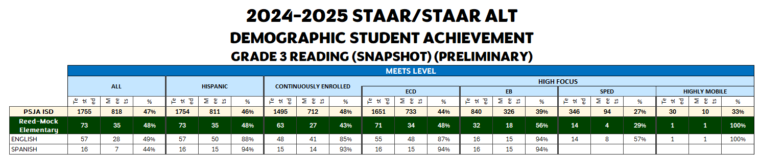
Comprehensive Needs Assessments
Demographics
Demographics Summary
Special Education:
The following accountability sources were used to review the Special Education data by the Campus Site-Based Decision-Making Committee (SBDM): State of Texas Assessments of Academic Readiness (STAAR) results, Performance Based Monitoring Assessment System (PBMAS) and State Performance Plan (SPP) indicators to determine strengths and needs of our Special Education students. In addition, the Special Education Department was very involved in the curriculum writing and revision for grades K-5 during the summer to ensure that the general curriculum meets the needs of our special education students. Professional development is also coordinated with the curriculum and instruction department to ensure that all general education teachers are well versed in best practices that support the learning of special education students.
Needs:
Align student goals and objectives outlined in IEP with TEKS being assessed on STAAR, STAAR Online, STAAR-Alt 2, TELPAS and TELPAS-ALT.
Personnel Needs:
Campus Administrators will work closely with Human Resources (HR) to ensure the selection of highly qualified employee(s) holding valid state issued certification.
Professional Development Needs:
Special Education Staff will be included in all Professional Development (PD) provided by the campus/district in the areas that are to be addressed by individual students. The Special Education Department will work closely with the Campus and provide PD in the area of co-teaching to implement the inclusion model effectively. Resource teachers will work collaboratively with homeroom teachers to ensure IEP implementation.

Emergent Bilinguals (EB):
The following accountability sources were used to review the Bilingual Education/Dual Language (BE/DL) Department data by the SBDM Committee: State of Texas Assessments of Academic Readiness (STAAR) results, Performance Based Monitoring Assessment System (PBMAS) and TELPAS indicators to determine strengths and needs of our EL students. The BE/DL Department was very involved in the curriculum writing and revision for grades K-5 during the summer to address the needs of our EL students and align the curriculum between English and Spanish Language Arts that led to a more coherent and consistent bi-literacy program.
GOAL AREA 1: Student Achievement
Areas Reviewed: Student Performance
Strengths
Pharr-San Juan- Alamo provides the campus with a standards-aligned Guaranteed and Viable Curriculum and scope and sequence. The district curriculum is developed and adjusted after the district content- based assessments and benchmark data are analyzed. The development and adjustment of the district curriculum is led by
the Curriculum & Instruction Department, and includes teachers, district content coordinators, and district Executive Officers for each level. The district also provides teachers and campus leaders access to assessments aligned to the standards and expected levels of rigor. A data assessment platform to capture immediate assessment data by item and student is inclusive as part of the curriculum practices and curriculum implementation. In addition:
- Curriculums and assessments are aligned to Texas Essential Knowledge and Skills (TEKS) and included in a year-long scope and sequence. After each
assessment, campus and district staff conduct data review sessions and adjustments are immediately made to the scope and sequence and resources are evaluated.
- The scope and sequence, units of study, and assessments are aligned to the standards for all state assessed subjects and grade levels in grades Pk-2nd, 3rd-5th, middle and high school.
- Lesson internalization district training along with follow ups during Teacher Collaborative Learning Community (TCLC).
- Assessments that are aligned to state standards at the appropriate level of rigor are administered strategically throughout the year to determine student
progress. Corrective instruction is built into the curriculums and scope and sequence.
- Instructional materials with key ideas, essential questions, and recommended materials including content-rich texts and phonics materials are used across classrooms. The instructional materials include resources intentionally designed to meet the needs of students with disabilities and English learners among other student groups.
- Professional development is provided throughout the year in response to classroom observations, formative assessments and campus performance.
- Learning Walks from district leaders and campus leaders to enhance instruction by the use of rubrics and observational feedback.

Challenges
The area of literacy, specifically in reading comprehension and writing, has been a challenge district-wide and great emphasis and resources are being dedicated to this area of need. Additionally, the 2025 STAAR Performance results indicate academic gaps in mathematics.
- The All-Student Group in ELA/Reading (Spanish) at Meets Grade Level Standard or Above was at 52%.
- High Focus Student Group (ECD) in ELA/Reading at Meets Grade Level Standard or Above was at 52%.
- Emergent Bilingual Student Group in ELA/Reading at Meets Grade Level Standard or Above was at 55%.
- Special Education (Current) Student Group in ELA/Reading at Meets Grade Level Standard or Above was at 19%.
- Student reading on level by third grade is an area that we as the district continue to work on and monitor through progress monitoring.
- Cross curricular writing must be done at all grade levels including analyzing the writing during TCLC.
- Professional development for teaching writing must be provided at all grade levels.
- The All-Student Group in Mathematics at Meets Grade Level Standard or Above was at 46%.
- High Focus Student Group (ECD) in Mathematics at Meets Grade Level Standard or Above was at 46%.
- Emergent Bilingual Student Group in Mathematics at Meets Grade Level Standard or Above was at 44%.
- Special Education (Current) Student Group in Mathematics at Meets Grade Level Standard or Above was at 21%.

Goal Area 1: Student Achievement

Annual Goal 1: The percentage of all students at Drs. Reed & Mock Elementary that score at the meets grade level or above on STAAR Mathematics will increase from the current rate to 51% by June 2026.

Objective 1: The percentage of students meeting or exceeding grade level on STAAR Mathematics will increase from the current rate to 51% by providing access to a standards-aligned, guaranteed, and viable curriculum.

Strategy 1: Provide lesson internalization PD for all teachers during TCLCs. Use Student Profile Sheets to track math progress. Implement small group, differentiated instruction.
Timeline: June 2025- June 2026
Title I School Components: Title I, Title II, Title III, Special Ed. & Bilingual Funds, Migrant Funds
Persons Responsible: Principal, Assistant Principal, CLL, Reading Coach, Teachers

Action Steps:
1) Implement standards-aligned math instruction daily using the district curriculum with fidelity.
2) Conduct data meetings every three weeks to analyze formative assessments and adjust instruction.
3) Provide small-group interventions for students performing below grade level, using targeted math resources.

Resources | Evidence of Implementation | Evidence of Impact | Formative Evaluation
Eureka Math/Internalization  Teachers notes  STAAR Released Tests for practice and analysis  i-Ready Math lessons and diagnostics  Progress monitoring tools (DMAC, or district-selected data platforms)  Professional development on math content and strategies | Curriculum documents  Lesson plans  Collaborative Learning Leader [CLL] agendas  Walkthrough documents  Lesson Internalization  DMAC data, Tutorial/Intervention | BM1 and BM2 scores show increases in student achievement and student performance growth  STAR Reports, I-ready, BOY, CBA, BM1, BM2 and STAAR | Formative assessments  Benchmarks [BMs]  STAAR/TELPAS  Results Driven Accountability  IReady Diagnostic  Student Growth Measures  [SGM] Pre/Post Test  Beginning Of the Year

Strategy 2: Provide targeted small-group instruction during Tier 1 focused on building math vocabulary and conceptual understanding through modeling, hands-on activities, and visual aids to support student participation and allow for immediate feedback.

Timeline: September 2025 - May 2026
Title I School Components: Title I - IV, State Bilingual Funds, State Comp.
Persons Responsible: Asst. Supt. For Academics, Executive Officers, Principal, Assistant principal, CLL

Action Steps:
1) Plan and deliver small-group lessons using hands-on activities, visual aids, and modeling to reinforce math vocabulary and concepts.
2) Monitor student understanding during small groups and provide immediate feedback to address misconceptions.
3) Adjust instruction based on data from formative assessments and observations to ensure all students are progressing toward
grade-level standards.

Resources | Evidence of Implementation | Evidence of Impact | Formative Evaluation
Bluebonnet Curriculum Materials (lesson plans, pacing guides, TEKS-aligned activities)  Math manipulatives (counters, base-ten blocks, fraction pieces)  Visual aids and anchor charts for key vocabulary and concepts  Interactive math tools (whiteboards, charts, or digital apps)  Formative assessment tools (exit tickets, quick checks, i-Ready Math diagnostics | Student participation records  Attendance and engagement data  Observation notes | Lesson plans and teacher notes  Formative assessment data  Progress monitoring reports  Student work samples | Ongoing formative assessments  Progress monitoring reports  Teacher observations and anecdotal notes  Data meetings

Strategy 3: Monitor student progress in i-Ready by tracking lesson completion rates, mastery percentages, time spent on lessons, and assessment scores to inform instruction and provide targeted support.

Timeline: August 2025 - June 2026
Title I School Components: Title I - IV, State Bilingual Funds, State Comp.
Persons Responsible: Principal, Assistant Principal, CLL, Teachers

Action Steps:
1) Review i-Ready data weekly to track lesson completion rates, mastery percentages, and time spent on lessons for each student.
2) Identify students needing targeted support based on assessment scores and mastery data and provide small-group or individual interventions.
3) Adjust instruction and assign appropriate i-Ready lessons based on data trends to ensure all students progress toward grade-level standards.

Resources | Evidence of Implementation | Evidence of Impact | Formative Evaluation
i-Ready Math platform  Teacher guides and reports  Data tracking tools  Professional development  Weekly Reports | i-Ready reports  Lessons completed  Observation notes  Data Reports | Increased student mastery percentages  Improved assessment scores  Higher lesson completion rates  Reduction in the number of students performing below grade level | Weekly review of i-Ready data  Teacher observations and anecdotal notes  Data meetings  Student self-reflections or goal-setting logs

Goal Area 2: Closing the Achievement Gap

Annual Goal 1: All identified student groups in the Closing the Gaps domain will be monitored to ensure that at least a 10% increase is achieved in the Academic Achievement component for Kindergarten Readiness, moving from 34% to at least 44% by the end of the 2025-2026 school year.

Objective 1: By May 2026, at least 40% of Pre-K and Kindergarten students in all identified student groups will demonstrate mastery of foundational literacy and numeracy skills, as measured by district BOY, MOY, and EOY assessments.

Strategy 1: Provide small-group, evidence-based literacy instruction three times per week using phonemic awareness, phonics, and vocabulary-building activities.

Timeline: September 2025- Aug. 2026
Title I School Components: Title I, Title II, Title III, Special Ed. & Bilingual Funds, Migrant Funds
Persons Responsible: Asst. Supt. For Academics, Executive Officers, Principal, CLL, Teachers

Action Steps:
1) Identify Students-Review assessment data to determine which students are below grade level in reading.
2) Group Students by Need-create flexible small groups based on specific skill deficits
3) Provide Intervention Sessions-Deliver small-group instruction at least 3 times a week

Resources | Evidence of Implementation | Evidence of Impact | Formative Evaluation
Mosaic Program  District Curriculum  i-Ready  Phonics  Digital & Online Resources  Professional Support | Lesson Plans  i-Ready usage reports  Progress monitoring data  Intervention logs  Walkthrough or observation notes | Increase in kindergarten readiness performance  Growth in i-Ready diagnostic scores  Improved phonics assessment scores | Assessment & Progress Monitoring Tools  Monthly review i-Ready growth reports  Bi-weekly phonics/letter-sound fluency checks  Progress monitoring data from district benchmarks

Strategy 2: Provide targeted internalization support through collaboration with the CLL, Reading Coach, focusing on strengthening teacher capacity to deliver high-quality phonemic awareness instruction.

Timeline: September 2025- Aug. 2026
Title I School Components: Title I - IV, State Bilingual Funds, State Comp.
Persons Responsible: Asst. Supt. For Academics, Executive Officers, Principals, Program Directors/Coordinators/CLL/Teachers

Action Steps:
1) Collaborate with CLL Reading Coach –Schedule bi-weekly planning sessions to review student data.
2) Implement Small-Group Interventions-Conduct targeted phonemic awareness sessions to identified pre-K and Kindergarten students at least 3 times per week.
3) Monitor Student Progress-Use formative assessment

Resources | Evidence of Implementation | Evidence of Impact | Formative Evaluation
CLL & Reading Coach  Phonemic Awareness Program (mosaic)  District Curriculum Materials  Assessment Tools  Digital Resources | Lesson plans  Logs of intervention  Coaching notes  Student work samples  Observation notes or walkthroughs | Increase in phonemic awareness mastery  Growth in the percentage of students meeting or exceeding literacy benchmarks  Improvement in kindergarten readiness performance | EOY Assessments  Weekly Assessment  i-ready assessments  Monthly review of intervention logs  Progress Monitoring

Strategy 3: Group students by reading level and design targeted, differentiated lessons for each group. Incorporate the Mosaic program to provide structured literacy support and integrate relevant professional development opportunities for teachers to strengthen instructional practices and address individual student needs.

Timeline: September 2025- Aug. 2026
Title I School Components: Title I - IV, State Bilingual Funds, State Comp.
Persons Responsible: Asst. Supt. For Academics, Executive Officers, Principals, Program Directors/Coordinators/Strategists, CLLs, Reading Coach

Action Steps:
1) Group Students by Reading Level-Use assessment data to identify student reading levels and create flexible groups.
2) Plan and Deliver Targeted Lessons-Design differentiated lessons for each group incorporating the Mosaic program and evidence-based literacy strategies.
3) Provide Teacher Support and PD-Offer professional development opportunities and coaching to ensure students are effectively implementing differentiated instruction and using the Mosaic program.

Resources | Evidence of Implementation | Evidence of Impact | Formative Evaluation
Mosaic Program  District Curriculum Materials  Assessment Tools  Professional Development Opportunities  Digital Resources | Lesson Plans  Small-group intervention logs  Assessment data  Teacher professional development records | Increase in the percentage of students meeting or exceeding grade-level benchmarks  Growth in i-Ready  Improved overall kindergarten readiness and early literacy outcomes | EOY Assessment  Bi-weekly progress monitoring  Monthly review of small-group logs  Classroom observations and walkthroughs  Mid-year assessments

Goal Area 3: Improve Safety, Public Support, Culture and Climate

Annual Goal 1: By 2026, Drs. Reed & Mock Elementary will increase student attendance to meet the district goal of 95%.
Objective 1: By May 2026, at least 90% of students at Drs. Reed & Mock will maintain an individual attendance rate of 95% or higher, as measured by the district attendance records, through implementation of targeted interventions and monitoring.

Strategy 1: Implement a schoolwide attendance incentive program, including class rewards, parent engagement activities, and timely communication with families to encourage daily attendance.
Timeline: September 2025- Aug. 2026
Title I School Components: Title I, Title II, Title III, Special Ed. & Bilingual Funds, Migrant Funds
Persons Responsible: Asst. Supt. For Academics, Executive Officers, Principal, Assistant Principal, CLL, Teachers

Action Steps:
1) Develop and Lauch Incentive Program-Create schoolwide attendance reward system including weekly or monthly recognition for classes and individual students with exemplary attendance.
2) Monitor and Communicate Attendance Data-Track daily and weekly attendance using the school’s system and share timely reports with teacher, students, and families to celebrate successes and address pattern of absenteeism.
3) Engage families- Organize parent workshops, send newsletters, and provide regular updates through calls or text to inform families about the importance of daily attendance and the incentive program.

Resources | Evidence of Implementation | Evidence of Impact | Formative Evaluation
Student Information System  Attendance Incentive Materials  Parent Communication Tools  Staff Support | Attendance logs and reports  Documentation of incentive program activities  Parent communication records  Workshop or family engagement attendance records | Increase in the percentage of student meeting the district attendance goal of 95%  Year-end reports showing that schoolwide attendance rates meet or exceed the district target | Weekly and monthly attendance reports  Review of incentive program participation  Regular staff meeting  Parent feedback and engagement tracking

Strategy 2: Establish a monthly attendance recognition program for students and classes demonstrating perfect or improved attendance.

Timeline: September 2025- Aug. 2026
Title I School Components: Title I - IV, State Bilingual Funds, State Comp.
Persons Responsible: Asst. Supt. For Academics, Executive Officers, Principals, Program Directors/Coordinators/CLL/Teachers

Action Steps:
1) Develop Recognition Criteria-Define what qualities as perfect or improved attendance for students and classes each month.
2) Organize Monthly Assemblies-Plan and conduct monthly school assemblies to publicly acknowledge students and classes meeting the attendance criteria
3) Distribute Awards and Certificates-Prepare and give certificates, small rewards, and other recognition items during assemblies.

Resources | Evidence of Implementation | Evidence of Impact | Formative Evaluation
Certificate, trophies, small prizes  School announcement system and assembly space for public recognition  Attendance data from the Student Information system to identify qualifying students and classes | Attendance records  Photos & videos  Logs of awards  Staff meeting notes | Increase in the percentage of students with perfect or improved attendance each month  Year-end attendance reports showing improvement | Monthly review of attendance data  Teacher and staff feedback on student engagement  Surveys or informal feedback

Strategy 3: Implement regular parent communication and engagement about the importance of daily attendance through newsletters, phone calls, and parent meetings, providing resources to support consistent school attendance.

Timeline: September 2025- Aug. 2026
Title I School Components: Title I - IV, State Bilingual Funds, State Comp.
Persons Responsible: Asst. Supt. For Academics, Executive Officers, Principals, Program Directors/Coordinators/Strategists, CLLs, Reading Coach

Action Steps:
1) Send monthly newsletters highlighting the importance of daily attendance and sharing tips for families to support consistent attendance.
2) Conduct parent phone calls or conferences for students with frequent absences to provide support and problem-solving strategies.
3) Host parent workshops or meetings each semester to discuss the impact of attendance on student success and share community resources.

Resources | Evidence of Implementation | Evidence of Impact | Formative Evaluation
School Communication Platforms (ClassDojo, Reminds, Newsletter, etc...)  Parent contact logs and phone call scripts  Professional development for staff on effective parent communication strategies | Documentation of parent phone calls and meetings Attendance workshop sign-in sheets and agendas  Copies of newsletters and communication logs | Improved student daily attendance rates  Fewer early dismissals and tardies reported.  Improved parent participation/attendance at school events and meetings. | Track attendance rates weekly and identify patterns or trends.  Monitor the number and frequency of newsletters, phone calls, and meetings conducted.  Collect parent sign-in sheets and participation records from meetings.

Goal Area 4: Language Proficiency (TELPAS/EBs)

Annual Goal 1: By 2026, Drs. Reed & Mock Elementary will achieve a 50% TELPAS composite score, demonstrating significant growth in English language proficiency.

Objective 1: By the end of each school year leading up to 2026, at least 55% of Emergent Bilingual students will demonstrate annual progress of one or more proficiency levels in at least one TELPAS domain (listening, speaking, reading, or writing), ensuring steady growth toward the 50% TELPAS composite goal.

Strategy 1: During TCLC sessions, teachers will analyze and graph their students’ TELPAS domain scores to identify strengths and areas of need, then develop targeted action plans that include differentiated instructional strategies, progress monitoring, and language supports to accelerate English language proficiency.
Timeline: September 2025- Aug. 2026
Title I School Components: Title I, Title II, Title III, Special Ed. & Bilingual Funds, Migrant Funds
Persons Responsible: Asst. Supt. For Academics, Executive Officers, Principal, Assistant Principal, CLL, Teachers

Action Steps:
1) Teachers will review TELPAS domain score reports and graph individual student progress during each TCLC session.
2) Grade-level teams will create action plans that outline specific instructional strategies and interventions aligned to student language needs (listening, speaking, reading, writing).
3) Teachers will implement action plans and monitor student progress every six weeks, adjusting strategies as needed based on formative data.

Resources | Evidence of Implementation | Evidence of Impact | Formative Evaluation
TELPAS domain score reports  Summit K-12 Platform  TCLC time for teacher collaboration  District English Learner (EL) instructional frameworks and guides. | Summit K-12 student usage reports and teacher lesson assignments  Student TELPAS graphs maintained by teachers  Completed action plans for each grade level | Increased percentage of students progressing at least one proficiency level annually in TELPAS  Growth in TELPAS composite scores toward the 50% goal  Higher student proficiency in practice activities on Summit K-12 | Review TELPAS graphs and action plans during TCLC every six weeks  Analyze interim data (unit assessments, reading/writing samples, language rubrics) for EB progress  Monitor implementation through classroom walkthroughs and coaching feedback

Strategy 2: Students will complete targeted TELPAS practice activities in Summit K-12, and teachers will guide them to create journals to document and reflect on their writing practice. This approach reinforces language development, strengthens writing skills, and promotes self-reflection on English proficiency growth.

Timeline: September 2025- Aug. 2026
Title I School Components: Title I - IV, State Bilingual Funds, State Comp.
Persons Responsible: Asst. Supt. For Academics, Executive Officers, Principals, Program Directors/Coordinators/CLL/Teachers

Action Steps:
1) Teachers will assign domain-specific TELPAS practice activities in Summit K-12 aligned to individual student needs.
2) Students will maintain journals to document their writing practice, reflections, and progress after each activity.
3) Teachers will review journals regularly to provide feedback, monitor growth, and adjust instruction based on student reflections and Summit K-12 performance.

Resources | Evidence of Implementation | Evidence of Impact | Formative Evaluation
Summit K-12 platform for TELPAS practice activities  Student journals or digital journal tools  TELPAS score reports for goal alignment  Teacher guides for writing and reflection strategies | Student completion records and activity reports from Summit K-12  Student journals with documented writing and reflection entries  Teacher feedback logs on journal entries | Increased student engagement in writing and TELPAS practice  Growth in student writing skills, as reflected in journals and classroom assessments  Improvement in TELPAS domain scores (writing, reading, speaking) | Review Summit K-12 completion reports weekly to monitor student participation  Check student journals every 2–3 weeks to track writing growth and reflection quality  Use short formative assessments to measure mastery of targeted language skills

Strategy 3: Teachers will conduct individual conferences with students to review current TELPAS proficiency levels, set personalized language goals, and develop action plans targeting growth in listening, speaking, reading, and writing. These conferences will empower students to take ownership of their language development and provide teachers with actionable insights for differentiated instruction.

Timeline: September 2025- Aug. 2026
Title I School Components: Title I - IV, State Bilingual Funds, State Comp.
Persons Responsible: Asst. Supt. For Academics, Executive Officers, Principals, Program Directors/Coordinators/Strategists, CLLs, Reading Coach

Action Steps:
1) Schedule individual conferences with each student to review TELPAS scores and discuss strengths and areas for growth.
2) Collaboratively set specific, measurable TELPAS goals for each student in listening, speaking, reading, and writing.
3) Follow up on goals regularly through check-ins, reviewing student progress, and adjusting action plans as needed.

Resources | Evidence of Implementation | Evidence of Impact | Formative Evaluation
TELPAS domain score reports  Student progress trackers or goal-setting forms  Summit K-12 or other practice platforms for targeted skill development | Conference schedule and sign-in sheets  Completed student goal setting and action plan forms  Teacher notes from conferences documenting discussion and next steps | Students demonstrating measurable progress in one or more TELPAS domains  Increased student engagement and ownership of language learning  Improvement in TELPAS composite scores toward the SIP goal | Monitor student progress toward goals through ongoing assessments and classroom work  Review completed action plans and update them during TCLC sessions as needed  Track changes in TELPAS domain scores and adjust instructional focus every six weeks

