NAME _________________________________________________ Cell:________________________
Autobiographical Sketch for Letters of Recommendation
Thank you for taking the time to complete these questions in detail. This will help us write a recommendation that conveys the “uniqueness” of you. Please allow recommenders 3 weeks to complete your letter, so be aware of your deadlines. Good luck on your applications!

- What are your academic interests/career goals/future college major possibilities?

- Which courses have you enjoyed the most? Explain.

- What challenges (academic/personal, etc.) have you encountered in your high school years and how did you work through it? Did you learn anything about yourself?

- What do you consider your greatest strengths? Give examples.

- What do you consider your areas of growth. Explain.

- What is your proudest academic achievement? Explain why.

- What is your proudest personal achievement? Explain why.

- List 5 adjectives that describe you:

- What are you passionate about? Give an example of this.

- Choose one of your experiences from your volunteer, work, or extracurricular activities and explain how it changed you as a person.

Is there anything else you would like us to address in your letter of rec?

When is your first college application deadline with a letter of recommendation? _______________
Are you working with an outside college counselor? If so, who? ______________________________

Please complete the attached Activities List OR attach a detailed Academic/Activities resume

ACTIVITIES & EMPLOYMENT SUMMARY
NAME

(First) (M.I.) (Last)
ADDRESSPHONE
CITY STATE ZIP CODE
ATTENDED SEHOME HIGH SCHOOL: 9 10 11 12 (Please Circle)
SCHOOL ACTIVITIES (CLUBS, ATHLETIC TEAMS, STUDENT GOVERNMENT, etc.):
Grade: 9 10 11 12
j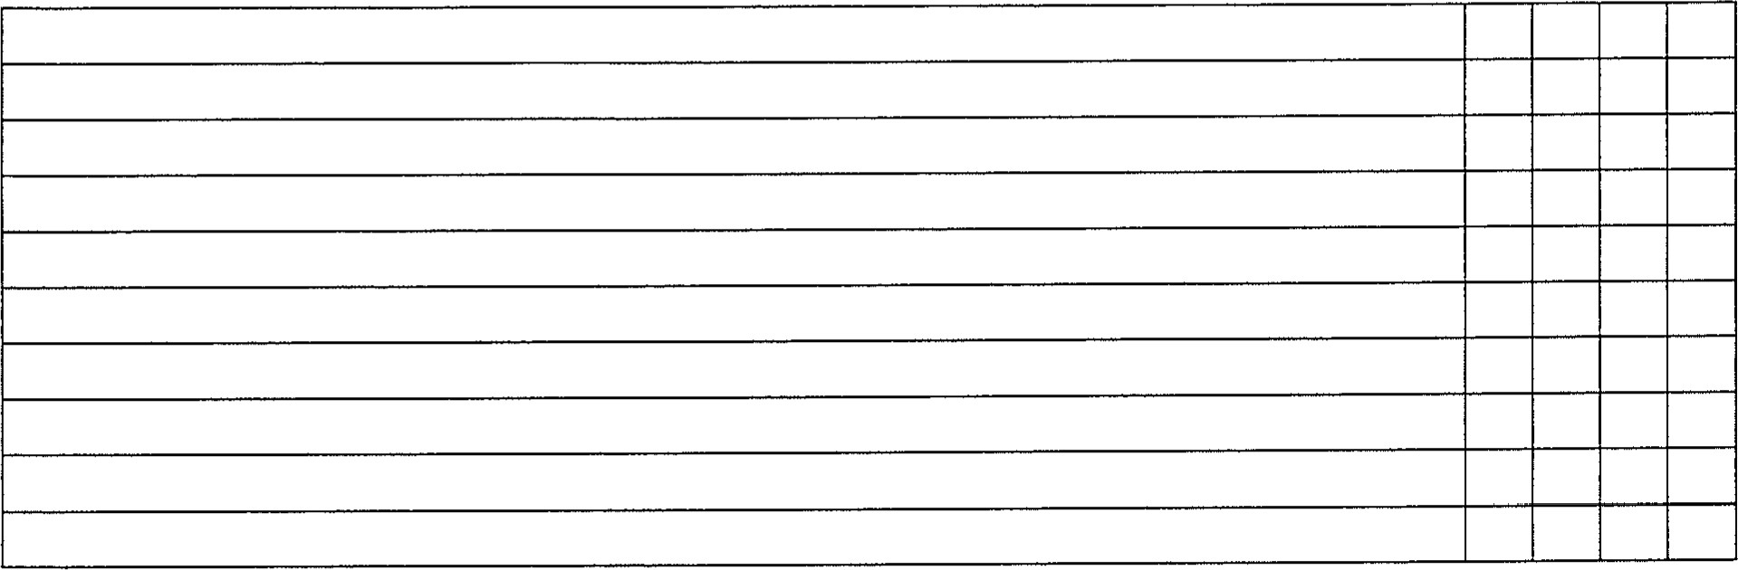
AWARDS/ HONORS/ LEADERSHIP 9 10 11 12
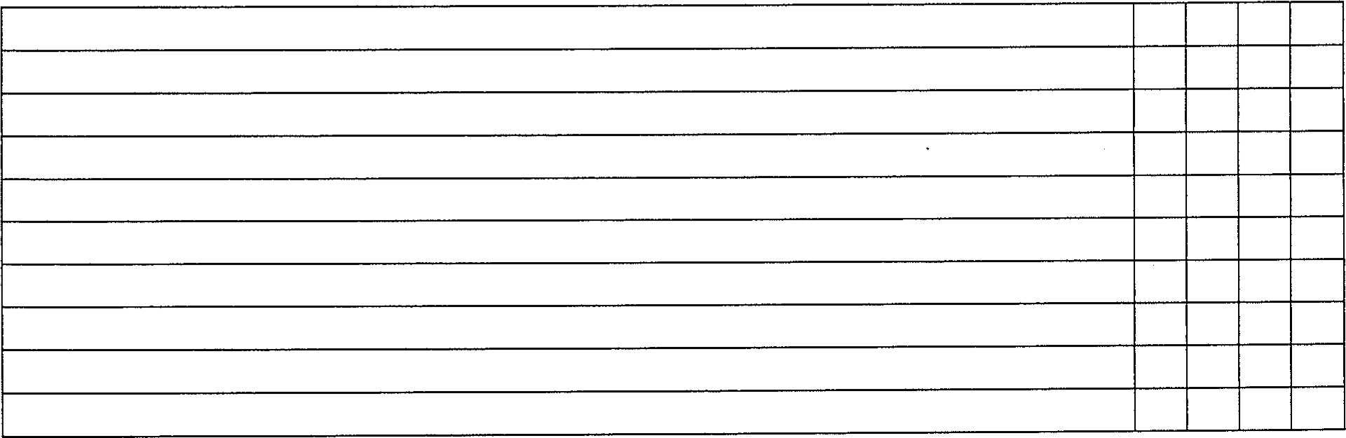
NON- SCHOOL ACTIVIES (Church, Community, Employment etc.) 9 10 11 12
