September 18, 2025
BOARD OF EDUCATION
SCOTT WALLACE
President

TODD KOCH
Vice President

ROBYN NORBECK
Treasurer

KATHLEEN MOCO, DBA
Secretary

REBECCA JENSEN
Trustee

ABIGAIL WASIL
Trustee

TODD BURROWS
Trustee

ADMINISTRATION

CARRIE WOZNIAK, Ph.D.
Superintendent

KERRY TERMAN
Assistant Superintendent for Human Resources &
Title IX Coordinator

KYLE RAY
Director of Secondary Instruction

MARY KATE MULLIGAN
Director of Elementary Instruction
BRENT BRASURE
Director of Career &
Technical Education

ANDREA AGRUSA
Business Manager

JANE STURGELL
Special Education Director

JIM BIRKO
Operations, Maintenance & Transportation Director

TROY LINDNER
Technology Director

KRISTIN SOMMER
Community Relations Director

Dear Board Member,

There will be a Regular Meeting of the Fraser Board of Education on Monday, September 22, 2025, at 7:00 p.m. to be held at the RMS Idea Lab, 33723 Klein, Fraser, MI 48026.

This meeting is a meeting of the Board of Education in public for the purpose of conducting the School District's business and is not to be considered a public community meeting. There is a time for public participation during the meeting.

The agenda for the Regular Meeting is as follows:

Business Items:
- Human Resources Report.
- Resolution to Meet in Closed Session in Accordance with the Open Meetings Act, Section 8c, Regarding Negotiations.

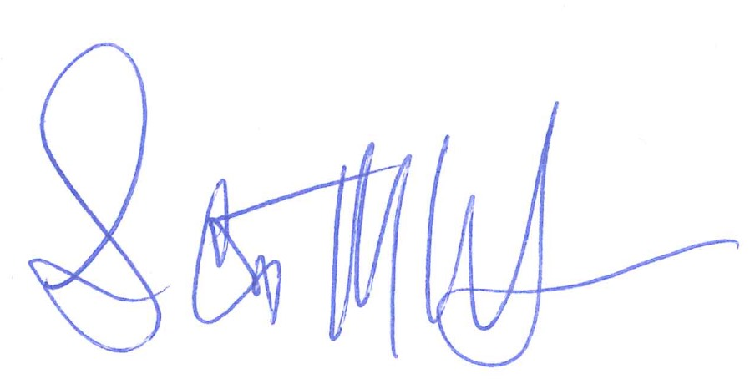
Sincerely,

Scott Wallace President
Fraser Board of Education

SW:ks

