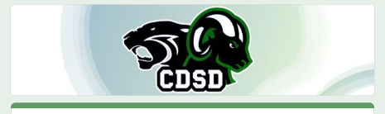
Business Sponsorship Package Application
After you fill out this order request, we will contact you to go over details and selection before the order is completed. Artwork must be provided in a high resolution vector format. Checks payable to CDSD
(75 S. Houcks Road, Harrisburg, PA 17109).

For questions contact Shannon Leib at the CDSD 717-545-4703, x 70217.
* Indicates required field

Name of Business*

Name of Contact Person*

Address*

Phone number*

E-mail*

Please Choose a Plan (1-Year Subscription. Must renew annually.)*
- Landis Field Sponsorship Package (fence sign), $1,000 plus cost of sign per year

- Gymnasium Sponsorship Package (CDHS/CDEHS), $2,000 plus cost of sign per year

Are you a new or existing customer?*
- I am a new customer

- I am an existing customer

Please provide a copy of your business card. Files provided need to be in vector format.

Questions and comments

