Insert all the items below:
School Information (Include City, State, and Zip): | Mimosa Elementary  1550 Warsaw Rd, Roswell, GA 30076
Principal Name: | Ariane Holcombe
Title/Topic: | Annual Title I Parent Meeting
Date of Meeting: | 8/21/2025
Time of Meeting: | 5:15 PM
Facilitator(s): | Ariane Holcombe- Principal, Robin Burke- Parent Liaison
Teams meeting link/Location Address: | Mimosa Cafeteria

For consistency and the best outcomes, the PowerPoint Presentation and Facilitator’s Guide should be used with the agenda to ensure each topic is accurately shared and discussed.
Topic | Notes
Introduction and Welcome | The meeting began at 5:15 p.m. Principal Holcombe gave an introduction and welcome. Parents were encouraged to sign in and fully participate in the meeting by asking questions. The principal also informed parents that an evaluation link would be provided at the end of the meeting to help improve future meetings. Parents were encouraged to stay until the meeting concluded, and completing the evaluation would be their “ticket out the door.”
Objectives and Purpose: | Principal Holcombe referred to the PowerPoint Presentation and stated that the objectives and purpose were to understand what makes our school a Title I school, including requirements, funding, and associated programs. Understand school-provided curriculum, assessment, parent resources, and staff contact information. Understand Family Engagement at our school.
What is a Title I school? | Principal Holcombe referred to the PowerPoint Presentation slide # and stated five bullets from PP slide to define “what is a Title I school?”
How does our school spend Title I money? | Principal Holcombe used the slide #5 to share the ways Title I money is spent.
How is Title I Parent and Family Engagement money spent? | The principal thanked parents for providing input on how we spend family engagement funds in the spring. By sharing the slide with families, a list was provided.  The Principal stated that a host of math and literacy resources were purchased.
How does our school participate in the Title I program? | The Principal shared the school’s participation by explaining what a Title I schoolwide program is by using this slide #7.
What are our school’s Title I (schoolwide or targeted assistance) requirements? | The principal shared all the school’s Title I requirements. She also explained more details would be shared later in the presentation about the parent's right to know.
Schoolwide Program— Past and Present  - What are our schoolwide goals?  - What programs/supports are in place to help my child? | The principal shared that the school’s grade was a “B” and explained how that impacts the school's goals and programs to support the whole child.
State Report Card | The principal shared the link and QR code on the slide #10 and told parents they could get more details by going to Governor’s Office of Student Achievement (GOSA).
What Curriculum does our school use? | https://case.georgiastandards.org/  The principal explained that Fulton County Schools uses the state standards provided by Georgia. All content areas and grade levels have different standards that are required so a QR code and link was shared for parents to look at what is applicable to their child(ren). Additionally, the principal explained that teachers would be able to answer content/curriculum specific questions in parent-teacher conferences.
Universal Screening and Diagnostic | The principal explained:  These are assessments that help determine a student’s overall academic performance level. These assessments…  We use i-Ready as our Universal Screener and Diagnostic for students in grades K-8. We use MAP for students in grades 9-12. Each of these are computer adaptive assessments – this means that as your student gets questions right, the tests “adapts” and provides harder questions. As students miss questions, the test “adapts” to provide easier questions. Because of this, students will only get about 50% of the questions correct – and this is important for you and students to know! They aren’t supposed to get all the questions right! This test helps determine what students know and what they don’t know yet. This helps teachers pinpoint the specific learning needs of your student. i-Ready also serves as an instructional technology program where students complete lessons tailored to their needs.
GA Milestones | The principal explained:  The state assessment you may be most familiar with is the Georgia Milestones; it is a criterion-referenced assessment. You may hear to it referred to as just Milestones, GMAS, or EOG (for end of grade in elementary and middle schools) or EOC (end of course for high school courses). It is designed to evaluate a student’s learning at the end of a grade or the course. It reports whether a student has achieved proficiency on the skills and concepts of the course. Administered on the computer. Students score in four categories: Beginning, Developing, Proficient, or Advanced. Provides valuable information about student learning to students, parents, teachers, district staff, state, and community stakeholders.
Other Assessments | The principal explained:  Milestones is not our only criterion-referenced state and national assessment. This slide shows others that may be required:  - GKIDS – is used for students in Kindergarten  - ACCESS – is used for English Language Learners to determine proficiency with the English Language. Results help determine the services ELL students receive.  - Georgia Alternate Assessment (GAA 2.0) is used for some special education students in lieu of the Georgia Milestones  - AP, or Advanced Placement Exams, are administered to students enrolled in Advanced Placement courses and may earn students college credit.
Checking Progress | To ensure you are keeping with grades your child’s teacher has posted and attendance data, be sure to register for a parent poral account with Infinite Campus. Infinite Campus is our Student Information System in Fulton County.
Parent and Family Engagement  - What is a School-Family Compact?  - What is the district’s Parent and Family Engagement Policy? What is the school’s Parent and Family Engagement Plan? | The principal / Parent Liaison informed parents of the law's requirements. She shared three documents with families (Compact, PFEP, District PFEP). The principal/Parent Liaison shared what a School-Family Compact is and how it can support their families. Lastly, the location of both school and district documents were shared.
If you are a Middle or High School and need evidence of Compact Discussion, add it to this agenda section (Required for MS and HS). Elementary Schools will continue to document this requirement during parent-teacher conferences.
Does my child’s teacher meet professional qualifications?  - What is a parent’s right to know?  - Code of Conduct | The principal shared The Parent's Right to Know and the Student Code of Conduct Handbook, referencing page 47. A link was provided to all parents. They were reminded to be sure to complete the acknowledgment of receipt.
What opportunities does the school provide for family engagement?  - List family engagement opportunities offered for school or home.  - List volunteer opportunities  - List parent decision-making opportunities/meetings/councils | The parent liaison shared information about volunteer opportunities and a list of areas where parents are most needed. She referred parents to Fulton County’s website to complete the volunteer registration form, indicating whether they plan to volunteer because it takes 24-48 hours to receive approval. The parent liaison also gave parents the family engagement calendar. She explained that the calendar is also on the school’s website. She encouraged parents to attend the Resource Center Open House on 8/29/25 from 8:00 am – 1:00 pm
Family Resource Center (if applicable)  - Room Location  - Hours of Operation  - Available Resources  - Contact PL | The principal and Parent Liaison explained the purpose of the Family Resource Center, where it’s located in our building, hours of operation, available resources we provide to families and who to contact for more information.
How responsive will the school be to my questions when staff is contacted?  - Provide staff contact information | The principal provided essential phone numbers and emails. She explained that some teachers will send personalized information home to parents tomorrow. In the meantime, parents should contact the parent liaison or the main number if they have urgent needs or questions.
Questions and Answers | The principal opened the floor for questions.  No questions were asked.
Closing & Thanks | The principal thanked everyone for attending and opened the floor for any additional questions or comments. She reiterated to parents that their ticket out the door was to complete a quick survey to help us improve on future meetings. She shared the last slide showing parents the QR Code and link. She gave specific instructions about the meeting type parents should choose when completing the survey.
Meeting Evaluation (Used to improve and revise future staff training) | HTTPS://BIT.LY/EVALUATION_FE  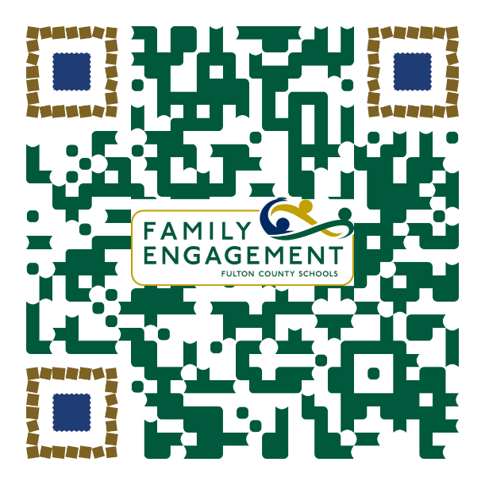
*This meeting was not used to collect input but provided as an opportunity to disseminate information

