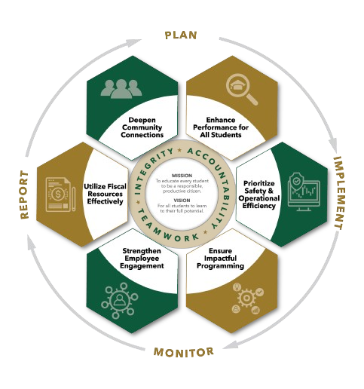


August agenda
Autrey Mill Middle School Governance Council
Date | time August 18, 2025| 7:45 am | Location Room A130

SGC Members

Trey Martin, Principal | Emma Cornwall, Teacher |Maud de Groot, Teacher | Ashley Perry, School Employee | Matthew McNamara, School Employee |Kathleen Newquist, Parent | Jessica Saszi, Parent |Beth Zampieri, Parent| Korina Calbay, Community Member |

Time | Item | Owner
7:45am | Call to Order  Meeting started at 7:47 | Mr. Martin
7:46am | Action Item: Approve Agenda  Motion: Cornwall  Second: Zampieri  All in favor: approved | Mr. Martin
7:47am | Action Item: Approve May Minutes  Motion: Zampieri  Second: Cornwall  All in favor: approved | Mr. Martin
7:50am | Discussion Item: Introductions  Everyone introduced themselves  - McNamara- 8th grade assistant principal, taking Mrs. Welch’s position  - Saszi-parent with 3 children, former teacher  - Newquist- parent with 3 children, has a high, middle, and elementary schoolers, also subs in Fulton  - DeGroot- ELA teacher,  - Cornwall- math teacher, 2nd term on SGC  - Lawson/Kinsey- SGC facilitator  - Zampieri- parent with 3 children, second term on SGC, does some to AMMS to talk about 9/11  - Calbay- community member with Summit counseling  - Martin- AMMS principal, non-voting member  - Perry- 6th grade assistance principal, taking Melanie McCollum position  - Still needing one community member | All Members
7:55am  8:00am  8:05 am | Action Item: Approve nominated Community Member  Tabled: We do not have one to submit at this time, but this will move to our next meeting  Some ideas may be a Johns Creek High School parent  Mrs. Lawson/Kinsey will get back to see if we could use a high school student who wants experience or other parents.  Action Item: Elect New Officers  Chair: Cornwall  Vice Chair: Zampieri  Parliamentarian: Newquist  Motion: McNamara, Cornwall, Zampieri  Second: Zampieri, McNamara, Cornwall  All in favor: approved, approved, approved  Action Item: Staff Standing Committees  - Budget and Finance: Perry, Zampieri, McNamara, Newquist  - Outreach and Communication: Calbay, Saszi, DeGroot, Cornwall  - Principal Selection: Cornwall, Saszi, de Groot, Newquist  Motion: Zampieri  Second: Newquist  All in favor: Approved | Mr. Martin  Mr. Martin  Chair- Cornwall
8:10 am | Discussion Item: Determine SY24-25 Council Norms  - Norms worked well last year, we keep the same norms | All Members
8:15am | Discussion Item: Strategic Planning  Initiate discussions about your school's Strategic Action Plan as they will be due for submission on September 30th.  Building upon the groundwork laid by our school leadership, we recommend focusing your August meeting on the following:  - Clarifying the principal’s vision and goals for the upcoming year.  - Identifying key lessons learned from the previous school year.  - Understanding the expectations outlined by your school's zone leader.  - Brainstorming specific ways your council can contribute to the development and implementation of the Strategic Action Plan.  After Mr. Martin talked about the different metrics that are used by the county so we can talk about what we want to focus on. Some the zone like to focus on are: GA Milestones, prioritize safety and operational efficiency, charter dollar expenditures, employee engagement, deepen community connection and ensure impactful programming.  We will look at this next month to send onto the next level | Mr. Martin
8:20am | Informational Item: Principals Update  - Vision and goals for this year are aligned with our zone. This year we are focusing on student discourse. Getting students to participate and engage more in the lessons and throughout the lesson. Total participation techniques is the main goal in TKES this year.  - Enrollment was projected to be 1265, including COSA students. We had one of the highest in the zone for this year. It’s all based on capacity of the school. Currently we are down with about 36 students. We have the potential to lose one position for teaching, so our goal is to gather funds for other budgets to keep this position.  - 1200 lets you get a 3rd-front office secretary, which is important.  - Patti Welch- the AMMS bookkeeper--is retiring, Mrs. Hundelt will replace her, we have a posted position as a data clerk. There is a hiring freeze currently. Hope that’s lifted by the end of the month. This is our only vacancy currently.  - Smooth start to the school year, PTA is satisfied. Waiting on some 6th grade computer cases.  - Looking forward to parent coffee meet ups this year.  - Applaud the deployment of mobile phones. Some parents had complete shifts of their own thinking. Nice to see kids interacting with each other instead of being focused on the phone and air pods with music. | Mr. Martin
8:25am  8:30am | Discussion Item: Draft Next Meeting Agenda  Add the community member to the next agenda  Strategic plan approval  Charter dollar funds  Students safety riding to school-bike, scooter, walks  3rd Monday of every month-calendar alerts- Cornwall will do this  Action Item: Meeting Adjournment  Motion: McNamara  Second: DeGroot  All in favor: approved | All Members  Chair

Meeting Norms
Silences Phones | Be Respectful of Others’ Opinions | Work for the Good of All Students

