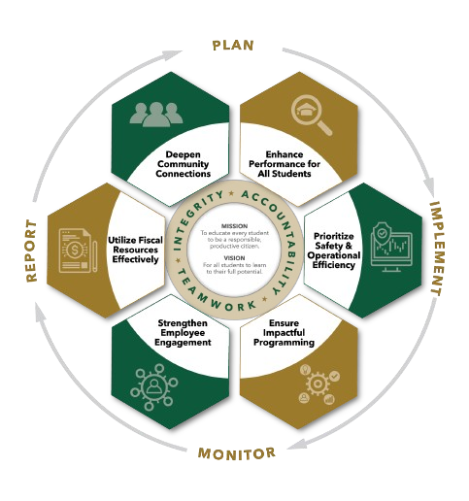


September agenda
Autrey Mill Middle School Governance Council
Date | time September 15, 2025| 7:45 am | Location Room A130

SGC Members: Trey Martin, Principal | Emma Cornwall, Teacher |Maud de Groot, Teacher | Ashley Perry, School Employee | Matthew McNamara, School Employee |Kathleen Newquist, Parent | Jessica Saszi, Parent |Beth Zampieri, Parent| Korina Calbay, Community Member |
Time | Item | Owner
7:45am | Call to Order | Cornwall
7:46am | Action Item: Approve Agenda | Cornwall
7:47am | Action Item: Approve September Minutes | Cornwall
7:50am | Discussion Item: Community Member | All Members
7:55am  7:58am  8:05am  8:10am  8:15am | Action Item (if needed): Approve nominated Community Member  Action Item: Approve Strategic Plan  Action item: Charter Dollar Funds  Discussion Item: Charter Proposals  Action item: Charter Dollar Proposals | Cornwall  Cornwall  Cornwall  Cornwall  Cornwall
8:20am | Discussion Item: Student Safety | All Members
8:30am | Informational Item: Principals Update | Mr. Martin
8:40am  8:45am | Discussion Item: Draft Next Meeting Agenda  Action Item: Meeting Adjournment | All Members  Cornwall

Meeting Norms
Silences Phones | Be Respectful of Others’ Opinions | Work for the Good of All Students

