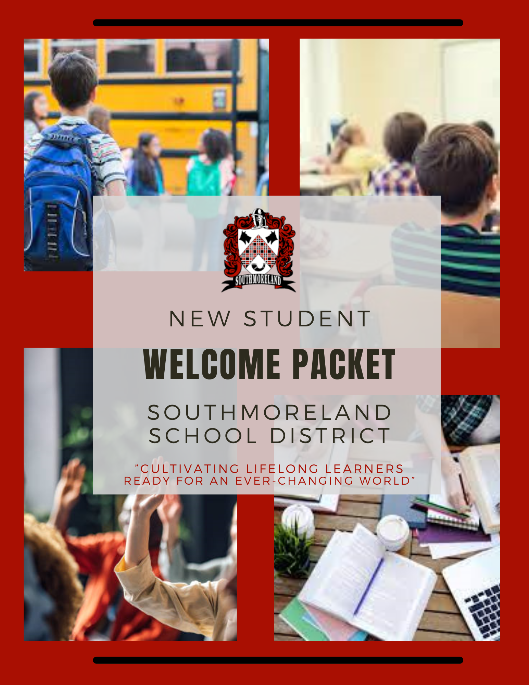

Table of Contents

ORIENTATION 1
CALENDAR 2
ADMINISTRATION 3
SCHOOLS 3
Southmoreland Primary Center 3
Southmoreland Elementary School 3
Southmoreland Middle School 4
Southmoreland High School 4
Work Permits 5
Student Driving 5
SCHOOL LUNCH 6
Food Service Department 6
Lunch Account Payment System 6
Free and Reduced Lunches 7
HEALTH SERVICES 7
TECHNOLOGY 8
Technology Device 9
Google Classroom 9
CSIU 9
Social Media 9
Internet Access 9
STUDENT SERVICES 10
TRANSPORTATION 11
ATHLETICS 12
Sports 12
Student Extra Curricular Activity Fee 13
Registering for PIAA Sports 14

ORIENTATION

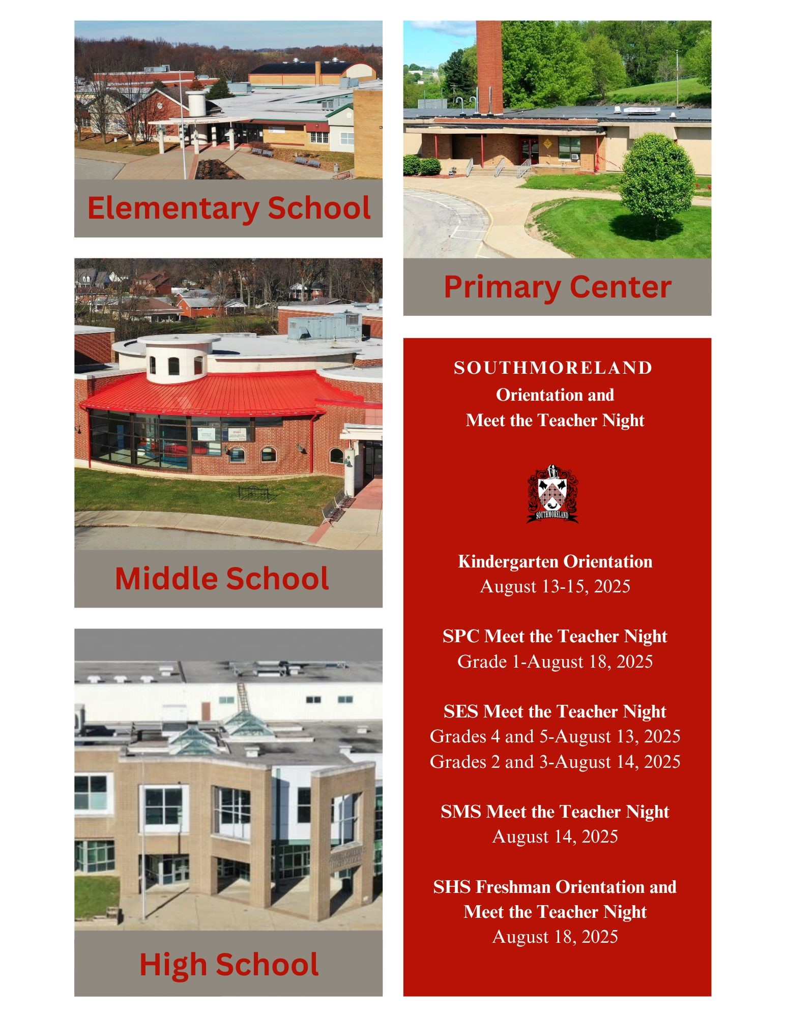

CALENDAR
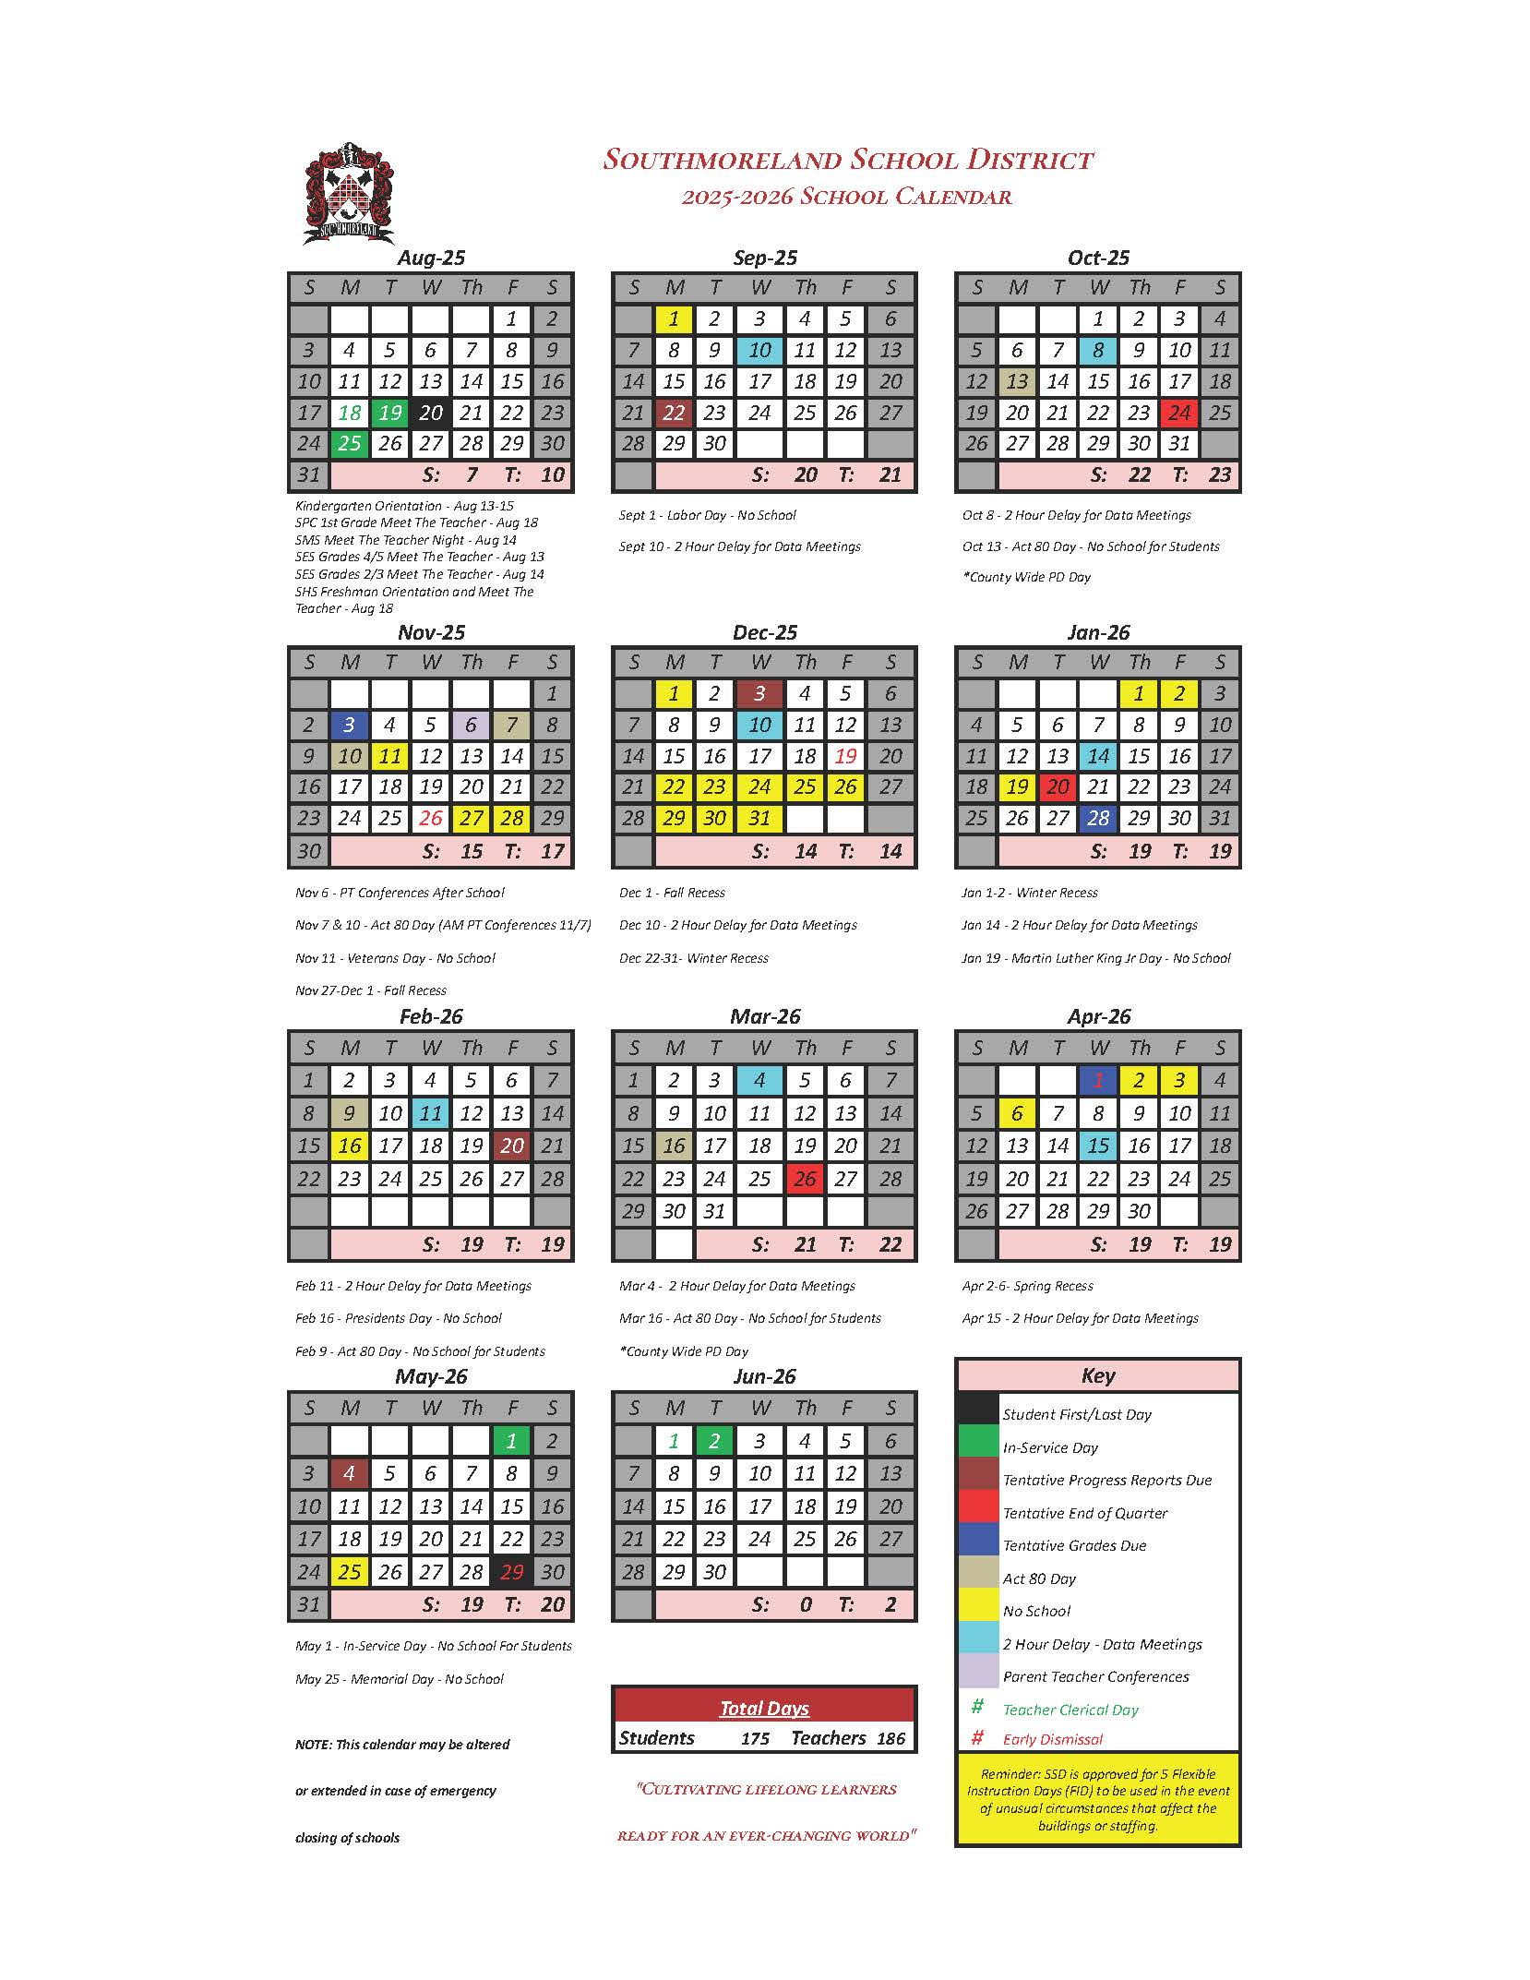

ADMINISTRATION
Dr. Jason Boone, Superintendent of Schools
Mrs. Lorie McTavish, Confidential Administrative Assistant to the Superintendent and School Board/Human Resource Specialist
 724-887-2005
 724-887-2055

Dr. Daniel Clara, Assistant to the Superintendent
Mrs. Lori Herman, Administrative Assistant for Communications, Child Accounting, Federal Programs and District Registrar
724-887-2000 *7202
 724-887-2043

SCHOOLS

Southmoreland Primary Center

Southmoreland Primary Center (Grades K-1)
1431 Water Street
Alverton, PA 15612

Mr. Ron Heitchue, SPC Principal/District Assessment Coordinator/K-8 Online Learning Principal
Ms. Morgan Tylka, Administrative Assistant to the Principal
724-887-2026
724-887-2044

Mrs. Sarah Whitacre, Counselor
Ms. Morgan Tylka, Administrative Assistant to the Principal
724-887-2026
724-887-2044

Ms. Netah Serock, Nurse
724-887-2049

School Hours 9:10 AM – 3:30 PM

Southmoreland Elementary School

Southmoreland Elementary School (Grades 2-5)
100 Scottie Way
Scottdale, PA 15683

Mr. Daniel Krofcheck, SES Principal
Mrs. Sonya Zahrobsky, Administrative Assistant to the Principal
724-887-2021
724-887-2025

Ms. Sara Yantko, Dean of Students
Mrs. Amanda Springer, Building Administrative Assistant
724-887-2020

Mrs. Lisa Romesberg, Counselor
Mrs. Amanda Springer, Building Administrative Assistant
724-887-2020
724-887-2025

Mrs. Stephanie Muir, Nurse
724-887-2023

School Hours 9:10 AM – 3:30 PM

Southmoreland Middle School

Southmoreland Middle School (Grades 6-8)
200 Scottie Way
Scottdale, PA 15683

Mr. James Klugh, Principal
Ms. Sara Yantko, Dean of Students
Mrs. Kris Leonard, Administrative Assistant to the Principal
724-887-2029
724-887-2032

Ms. Brianna Edwards, Counselor
Mrs. Kris Leonard, Administrative Assistant to the Principal
724-887-2029
724-887-2032

Mrs. Stephanie Muir, Nurse
724-887-2023

School Hours 8:10 AM – 3:05 PM

Southmoreland High School

Southmoreland High School (Grades 9-12)
2351 State Route 981
Alverton, PA 15612

Mrs. Charity Colebank, Principal
Mrs. Kelly Vance, Administrative Assistant to the Principal
724-887-2010
 724-887-2980

Ms. Kaely Potochnik, Assistant Principal/Grades 9-12 Online Learning Principal
Mrs. Amy Clawiter, Building Administrative Assistant
724-887-2011

Mrs. Lauren Dillon, Counselor (A-K)
Ms. Keera Miller, Counselor (L-Z)
Ms. Tiffany Beltz, Counseling Administrative Assistant
724-887-2013
724-887-2059

Mrs. Cathy Pallygus, Nurse
724-887-2012

School Hours 7:35 AM – 2:25 PM

Work Permits

Student Work Permit Application:

Student work permits are issued from the SHS Main Office during regular business hours.
To obtain a permit please complete the Work Permit Application:
- print and sign the form
- take a picture of the form and the birth certificate
- email to: vancek@southmoreland.net or clawitera@southmoreland.net
The completed work permit will be emailed back to you.
NOTE: Please provide the current place of employment as well as the hospital and city where your child was born.

Work permits are good until the student is 18 and graduated and transferrable from job to job. Please update us with each job change. The student must sign the permit to make it valid.

Student Driving

Driver's Application/Rules and Guidelines:

Senior and Junior students who wish to drive to school this year please read the Rules and Guidelines and print out and complete the application form. Beginning August 11-August 19, 2025, students may come in with the completed application along with the necessary documents and see Mrs. Vance or Mrs. Clawiter in the main office for their parking pass. They will also be available throughout the school year.

SCHOOL LUNCH

Food Service Department

Mr. Zachary Malavite, Food Service Director
Serv-Safe Certified

Mrs. Amy Yezek, Food Service Administrative Assistant
724-887-2015
724-887-2043

Lunch Account Payment System

- SOUTHMORELAND FOOD SERVICE NOW USES THE SCHOOLCAFE POINT OF SALE COMPUTERIZED LUNCH SYSTEM AND ONLINE PAYMENT SYSTEM.

Click here for Information on the Schoolcafe system

Click here for Schoolcafe system FAQ

Click here to set up an account in Schoolcafe

(You will need your child's ID number to complete this process)
Schoolcafe provides parents the ability to view their child(ren)’s account balance online from the privacy of their own homes and to place online payments in their child(ren)'s lunch account. By having money in each child’s account prior to entering the cafeteria, we find the lunch lines move along much faster so the child has more time to eat and be with friends. With this service, parents also do not have to worry about sending cash or checks to school with their children. Parents will have the ability to print out a copy of their child’s eating history report. This history report will show you all dates and times that your child has purchased a breakfast and/or lunch.
It is not required that you make payments online to view your child’s transaction history.
  - Some parents may already have a schoolcafe account if they have completed a free/reduced meal application.
  - If you have more than one child in the district, you can handle all online prepayments from the same online account.
  - In order to use the online prepayment service, a small convenience fee for each transaction will be assessed to cover transaction handling fees. Our district does not operate Schoolcafe and does not receive any of the fees collected from online payments.
  - Southmoreland School District does not utilize Schoolcafe for any other school-related payments (i.e., yearbook, tickets, etc.). It is utilized only for school meal payments.
  - If you choose not to take advantage of the online prepayment service you may continue to make advance payments via check, which should be made payable to the Southmoreland Cafeteria Fund. Please write your child's full name on the check. Checks can be deposited into only one child's account. If you wish to transfer money into another account, please notify the Food Service Office.

If you have any questions about these services, please feel free to contact the Food Service Department at 724-887-2015.

Free and Reduced Lunches
Southmoreland School District uses an online Meal Application system provided by the Pennsylvania Department of Education to apply for Free and Reduced meals.
If you cannot complete the online form, please call the Food Service office at 724-887-2015.
Families who are “automatically” qualified to receive free meals will receive a “Direct Certification” notification letter.
These households do NOT have to complete an application.
All other families should click HERE To be directed to the website to file a meal application

HEALTH SERVICES

K-12 School Health Services Department is an integral part of our educational institution, dedicated to promoting the health and well-being of students across all grade levels. Our primary goal is to support and enhance the overall health and wellness of students, ensuring a safe and conducive learning environment. We provide comprehensive healthcare services that encompass preventive care, health promotion, and the management of acute and chronic health conditions.
Preventive Care: Our department emphasizes the importance of preventive care to maintain optimal health among students. We administer routine health screenings, such as vision and hearing tests, to identify any potential issues early on. We also collaborate with parents and teachers to promote healthy lifestyle choices, including proper nutrition, physical activity, and hygiene practices.
Health Promotion: We strive to empower students with the knowledge and skills necessary to make informed decisions about their health. Through educational programs and workshops, we educate students on a wide range of health topics, including personal hygiene, mental health awareness, substance abuse prevention, and healthy relationships. Our goal is to equip students with the tools they need to lead healthy and fulfilling lives.
Management of Acute and Chronic Health Conditions: Our healthcare professionals are trained to address a variety of acute and chronic health conditions that students may encounter. We provide immediate care for injuries, illnesses, and emergencies that may occur during school hours. For students with chronic health conditions, such as asthma, diabetes, or allergies, we work closely with parents, physicians, and teachers to develop individualized healthcare plans. These plans outline necessary accommodations, medication administration, and emergency protocols to ensure the student's well-being while at school.
Medication Administration: We strictly adhere to medication administration protocols to ensure the safety and well-being of students requiring medication during the school day. Our trained nursing staff is responsible for administering prescribed medications, such as asthma inhalers, epinephrine auto-injectors, and other necessary medications, in accordance with the student's individualized healthcare plan. We maintain accurate records and ensure proper storage and handling of medications to meet safety standards.
Collaboration and Referrals: We believe in fostering strong partnerships with parents, teachers, administrators, and community healthcare providers. We actively collaborate with these stakeholders to address the unique health needs of our students. When necessary, we facilitate referrals to external healthcare providers, specialists, or counseling services to ensure students receive comprehensive care beyond the school setting.
The K-12 School Health Services Department is dedicated to providing compassionate and comprehensive healthcare services to support the overall well-being of our students. We prioritize their physical, mental, and emotional health, recognizing that healthy students are better equipped to succeed academically and thrive in all aspects of their lives.

PRIMARY CENTER NURSE | SES/MS NURSE | HIGH SCHOOL NURSE
Ms. Netah Serock  serockn@southmoreland.net  1431 Water Street  Alverton, PA 15612  724-887-2049  724-887-2044 | Mrs. Stephanie Muir  muirs@southmoreland.net  200 Scottie Way  Scottdale, PA 15683  724-887-2023  724-887-2032 | Mrs. Cathy Pallygus  pallygusc@southmoreland.net  2351 Route 981  Alverton, PA 15612  724-887-2012  724-887-2980

Physical Exams for School Age Children
The Pennsylvania Public School Code Section 1402. Health Services (e) requires that students upon original entry, sixth grade and 11th grade be given a "comprehensive appraisal" of their health. In addition, Section 1402(c) requires the completion of medical questionnaires which are to become part of the student's health record.
Please Click Here to Access The Physical Form.

Other Health Forms:
Dental Form
Medication Administration Form
Inhaler Permission to Carry Form
Epi-pen Permission to Carry Form

TECHNOLOGY

The K-12 Technology Department is an essential component of our educational institution, dedicated to integrating technology into all aspects of teaching, learning, and administrative functions. Our primary goal is to leverage technology as a tool for enhancing education, fostering innovation, and preparing students for success in a rapidly evolving world. We focus on providing robust infrastructure, implementing effective instructional technology strategies, ensuring data privacy and security, and delivering exceptional technical support.

Mr. Steve Smithula, Director of Technology

Technology Device

Southmoreland students grades 1-12 have the option to use a school device or their own. These devices may be used in classes throughout the day and taken home to use for extended learning.

If technology service is needed, the student will need to report to the main office to have someone take a look at the device.

Google Classroom

The Google Classroom is a free Google app that is used for a web-based learning environment. By using this app everything is housed in one location and teachers are able to post assignments and give feedback to students.

Click on the link below for more detailed instructions:
Google Classroom Help\Instructions

CSIU

The CSIU operating system facilitates a user friendly student data management system where applications can be used to track attendance, grades and discipline, maintain transcripts and create student/teacher schedules.

Parents can access their child’s attendance and grades from the parent portal.

The financial software application can be used for payroll, purchasing, taxes and personnel information.

Social Media

 https://www.facebook.com/SouthmorelandSD
 https://twitter.com/sdsouthmoreland
 https://www.youtube.com/user/southmorelandschools

Internet Access

The Affordable Connectivity Program provides low income households with internet access at a discounted rate for those that are eligible. Click on the links below to apply:

https://broadband.pa.gov/resources/residents-community/

https://armstrongonewire.com/Internet/ACP

https://www.xfinity.com/learn/internet-service/acp/free-internet

https://www.verizon.com/home/internet/acp/free-internet/

STUDENT SERVICES

Dr. Daniel Clara, Director of Pupil Services
Michele Shawley, Administrative Assistant for Special Education
724-887-2009
724-887-2040

The K-12 Student Services Department is an essential component of our educational institution, committed to providing comprehensive support services that enhance the academic, social, emotional, and behavioral development of our students. Our department comprises a team of dedicated professionals, including school counselors, psychologists, contracted service providers, and support staff, who collaborate with students, parents, teachers, and community members to foster student success and well-being.
Our primary goal is to create a nurturing and inclusive environment where all students can thrive and reach their full potential. We offer a range of student support services that address the diverse needs of our student population, promote positive mental health, and ensure equitable access to educational opportunities.
Social-Emotional Support: We provide social-emotional support services to help students develop the skills and resilience needed to navigate challenges, manage emotions, and build healthy relationships. Our counselors and psychologists offer individual counseling, group therapy, and crisis intervention to address a variety of social and emotional concerns. We collaborate with teachers and parents to create supportive plans and interventions that promote student well-being and success.
Academic Support: Our department offers academic support services to enhance student learning and achievement. We work closely with teachers to identify students' academic needs and provide targeted interventions, such as tutoring, study skills training, and academic planning. We also assist in the identification and support of students with learning disabilities or special educational needs, ensuring they receive appropriate accommodations and individualized education plans.
Career Development: We help students explore career interests, develop career goals, and make informed decisions about their educational and career pathways. Our department offers career assessments, guidance on course selection, and information about post-secondary education and career opportunities. We provide resources, workshops, and work-based learning experiences to help students develop essential skills for success in the workforce.
Family and Community Engagement: We recognize the importance of strong partnerships with families and the broader community in supporting student success. We actively engage with parents through regular communication, parent education workshops, and involvement in decision-making processes. We collaborate with community organizations, local businesses, and volunteers to provide additional resources and opportunities that enrich the educational experience of our students.
Special Education Services: Our department is dedicated to meeting the unique needs of students with disabilities through our special education services. We collaborate with teachers, parents, and external agencies to develop and implement Individualized Education Programs (IEPs) that address students' specific learning and support requirements. We provide specialized instruction, accommodations, and related services to ensure students with disabilities can access and succeed in the general education curriculum.
Positive Behavior Support: We promote positive behavior and foster a safe and inclusive school climate through our behavior support programs. Our department collaborates with school staff to implement evidence-based strategies for behavior management and social skills development. We offer interventions, restorative practices, and conflict resolution programs to create a positive learning environment that encourages responsible behavior and respectful interactions.
Student Advocacy and Transition Support: We serve as advocates for students, ensuring that their voices are heard and their needs are met. We support students during transitions, such as the move from one grade level to another or the transition from school to post-secondary education or employment. We provide guidance, resources, and support to help students successfully navigate these transitions and set the foundation for their future success.
The K-12 Student Services Department is committed to supporting the holistic development and well-being of our students. Through collaboration, individualized support, and evidence-based interventions, we strive to create an environment where every student feels valued, supported, and empowered to achieve their academic and personal goals. By providing comprehensive student services, we enhance the overall educational experience and contribute to the success and well-being of our students.

TRANSPORTATION

Ms. Pam Mondock, Transportation Manager

Miss Shera Barnhart, Transportation Administrative Assistant
724-887-2036
724-887-2043

The K-12 Transportation Department plays a crucial role in our educational institution, responsible for providing safe, reliable, and efficient transportation services for students to and from school. Our primary goal is to create a transportation system that promotes the well-being and success of students by providing on-time arrivals, adhering to safety protocols, and fostering a positive and respectful environment on school buses.

Student Safety: The safety of our students is our top priority. We rigorously adhere to local, state, and federal regulations regarding student transportation safety. Our bus drivers receive comprehensive training on safe driving practices, emergency procedures, and student management techniques. We conduct regular inspections of our bus fleet to ensure they meet safety standards, and we enforce protocols for loading and unloading students safely at bus stops and school entrances.
Reliable and Efficient Service: We strive to provide reliable and efficient transportation services, ensuring that students arrive at school and return home in a timely manner. Our department develops and optimizes bus routes to minimize travel time and maximize efficiency. We utilize advanced routing software and GPS tracking systems to monitor and adjust routes as needed. We communicate route information to parents and maintain open lines of communication to address any transportation-related concerns or changes.
Special Needs Transportation: We provide specialized transportation services for students with special needs or disabilities, ensuring that their unique transportation requirements are met. We collaborate closely with families, educators, and healthcare professionals to develop individualized transportation plans and accommodate any necessary accommodations or equipment.
Communication and Collaboration: We maintain open and effective lines of communication with parents, school administrators, and other stakeholders to foster collaboration and address transportation-related concerns. We provide regular updates on transportation schedules, changes, and other important information. We work closely with school staff to coordinate transportation for field trips, extracurricular activities, and other special events.
Continuous Improvement: Our department is committed to continuous improvement and seeks feedback from students, parents, and staff to enhance our transportation services. We regularly evaluate our procedures, routes, and policies to identify opportunities for improvement. We stay abreast of industry best practices, technological advancements, and transportation regulations to ensure that our services remain current and efficient.
The K-12 Transportation Department is dedicated to providing safe, reliable, and efficient transportation services that support student success and well-being. By adhering to strict safety standards, maintaining open communication, and continuously improving our services, we contribute to the positive educational experience of our students and provide peace of mind to parents and guardians.

ATHLETICS

Mr. Brian Pritts, Athletic Director
Mrs. Georgia Speer, Athletic Administrative Assistant
724-887-2018
724-887-2040

To see athletic schedules click the link below:
https://shsathletics.org/main/calendar/day

Sports
FALL | WINTER | SPRING
Girls Basketball  Middle School | Boys Basketball  Varsity  Junior Varsity  Middle School | Baseball  Varsity  Junior Varsity  Middle School
Boys Cross Country  Varsity | Girls Basketball  Varisty  Junior Varsity | Softball  Varsity  Junior Varsity  Middle School
Girls Cross Country  Varsity | Coed Swimming  Varisty | Boys Tennis  Varsity
Football  Varsity  Junior Varsity  Middle School | Girls Volleyball  Middle School | Co-Ed Track and Field  Varsity  Middle School
Boys Golf  Varsity | Girls Wrestling  Varsity
Girls Golf  Varsity | Wrestling  Varsity  Middle School
Boys Soccer
Varsity
Junior Varsity
Middle School
Girls Soccer
Varsity
Junior Varsity
Middle School
Girls Tennis
Varsity
Girls Volleyball
Varsity
Junior Varsity

Student Extra Curricular Activity Fee

The Southmoreland School District takes great pride in offering many athletic programs that are available to all students’ grades 7-12. We strongly believe that these programs offer students a significant opportunity to learn and grow beyond the classroom.

In the past, the school district has been able to offer these great programs at no cost to families. Recently, we have faced many decisions regarding the future funding of these programs.

An annual fee is now assessed to all students in grades 7-12 who plan to participate in any athletic program or marching band. This annual fee will permit each student to participate in as many athletic programs as they would like. Payment of the fee does not guarantee your child playing time.
Students dismissed from the team, injured, or quit will not be reimbursed the activity fee.

Varsity Sports and Programs (Grades 9-12) $50 per participant, per year. $25 per additional child per family.
Football, Cheerleading, Marching Band, Golf, Volleyball, Cross Country, Tennis, Basketball, Wrestling, Baseball, Softball, Track, Swimming, Soccer

Middle School Sports: (Grades 7-8) $30 per participant, per year. $15 per additional child per family.
Football, Soccer, Basketball, Wrestling, Baseball, Softball, Volleyball, Cheerleading, Track

Deadline for Payment: Prior to first regular season contest.

Submit Payments To: High School Athletic Office, Middle School Main Office or use the online payment link below.
Click here to make online payments

Make Checks Out To: Southmoreland School District

Registering for PIAA Sports

To print a PIAA Physical Form click on the link below:
https://www.piaa.org/assets/web/documents/PIAA_CIPPE_FORMS_SECTION(S)_1_-_10(1).pdf
NOTE: Section six of the physical form must be completed by a physician/doctor. All other information will be filled in electronically on Family ID.
