Richmond County Public Schools
Student Login How To
Logging into Student Accounts
Richmond County Public School students have ONE login that allows them to use school computers at present. Now students will log in with their own user name and password. The old log in will be disabled.
Logging in to school devices(computer)
Student account Log In
Your login is last name.first name middle initial (+ maybe a number if anyone has the same name).
EXAMPLE Name: Roy Man Rogers User Name: Rogers.RoyM
Your password will be randomly generated. Teachers will provide Password from Infinite Campus to Students.
Your Email address will be: login (last name.first name middle initial) @student.rck12.net
EXAMPLE Email Address for Roy Man Rogers will be - Rogers.RoyM@student.rck12.net

Logging in to Infinite Campus will not change at present.

Logging in to Office 365
*Office 365 Login: username@richmond .k12.ga.us Password=
To log into Office 365 Platform to access Email and other Office Applications go to www.RCBOE.ORG or access Email under your school website.
Open Internet Explorer, Go to https://WWW.RCBOE.ORG

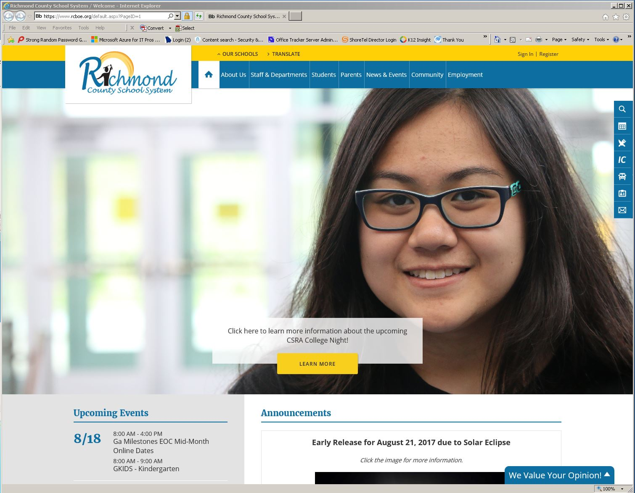

Click on the email tab on the right side of the web page. (The envelope.)

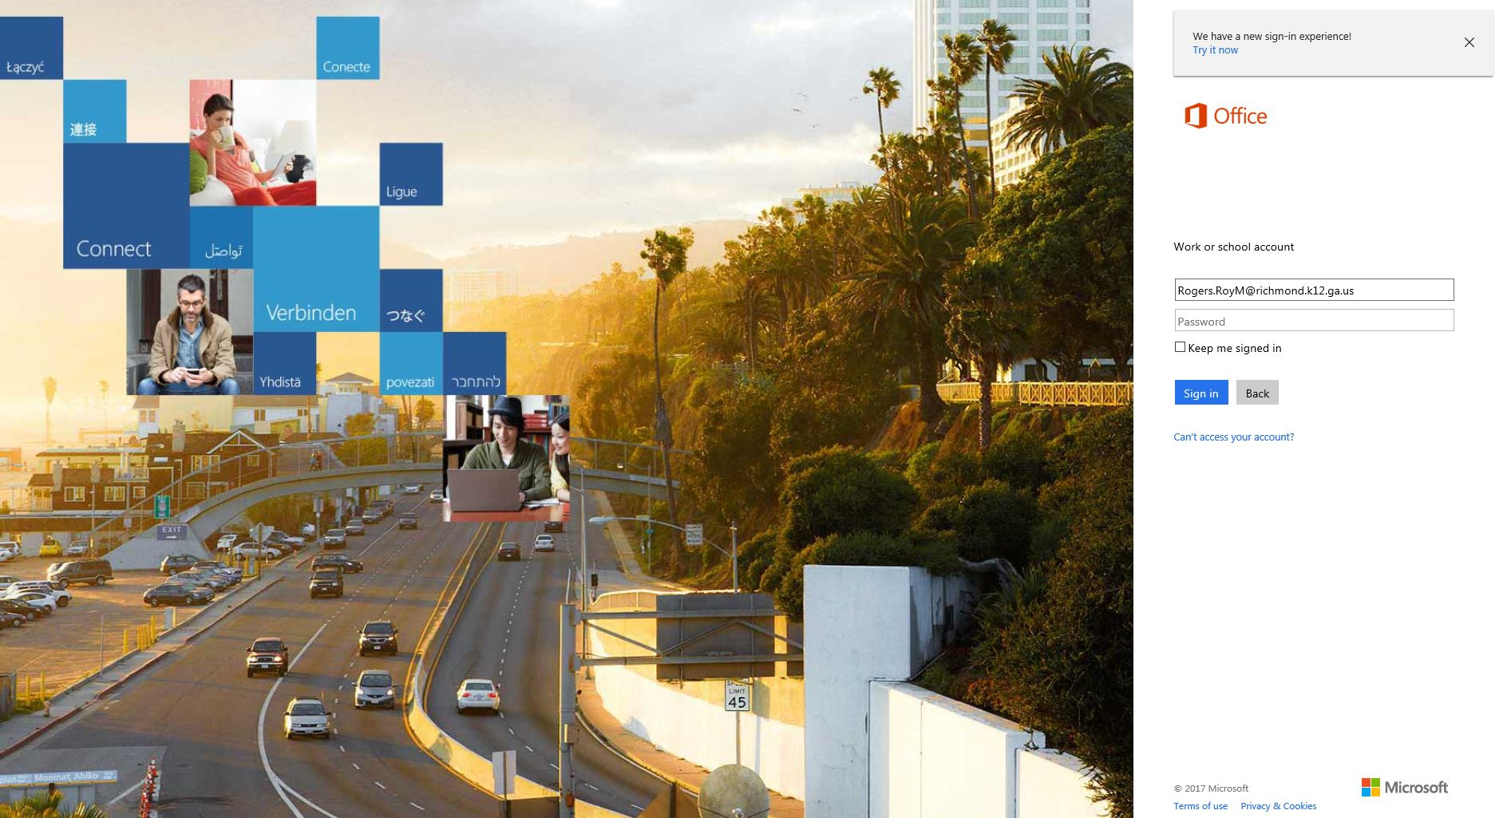

*Login for O365 requires the username to appear as follows: Ex: Rogers.RoyM @Richmond.k12.ga.us
Type your “login@richmond.k12.ga.us”
(EXAMPLE: Rogers.RoyM@richmond.k12.ga.us ).
Type in your password and click “Sign in.”

The first time you log in you will see a box that says set your time zone. Set it to Eastern time zone. Click Save. (if not set correctly it will cause issues with your calendar.)
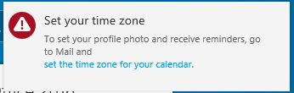

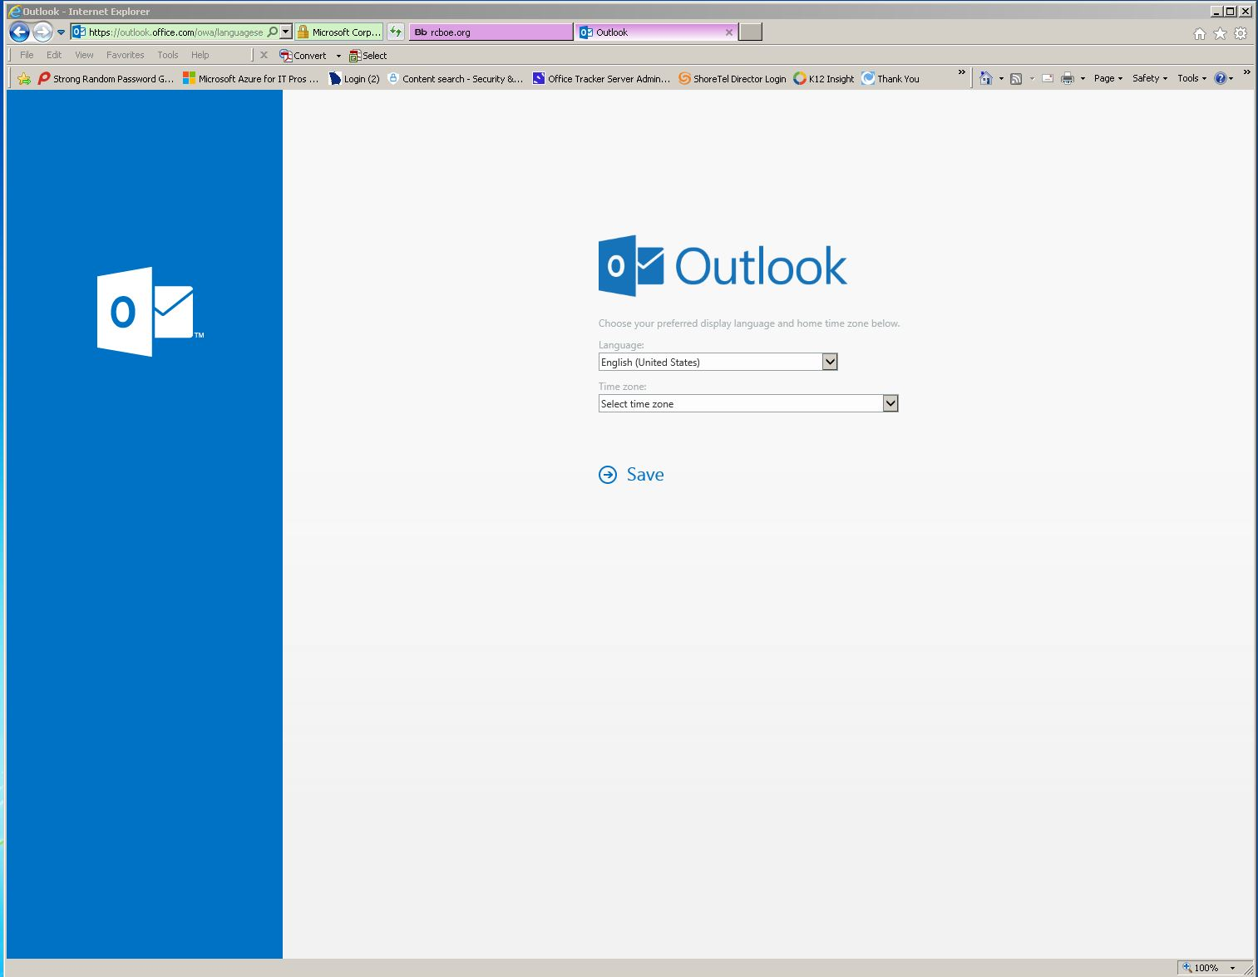

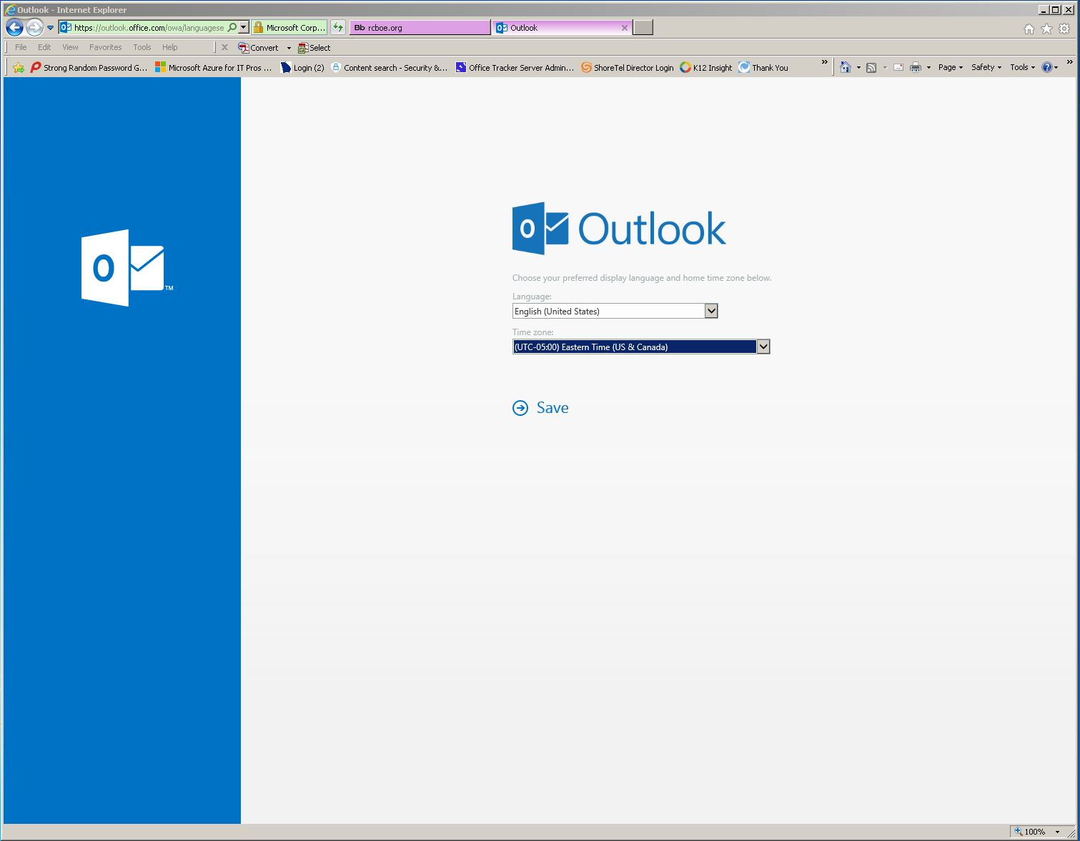


If you see this ignore it office is already installed on your school computer.
This option is for home and personal computers, up to 5 devices.
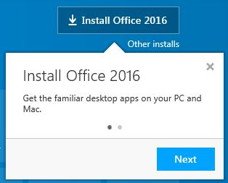

Then it will open to your email.
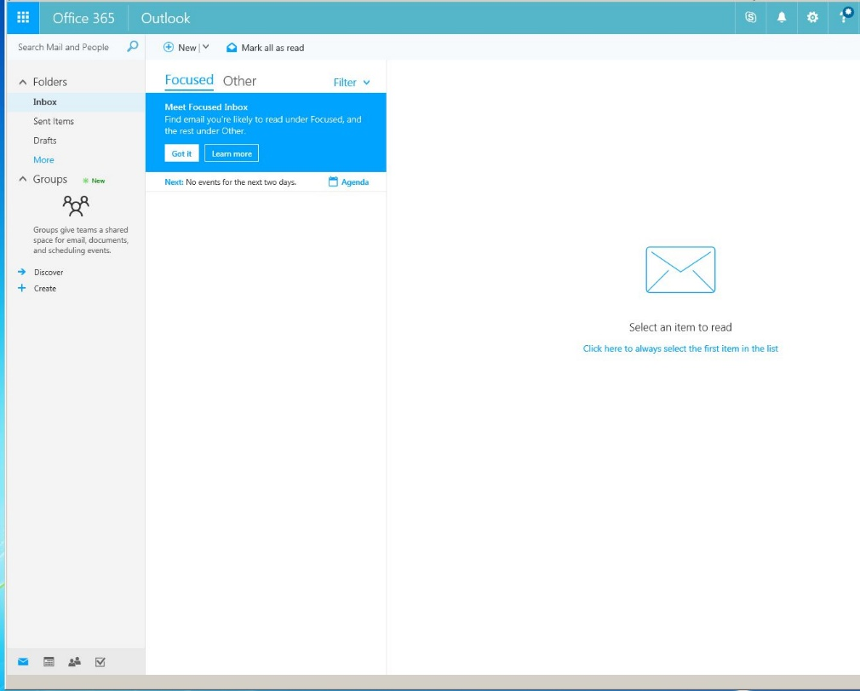

NOTE: All students will have emails grouped by the level i.e. High, Middle, and Elementary Schools. Accounts will be issued in three phases first High, Middle, and then Elementary Schools.

Support Contact information if you have any question are as follows.
- Teacher
- School Tech
- NETWORK TEAM/Technology Department contact: 706-826-1103.

