ClassFlow (Search Marketplace for Flipcharts)

- Sign into www.classflow.com
- On the home page Inside of the white box search by Georgia Standards or by subject that you are working on.
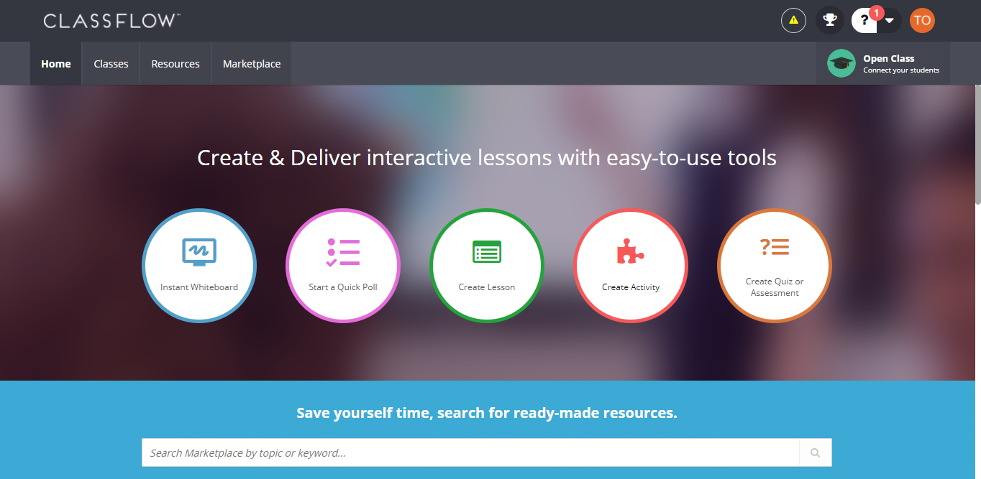
- On the left hand side scroll to the bottom and click on Flipcharts. Once you find something you would like to use. Click on the flipchart then.
- Once it says successfully added click on the blue box. Now you are in your resources. (My Resources) Click  Find your flipchart and download it.
- Once it has downloaded it will show up on the left hand corner of your screen. Click on it and it should open in ActivInspire.
- Explore & have fun!

