

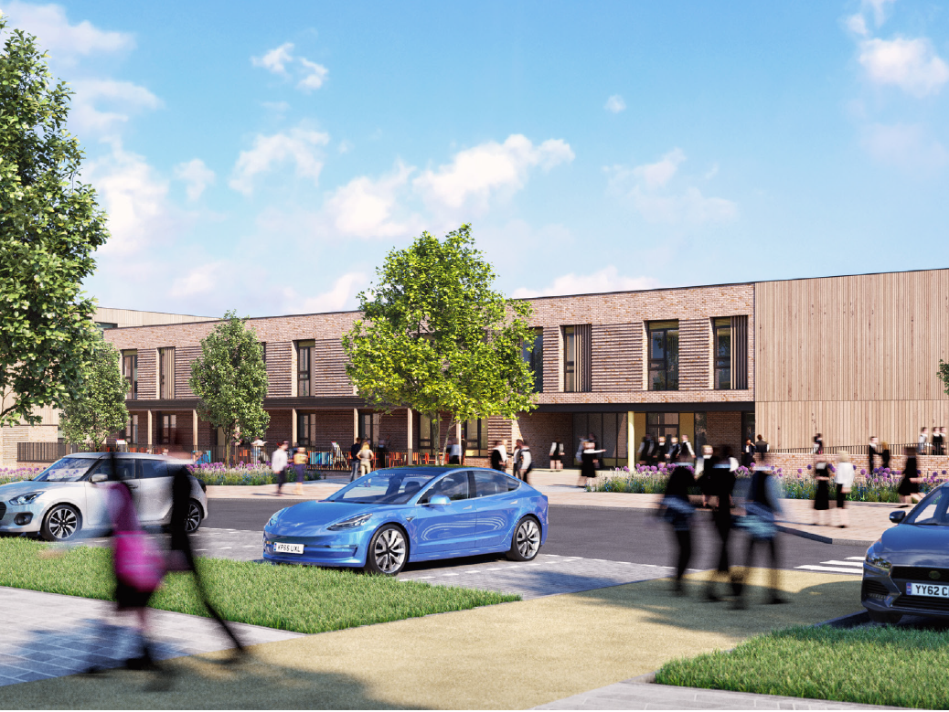 New Parent Guide
2025-2026


Contents
Pg 3 Headteacher’s Introduction
Pg 3 About our School
Pg 4 Key Staff
Pg 5 Safeguarding Children
Pg 5 Induction Process
Pg 5 Vision
Pg 5 Curriculum
Pg 8 Religious Education
Pg 8 Working in Partnership
Pg 9 PTSA – Friends of Oakley School (FoOS)
Pg 9 Communication
Pg 10 Values and Expectations
Pg 10 Home Learning
Pg 11 Assessment and Feedback
Pg 12 Inclusion
Pg 12 House System
Pg 13 Uniform – inc. PE kit and outdoor learning
Pg 14 Behaviour
Pg 15 Attendance
Pg 15 Illness, Accidents and Medications
Pg 16 Bullying
Pg 16 Unforeseen Closures
Pg 16 School Meals and Milk
Pg 17 Pupil Premium
Pg 17 School Term Dates
Pg 18 The School Day
Pg 18 Wraparound Care Provision
Pg 18 Useful Information
Pg 19 Governors

Headteacher’s Introduction

Welcome to Oakley School and thank you for entrusting your child’s education with us. This is a responsibility that we take very seriously. We aim to ensure that by working in partnership with all parents and carers we can provide pupils at Oakley School with a first-class educational experience, an experience that allows pupils to succeed academically and gain the confidence and skills which will allow them to become outstanding citizens.
As parents and carers, I would like to state that this is your school, so please come and talk to us about any matter relating to your child.
Our vision is for all pupils to believe that anything is achievable by being the best they can be. We will constantly support them to reach new heights in academic success and in every aspect of school life through promoting our values of kindness, confidence and resilience.
2025/26 School Priorities
• Provide pupils with as wide a range of memorable experiences as possible and instil our values of Kindness, Confidence and Resilience.
• Develop learning and teaching so that every lesson embeds previous learning and enables new learning.
• Raise achievement so that every pupil fulfils their potential.
Finally, I hope that this guide reflects our commitment to your child and that it answers any questions you may have. I look forward to working with you.
Sarah Kaye
About our School
We opened our doors to our first Reception cohort in September 2024 on our brand-new site on Oakley Wood Road. It has been an exciting and highly successful first year, full of growth, innovation, and community spirit. We are very much looking forward to growing our school community and we can’t wait for you to join!
At Oakley School we have a fantastic team of dedicated and passionate staff who share in a vision of educational excellence for the children, families and wider school community that we serve. It is important to us that we get to know our children and young people really well and know how to support them to be the best they can be. Our rich and ambitious curriculum has been tailor-made to meet the needs of our pupils and inspire them to achieve their full potential. We work closely with other schools in our Multi Academy Trust, particularly Myton Gardens and Coten End Primary School, to collaboratively develop our curriculums, deepen professional expertise, support one another, broaden our collective skill set, and ensure the highest possible outcomes for all our pupils.
Our strong pastoral care underpins a nurturing, inclusive environment where relationships matter. Guided by restorative practice and rooted in our core values of kindness, confidence, and resilience, we empower pupils to thrive and grow into respectful, responsible citizens.

Key Staff
Primary
  Mrs S Kaye  Headteacher |  |   Mrs G Welbourne  Assistant Headteacher  Responsible for EYFS and KS1
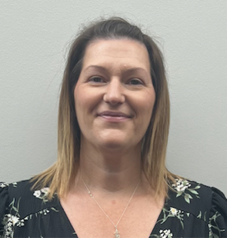  Mrs C Shirley  Deputy Headteacher  Pastoral |   Mrs L Spencer  Deputy Headteacher  Teaching & Learning (Secondary) |  | 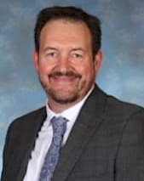  Mr M Few  Designated Safeguarding Lead
  Mrs B Kelsall-Gooch  (Mrs K-G)  Primary SENDCo |   Miss G Geary  Reception Class Teacher |  |   Mrs W Brebner  Teaching Assistant
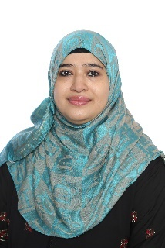  Mrs Mehera  Teaching Assistant |   Mrs Jones  Head’s PA &  Office Manager |  |   Mrs R Mobbs  Administrator

Safeguarding Children
Our school is committed to safeguarding and promoting the welfare of children, and we work closely with Warwickshire Safeguarding. We regard safeguarding children as everyone’s responsibility and expect all staff and volunteers to share this commitment. All our staff are trained accordingly, and we have sound procedures in place to protect children.
The Designated Safeguarding Lead in school is Mr Mike Few.
The Deputy Safeguarding Lead for Primary is Mrs Grace Welbourne, Assistant Headteacher.
The Safeguarding Governor is Amanda Bishop.
Under the Education Act 2002 (Section 175 for maintained schools/Section 157 for academies/free/independent schools), schools must make arrangements to safeguard and promote the welfare of children. Parents/carers should know that the law (Children Act 1989) requires all school staff to pass on information which gives rise to a concern about a child’s welfare, including risk from neglect, physical, emotional or sexual abuse. Staff will seek, in general, to discuss any concerns with the parent/carer and discuss the need to make a referral to Children’s Social Care if that is considered necessary. This will only be done where such discussion will not place the child at increased risk of significant harm or cause undue delay. The school will seek advice from Children’s Social Care when they have reasonable cause to suspect a child may be suffering or likely to suffer significant harm. Occasionally, concerns are passed on which are later found to be unfounded. Parents/carers will appreciate that the school’s Designated Safeguarding Lead carries out their responsibilities in accordance with the law and acts in the best interests of all children.

Induction Process
If your child is offered a place in Years 1–6, we will aim to organise a visit to the school for both your child and their parents or carers. We are passionate about building strong partnerships with our families from the very beginning and want you to have the opportunity to ask any questions you may have before your child starts with us. This visit also gives your child the chance to see their new environment and, hopefully, meet their new teacher and the classroom adult.

Vision
Our vision for Oakley School is for the school to be a place where pupils are happy and safe. A place where pupils are nurtured to develop the talents that exist within every child so that they develop the knowledge and skills to be kind, confident and resilient young people who are fully prepared for the future. We are passionate that every child has a wonderful school experience every day and when they look back at their time at Oakley School they will do so with great fondness and appreciation.
Oakley School is an inclusive school which sits at the very heart of the community, providing pupils with an inspiring environment where they are encouraged to ‘dream big’ and achieve their goals. As part of this vision, we are committed to serving and enriching the local community and meeting their needs.

Curriculum
Intent
At Oakley School, our broad and enriching curriculum fosters a lifelong love of learning and a deep thirst for knowledge and understanding. It is carefully planned and coherently sequenced to build knowledge and skills over time, providing opportunities for academic, artistic, technical, and sporting excellence.
Our curriculum is designed to promote long-term learning by making meaningful links across subjects and themes, reinforcing key concepts and vocabulary. In Key Stage 1, we embrace a Continuous Provision approach, enabling children to retrieve, practise, and apply their learning through hands-on, investigative, and inspiring activities. This approach nurtures independence, autonomy, and a strong sense of agency in their learning journey.
We place a strong emphasis on behaviour and wellbeing, supporting pupils to become resilient, confident, and independent learners, while helping them to stay physically and mentally healthy. Teachers use a range of assessment strategies to identify and address learning needs, ensuring that every child is engaged, inspired, and appropriately challenged.
Our aim is for all pupils to leave Oakley School as responsible, respectful, and active citizens who understand and uphold fundamental British values. The curriculum is ambitious, inclusive, and designed to equip every learner with the knowledge and cultural capital they need to succeed in life.
Our curriculum includes:
- The statutory National Curriculum and Early Years Foundation Stage (EYFS) Curriculum.
- An inclusive approach that adapts learning for pupils with Special Educational Needs or Disabilities (SEND). We hold high expectations for all and are committed to meeting the requirements of the Equality Act 2010 and the SEND Regulations 2014. More details are available in our SEND Provision and Equality Policy and Objectives.
- Religious Education in accordance with the Warwickshire Agreed Syllabus (SACRE).
- A comprehensive PSHE programme, delivered weekly across all year groups, including:
  - Statutory Relationships, Health and Sex Education (taught through the Jigsaw scheme)
  - Protective Behaviours (delivered through The Taking Care Project)
- Swimming lessons beginning in Year 2 for all pupils.
- Modern Foreign Languages introduced in EYFS through songs, stories, and greetings in a range of languages, with formal MFL teaching (primarily French, with some Spanish and German) beginning in Key Stage 2, delivered by a specialist teacher.
- A wide range of extra-curricular activities offered by school staff and external providers outside of curriculum hours.
Implementation
- At Oakley School, we bring our vision and curriculum intent to life through a carefully considered, dynamic, and inclusive approach to teaching and learning. Our curriculum is delivered in the following ways:
- Creative, immersive half-termly themes that make learning meaningful and enjoyable.
- A Continuous Provision approach in Key Stage 1, promoting independence, retrieval, and hands-on investigation.
- A supportive and nurturing environment that celebrates achievement and encourages ambition.
- A broad and balanced curriculum covering all subjects with depth and rigour.
- Strong, aspirational leadership across the school, including subject-specific leadership and effective governance.
- Clear, progressive skills underpinning the planning, delivery, and assessment of each subject.
- A strong emphasis on phonics and reading, recognised as a priority across the school.
- Regular retrieval practice, including effective questioning and low-stakes quizzes, to deepen and embed learning.
- Use of Knowledge Organisers to support vocabulary development and knowledge retention.
- High-quality teaching driven by subject expertise, enthusiasm, and praise.
- A commitment to reflective practice and ongoing professional development.
- Effective use of high-quality, age-appropriate resources to enhance teaching and learning.
- A wide variety of high-quality texts to enrich the curriculum and foster a love of reading.
- A safe, structured approach to digital learning, with high-quality teaching in online safety and technology use.
- Specialist teaching in PE, Modern Foreign Languages, and Music, supported by expertise from secondary subject leaders.
- Purposeful cross-curricular links to help pupils apply knowledge and skills across subjects.
- Outstanding pastoral care that supports emotional wellbeing and personal growth.
- A rich PSHE curriculum and strong personal development programme.
- A wide variety of enrichment activities including school trips, after-school clubs, and visiting specialists.
- Half-termly theme days to make learning engaging and memorable.
- Differentiated tasks to ensure all pupils can access and enjoy the curriculum.
- High participation in sport and physical activity, including competitions and festivals.
- Extensive opportunities for outdoor learning and real-world exploration.
- Pupil and parent voice is valued, regularly sought, and used to shape and improve provision.
- Curriculum Enhancements include:
- Educational visits to locations such as Canalside Community Foods, local theatres, galleries, and parks.
- Inspiring visitors including parents sharing expertise, religious leaders, immersive workshops (e.g. planetariums, palaeontology digs), and arts professionals.
- Specialist-led workshops in areas such as sculpture, music, and history.
- Competitions and themed weeks or days to enrich the curriculum.
- “Come and Learn” sessions where parents and grandparents work alongside pupils in Reading, Writing, and Maths.
- Performance opportunities such as Christmas productions, concerts, and community performances.
- Pupil Leadership:
- Pupils are encouraged to take on roles of responsibility across the school including class monitors, play leaders, and House Captains. These opportunities will grow alongside our pupils as the school develops.
Impact
- The impact of our curriculum is evident in the outcomes and experiences of our pupils:
- Pupils are happy, safe, and nurtured. They are proud of their school and consistently demonstrate our core values.
- Staff are proud of the school and united in achieving shared goals.
- Pupil outcomes at the end of the Foundation Stage, Key Stage 1, and in Key Stage 2 SATs are consistently above national averages.
- Children’s books showcase high-quality work and strong progress across all subjects.
- Pupil voice indicates that children speak confidently and enthusiastically about their learning.
- Teachers rigorously monitor progress across all subjects to inform planning and ensure next steps are well supported.
- Behaviour and learning attitudes across the school are excellent.
- Participation in clubs, sporting events, and wider opportunities is high.
- Pupils and staff regularly reflect on personal growth using our school values and curriculum aims.
- Children leave Oakley School confident, well-prepared, and excited for the next stage of their education and beyond.

Religious Education
R.E. is part of the curriculum for all ages and is one of the nine Protected Characteristics (Equality Act 2010). We aim to help children understand the nature of religion through a World Views approach. We will encourage them to develop their own views and opinions. In addition to teaching about Christianity, other world faiths are fully included and encouraged. Children are encouraged to respect the beliefs of others. An assembly is held every day in accordance with the Education Reform Act 1988. You are entitled to withdraw your child from RE lessons and assemblies. Please contact the Headteacher if you would like to discuss this.

Working in Partnership
At Oakley School, we place great emphasis on the home-school partnership. We believe that successful learning takes place when there is a strong relationship between school, the child and you as parents and carers. At our school, this means taking an active interest in your child’s learning, encouraging them to have a positive attitude and to try their best, talking about their day, and supporting them with activities such as reading or maths.
‘Talk’ is a proven vital tool for success and we encourage you to support your child’s speaking and listening skills through daily conversations and opportunities to talk, encouraging children to speak in full sentences, where possible and greet those around them. We also encourage positive and open communication with your child’s class teacher. We hope that you will collaborate with us to share information about your child and help us to understand what your child enjoys, what your child is good at and enable us to plan future activities to scaffold their learning and support their progress.
There are also many planned opportunities throughout the year to support our partnership. We will ask you to attend Parents’ Evenings twice a year and there will be opportunities for you to come into class to work alongside your child in events called ‘Come and Learn’.

In Reception and Key Stage 1 we also use an online Learning Journey called ‘Tapestry’. This is a fantastic way for you to see significant stages in your child’s development and independent work they have completed. We also encourage you as parents to upload any achievements children have outside of school. For more information on Tapestry please visit: http://eyfs.info/tapestry-info/introduction.
Other ways that parents and carers can support their child include:
- Arriving at school on time each day so your child has a calm start to their learning.
- Collecting your child on time at the end of the day to avoid anxiety.
- Ensuring your child has everything they need each day, such as Book Bag, Reading Diary, and Water Bottle.
- Avoid taking holidays during term time.
- Show an interest in your child’s learning and take every opportunity to praise their efforts and celebrate their achievements.
- Encourage your child to read regularly at home, and comment and sign in their Reading Diary (more information below).
- Support the school’s policies and high expectations.
- Maintain positive and open communication with your child’s teacher.
- Make the school aware of any concerns, problems or medical conditions that might affect your child’s wellbeing/work/behaviour.

For its part, the school will endeavour to:
- Ensure that your child achieves their full potential as a valued member of the school community.
- Provide a rich and ambitious curriculum which meets the individual needs of your child, enhanced by memorable learning experiences.
- Help your child to enjoy their learning and achieve high standards of work and behaviour through building positive, meaningful relationships.
- Keep you informed about general school matters and about your child’s progress.
- Promote healthy living and care for your child’s safety and happiness.
- Be open and always welcoming and offer opportunities for you to become involved in the life of the school.

Friends of Oakley School – PTSA
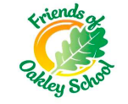
To further enhance our growing school community, we are incredibly keen to develop our PTSA. All parents, pupils and staff at Oakley School are automatically members of Friends of Oakley School PTSA. The work of a successful PTSA will help to raise funds to provide resources, opportunities and create memorable experiences for all children at Oakley School.
Current postholders:
Chair of Friends of Oakley School- Justyna Zarzecka
Vice Chair (Primary) – Rachael Escott
Vice Chair (Secondary) and Secretary - Susi Wisniewski
Treasurer – Tom Jeskines
Social Media and Communication Executive - Bogdan Petrica
There are many ways that you can help, depending on how much time you have to give, and we would be incredibly grateful for as much support as possible to help grow our school community successfully. I
f you would like to know more about the work they do or would like to help please contact them via their Facebook group Friends of Oakley School https://www.facebook.com/groups/313443781554720 or email Justyna at: foos.chair@gmail.com or contact the school office.

Communication

In addition to the aforementioned ‘Tapestry’ app in Reception and KS1, we will also make use of our whole school communication app, ‘My Child at School’. This will be the main source of communication between Oakley School and our pupils’ parents/carers. We will use the communication features of the app to keep you regularly updated and informed. The app can be downloaded onto Apple and Android devices and can also be accessed via an online portal (www.mychildatschool.com). Further details of how to download and access the app has already been sent out separately to parents/carers via email – please let us know ASAP if you have not managed to join this app yet.
We will also regularly update our website and social media platforms with our latest activities and achievements, including a Year Group Blog.
To support effective communication between home and school, please update us with any changes to your contact details or get in touch for any support with accessing the platforms we use.

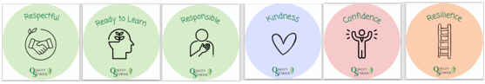
Values and Expectations

At Oakley School, our core values of Kindness, Confidence and Resilience are at the heart of everything we do. These values, combined with a strong culture of high expectations, guide our approach to learning and behaviour across the school. We expect our pupils to strive for their best, show respectful behaviour, present themselves smartly, and communicate with courtesy and care to both peers and adults.
We believe that children and young people flourish in an environment that both challenges and supports them. Through our carefully planned Pastoral curriculum, and reinforced in all aspects of school life, pupils are taught to become respectful, responsible, and ready to learn. As part of our commitment to equality and inclusion, we actively promote and uphold the Protected Characteristics as defined in the Equality Act 2010, ensuring that all members of our school community are treated with dignity and respect. These attributes are the foundation of lifelong learning and personal growth.
You can help reinforce these high standards by supporting the following behaviours and attitudes at home:
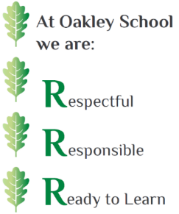
- Respectful Learners: listen attentively to others, take turns to speak, use good manners, and interact positively with peers and adults. They show kindness by caring and sharing during collaborative activities.
- Responsible Learners: make safe and sensible choices, follow adult instructions, act in line with our school values, and take responsibility for their actions, including offering sincere apologies when needed.
- Readiness to Learn means listening and responding to instructions, cooperating and sharing with others, making safe and thoughtful decisions during independent learning, and always trying their best.

Home Learning

The book bag is an essential item on the school uniform list, and this is where your child’s home learning will be provided. In Reception, home learning is centred around the importance of learning to read.

Phonics
At our school, teaching children to read is a top priority, as we recognise it as a powerful gateway to knowledge, skill development, and lifelong opportunities. Children will learn phonic every day during EYFS and KS1. They will learn the sound that a letter makes, learn the shape of the letter, and learn an action that accompanies this. We follow a prescriptive, comprehensive and highly successful scheme called Little Wandle. In Reception and Year 1 parents will be invited to a meeting where we will share more information about the way in which we teach Phonics and how you can support at home.
Reading Books
Through our chosen scheme, Little Wandle, children are issued with a phonetically decodable reading book pitched at the level your child is working at. They will engage in 3 Guided Readings sessions a week at school, focussing on ‘Decoding’, ‘Prosody’, and ‘Comprehension’. After these sessions have been delivered, children will bring their book home to share with you. It is essential that children practise reading their book for a few minutes daily to support progress and fluency. Children will change this reading book each week and will be assessed on their reading progress at various points each half term. This progress will be shared in their reading diary.
Library Books
We are passionate and committed to promoting children to be avid readers and have developed a wide range of library books to promote ‘Reading for Pleasure’ at Oakley School. We work closely with local book shops including Warwick Books and reps from Harper Collins and Scholastic to ensure our library selection is high quality and continuously updated. Each week, children will be issued with a high-quality text to enjoy as a family. Please note, these books are not for children to attempt to read independently but rather to be read aloud by an adult. Our Library books have been carefully selected to ensure there is a diverse, inclusive, and engaging selection for the children to enjoy. They consist of a combination of classics, best-sellers, and new titles.
We take great pride and respect in the resources we have in school and would appreciate great care being taken when school resources, such as books, are sent home. We understand that accidents happen but if any books are misplaced or mistreated, we will request for books to be replaced.
Reading Diary
The Reading Diary is a written record of the reading your child does at home and in school. When you share your child’s reading book at home, please write the date, title of the book and a short comment. Please ensure that this is in your child’s book bag every day.
“If you read one book to your child every day, by their 5th birthday
they will have heard 1825 books” – Dr Mary Kane
Assessment and Feedback
Assessment happens on a daily basis. Through quality interactions teachers are able to build knowledge about your child, shape their teaching and respond immediately to their learning needs. Through our inspiring, hands-on Continuous Provision curriculum, teachers skilfully provide both direct teaching input and independent activities to cater for your child’s next steps and are able to instruct, guide and enhance this every day.
When your child starts with us, teachers will conduct a Baseline Assessment to gauge what your child is able to do and what their next steps in learning may be. This will help inform the curriculum provision and ensure we meet children where they are at. Our curriculum meets the needs of all our learners, and we use Quality First Teaching methods to ensure our pupils get the very best curriculum offer.
Following this, throughout the year, teachers will conduct ‘checkpoint activities’ to ensure your child is on-track and making progress.
Each year there will be two face-to-face Parents’ Evenings (usually Autumn and Spring term) where teachers will share the information that they have gathered in a school context. The home-school partnership is crucial in supporting teachers to have a thorough understanding of the ‘whole child’ and we welcome your discussions about the progress your child is making at home and/or any challenges they may be facing.
You will also receive day-to-day snapshots through our use of Tapestry.
In the final term of each year, teachers will complete their final assessments to help inform the new class teachers of where your child is at, to help them plan effectively for the following year. You will receive this information in a formal written School Report at the end of the year.

Inclusion
At Oakley School our vision is to create a positive ethos which promotes inclusion of all pupils to achieve their full potential within a supportive, caring atmosphere. To achieve this, the following principles govern the inclusive way in which we work:
- All children are valued equally i.e., children of all abilities and disabilities, from all cultures, races and gender identity.
- All children have an entitlement to the full curriculum and, whenever possible, are integrated into mainstream classes.
- All teachers are committed to ensuring that the individual needs of children are met by adapting aspects of the curriculum and employing teaching strategies to ensure all pupils achieve their full potential.
- All teachers accept and understand their responsibility within the overall school policy for meeting Special Educational Needs and Disabilities.
To meet the special educational needs of individual pupils:
The SEND Code of Practice sets out stages for SEND provision and Oakley School’s strategies for meeting SEND are aligned to these stages.
The needs of pupils with SEND are identified, assessed, provided for and regularly reviewed.
- Oakley School has a team of Teaching Assistants who support children in all curriculum areas in accessing the mainstream curriculum and working towards personalised goals.
- Additional support is available according to an individual pupil’s needs, including home learning support sessions, shared reading, and mentoring.
- Oakley School works in close partnership with parents/carers and other relevant agencies, as appropriate, in supporting pupils to reach their full potential.

House System
All pupils are placed into one of three houses: Peacock (Red), Meadow (Blue), or Admiral (Purple). These are common butterflies found in our local Oakley Woods.
The aim of the House system is to create the best possible ethos for pupils’ personal development and for the achievement of their potential in all aspects of life.
The three Houses compete to win the annual House competition, the winning House being the one with the most points at the end of the Summer Term. Pupils in the winning House have the opportunity of taking part in a House trip in the following Autumn Term.
Pupils can gain House Achievement Points (HAPs) in several ways including effort when learning, displaying and living out our school values, participation in memorable experiences etc. As pupils move into older year groups, they will also have the opportunity to represent their house and tutor group by being elected to the Pupil Council. Each year, our pupil leaders select and vote for a ‘Charity of the Year’ and the proceeds of all our fundraising efforts including Charity Week and Non-uniform days go towards it. Each House competes to raise the most money for additional HAPs.

Uniform
At Oakley School, we believe that having a uniform encourages our sense of cohesion and community. We want our children to feel proud to wear their Oakley School uniform and represent the school in the very best way.
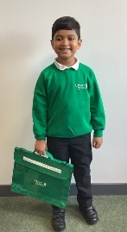
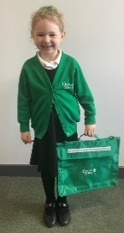
We request that parents and carers support pupils to meet our high standards by providing the correct uniform as outlined below. We aim to make our uniform as flexible as possible for parents, so generic uniform (without the school badge) can be purchased from a variety of stores. However, should you wish to purchase items with the school badge on please see details below.

Uniform:
- White or Green Polo shirt - plain or school logo
- Green Sweatshirt or Cardigan - plain or school logo
- Black school trousers, or school shorts, or school skirt, or school pinafore dress
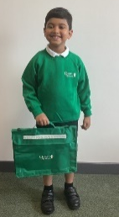
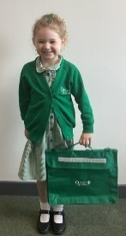
- Black school shoes (trainers, Vans or pumps are not
- permitted)
- Black or white socks or black tights
- Green gingham summer dress (Summer Term)
- A suitable coat for all weather (any colour) –
hoodies are not permitted
- Book bag with school logo
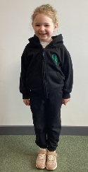
PE Uniform:
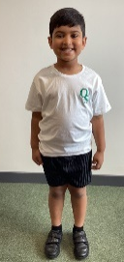
- PE t-shirt with school logo
- PE hooded top with school logo or plain black hooded top or plain black sweatshirt
- Plain black tracksuit bottom
- s or black PE shorts or black PE skort or black leggings
- Trainers for outdoor PE (ideally without laces)
- PE pumps for indoor PE (without laces)
Children will be invited to wear their PE kit for the whole day on their PE days. Further information about this will be shared at the Parent Introduction Evening and at the start of Autumn Term.

Outdoor Learning
We place strong emphasis on the encouragement of outdoor learning to support children’s wellbeing but also encourage resilience and futher opportunities to learn and discover. Children in KS1 will spend some parts of the week outside and it is essential that they have the correct clothes to support this. Please ensure every item is clearly named.
- An appropriate coat with a hood.
- Woolly hat, scarf, and gloves.
- Sunhat when the weather is warm.
- Wellies (EYFS only)– please send these in during your child’s first week at school. These will then remain at school for the remainder of the year.
Forest School
During the 2025–26 academic year, we are excited to begin developing our Forest School area. This will be a fantastic outdoor learning environment where children can explore, play, and grow in confidence and resilience. Several members of our staff are currently undertaking accredited Forest School training to support the successful development and delivery of this initiative. As we plan and prepare, we will be reaching out to our school families and local community for support with both fitting and resourcing the space. If you know of any materials, resources, or local companies that might be able to help, we’d love to hear from you.
Water Bottles
All children must bring a filled water bottle from home each day that they are freely able to access during the school day. Squash or juice is not permitted. The bottle will be sent home every day to be washed and refilled. Please ensure this bottle is transparent and clearly named. Metal bottles/ Air Up bottles etc are not permitted.

Uniform Supplier:
Items with a school logo can be purchased online or in person from Stitch-Tech.
Please do not underestimate the need to clearly name all items of
school uniform and PE kit, even socks. Please use either sew-in, iron-on or a permanent ink pen and regularly check that your child’s clothes belong to them and are still named!
Stitch-tech Ltd
7C Jenton Road
Sydenham Industrial Estate
Leamington Spa
CV31 1XS
Tel: 01926 883366
sales@stitchtech.co.uk
If your child is in receipt of Pupil Premium funding, their allocation can be used for uniform if you wish. Please see page 18 for further information about Pupil Premium funding. If any parent/carer experiences any difficulty or financial hardship in purchasing school uniform, please contact our suppliers who may offer a payment plan. Alternatively, contact the school in confidence to speak to a member of the admin team.

Behaviour
We use ‘Restorative Approaches’ towards behaviour. Being ‘restorative’ focuses on building positive relationships based on responsibility, respect, and fairness. In turn, this creates a community that is supportive, accountable, and respectful. We believe that every individual is responsible for their own behaviour. We endeavour to promote and model environments that are supportive, polite, and safe for all.

Rewards
At Oakley School, we promote the positive attitudes and behaviours expected of our pupils by acknowledging and rewarding them for their efforts and achievements.
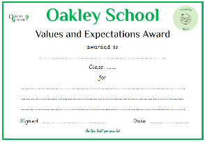
How will my child be rewarded?
- Praise Stickers and Value stickers
- Verbal praise
- Praise Postcard
- Star in the Jar – whole class incentive
- Parental Email/Telephone Call
- Individual Awards (Weekly Celebration Assembly)
- Display of Work – Writer of the Week, Mathematician of the Week
- House Achievement Points (HAPs)
- End of Year Celebration Assembly

Sanctions
In times where pupils do not meet our expectations of behaviour and attitude, we will engage in restorative conversations to support children to reflect on and take responsibility for their behaviour, repairing any harm done, and rebuilding and restoring relationships. In the Early Years, adults have a key role in modelling the use of communication and language in instances such as sharing, turn-taking and respectful use of resources and space. If necessary, this will be escalated to the Assistant Head who is responsible for Primary. We place great importance on the partnership and collaboration we share with parents and carers. If your child is involved in such incidences this will be shared with you to enable you to discuss this further at home. Our partnership is essential in creating consistent and united messages to the children.

Attendance
We encourage you to work with us to ensure your child attends school as much as possible and arrives on time. Regular and punctual attendance is both a legal requirement and essential for pupils if they are to get the most of their school experience.
Doors open at 8:35a.m. and close at 8:45a.m.
If your child is going to be absent from school due to illness, please telephone the office before 9.15am each day that they are absent or notify school via the school app.
Where possible please arrange for dental/medical appointments to take place outside of school hours. If appointments are during the school day, then please email the school office in advance to inform us.
If we do not receive an email explaining why your child is absent, we will try to contact you.

Planned absence or Holidays in Term Time
Headteachers are no longer permitted to authorise absence for holidays taken during term time. They are only permitted to grant leave for exceptional circumstances. If you think you have exceptional circumstances, please talk to us without delay and before arrangements are entered into or money committed. If exceptional circumstances are accepted, the Headteacher and the School Governors will determine how much absence will be authorised.
You must complete a Leave of Absence form to request permission.
This form along with further information can be found here on our school website - https://www.oakley-school.com/parent/parents-primary/attendance

Illness, Accidents and Medications
In line with Statutory Requirements and safeguarding procedures, we have dedicated members of staff who are fully trained in Paediatric First Aid and are always available throughout the day to respond to any accidents or first aid needs. If a pupil becomes unwell or has an accident during the school day, a member of staff will contact you. Should your child be too unwell to remain in school, or if hospital treatment is required, we will call a parent or carer to make appropriate arrangements or contact emergency services as necessary.
Medication
If your child needs to have medicine for a short time or for an ongoing period, a medical form must be completed and signed by parents at the school office. Classroom staff will then administer the medicine at the appropriate time.
• Medicine must be delivered personally to the school office
• Parents/carers are encouraged to ask GPs to prescribe an antibiotic which can be given outside of school hours wherever possible. Three times a day doses can be given before and after school and at bedtime.
• Any prescribed medicine must be supplied to the school in a container clearly labelled (by the Pharmacist) with the name of the medicine, full instructions for use and the name of the pupil.
• All medicines should be in the original container bearing the manufacturer’s instructions for administration, dosage, and storage (the school may refuse to administer any medicines supplied in inappropriate containers).
• Medications must be renewed when required as the school cannot administer out-of-date medications.
If your child uses an inhaler or epi-pen, please let the school now as soon as possible. These will be kept in the classrooms and administered by staff as and when required. A medical form and an Individual Health Care Plan must also be completed with school staff when your child starts school.

Bullying
Oakley School is a caring and inclusive community, built on strong, respectful relationships. We have a zero-tolerance approach to bullying in any form, including verbal, physical, racial, homophobic, transphobic, and cyberbullying. Our robust Anti-Bullying Policy ensures that all concerns are taken seriously, investigated thoroughly, and responded to with swift, decisive action. All incidents are recorded, and repeat behaviours are addressed firmly. We urge parents and pupils to report any concerns immediately, providing clear information to support our response. We actively promote a culture of kindness and respect throughout the year and take part in many nationally recognised events, such as National Anti-Bullying Week to reinforce the message that bullying has no place at Oakley School. A copy of our Anti-Bullying Policy is available on our website.

Unforeseen Closures
If the school must close due to bad weather or other unforeseen circumstances, we will communicate via the ‘My Child at School’ app and school website to provide information and updates.

School Meals
All children in Reception, Year One, and Year Two are currently eligible for daily Free School Meals. You will be able to choose your child’s lunch option via the My Child at School app/website.
Packed lunches
If you prefer to send your child with a packed lunch, this should be a healthy lunch sent in a box clearly labelled with your child’s name. For health and safety reasons please do not send fizzy drinks, cans, or glass bottles.
Children in EYFS do not need to bring in a snack as fresh fruit is provided each day.
Nut Free and Allergen Aware
Many children have food allergies, and some may experience severe reactions to certain allergens. At Oakley School, we have pupils with serious nut allergies who must avoid all contact with nuts and nut products. To ensure their safety, we ask all families to carefully check food labels and packaging to confirm that items brought into school do not contain nuts, traces of nuts, or any warning that they may contain nuts. Your vigilance is essential in helping us maintain a safe environment for all children.

Milk
Children have milk in their classrooms in a small carton containing 189ml during the day. Children under the age of five are entitled to free milk at school. For children who are over the age of five, milk needs to be paid for. If your child is receiving free milk, this automatically stops the week commencing their fifth birthday, you will need to contact Cool Milk if you wish your child to continue to have milk after their fifth birthday. Please contact the staff at www.coolmilk.co.uk to register your child’s details and make payments where necessary. Should you have any problems doing this, please see the school office. If you do not want your child to have milk when they start school, please contact the office.

Pupil Premium
The school receives additional Pupil Premium funding for pupils who meet one or more of the following criteria:
- Income support
- Income-based Jobseeker’s Allowance (JSA)
- Income-related employment and support allowance (ESA)
- Guarantee element of state pension credit
- Universal Credit (with an annual income of less than £7,400)
- Both income-based and contribution-based JSA/ESA if you receive the same amount for both. You should qualify if you receive both but the income-based amount is greater, but not if the contribution-based amount is greater.
- Families who are awarded Child Tax Credit and have an annual income, as assessed by HMRC, not in excess of £16, 190 are also eligible to claim free school meals providing there is no entitlement to Working Tax Credit (unless in respect of a 4-week ‘run-on’).
- One of their parents is serving in the regular armed forces, served in the last 3 years or died while serving in the armed forces
- Has been looked after in social care for 1 day or more
- Has been adopted from care or left care under a special guardianship order or a residence order.

At Oakley School, families who are awarded Pupil Premium also receive a £100 annual contribution to help with the cost of uniform, school trips, and other educational needs. This is held in trust by our finance team and parents/carers can direct this funding as they wish by contacting the finance office directly or speaking to the school office.

If you receive any qualifying benefits, it is crucial that you apply for Pupil Premium, even if your child already receives a free meal. If you need support with this, please speak to a member of the SLT.
HOW TO APPLY:
Online: www.warwickshire.gov.uk/freeschoolmeals
By telephone: 01926 742060 (Customer Service Centre)
Your application could make a real difference.

School Term Dates
Autumn Term 2025
Monday 1st September: Teacher Training Day (pupils not in school)
Tuesday 2nd September: Teacher Training Day (pupils not in school)
Wednesday 3rd September: Year 7 and Year 1 start of Autumn term
Thursday 4th September: Year 8 and Year 9 start of Autumn term
Wednesday 10th September: Reception start of Autumn term
Monday 27th October to Friday 31st October: Half Term Break
Friday 28th November: Teacher Training Day (pupils not in school)
Friday 19th December: Autumn term ends (12:20pm Secondary / 1:00pm Primary)

Spring Term 2026
Monday 5th January: Teacher Training Day (pupils not in school)
Tuesday 6th January: start of Spring term
Monday 16th February to Friday 20th February: Half Term Break
Friday 27th March: Spring term ends 3:15pm

Summer Term 2026
Monday 13th April: start of Summer term
Monday 4th May: Bank Holiday
Monday 25th May to Friday 29th May: Half Term Break
Friday 26th June: Teacher Training Day
Friday 17th July: Summer term ends (12:20pm Secondary / 1:00pm Primary)

The School Day
8:35 a.m. Doors open
8:45 a.m. School starts and doors close
12:10 – 1:00 p.m. Lunchtime
1.00 p.m. Afternoon Registration
3:15 p.m. End of the school day


Wraparound Care Provision
Our Wraparound provider is Onside Coaching. They are committed to ensuring that any Oakley School pupil that requires wraparound care can be catered for. Their bookings are online at https://oakley.onsidelive.co.uk/
Please see the associated flyer in your transition pack and the information on our website.
https://www.oakley-school.com/parent/parents-primary/wraparound

Useful Information
Address: Oakley School, Quercus Way, Oakley Wood Road, Bishop’s Tachbrook, CV33 9QE
Telephone No: 01926 290646
Email: oakleyschool@stowevalley.com
Website: www.oakley-school.com

Governors
Oakley School’s Governing Body is made up of a combination of Parent, Staff and Community Governors. Governor contact details can be found on our school website.
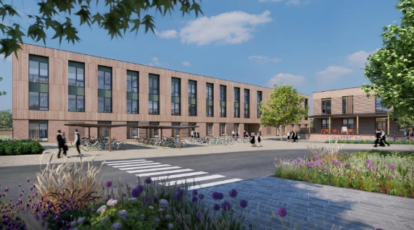

We look forward to welcoming you into our
school community.

