ASD Job Applications:

Applicant User Guide



Published by the ASD Talent Management Department
www.asdk12.org/workforasd
907-742-4115 or talentmanagement@asdk12.org
HR #518
Contents
Welcome to the Anchorage School District 3
Finding Information on Jobs 4
Work For ASD Page 5
Viewing Job Postings 6
Filling Out the Application 8
System Basics 8
Not a current ASD employee, or currently a temporary or substitute employee with ASD 9
Current Regular ASD Employee Transfer Applicants (Non AEA) 14
Current AEA Transfer Applicants 14
Applying for Another Job 15
No Longer Interested 15

Welcome to the Anchorage School District

The following pages are a reference for both new applicants and ASD employees interested in positions with the Anchorage School District.

All of ASD’s positions are advertised on our website, www.asdk12.org/workforasd. When applying, you will be applying through our Frontline Recruiting & Hiring system. Both members of the public and current employees interested in positions in ASD apply through this system. If you are in need of assistance, please feel free to call us at 907-742-4115 or email us at talentmanagement@asdk12.org. We would also be happy to greet and work with you in person at the Talent Management front counter, 5530 E Northern Lights Blvd.

Finding Information on Jobs
Information on working for Anchorage School District as well as current position vacancies are viewed online on the ASD website.
- On the homepage, look at the right for the yellow menu button labeled I WANT TO.
- Click on the words Apply for a Job.
- Or you can go to the Work for ASD website directly, at www.asdk12.org/workforasd.

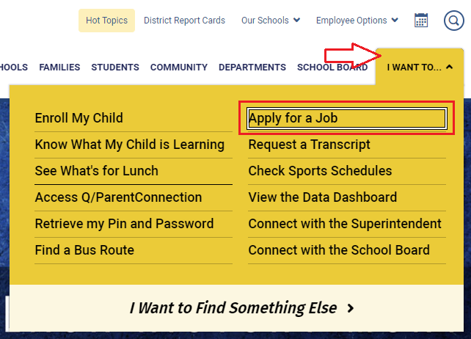

Work For ASD Page
On the Work for ASD page, links in the left side bar contain general information on working for the Anchorage School District. Each area has an overview of the types of positions that support our district and the benefits we offer our regular employees.

When you are ready to view our openings and apply, scroll down to the section with the header Apply for a Job. You will see several buttons.
- External positions: Click View external applicant positions to view ASD vacancies that are open to any qualified applicant.
- Internal positions: Click View internal applicant positions to see all open ASD vacancies.
  - Positions marked with the red internal only note are only open to ASD employees who are currently working in that position’s associated bargaining unit.
- If you have applied with us before and want to update your profile or already know which job you wish to apply for, click Create or edit an application to log into your previous application profile.
  - Enter the email address and password you used when you previously applied. If you wish to use a new email address, change it after logging in with the previous email as your username, rather than creating a new account.

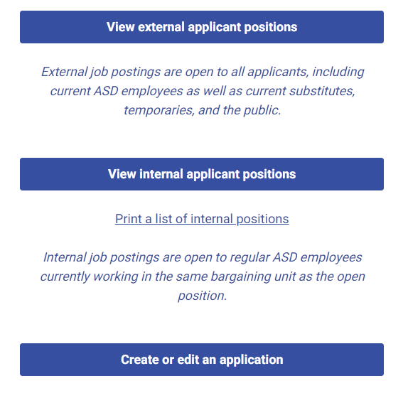

Viewing Job Postings

There are two ways to view open positions:
- Clicking the blue View external applicant positions button will filter the list to only display positions open for anyone to apply.
  - Positions without the red (Internal Only) message are open to any qualified applicant who wishes to apply.
- Clicking the blue View internal applicant positions button will display all positions currently open, including internal only.
  - Positions with a red (Internal Only) note are currently only open to ASD employees who already work in that bargaining unit. Only internal applicants are being considered at this stage.
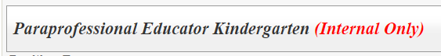

On the jobs listing page, the sidebar at the left shows both featured jobs and the different categories of jobs. The categories show how many vacancies are open in that category.

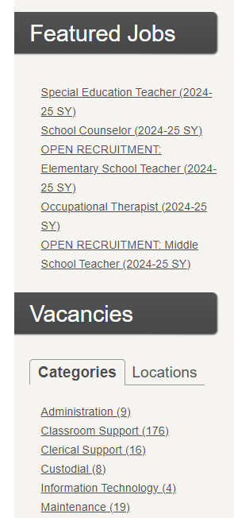

Clicking on a category shows a list of open positions in that group. The main header shows the title, date posted, and work or department location.
- To view the entire job description, click Show/Hide at the bottom of the posting summary. It will expand to show the vacancy’s pay, work year, minimum qualifications, and job duties. Click the link again to hide the description.
- To apply for a position, click the red Apply button in the upper right corner of the vacancy summary. This will open a window to either create a new application or log into your existing profile.

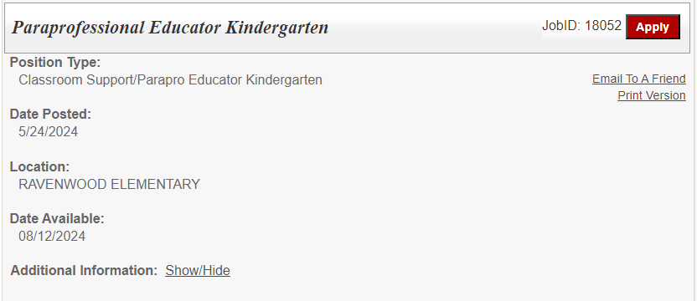

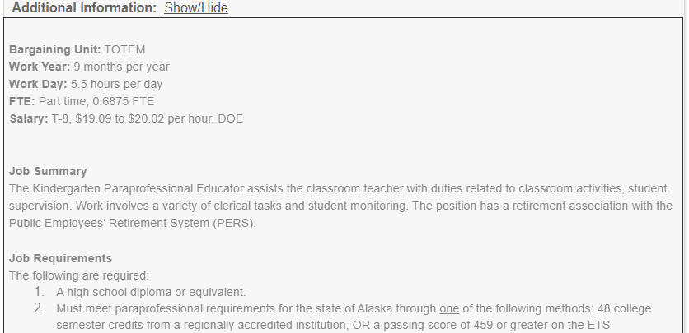

Filling Out the Application
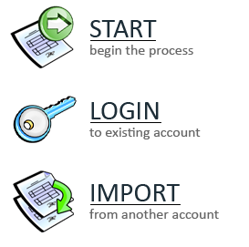
After clicking Apply on the job description, a new window will open to start or log into your application. There are several options on the application login screen:
- Start: Creates a new profile and application for applicants who have never applied for Anchorage School District using Recruiting & Hiring.
- Login: Allows applicants who applied with Anchorage School in the past to log in and update their profile and/or apply for another job. Note that returning applicants should review any existing information and update it as needed.
- Import: Allows new applicants who have previously applied to a different school district that uses the Recruiting & Hiring/AppliTrack system to import basic information into their new ASD profile. Note that this option only brings over basic information that is the same in both systems.

System Basics
- When completing each section, make sure to click Next Page at the bottom right so that the system will accept your information and move you forward in the application.

- You may save your application at any time in the process by clicking Save as Draft. When you return later, click LOGIN and enter your email address and password.
  - Note that after 30 days the system will automatically delete any unfinished application if it has never been submitted.

- Questions with a red asterisk are required. When you have finished answering all of the questions, click Finish and Submit.


Not a current ASD employee, or currently a temporary or substitute employee with ASD
Applicants who are new to ASD or are a current temporary or substitute employee fill out the full application.
Selecting Employment Status
- To begin, click START or LOGIN. Either enter your personal information or update it. The email address you enter will become the username for your profile. Remember this email and password so that you can log in again in the future.
- On the first page, enter your name and basic contact information:
        - Your email address.
        - A password. This will allow you to save a partly completed application and come back to it later, or to apply for additional positions in the future.
        - Choose a secret question and type in the answer. This will help you to log in to your account if you forget your password.
- Click the Next Page arrow at the bottom right of the screen to continue.

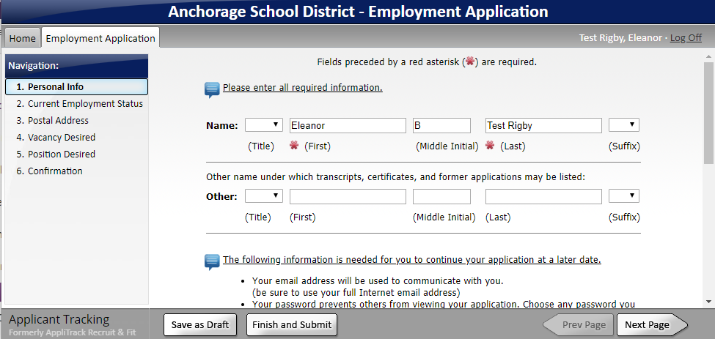

- On the second page, choose Not a current ASD employee ….
        - At this point, at the bottom of the page you will see the option Save as Draft. Clicking this option allows you to save your application with the information you have already filled out. You can return to the application later to finish it. However, the application has not yet been submitted–you have not yet applied for a position.

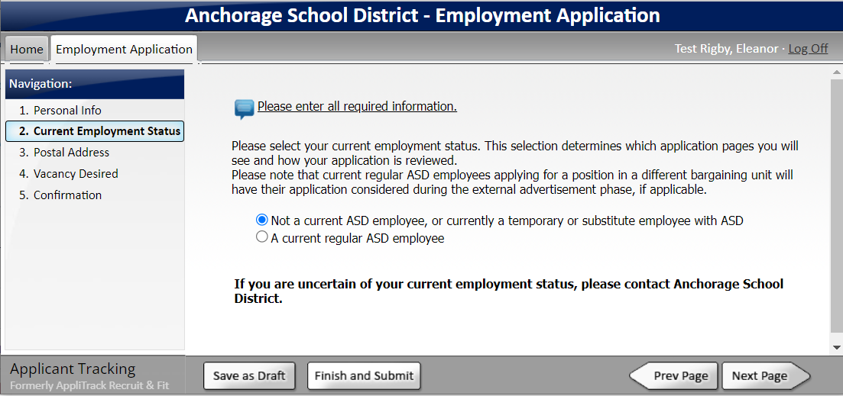

Other Application Pages
Many application pages are the same among all of the positions we post. However, some will have pages that are specific to the type of position, so you may see other pages in addition to the below.

- On the Postal Address page, fill in your mailing address under Permanent Address. If you are temporarily receiving your mail at another address, enter this second address under Present Address. Click Next Page to continue.

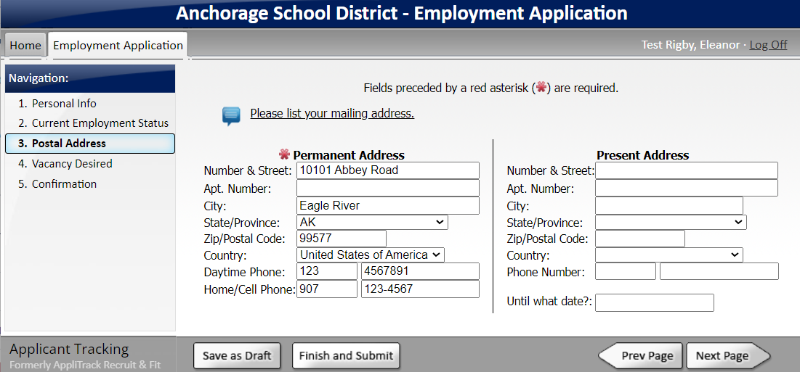

- The Vacancy Desired page lists jobs that are currently open. If you wish to see more information on the position, click the job ID number. It will open the job description.
- Check the box next to the job or jobs in which you are interested.
        - A box may pop up with instructions to be sure to fill out all of the new pages that have been created. Click Ok to continue.
        - If you wish to withdraw your application from consideration or have applied for a particular job in error, uncheck the box and resubmit. If the position has already closed, please contact HR Talent Management at 907-742-4115.
- Some positions require a certain amount of experience. After clicking the box, a question and drop down menu may pop up asking how many years of experience you have. Click the menu to choose the number of years.

- Click the next page arrow at the bottom to continue. You may have to click it several times to scroll through the list of vacancies before the application moves to the next page.
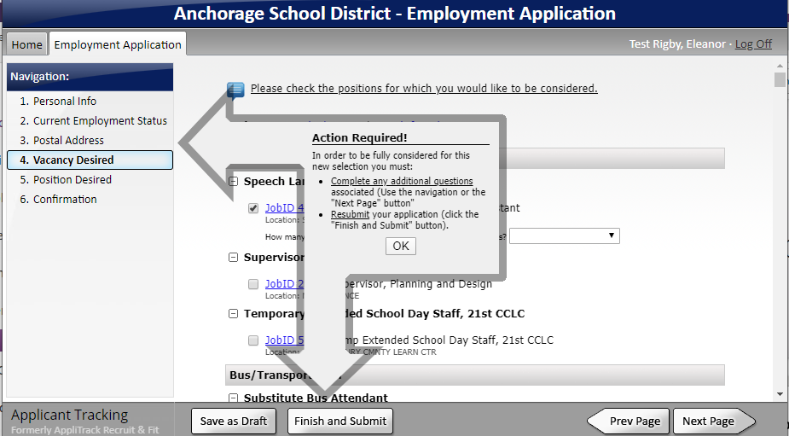
- The Position Desired page is not currently used, skip to the next page.
- On the next page, enter information on your previous job experience.

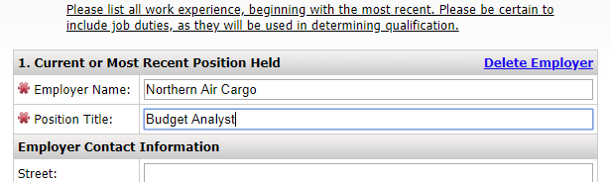

- On the Reference page, please enter the name and contact information of any references.
        - For certificated educator positions, please be sure to enter an accurate email address. The reference will receive an emailed reference survey. Please have the reference complete the reference form.
- On the next few pages, enter your education, certifications, and additional skills.

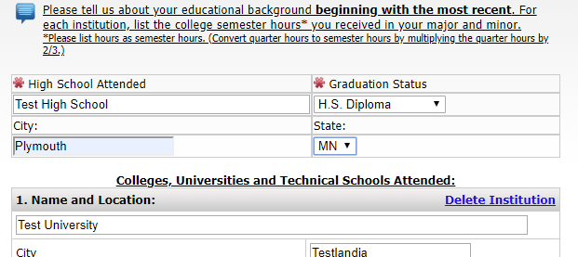

- On the page Attach Resume References and Supporting Documents, you may upload files of your resume, cover letter, letters of recommendation, etc. You must create or scan the documents and attach the files yourself; HR Talent Management cannot scan or attach documents for applicants.
        - To upload the file, click Add File next to the type of document you are uploading.

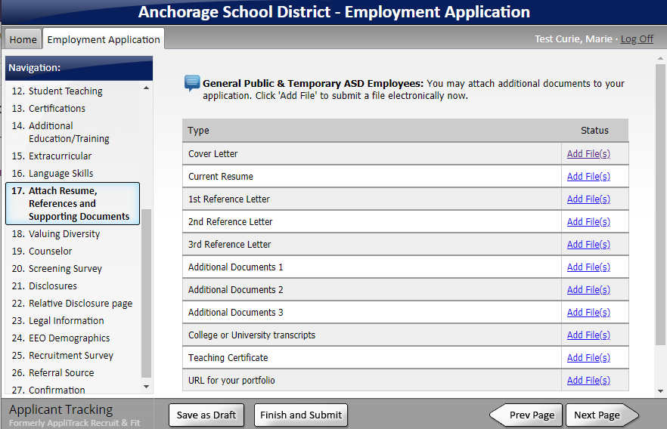

        - On the next page, click Browse. Search for the document on your computer. Click the document to highlight it, then click Open.
        - After browsing and choosing the document, click Upload. A message should appear stating that the document was saved successfully. Click Continue.
        - Upload any other documents. When finished uploading, click Next Page.
- Continue filling out the next pages, always clicking Next Page when finished.
- On the Legal Information page, please read the entire document and answer yes or no to the questions. If you answer yes to any question, you must type a statement regarding the issue in the text box provided. A yes answer does not automatically exclude your application from consideration. After answering all the questions, please be sure to click I agree at the bottom of the page, then click the Next Page arrow to continue.

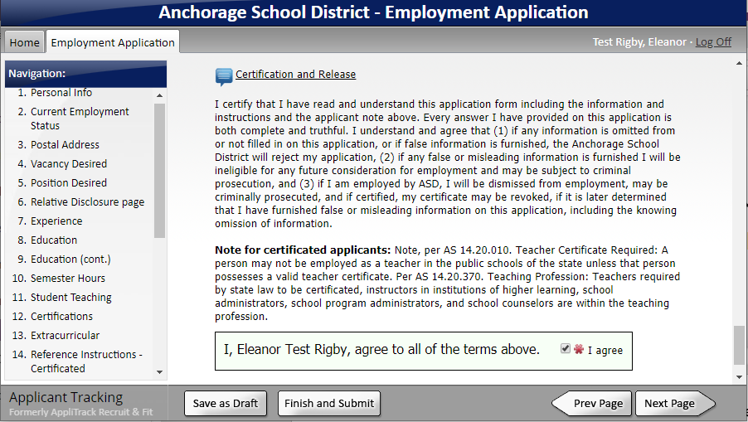

- The questions on the Equal Employment Opportunity page are optional. The answers to these questions are confidential and not used in the hiring process.
- The surveys about where you search for jobs and how you found us are also optional but help ASD in our recruiting efforts.
- When you are finished with all the pages, click Finish and Submit at the bottom of the page.
        - If at the end of the application you receive an error or warning, you must complete the missing information on the indicated pages before submitting. An application with missing information can be saved as a draft to work on later.

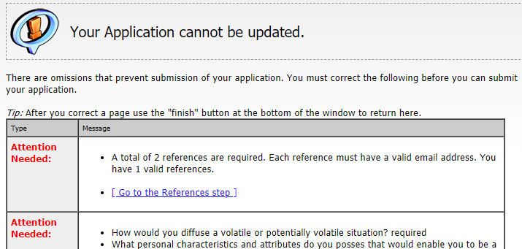

- On the last page, you will have the option to print the application.
- When the application is successfully submitted you will receive an email confirming your application and listing the positions for which you applied.

Current Regular ASD Employee Transfer Applicants (Non AEA)
All applicants will fill out the application similar to the previous section. Applicants who are currently regular employees will fill out either a shorter internal application or the full external application depending on which position is being applied for. Current AEA please see the next section.

- Like the full application, to begin click START or LOGIN. Depending on whether you have used our current system, either enter your personal information or update it. The email address you enter is the username for your profile.
- On the first page, review or enter your name and basic contact information.
- Click the Next Page arrow at the bottom right of the screen to continue.
- On the Current Employment Status page:
        - If you are applying for a position that is part of a different bargaining unit than the one you currently work in, click I am currently a member of the public….
        - If you are applying for a position that is part of the same bargaining unit as the one you currently work in, click I am a regular employee of the Anchorage School District.
        - Click Next Page at the bottom right.
- Continue filling out the rest of the provided application pages, the same as a new applicant.
- Click Finish and Submit when done.
- On the last page, you will have the option to print the application.
- When the application is successfully submitted you will receive an email confirming your application and listing the positions for which you applied.

Current AEA Transfer Applicants
If you are currently working in a position associated with AEA and would like to apply for a transfer to another AEA position, have been displaced, or are returning from leave:
- Start the process by choosing I am a regular employee of the Anchorage School District.
- On the Vacancy Desired page, only select the job labeled AEA Transfer Request. This will provide you with the required page and make you visible to principals.
  - Your application may not be seen if you skip this step.
  - If you select any other jobs on this page, you will fill out the longer external application and it will not aid in principals seeing your application.
- On the AEA transfer page, be certain to mark your preferred school/work locations. Principals will not know you are interested in their school if it is not marked in this section.
- After completing all the pages, click Finish and Submit.

Applying for Another Job
If later other positions open in which you have interest, do not start a new application. You will log back in to the account you already created.
- Starting on the Work for ASD page, scroll down and click the blue button Create or Edit an Application.

  - Or, go to the job posting you are interested in and click the red Apply button at the upper right.
- Enter the email address and password you provided earlier and click LOGIN.
- Once logged in, you will see all the information you provided previously. Review it and update it as needed.
- On the Vacancy Desired page, checkmark whichever new Job ID you are interested in. Uncheck any position you are no longer interested in.
- Choosing a new Job ID or position may create new pages in the application. Review the rest of the pages to be sure all of the required questions are complete.
- Click Finish and Submit when complete.
- On the last page, you will have the option to print the application.
- When the application is successfully submitted you will receive an email confirming your application and listing the positions for which you applied.

No Longer Interested
If after submitting your application you decide you are no longer interested in the position:
- Log back into your application and go to the Vacancy Desired page and/or Position Desired page.
- Uncheck the box next to the Job ID or content area you no longer want to be considered for.
  - If the Job ID/position has already closed, it will not be listed. If this occurs, please call us at 907-742-4115 to let us know you are no longer interested in the position.
- Click Finish and Submit.

